***Section* 1.4 – Lines and Curves in Space**

**Lines and Line Segments in Space**

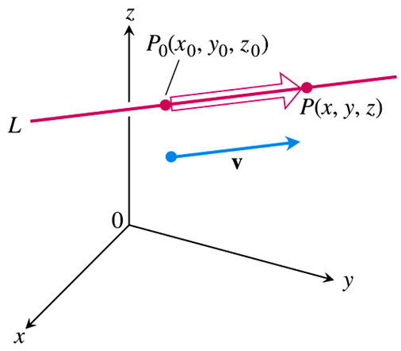

The expanded form of the equation  is



**Vector Equation for a Line**

A **vector equation for the line** ***L*** through  parallel to ***v*** is



Where *r* is the position vector of a point  on *L* and  is the position vector of .

**Parametric Equations for a Line**

A **standard parametrization** of the line through  parallel to  is



***Example***

Find the parametric equations for the line through (−2, 0, 4) parallel to 

***Solution***



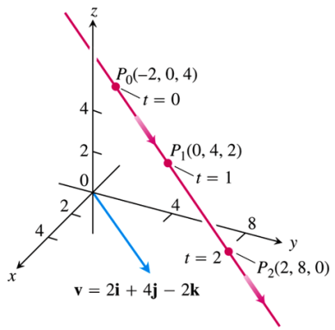

***Example***

Parametrize the line segment joining the points *P*(−3, 2, −3) and *Q*(1, −1, 4)

***Solution***



The point 

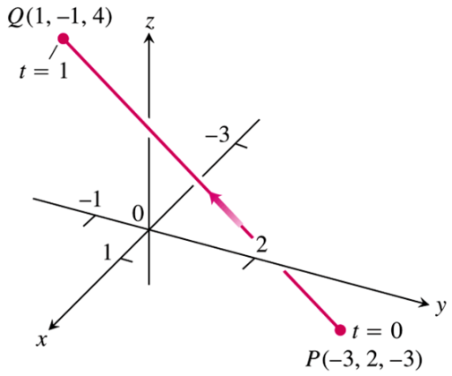

On the line passes through *P* at *t* = 0 and *Q* at *t* = 1.

That implies the restriction  to parameterize the segment



The position of a particle at time *t* is written:





***Example***

A helicopter is to fly directly from a helipad at the origin in the direction of the point (1, 1, 1) at a speed of 60 *ft/sec*. What is the position of the helicopter after 10 *sec.*?

***Solution***

The unit vector: 



Therefore; the position of the helicopter at any time *t* is







The position after 10 *sec*:





The distance is traveled:





**Distance from a Point *S* to a Line through *P* parallel to *v***

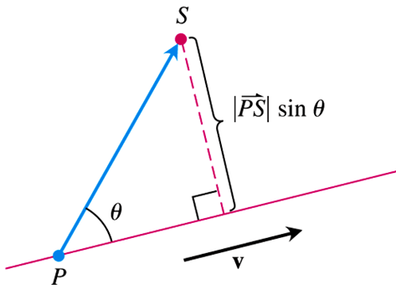



***Example***

Find the distance from the point *S* (1, 1, 5) to the line 

***Solution***

At *t =* 0, the equations for *L* passes through *P*(1, 3, 0) parallel to 

















**An Equation for a Plane in Space**

A plane in space is determined by knowing a point on the plane and its “tilt” or orientation. This “tilt” is defined by specifying a vector that is perpendicular or normal to the plane.

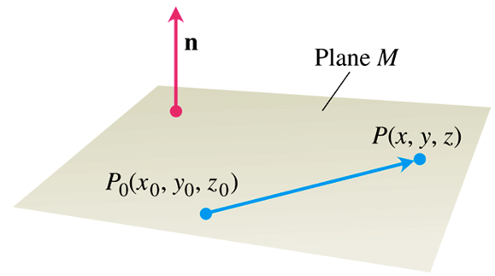

The dot product , since  is orthogonal to .





**Equation for a Plane**

The plane through  normal to  has

***Vector equation***: 

***Component equation***: 

***Component equation simplified***: 

***Example***

Find an equation for the plane through  perpendicular to 

***Solution***

The component equation is









***Example***

Find an equation for the plane through.

***Solution***





The cross product





Normal to the plane.

We substitute the components of this vector and the coordinates of *A*(0, 0, 1) into the component form of the equation to obtain



 

***Lines of Intersection***

***Example***

Find a vector parallel to the line of intersection of the planes 

***Solution***

The line of intersection of two planes is perpendicular to both planes’ normal vectors  and  and therefore parallel to .





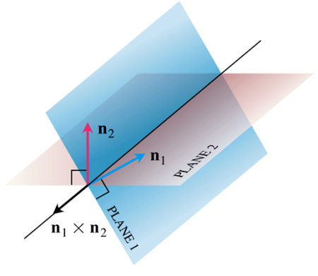

***Example***

Find the point where the line  intersects the plane .

***Solution***

The point: 

lies in the plane if its coordinates satisfy the equation of the plane, that is, if









The point of intersection is: 

**The distance from a Point to a Plane**



***Example***

Find the distance from *S*(1, 1, 3) to the plane 

***Solution***

The coefficients in the equation  give 

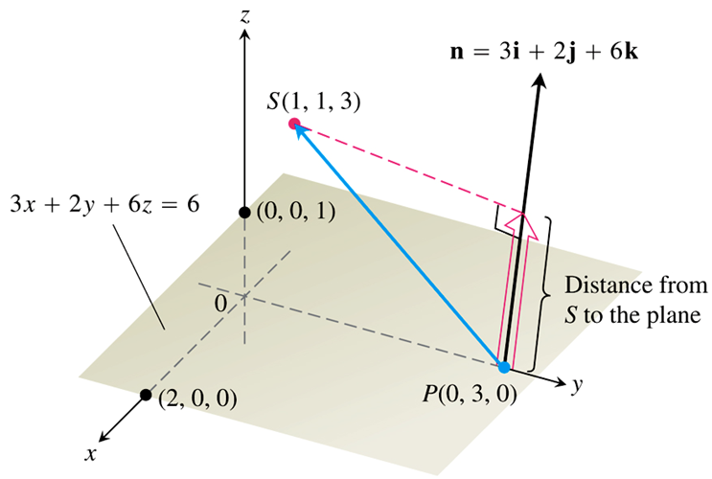







The distance from *S* to the plane is









***Angles Between Planes***

***Example***

Find the angle between the planes  and 

***Solution***

The vectors:  are normal to the planes.

The angle between them is:









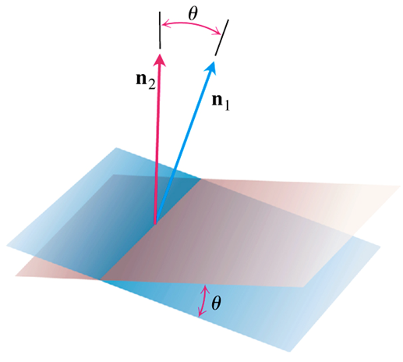

***Curves***

The coordinates for a particle moving through space during a time interval *I*, are defined as function on *I*:



The points , make up the curve in space that we call the particle’s path.

|  |  |
| --- | --- |
|  |  |
|  |  |

***Example***

Graph the vector function 

***Solution***



The curves traced by  winds around a circular cylinder, satisfies the equation.

The curve rises as the ***k***-components *z = t* increases. Each time *t* increases by 2π, the curve completes one turn around the cylinder. The curve is called a helix (from an old Greek word for “spiral”). The equations



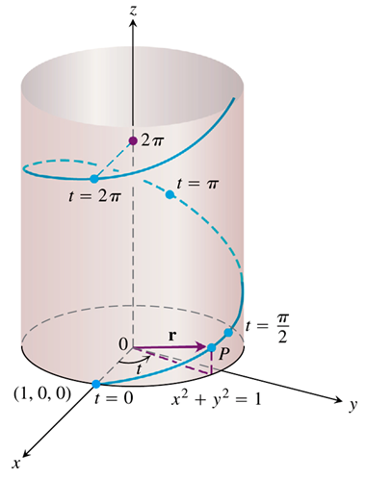

|  |  |
| --- | --- |
|  |  |

**Limits and Continuity**

***Definition***

Let  be a vector function with domain *D*, and ***L*** a vector. We say that ***r*** has limit ***L*** as *t* approaches  and write



If, for every number , there exists a corresponding number  such that for all 



***Example***

Find the limit of  as *t* approaches 

***Solution***





***Definition***

A vector fumction  is ***continuous at a point***  in its domain if . The function is continuous if it is continuous at every point in its domain.

***Exercises*** ***Section* 1.4 – Lines and Curves in Space**

1. Find the parametric equation for the line through the point  parallel to the vector 
2. Find the parametric equation for the line through the points  and 
3. Find the parametric equation for the line through the points  and 
4. Find the parametric equation for the line through the origin parallel to the vector 
5. Find the parametric equation for the line through the point  parallel to the line 
6. Find the parametric equation for the line through  perpendicular to the plane 
7. Find the parametric equation for the line through  perpendicular to the vectors  and 
8. Find the parameterization for the line segment joining the points . Draw coordinate axes and sketch the segment, indicate the direction on increasing *t* for the parametrization.
9. Find the parameterization for the line segment joining the points . Draw coordinate axes and sketch the segment, indicate the direction on increasing *t* for the parametrization.
10. Find equation for the plane through  normal to 
11. Find equation for the plane through  parallel to the plane 
12. Find equation for the plane through ,  and 
13. Find equation for the plane through  perpendicular to the line 
14. Find equation for the plane through  perpendicular to the vector from the origin to *A*.
15. Find the point of intersection of the lines  and , and find the plane determined by these lines.
16. Find the plane determined by the intersecting lines:





1. Find a plane through and perpendicular to the line of intersection of the planes 

(**18 − 25**) Find the distance from the point to the plane

1. 
2. 
3. 
4. 
5. 
6. 
7. 
8. 

(**26 − 27**) Find the distance from the point to the line

1. 

1. 
2. Find the distance from the plane  to the plane 

(**29 − 32**) Find the angle between the planes

1. 
2. 
3. 
4. 
5. Find the point in which the line meets the plane 
6. Find the point in which the line meets the plane 
7. Find an equation of the line through the point  and parallel to the line 
8. Find an equation of the line through the point  that is orthogonal to both  and 
9. Find an equation of the line through the point  that is orthogonal to the vector  and the 
10. Suppose that  is normal to a plane and that is parallel to the plane. Describe how you would find a vector that is both perpendicular to and parallel to the plane.
11. Given a point  and a vector  in , describe the set of points that satisfy the equation . Use this result to determine an equation of a line in  passing through  parallel to the vector .
12. The parallelogram has vertices at *A*(2, −1, 4), *B*(1, 0, −1), *C*(1, 2, 3) and *D*. Find

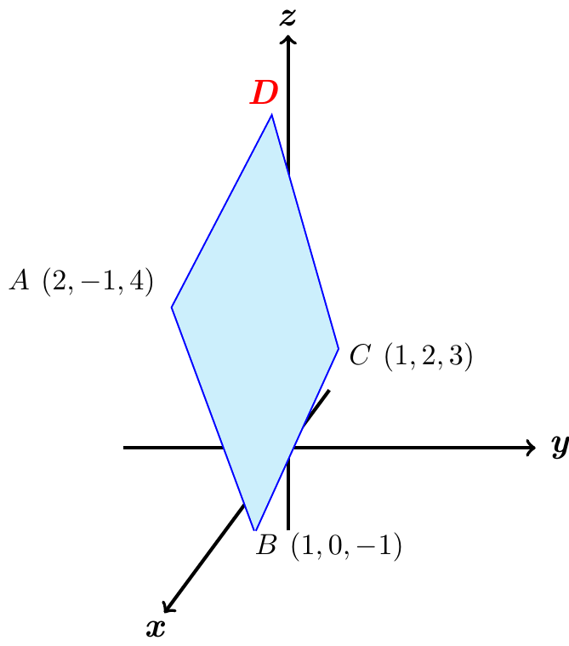

1. The coordinates of D,
2. The cosine of the interior angle of B
3. The vector projection of  onto ,
4. The area of the parallelogram,
5. An equation for the plane of the parallelogram,
6. The areas of the orthogonal projection of the parallelogram on the three coordinate planes.
7. *a*) Find the distance from the point  to the plane *P* having equation



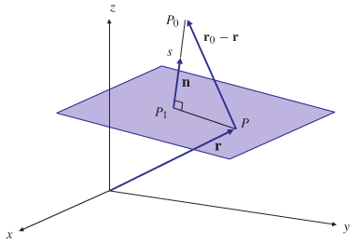

*b*) What is the distance from  to the plane ?