***Solution*** ***Section* 1.4 – Lines and Curves in Space**

***Exercise***

Find the parametric equation for the line through the point  parallel to the vector 

***Solution***



***Exercise***

Find the parametric equation for the line through the points  and 

***Solution***

The direction:  and 



***Exercise***

Find the parametric equation for the line through the points  and 

***Solution***

The direction:  and 



***Exercise***

Find the parametric equation for the line through the origin parallel to the vector 

***Solution***

The direction:  and 



***Exercise***

Find the parametric equation for the line through the point  parallel to the line 

***Solution***

The direction:  and 



***Exercise***

Find the parametric equation for the line through  perpendicular to the plane 

***Solution***

The direction:  and 



***Exercise***

Find the parametric equation for the line through  perpendicular to the vectors  and 

***Solution***

The direction:





The point on the line: 



***Exercise***

Find the parameterization for the line segment joining the points .

Draw coordinate axes and sketch the segment, indicate the direction on increasing *t* for the parameterization.

***Solution***

*Let*: 

The direction: 

The line is given by: 

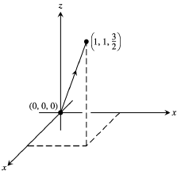

***Exercise***

Find the parameterization for the line segment joining the points . Draw coordinate axes and sketch the segment, indicate the direction on increasing *t* for the parameterization.

***Solution***

The direction:  and 



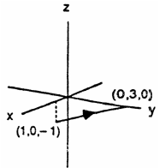

***Exercise***

Find equation for the plane through normal to 

***Solution***







***Exercise***

Find equation for the plane through  parallel to the plane 

***Solution***







***Exercise***

Find equation for the plane through,  and 

***Solution***





 is normal to the plane.







***Exercise***

Find equation for the plane through  perpendicular to the line 

***Solution***











***Exercise***

Find equation for the plane through  perpendicular to the vector from the origin to *A*.

***Solution***









***Exercise***

Find the point of intersection of the lines  and , and find the plane determined by these lines.

***Solution***









 ***√*** (Satisfied)

The lines intersect when *t* = 0 and *s* = −1

⇒ The point of intersection 

Therefore; the point is 

The normal vectors: 





 are directions of the lines.

The plane containing the lines is represented by





***Exercise***

Find the plane determined by the intersecting lines:





***Solution***

The normal vectors: 







Let *t* = 0



Therefore; the desired plane is:









***Exercise***

Find a plane through and perpendicular to the line of intersection of the planes 

***Solution***

The normal vectors: 



 is the vector in the direction of the line of intersection of the planes.





 is the desired plane containing 

***Exercise***

Find the distance from the point to the plane 

***Solution***

At *t* = 0  and let 

 and 















***Exercise***

Find the distance from the point to the plane 

***Solution***

At *t* = 0  and let 

 and 





 







***Exercise***

Find the distance from the point to the plane 

***Solution***

At *t* = 0  and let 

 and 





 









***Exercise***

Find the distance from the point to the plane 

***Solution***

 and let 

 and 



 





***Exercise***

Find the distance from the point to the plane 

***Solution***





 and let 

 and 



 



***Exercise***

Find the distance from the point to the plane 

***Solution***

 and let 

 and 



 





***Exercise***

Find the distance from the point to the plane 

***Solution***

Let , then the point *P* (4, 0 ,0) lies on the line 

 and 

 





***Exercise***

Find the distance from the point to the plane 

***Solution***

Let , then the point *P* (1, 0 ,0) lies on the line 

 and 

 





***Exercise***

Find the distance from the point to the line 

***Solution***

The line passes through the point *P*(0, 0, −1) parallel to 







 





***Exercise***

Find the distance from the point to the line 

***Solution***

The line passes through the point *P*(2, 2, 0) parallel to 







 





***Exercise***

Find the distance from the plane  to the plane 

***Solution***





 and 



 





***Exercise***

Find the angle between the planes 

***Solution***

The vectors:  are normal to the planes.

The angle between them is:

 

 



***Exercise***

Find the angle between the planes 

***Solution***

The vectors:  are normal to the planes.

The angle between them is:

 





***Exercise***

Find the angle between the planes 

***Solution***

The vectors:  are normal to the planes.

 





***Exercise***

Find the angle between the planes 

***Solution***

The vectors:  are normal to the planes.

 





***Exercise***

Find the point in which the line meets the plane 

***Solution***













***Exercise***

Find the point in which the line meets the plane 

***Solution***













***Exercise***

Find an equation of the line through the point  and parallel to the line 

***Solution***

Direction: 

Line: 



***Exercise***

Find an equation of the line through the point  that is orthogonal to both  and 

***Solution***

Direction: 



Line through : 

***Exercise***

Find an equation of the line through the point  that is orthogonal to the vector  and the 

***Solution***



Direction: 



Line through : 

***Exercise***

Suppose that  is normal to a plane and that  is parallel to the plane. Describe how you would find a vector  that is both perpendicular to  and parallel to the plane.

***Solution***

The desired vector is  or , since  is perpendicular to both  and , therefore, also parallel to the plane

***Exercise***

Given a point  and a vector  in , describe the set of points that satisfy the equation . Use this result to determine an equation of a line in  passing through  parallel to the vector 

***Solution***













Equation of a line passing through  parallel to the vector 



***Exercise***

The parallelogram has vertices at *A*(2, −1, 4), *B*(1, 0, −1), *C*(1, 2, 3) and *D*. Find

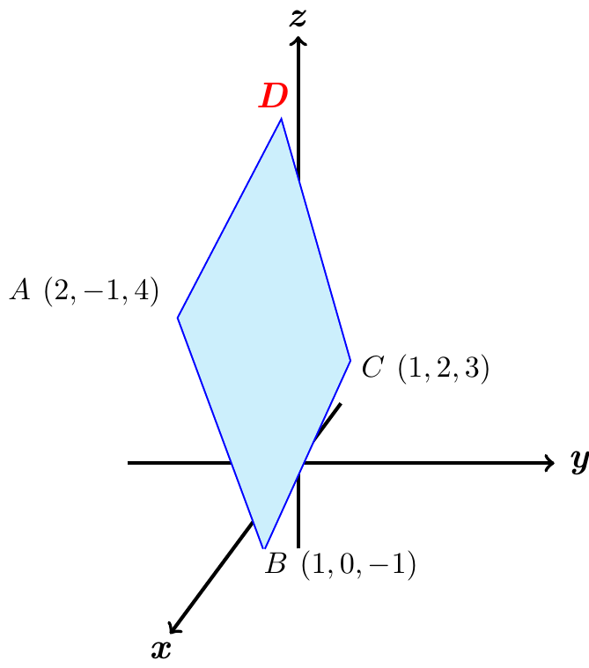

1. The coordinates of *D*,
2. The cosine of the interior angle of *B*
3. The vector projection of  onto ,
4. The area of the parallelogram,
5. An equation for the plane of the parallelogram,
6. The areas of the orthogonal projection of the parallelogram on the three coordinate planes.

***Solution***

1. 













1. 















1. 









1. 











1. 









1. 

Area of the projection on  

Area of the projection on  

Area of the projection on  

***Exercise***

*a*) Find the distance from the point  to the plane *P* having equation



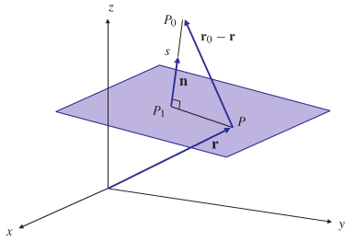

*b*) What is the distance from  to the plane ?

***Solution***

1. 



Let 



 





1. Distance  to 





