***Section* 1.5 – Calculus of Vector-Valued Functions**

**Derivative**

***Definition***

The vector function  has a derivative (is differentiable) at *t* if *f, g*, and *h* have derivatives at *t*. The derivative is the vector function







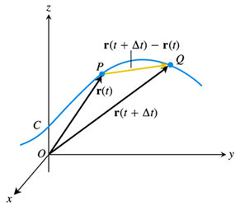 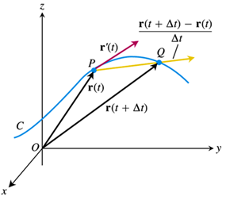

***Definitions***

If ***r*** is the position vector of a particle moving along a smooth curve in space, then



is the particle’s ***velocity vector***, tangent to the curve. At any time *t*, the direction of  is the ***direction of motion***, the magnitude of  is the particle’s ***speed***, and the derivative , when it exists, is the particle’s ***acceleration vector***. In summary,

1. Velocity is the derivative of position: 
2. Speed is the magnitude of velocity: 
3. Acceleration is the derivative of velocity: 
4. The unit vector  is the direction of motion at time *t*.

***Example***

Find the velocity, speed, and acceleration of a particle whose motion in space is given by the position vector . Sketch the velocity vector 

***Solution***

The velocity vector at time *t* is:





The acceleration vector at time *t* is:



The speed is:





 

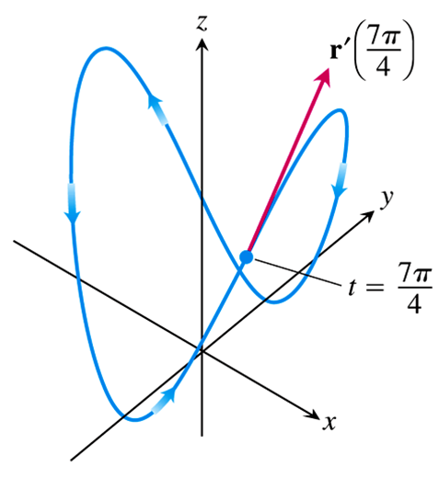 













***Differentiation Rules* for vector Functions**

Let  and  be differentiable vector functions of *t*, *C* a constant vector, *c* any scalar and *f* any differentiable scalar function.

1. *Constant Function Rule*: 
2. *Scalar Multiple Rules*: 



1. *Sum Rule*: 
2. *Difference Rule*: 
3. *Dot Product Rule*: 
4. *Cross Product Rule*: 
5. *Chain Rule*: 

**Vector Functions of Constant Length**

The position vector, of a particle that is moving on a sphere, has a constant length equal to the radius of the sphere. The velocity vector , tangent to the path of motion, is tangent to the sphere and hence perpendicular to  . the vector and its first derivative are orthogonal.

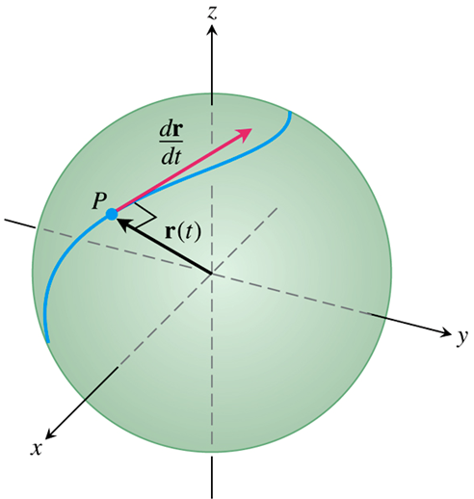

 

 ***Differentiate both sides***





If  is a differentiable vector function of *t* of constant length, then



***Exercises*** ***Section* 1.5 – Calculus of Vector-Valued Functions**

**(1 − 4)** is the position of a particle in the *xy*-plane at time *t*. Find an equation in *x* and *y* whose is the path of the particle. Then find the particle’s velocity and acceleration vectors at the given value of *t*.

|  |  |
| --- | --- |
|  |  |

**(5 − 6)** Give the position vectors of particles moving along various curves in the *xy*-plane. Find the particle’s velocity and acceleration vectors at the stated times and sketch them as vectors on the curve

1. Motion on the circle 
2. Motion on the cycloid 

**(7 − 11)**  is the position of a particle in the *xy*-plane at time *t*. Find the particle’s velocity and acceleration vectors. Then find the particle’s speed and direction of motion at the given value of *t*. Write the particle’s velocity at that time as the product of its speed and direction.

1. 
2. 
3. 
4. 
5. 
6. Find all points on the ellipse , for , at which  and  are orthogonal.