***Solution*** ***Section*** **1.5 – Calculus of Vector-Valued Functions**

***Exercise***

 is the position of a particle in the *xy*-plane at time *t*. Find an equation in *x* and *y* whose is the path of the particle. Then find the particle’s velocity and acceleration vectors at the given value of *t*.



***Solution***















***Exercise***

 is the position of a particle in the *xy*-plane at time *t*. Find an equation in *x* and *y* whose is the path of the particle. Then find the particle’s velocity and acceleration vectors at the given value of *t*.



***Solution***











 







 









***Exercise***

 is the position of a particle in the *xy*-plane at time *t*. Find an equation in *x* and *y* whose is the path of the particle. Then find the particle’s velocity and acceleration vectors at the given value of *t*.



***Solution***









 











***Exercise***

 is the position of a particle in the *xy*-plane at time *t*. Find an equation in *x* and *y* whose is the path of the particle. Then find the particle’s velocity and acceleration vectors at the given value of *t*.



***Solution***



















***Exercise***

Give the position vectors of particles moving along various curves in the *xy*-plane. Find the particle’s velocity and acceleration vectors at the stated times and sketch them as vectors on the curve

Motion on the circle 

***Solution***





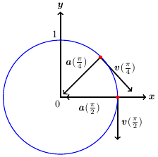 















***Exercise***

Give the position vectors of particles moving along various curves in the *xy*-plane. Find the particle’s velocity and acceleration vectors at the stated times and sketch them as vectors on the curve

Motion on the cycloid 



***Solution***







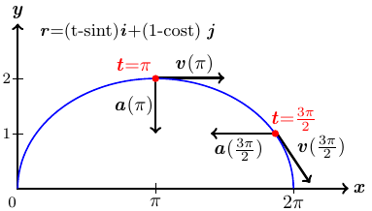 













***Exercise***

 is the position of a particle in the *xy*-plane at time *t*. Find the particle’s velocity and acceleration vectors. Then find the particle’s speed and direction of motion at the given value of *t*. Write the particle’s velocity at that time as the product of its speed and direction.



***Solution***







***Speed***: 

***Direction***: 





***Exercise***

 is the position of a particle in the *xy*-plane at time *t*. Find the particle’s velocity and acceleration vectors. Then find the particle’s speed and direction of motion at the given value of *t*. Write the particle’s velocity at that time as the product of its speed and direction.



***Solution***







***Speed***: 

***Direction***: 





***Exercise***

 is the position of a particle in the *xy*-plane at time *t*. Find the particle’s velocity and acceleration vectors. Then find the particle’s speed and direction of motion at the given value of *t*. Write the particle’s velocity at that time as the product of its speed and direction.



***Solution***









***Speed***: 

***Direction***: 





***Exercise***

 is the position of a particle in the *xy*-plane at time *t*. Find the particle’s velocity and acceleration vectors. Then find the particle’s speed and direction of motion at the given value of *t*. Write the particle’s velocity at that time as the product of its speed and direction.



***Solution***







***Speed***: 

***Direction***: 





***Exercise***

 is the position of a particle in the *xy*-plane at time *t*. Find the particle’s velocity and acceleration vectors. Then find the particle’s speed and direction of motion at the given value of *t*. Write the particle’s velocity at that time as the product of its speed and direction.



***Solution***

 



***Speed***: 

***Direction***: 





***Exercise***

Find all points on the ellipse , for , at which  and  are orthogonal.

***Solution***



 and  are orthogonal that implies to 















