***Section* 1.6 – Motion in Space**

***Integrals of Vector Functions***

A differentiable vector function  is an antiderivative of a vector function  on interval *I* if  at each point on *I*.

***Definition***

The indefinite integral of with respect to *t* is the set of all antiderivatives of, denoted by . If  is any antiderivative of, then



***Example***

Integrate: 

***Solution***





 

***Definition***

If the components of  are integrable over [*a, b*], then so is, and the ***definite integral*** of  from *a* to *b* is



***Example***

Evaluate the integral: 

***Solution***







***Example***

Suppose the acceleration vector of the path of a hang glider is given by . At time *t* = 0, the glider departed from the point (3, 0, 0) with velocity . Find the glider’s position as a function of *t*.

***Solution***







***Given***: 















***Given***: 









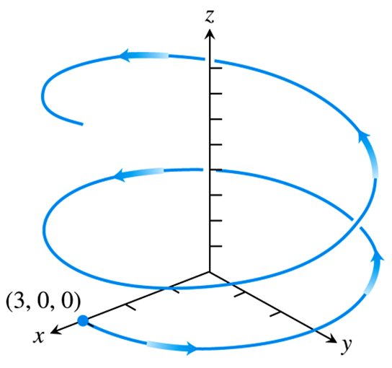

**The vector and Parametric Equations for Ideal Projectile Motion**

A projectile motion describes how an object fired at some angle from an initial position, and acted upon by only the force of gravity, moves in a vertical coordinate plane. We ignore the effects of any frictional drag on the object, which may vary with its speed and altitude, and also the fact the force of gravity changes slightly with the projectile’s changing height.

To derive equations for projectile motion, we assume that the projectile behaves like a particle moving in a vertical coordinate plane and the only force acting on the projectile during its flight is the constant force of gravity, which always points straight down.

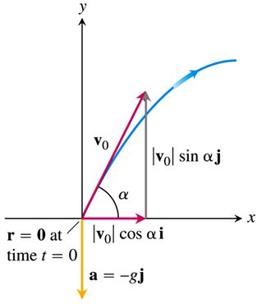 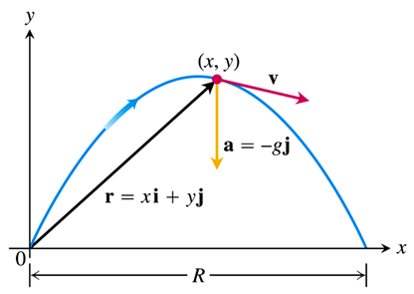

**Ideal Projectile Motion Equation**



This is the vector equation for ideal projectile motion. The angle α is the projectile’s ***launch angle*** (***firing angle, angle of elevation***), and  is the projectile’s ***initial speed***. The components of ***r*** give the parametric equations



Where *x* is the distance downrange and *y* is the height of the projectile at time *t* ≥ 0.

***Example***

A projectile is fired from the origin over horizontal ground at an initial speed of 500 m/sec and a launch angle of 60°. Where will the projectile be 10 sec later?

***Solution***

***Given***: 







After 10 *sec*, the projectile is about 3840 *m* above the ground and 2500 *m* downrange from the origin.

**Height, Flight Time, and Range for Ideal Projectile Motion**

For ideal projectile motion when an object is launched from the origin over a horizontal surface with initial speed  and launch angle α:

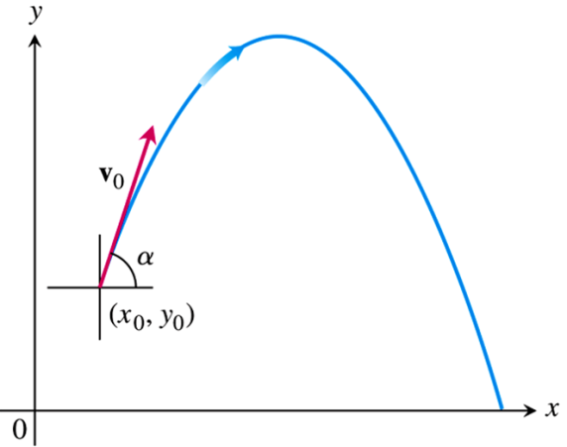*Maximum height*: 

*Maximum time*: 

*Flight time*: 

*Range*: 

If we fire a projectile from a point  instead of the origin, then the position vector for the path of motion is



**Projectile Motion with Wind Gusts**

***Example***

A baseball is hit when it is 3 *feet* above the ground. It leaves the bat with initial speed of 152 *ft/sec*, making an angle of 20° with the horizontal. At the instant the ball hit, an instantaneous gust of wind blows in the horizontal direction directly opposite the direction the ball is taking toward the outfield, adding a component of  to the ball’s initial velocity .

1. Find a vector equation (position vector) for the path of the baseball.
2. How high does the baseball go, and when does it reach maximum height?
3. Assuming that the ball is not caught, find its range and flight time.

***Solution***

1. The initial velocity of the baseball is:





The initial position is .









1. The baseball reaches its highest point when the vertical component of velocity is zero:













The maximum height of the baseball is about 45.2 *feet*, reached about 1.6 *sec* after leaving the bat.

1. The vertical component for  equal to 0:



 ***Solve for t.***







The horizontal range is about 442 *feet*, and the flight time is about 3.3 *sec*.

***Exercises*** ***Section* 1.6 – Motion in Space**

Evaluate the integral

|  |  |
| --- | --- |
|  |  |

1. Solve the initial value problem for  as a vector function of *t*.



1. Solve the initial value problem for  as a vector function of *t*.



1. Solve the initial value problem for  as a vector function of *t*.



1. Solve the initial value problem for  as a vector function of *t*.



1. Solve the initial value problem for  as a vector function of *t*.





1. Consider 
2. Evaluate  and , if each exists
3. Find  and evaluate 
4. Find 
5. Evaluate 
6. Consider 
7. Evaluate  and , if each exists
8. Find  and evaluate 
9. Find 
10. Evaluate 
11. Consider 
12. Evaluate  and , if each exists
13. Find  and evaluate 
14. Find 
15. Evaluate 
16. Consider 
17. Evaluate  and , if each exists
18. Find  and evaluate 
19. Find 
20. Evaluate 
21. At time *t* = 0, a particle is located at the point . It travels in a straight line to the point , has speed 2 at  and constant acceleration . Find an equation for the position vector of the particle at time *t*.
22. A projectile is fired at a speed of 840 *m/sec* at an angle of 60°. How long will it take to get 21 *km* downrange?
23. Find the muzzle speed of a gun whose maximum range is 24.5 *km*.
24. A spring gun at ground level fires a golf ball at an angle of 45°. The ball lands 10 *m* away.
25. What was the ball’s initial speed?
26. For the same initial speed, find the two firing angles that make the range 6 *m*.
27. An electron in a TV tube is beamed horizontally at a speed of toward the face of the tube 40 *cm* away. About how far will the electron drop before it hits?
28. A golf ball is hit with an initial speed of 116 *ft/sec* at an angle of elevation of 45° from the tee to a green that is elevated 45 *feet* above the tee. Assuming that the pin, 369 *feet* downrange, does not get in the way, where will the ball land in relation to the pin?

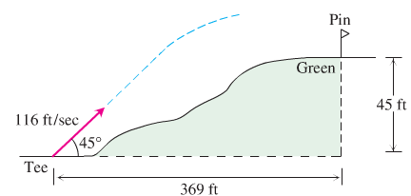

1. An ideal projectile is launched straight down an inclined plane.
2. Show that the greatest downhill range is achieved when the initial velocity vector bisects angle *AOR*.
3. If the projectile were fired uphill instead of down, what launch angle would maximize its range?

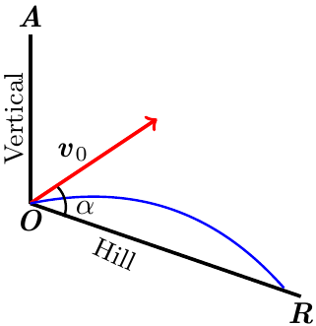

1. A volleyball is hit when it is 4 *feet* above the ground and 12 *feet* from a 6-*foot*-high net. It leaves the point of impact with an initial velocity of 35 *ft/sec* at an angle of 27° and slips by the opposing team untouched.
2. Find a vector equation for the path of the volleyball.
3. How high does the volleyball go, and when does it reach maximum height?
4. Find its range and flight time.
5. When is the volleyball 7 *feet* above the ground? How far (ground distance) is the volleyball from where it will land?
6. Suppose that the net is raised to 8 *feet*. Does this changes things? Explain.
7. A toddler on level ground throws a baseball into the air at an angle of 30° with the ground from a height of 2 *feet*. If the ball lands 10 *feet* from the child, determine the initial speed of the ball.
8. A basketball player tosses a basketball into the air at an angle 45° with the ground from a height of 6 *feet* above the ground. If the ball goes through the basket 15 *feet* away and 10 *feet* above the ground, determine the initial velocity of the ball.
9. The position of a particle in the plane at time *t* is . Find the particle’s highest speed.
10. A particle traveling in a straight line located at the point  and has speed 2 at time *t* = 0. The particle moves toward the point  with constant acceleration . Find the position vector  at time *t*.
11. A circular wheel with radius 1 *foot* and center *C* rolls to the right along the *x*-axis at a half-run per second. At time *t* seconds, the position vector of the point *P* on the wheel’s circumference is



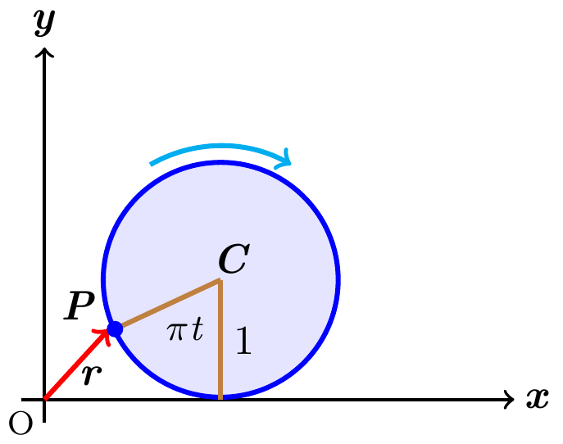

1. Sketch the curve traced by *P* during the interval 
2. Find  and  at *t* = 0, 1, 2, and 3 and add these vectors to your sketch
3. At any given time, what is the forward speed of the topmost point of the wheel? Of *C*?
4. A shot leaves the thrower’s hand 6.5 *feet* above the ground at a 45° angle at 44 *ft/sec*. Where is it 3 *sec* later?