***Solution*** ***Section* 1.6 – Motion in Space**

***Exercise***

Evaluate the integral: 

***Solution***







***Exercise***

Evaluate the integral: 

***Solution***









***Exercise***

Evaluate the integral: 

***Solution***













***Exercise***

Evaluate the integral: 

***Solution***













***Exercise***

Evaluate the integral: 

***Solution***









***Exercise***

Evaluate the integral: 

***Solution***

|  |  |  |
| --- | --- | --- |
|  |  |  |
|  |  |  |
|  |  |  |
|  |  |  |

 











***Exercise***

Evaluate the integral: 

***Solution***











***Exercise***

Solve the initial value problem for ***r*** as a vector function of *t*.



***Solution***













***Exercise***

Solve the initial value problem for ***r*** as a vector function of *t*.



***Solution***













***Exercise***

Solve the initial value problem for ***r*** as a vector function of *t*.



***Solution***















***Exercise***

Solve the initial value problem for as a vector function of *t*.



***Solution***























***Exercise***

Solve the initial value problem for  as a vector function of *t*.



***Solution***























***Exercise***

Consider 

1. Evaluate  and , if each exists
2. Find  and evaluate 
3. Find 
4. Evaluate 

***Solution***

1. 







1. 



1. 
2. 



***Exercise***

Consider 

1. Evaluate  and , if each exists
2. Find  and evaluate 
3. Find 
4. Evaluate 

***Solution***

1. 







1.  



1.  
2. 





***Exercise***

Consider 

1. Evaluate  and , if each exists
2. Find  and evaluate 
3. Find 
4. Evaluate 

***Solution***

1. 













1. 



1.  

|  |  |  |
| --- | --- | --- |
|  |  |  |
| + |  |  |
| − |  |  |

1. 



***Exercise***

Consider 

1. Evaluate  and , if each exists
2. Find  and evaluate 
3. Find 
4. Evaluate 

***Solution***

1. 







1. 



1. 
2. 



***Exercise***

At time *t* = 0, a particle is located at the point . It travels in a straight line to the point , has speed 2 at  and constant acceleration . Find an equation for the position vector of the particle at time *t*.

***Solution***







Since the particle travels in a straight line in the direction of the vector:



At *t* = 0, the particle has a speed of 2.













At time *t* = 0, a particle is located at the point  









***Exercise***

A projectile is fired at a speed of 840 *m/sec* at an angle of 60°. How long will it take to get 21 *km* downrange?

***Solution***









***Exercise***

Find the muzzle speed of a gun whose maximum range is 24.5 *km*.

***Solution***



Maximum *R* occurs when sine equals to 1 









***Exercise***

A spring gun at ground level fires a golf ball at an angle of 45°. The ball lands 10 *m* away.

1. What was the ball’s initial speed?
2. For the same initial speed, find the two firing angles that make the range 6 *m*.

***Solution***

1. 











1. 









***Exercise***

An electron in a TV tube is beamed horizontally at a speed of toward the face of the tube 40 *cm* away. About how far will the electron drop before it hits?

***Solution***

***Given***: 



 ***Horizontal α* = 0°**









Therefore, the electron drop 

***Exercise***

A golf ball is hit with an initial speed of 116 *ft/sec* at an angle of elevation of 45° from the tee to a green that is elevated 45 *feet* above the tee. Assuming that the pin, 369 *feet* downrange, does not get in the way, where will the ball land in relation to the pin?

***Solution***



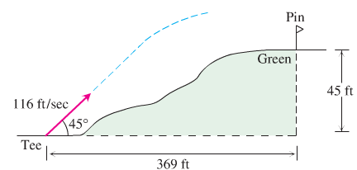













It will take the ball 4.5 *sec* to travel 369 *feet*. at the time the ball will be 45.11 *feet* in the air and will hit the green past the pin.

***Exercise***

An ideal projectile is launched straight down an inclined plane.

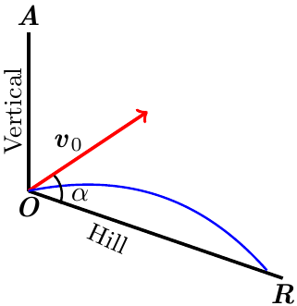

1. Show that the greatest downhill range is achieved when the initial velocity vector bisects angle *AOR*
2. If the projectile were fired uphill instead of down, what launch angle would maximize its range?

***Solution***

1. 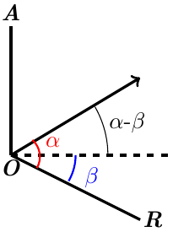











;

Which is time when the projectile hits the downhill slope.

















 

1. 

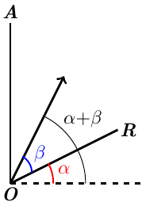









; which is time when the projectile hits the uphill slope.















 

***Exercise***

A volleyball is hit when it is 4 *feet* above the ground and 12 *feet* from a 6-*foot*-high net. It leaves the point of impact with an initial velocity of 35 *ft/sec* at an angle of 27° and slips by the opposing team untouched.

1. Find a vector equation for the path of the volleyball.
2. How high does the volleyball go, and when does it reach maximum height?
3. Find its range and flight time.
4. When is the volleyball 7 *feet* above the ground? How far (ground distance) is the volleyball from where it will land?
5. Suppose that the net is raised to 8 *feet*. Does this change things? Explain.

***Solution***

***Given***: 

1. 









1. 









1.  *Solve for* ***t***





***Range***: 



1.  *Solve for* ***t***















1. Since , the ball won’t clear the 8 *ft* net, therefore, Yes, it changes things.

***Exercise***

A toddler on level ground throws a baseball into the air at an angle of 30° with the ground from a height of 2 *feet*. If the ball lands 10 *feet* from the child, determine the initial speed of the ball.

***Solution***



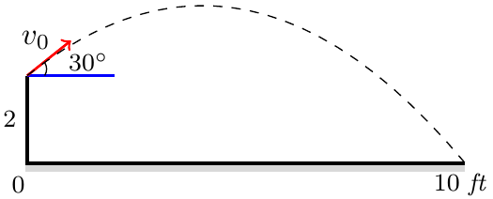 





At 10 *feet* 



















***Exercise***

A basketball player tosses a basketball into the air at an angle 45° with the ground from a height of 6 *feet* above the ground. If the ball goes through the basket 15 *feet* away and 10 *feet* above the ground, determine the initial velocity of the ball.

***Solution***



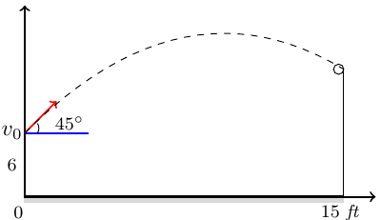











***Exercise***

The position of a particle in the plane at time *t* is . Find the particle’s highest speed.

***Solution***

 









To maximize the speed :





***Exercise***

A particle traveling in a straight line located at the point  and has speed 2 at time *t* = 0. The particle moves toward the point  with constant acceleration . Find the position vector  at time *t*.

***Solution***







The particle travels in the direction:



At 













Given the starting point at  . Then, 







***Exercise***

A circular wheel with radius 1 *foot* and center *C* rolls to the right along the *x*-axis at a half-run per second. At time *t* seconds, the position vector of the point *P* on the wheel’s circumference is



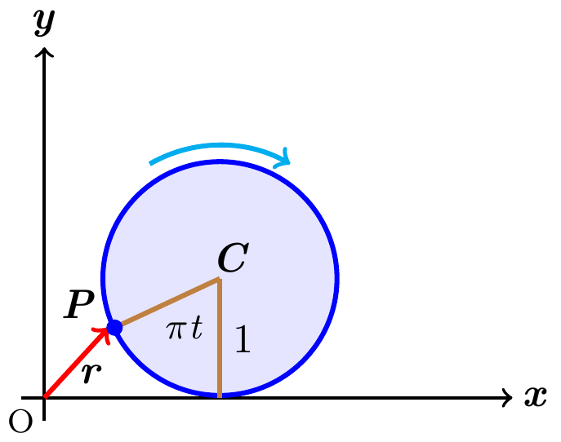

1. Sketch the curve traced by *P* during the interval 
2. Find  and  at *t* = 0, 1, 2, and 3 and add these vectors to your sketch
3. At any given time, what is the forward speed of the topmost point of the wheel? Of *C*?

***Solution***

1. 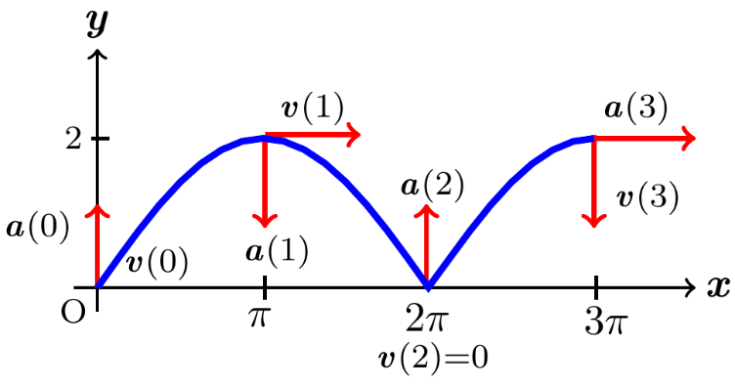

|  |  |  |
| --- | --- | --- |
| ***t*** | ***x*** | ***y*** |
| 0 | 0 | 0 |
|  |  | 1 |
| 1 | *π* | 2 |
| 2 | 2 *π* | 0 |
| 3 | 3 *π* | 2 |

1. 



|  |  |  |
| --- | --- | --- |
| ***t*** |  |  |
| 0 | 0 |  |
| 1 |  |  |
| 2 | 0 |  |
| 3 |  |  |

1. Forward speed at the most point 

Since the circles makes , the center moves  parallel to *x-*axis each second.

Forward speed of *C* is 

***Exercise***

A shot leaves the thrower’s hand 6.5 *ft* above the ground at a 45° angle at 44 *ft/sec*. Where is it 3 *sec* later?

***Solution***

***Given***: 









 

The shot is on the ground at .















