***Section* 1.7 – Length of Curves**

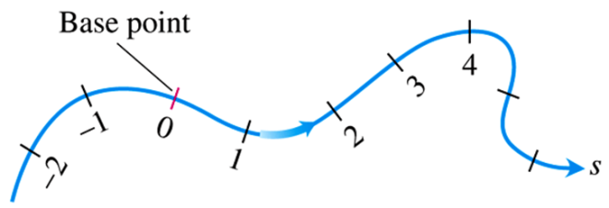

**Arc Length along a Space Curve**

***Definition***

The ***length*** of a smooth curve , that is traced exactly once as *t* increases from *t = a* to *t = b*, is



**Arc Length Formula** 

***Example***

A glider is soaring upward along the helix . How long is the glider’s path from *t* = 0 to *t* = 2π?

***Solution***

The path segment during this time corresponds to one full turn of the helix. The length of this portion of the curve is

 









∴ This is  times the circumference of the circle in the *xy-*plane over which the helix stands.

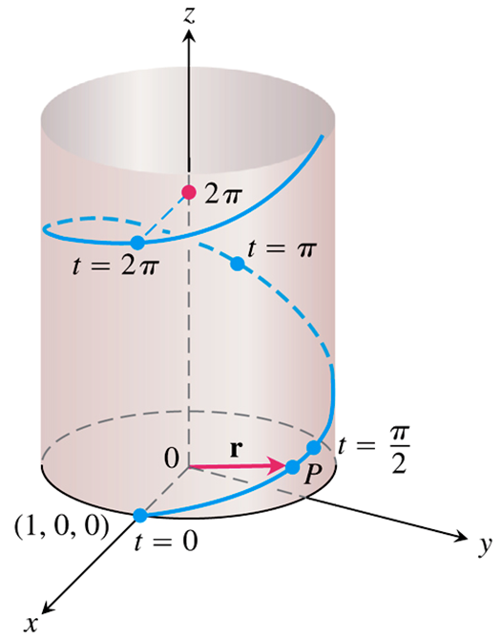

**Arc Length Parameter with Base Point **





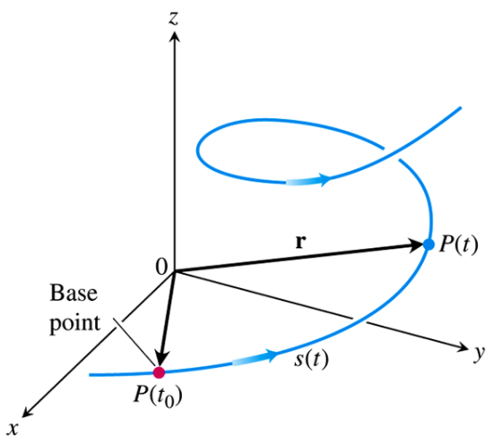

**Unit Tangent Vector**

The velocity vector  is tangent to the curve  and that the vector



A unit vector tangent to the (*smooth*) curve, called the ***unit tangent vector***.

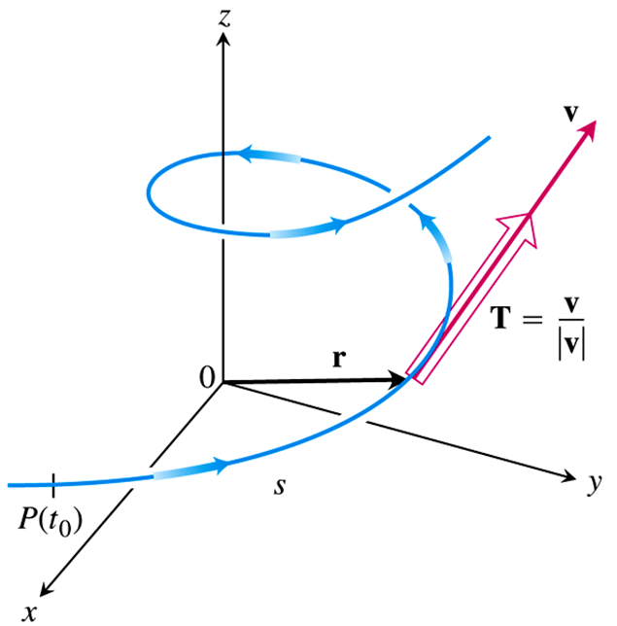

***Example***

Find the unit tangent vector of the curve  representing the path of the glider.

**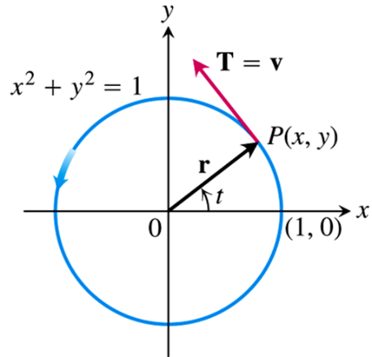*Solution***











***Exercises*** ***Section* 1.7 – Length of Curves**

(**1 – 6**) Find the curve’s unit tangent vector. Also, find the length of the indicated portion of the curve

1. 
2. 
3. 
4. 
5. 
6. 
7. Find the point on the curve  at a distance 26π units along the curve from the point (0, 5, 0) in the direction of increasing arc length.

(**8 – 13**) Find the arc length parameter along the curve from the point. Also, find the length of the indicated portion of the curve.

1. 
2. 
3. 
4. 
5. 
6. 

(**14 – 15**) Find the lengths of the curves

1. 

1. 
2. The acceleration of a wayward firework is given by . Suppose the initial velocity of the firework is .
3. Find the velocity of the firework, for .
4. Find the length of the trajectory of the firework over the interval 
5. If a string wound around a fixed circle in unwound while held taut in the plane of the circle, its end *P* traces an involute of the circle. The circle in question is the circle  and the tracing point starts at (1, 0). The unwound portion of the string is tangent to the circle at *Q*, and *t* is the radian measure of the angle from the position *x*-axis to segment *OQ*.

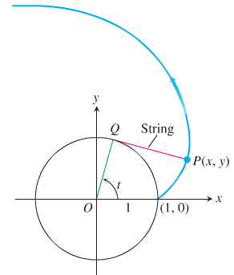

Derive the parametric equations 

of the point  for the involute.