***Section* 1.8 – Curvature and Normal Vectors**

**Curvature of a Plane Curve**

As a particle moves along a smooth curve in the plane,  turns as the curve bends. Since  is a unit vector, its length remains constant and only its direction changes as particle moves along the curve. The rate at which  turns per unit of length along the curve is called the ***curvature***.

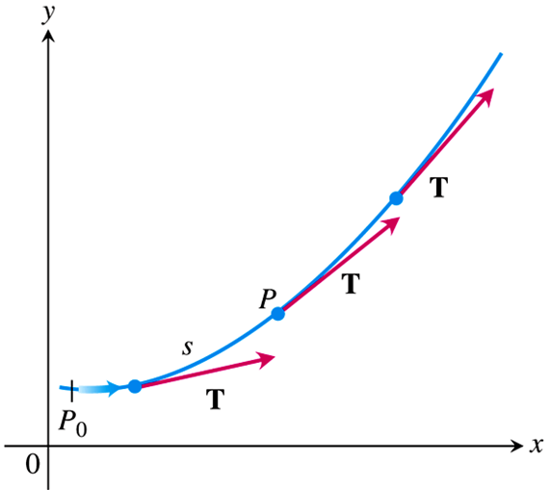

***Definition***

If  is the unit vector of a smooth curve, the ***curvature*** function of the curve is



**Formula for Calculating Curvature**

If  is a smooth curve, then the curvature is



Where  is the unit tangent vector.

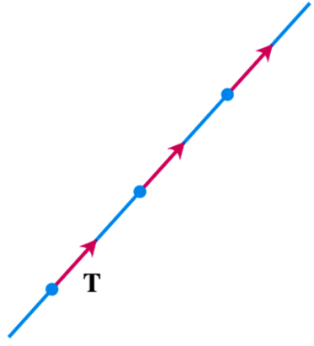***Example***

A straight line is parametrized by  for constant vectors  and . Thus , and the unit tangent vector  is a constant vector that always points in the same direction and has derivative **0**. It follows that, for any value of the parameter *t*, the curvature of the straight line is



***Example***

Find the curvature of a circle  of radius *a*.

***Solution***









 ***Since a > 0***















***Definition***

At a point where , the **principal unit normal** vector for a smooth curve in the plane is



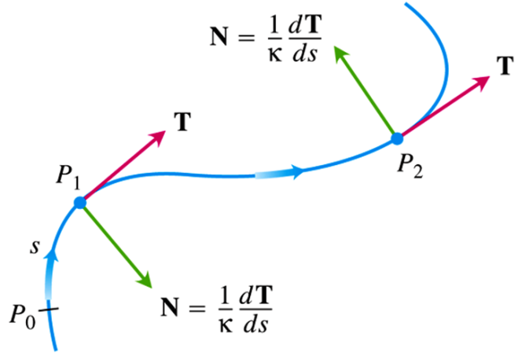

**Formula for Calculating *N***

If  is a smooth curve, then the principal unit normal is



Where  is the unit tangent vector.

***Example***

Find ***T*** and ***N*** for the circular motion 

***Solution***

























***Circle of Curvature* for plane Curves**

The ***circle of curvature*** or ***osculating circle*** at a point *P* on a plane where  is the circle in the plane of the curve that

1. is tangent to the curve at *P* (has the same tangent line the curve has)
2. has the same curvature the curve has at *P*
3. lies toward the concave or inner side of the curve

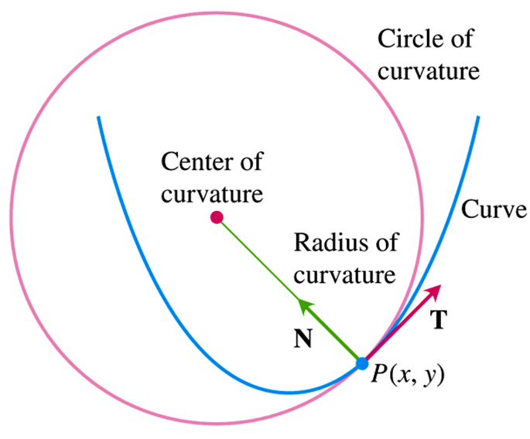

The ***radius of curvature*** of the curve at *P* is the radius of the circle of curvature, which is



To find *ρ*, we find *κ* and take the reciprocal. The ***center of curvature*** of the curve at *P* is the center of the circle of curvature.

***Example***

Find and graph the osculating circle of the parabola  at the origin.

***Solution***

Assume: 





















At the origin, *t* = 0, so the curvature is











The radius of curvature is: 

At the origin, *t* = 0:



The center of the circle is 

The equation of the osculating circle is: 

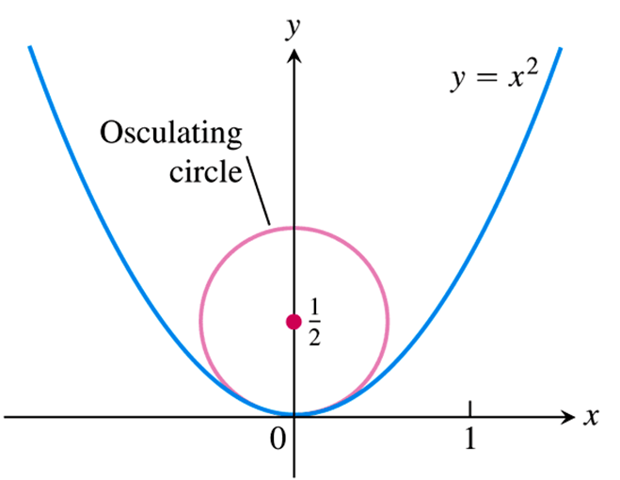

**Curvature and Normal Vectors for Space Curves**

If a smooth curve in space is specified by the position  as a function of somw parameter *t*, and if *s* is the arc length parameter of the curve, then the unit tangernt vector  is . The curvature in space is then defiined to be



Just as for plane curves. The vector  is orthogonal to , and we define the ***principal unit normal*** to be



***Example***

Find the curvature for the helix 

***Solution***

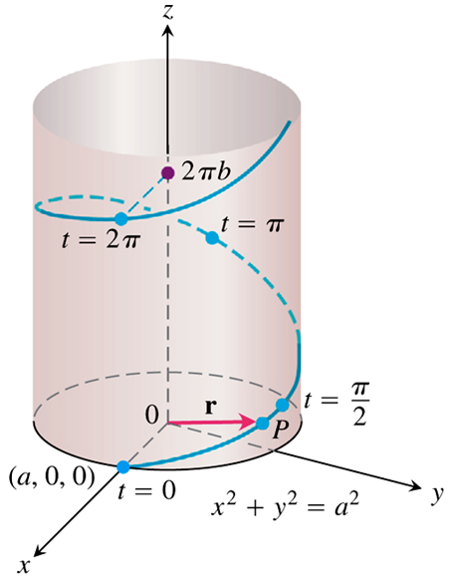





















***Example***

Find  for the helix 

***Solution***













**TNB Frame**

The ***binormal vector*** of a curve in space , a unit vector orthogonal to both  and . Together ***, ***, and  define a moving right-handed vector frame that play a significant role in calculating the paths of particles moving through space. It is called the ***Frenet frame*** or ***TNB frame***.

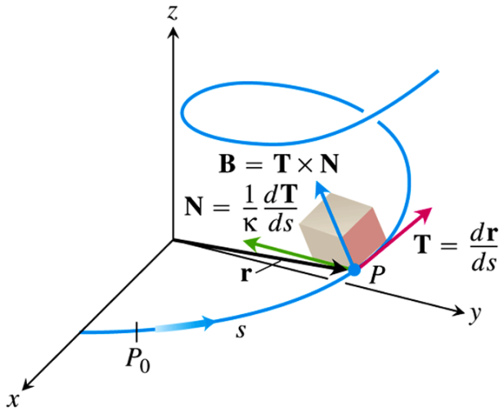

**Tangential and Normal Components of Acceleration**

When an object is accelerated by gravity, brakes, or a combination of rocket motors, how much of the acceleration acts in the direction of motion, in the tangential direction .

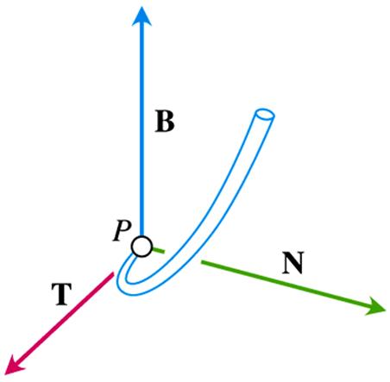

















***Definition***

If the acceleration vector is written as



then



are the ***tangential*** and ***normal*** scalar components of acceleration.

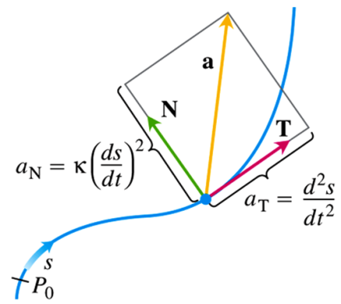

**Formula for Calculating the Normal Component of Acceleration**



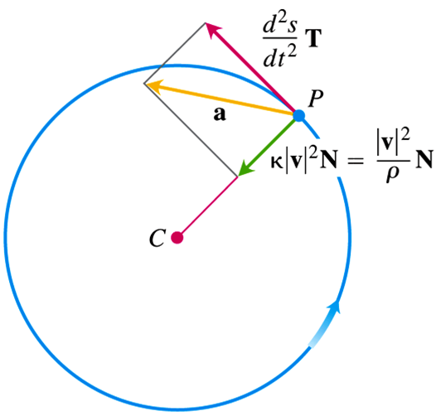

***Example***

Without finding  and , write the acceleration of the motion



In the form 

***Solution***

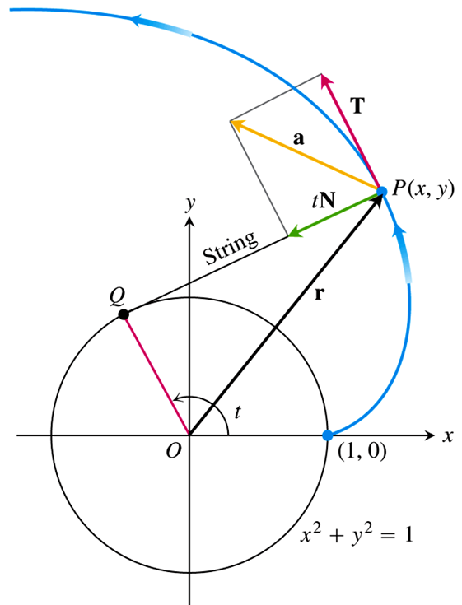









** *t* > 0**































***Torsion***

***Definition***

Let . The torsion function of a smooth curve is



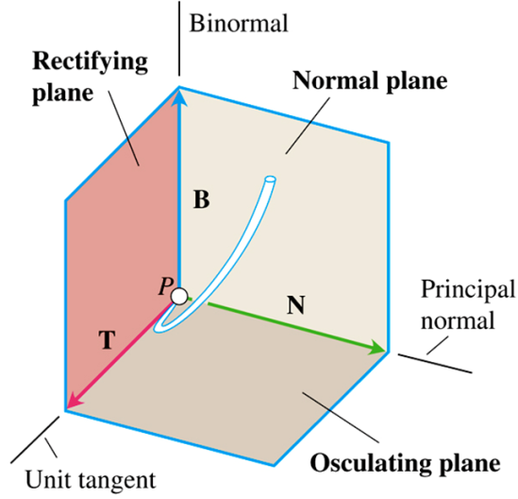

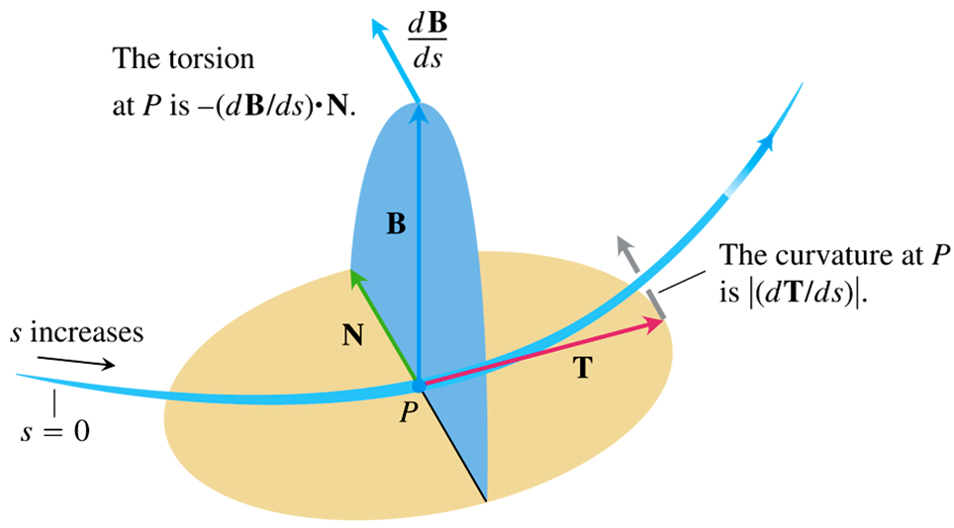

**Computation Formulas for Curves in Space**

*Unit tangent vector*: 

*Principal unit normal vector*: 

*Binormal vector*: 

*Curvature*: 

*Torsion*: 

Tangential and normal scalar

components of acceleration: 







***Exercises Section* 1.8 – Curvature and Normal Vectors**

(**1 – 9**) Find , , and *κ* for the plane curves:

|  |  |
| --- | --- |
|  |  |

1. Find an equation for the circle of curvature of the curve , at the point . (The curve parameterizes the graph  in the *xy*-plane.)

(**11 – 17**) Write  of the motion  without finding  and .

1. 
2. 
3. 
4. 
5. 
6. 
7. 

(**18 – 19**) Graph the curves and sketch their velocity and acceleration vectors at the given values of *t*. Then write  of the motion  without findingand , and find the value of *κ* at the given values of *t*.

1. 

1. 

(**20 – 22**) Find , , , τ, and *κ* at the given value of *t* for the plane curves

1. 
2. 
3. 

(**23 – 24**) Find , , , τ, and *κ* at the given value of *t*. Then find equations for the osculating, normal, and rectifying planes at that value of *t*.

1. 
2. 

(**25 – 27**) Find  and *τ* for:

1. 
2. 
3. 
4. The speedometer on your car reads a steady 35 *mph*, could you be accelerating? Explain.
5. Can anything be said about the acceleration of a particle that is moving at a constant speed? Give reasons for your answer.
6. Find , , , τ, and *κ* as functions of ***t*** for the plane curves: , then write  of the motion 
7. Consider the ellipse 
8. Find the tangent vector , the unit vector , and the principal unit normal vector  at all points on the curve.
9. At what points does  have maximum and minimum values?
10. At what points does the curvature have maximum and minimum values? Interpret this result in light of part (*b*).
11. Find the points (if any) at which  and  are parallel.
12. Find the following for all values of *t* for which the given curve is defined by 
13. Find the tangent vector and the unit tangent vector
14. Find the curvature.
15. Find the principal unit normal vector.
16. Verify that 
17. Graph the curve and sketch  and  at two points.
18. Find the following for all values of *t* for which the given curve is defined by



1. Find the tangent vector and the unit tangent vector
2. Find the curvature.
3. Find the principal unit normal vector.
4. Verify that 
5. Graph the curve and sketch  and  at two points.
6. Find the following for all values of *t* for which the given curve is defined by



1. Find the tangent vector and the unit tangent vector
2. Find the curvature.
3. Find the principal unit normal vector.
4. Verify that 
5. Graph the curve and sketch  and  at two points.
6. Find the following for all values of *t* for which the given curve is defined by 
7. Find the tangent vector and the unit tangent vector
8. Find the curvature.
9. Find the principal unit normal vector.
10. Verify that 
11. Graph the curve and sketch  and  at two points.
12. Find equations for the osculating, normal and rectifying planes of the curve  at the point (1, 1, 1).
13. Consider the position vector  of the moving objects
14. Find the normal and tangential components of the acceleration.
15. Graph the trajectory and sketch the normal and tangential components of the acceleration at two points on the trajectory. Show that their sum gives the total acceleration.
16. Consider the position vector  of the moving objects
17. Find the normal and tangential components of the acceleration.
18. Graph the trajectory and sketch the normal and tangential components of the acceleration at two points on the trajectory. Show that their sum gives the total acceleration.
19. Consider the position vector  of the moving objects

Find the normal and tangential components of the acceleration.

1. Consider the position vector  of the moving objects
2. Find the normal and tangential components of the acceleration.
3. Graph the trajectory and sketch the normal and tangential components of the acceleration at two points on the trajectory. Show that their sum gives the total acceleration.
4. Compute the unit binormal vector  and the torsion of the curve 
5. At point *P*, the velocity and acceleration of a particle moving in the plane are  and . Find the curvature of the particle’s path at *P*.
6. Consider the curve 
7. Find  at all points of *C*.
8. Find  and the curvature at all points of *C*.
9. Sketch the curve and show  and  at the points of *C* corresponding to  and .
10. Are the results of parts (*a*) and (*b*) consistent with the graph?
11. Find  at all points of *C*.
12. Describe three calculations that serve to check the accuracy of your results in part (*a*) − (*f*).
13. Compute the torsion at all points of *C*. Interpret this result.
14. Consider the curve 
15. Find  at all points of *C*.
16. Find  and the curvature at all points of *C*.
17. Sketch the curve and show  and  at the points of *C* corresponding to  and .
18. Are the results of parts (*a*) and (*b*) consistent with the graph?
19. Find  at all points of *C*.
20. Describe three calculations that serve to check the accuracy of your results in part (*a*) − (*f*).
21. Compute the torsion at all points of *C*. Interpret this result.
22. Suppose , where *f, g*, and *h* are the quadratic functions , , and , and where at least one of the leading coefficients  is nonzero. Apart from a set of degenerate cases (for example , whose graph is a line), it can be shown that the graph of  is a parabola that lies in a plane
23. Show by direct computation that  is constant. Then explain why the unit binormal vector is constant at all points on the curve. What does this result say about the torsion of the curve?
24. Compute  and explain why the torsion is zero at all points on the curve for which the torsion is defined.
25. Let *f* and *g* be continuous on an interval *I*. consider the curve



For *t* in *I*, and where , for , are real numbers

1. Show that, in general, *C* lies in a plane.
2. Explain why the torsion is zero at all points of *C* for which the torsion is defined.