***Lecture Two* – Partial Derivatives**

***Section* 2.1 – Graphs and Level Curves**

***Definitions***

Suppose *D* is a set of *n*-tuples of real numbers . A ***real-valued function*** *f* on *D* is a rule that assigns a unique (single) real number



To each element in *D*. The set *D* is the function’s ***domain***. The set of *w*-values taken on by *f* is the function’s ***range***. The symbol *w* is the ***dependent variable*** of *f,* and *f* is said to be a function of the *n* ***independent variables***  to . We also call the  the function’s ***input variables*** and call *w* the function’s ***output variable***.

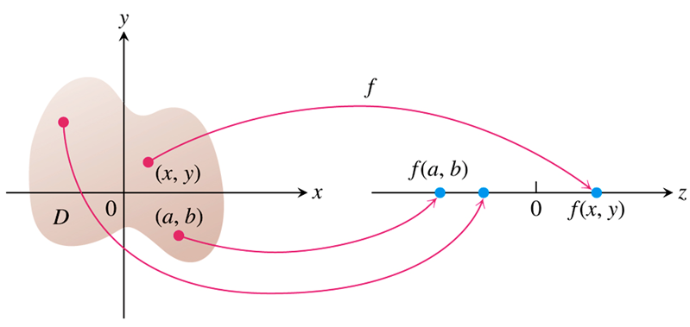

**Domains and Ranges**

***Functions of two variables***

|  |  |  |
| --- | --- | --- |
| ***Function*** | ***Domain*** | ***Range*** |
|  |  |  |
|  |  |  |
|  |  |  |

***Functions of three variables***

|  |  |  |
| --- | --- | --- |
| ***Function*** | ***Domain*** | ***Range*** |
|  |  |  |
|  |  |  |
|  |  |  |

**Functions of Two Variables**

***Definitions***

A point  in a region (set) *R* in the *xy*-plane is an ***interior point*** of *R* if it is the center of a disk of positive radius that lies entirely in *R*. A point  is a ***boundary point*** of *R* if every disk centered at  contains points that lie outside of *R* as well as points that lie in *R*. (The boundary point itself need not belong to *R*.)

The interior points of a region, as a set, make up the **interior** of the region. The region’s boundary points make up its ***boundary***. A region is ***open*** if it consists entirely of interior points. A region is ***closed*** if it contains all its boundary points.

|  |  |  |  |  |
| --- | --- | --- | --- | --- |
|  | |  |  | |
| ***Interior point*** | |  | ***Boundary point*** | |
|  |  | | |  | |
| *Open unit disk* | *Boundary of unit disk* | | | *Closed unit disk* | |

***Definitions***

A region in the plane is ***bounded*** if it lies inside a disk of fixed radius. A region is ***unbounded*** if it is not bounded.

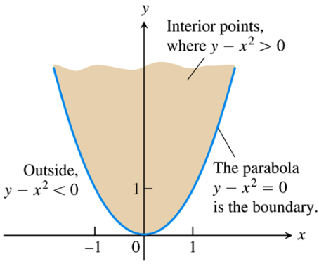

**Graphs, Level Curves, and contours of Functions of two Variables**

***Definitions***

The set of points in the plane where a function  is called a ***level curve*** of *f*. The set of all points  in space, for  in the domain of f, is called the ***graph*** of *f*. The graph of *f* is also called the ***surface*** 

***Example***

Graph  and plot the level curves  in the domain of *f* in the plane.

**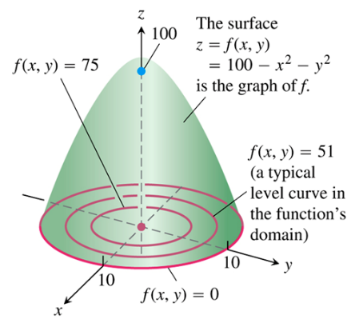*Solution***

The domain of *f* is the entire *xy*-plane, and the range of *f* is the set of real numbers less than or equal to 100.

The graph is the paraboloid , the positive portion of which is shown in the picture.

At 

Which is the circle of radius 10 centered at the origin (level curve).

At 

Which is the circle of radius 7 centered at the origin.

At 

Which is the circle of radius 5 centered at the origin.

If , then the values of  are negative.

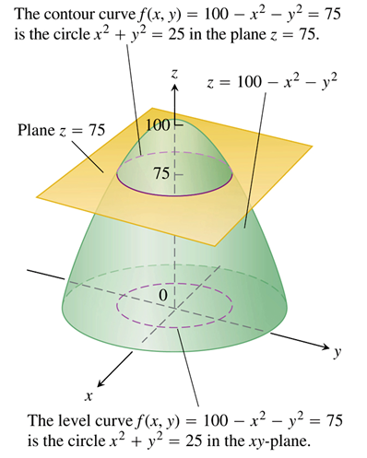

**Functions of Three Variables**

***Definition***

The set of points  in space where a function of three independent variables has a constant value  is called a ***level surface*** of *f*.

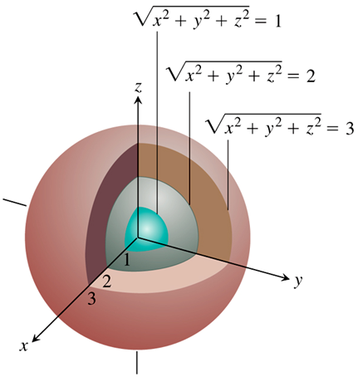

***Example***

Describe the level surfaces of the function



***Solution***

The value of *f* is the distance from the origin to the point .

Each surface , is a sphere of radius *c* centered at the origin.

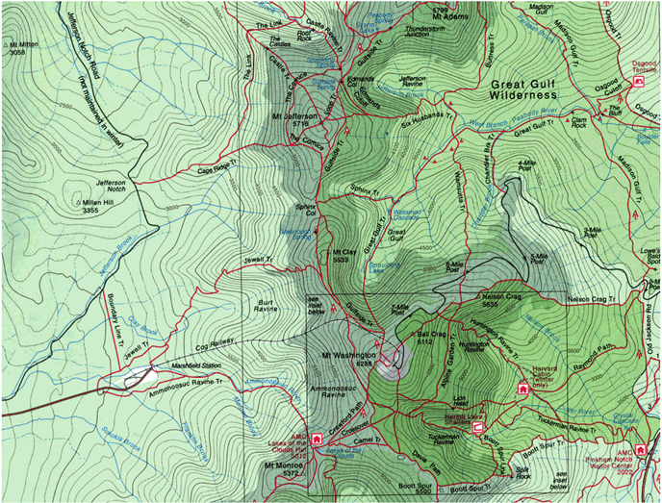

***Definitions***

A point  in a region ***R*** in space is an ***interior point*** of ***R*** if it is the center of a solid ball that lies entirely in ***R***. A point  is a ***boundary point*** of ***R*** if every solid ball centered at  contains points that lie outside of ***R*** as well as that lie inside ***R***. The ***interior*** of R is the set of interior points of ***R***. The ***boundary*** of ***R*** is the set of boundary points of ***R***.

A region is ***open*** if it consists entirely of interior points. A region is ***closed*** if it contains its entire boundary.

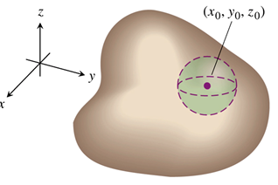 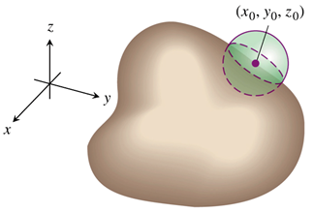

***Example***

The temperature *w* beneath the Earth’s surface is a function of the depth *x* beneath the surface and the time *t* of the year. If we measure *x* in feet and *t* as the number of days elapsed from the expected date of the yearly highest surface temperature, we can model the variation in temperature with the function



The temperature at 9 *ft* is scaled to vary from +1 to −1, so that the variation at *x* *ft*. can be interpreted as a fraction of the variation at the surface.

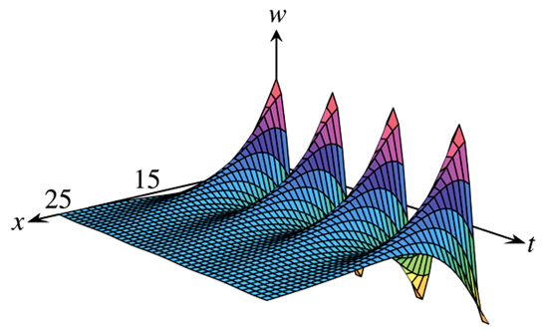

|  |  |  |
| --- | --- | --- |
|  |  |  |
|  |  |  |
|  |  |  |

***Exercises*** ***Section* 2.1 – Graphs and Level Curves**

1. Find the specific values for 

*a*)  *b*)  *c*)  *d*) 

1. Find the specific values for 

*a*)  *b*)  *c*)  *d*) 

(**3 – 11**) Find and sketch the domain for each function

|  |  |
| --- | --- |
|  |  |

(**12 – 13**) Find and sketch the level curves  on the same set of coordinate axes for the given values of *c*, we refer to these level curves as a contour map.

1. 
2. 
3. For the function: :
4. Find the function’s domain
5. Find the function’s range
6. Find the function’s level curves
7. Find the boundary of the function’s domain
8. Determine if the domain is an open region, a closed region, or neither
9. Decide if the domain is bounded or unbounded
10. For the function: :
11. Find the function’s domain
12. Find the function’s range
13. Find the function’s level curves
14. Find the boundary of the function’s domain
15. Determine if the domain is an open region, a closed region, or neither
16. Decide if the domain is bounded or unbounded
17. For the function: :
18. Find the function’s domain
19. Find the function’s range
20. Find the function’s level curves
21. Find the boundary of the function’s domain
22. Determine if the domain is an open region, a closed region, or neither
23. Decide if the domain is bounded or unbounded
24. For the function: :
25. Find the function’s domain
26. Find the function’s range
27. Find the function’s level curves
28. Find the boundary of the function’s domain
29. Determine if the domain is an open region, a closed region, or neither
30. Decide if the domain is bounded or unbounded
31. Find an equation for  and sketch the graph of the level curve of the function  that passes through the point 
32. Find an equation for  and sketch the graph of the level curve of the function  that passes through the point 

(**20 – 23**) Sketch a typical level surface for the function

|  |  |
| --- | --- |
|  |  |