***Solution*** ***Section* 2.1 – Graphs and Level Curves**

***Exercise***

Find the specific values for 

*a*)  *b*)  *c*)  *d*) 

***Solution***

1. 



1. 







1. 





1. 



***Exercise***

Find the specific values for 

*a*)  *b*)  *c*)  *d*) 

***Solution***

1. 



1. 



1. 



1. 





***Exercise***

Find and sketch the domain for function 

***Solution***



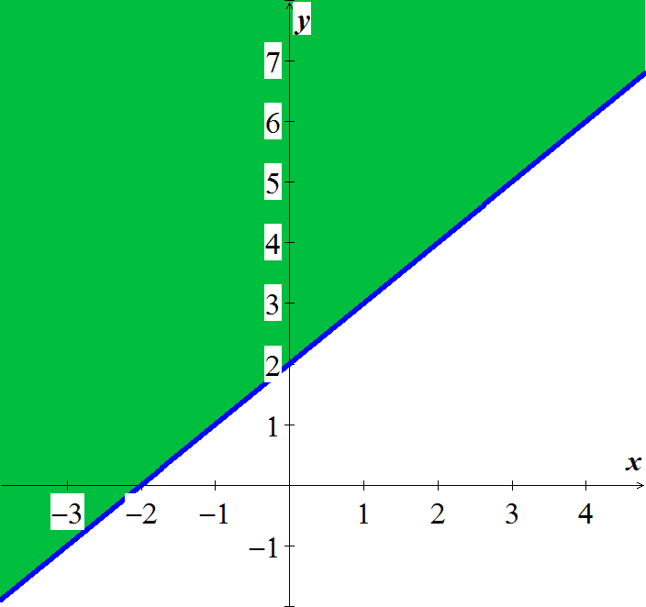

***Exercise***

Find and sketch the domain for function 

***Solution***



*Domain*: All points  outside the circle

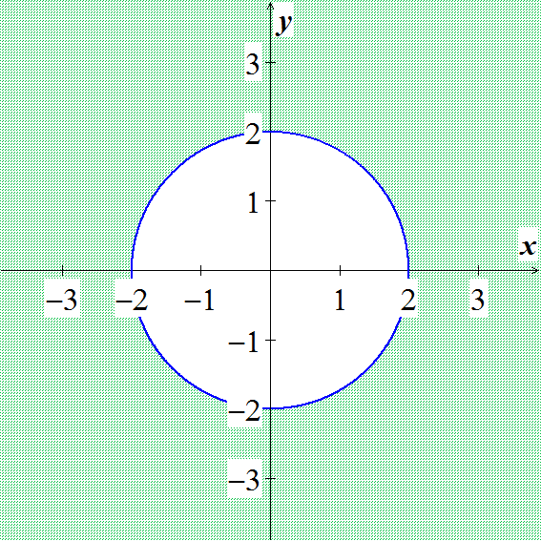

***Exercise***

Find and sketch the domain for function 

***Solution***



*Domain*: All points  not lying on the circle 

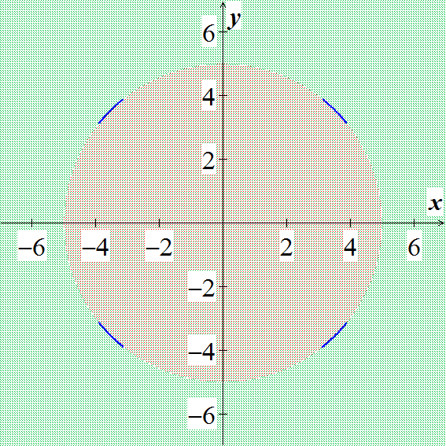

***Exercise***

Find and sketch the domain for function 

***Solution***





*Domain*: All points  satisfying 

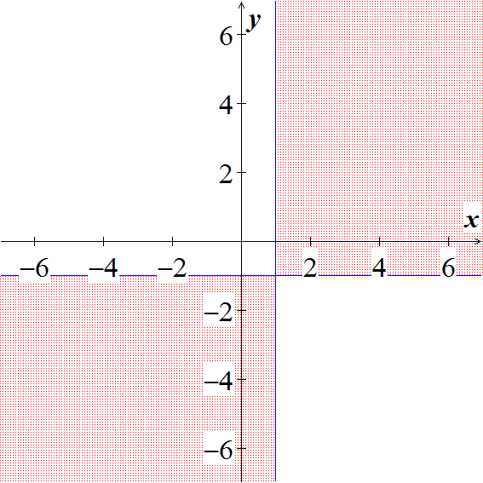

***Exercise***

Find and sketch the domain for function 

***Solution***



*Domain*: All points  satisfying 

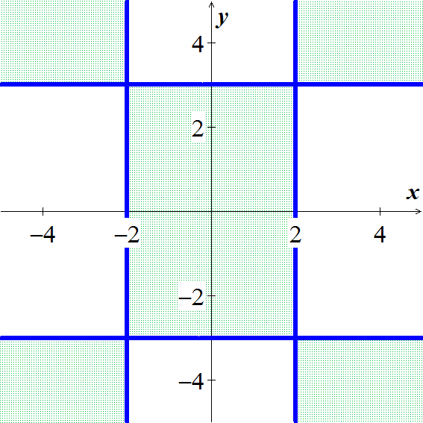

***Exercise***

Find and sketch the domain for function 

***Solution***

*Domain* =

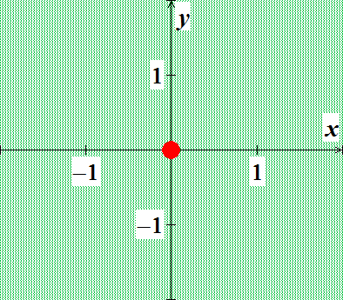

***Exercise***

Find and sketch the domain for function 

***Solution***

*Domain* =

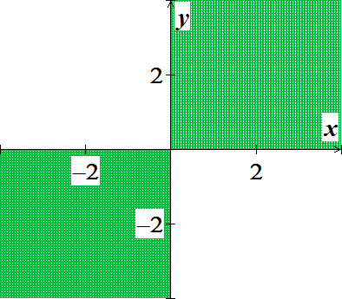

***Exercise***

Find and sketch the domain for function 

***Solution***

*Domain* =

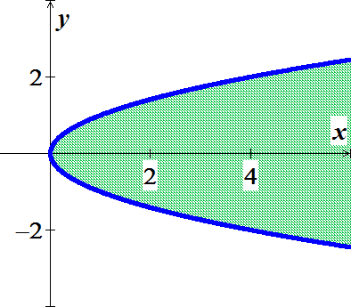

***Exercise***

Find and sketch the domain for function 

***Solution***

*Domain* = 

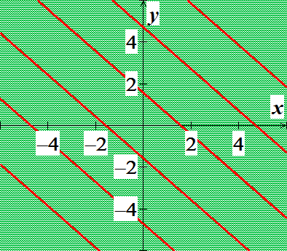

***Exercise***

Find and sketch the level curves  on the same set of coordinate axes for the given values of *c*, we refer to these level curves as a contour map. 

***Solution***

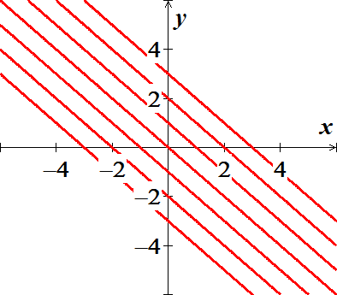

***Exercise***

Find and sketch the level curves  on the same set of coordinate axes for the given values of *c*, we refer to these level curves as a contour map.



***Solution***

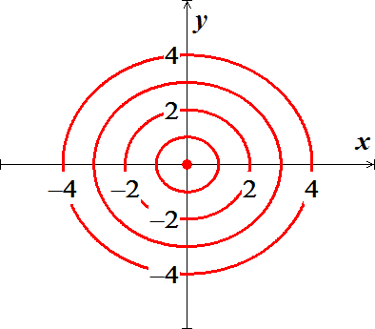

***Exercise***

For the function: :

1. Find the function’s domain
2. Find the function’s range
3. Find the function’s level curves
4. Find the boundary of the function’s domain
5. Determine if the domain is an open region, a closed region, or neither
6. Decide if the domain is bounded or unbounded

***Solution***

1. *Domain*: all points in the *xy*-plane
2. *Range*: 
3. Level curves: For 

For  with center (0, 0) and major and minor axes along the *x*- and *y*-axes, respectively

1. No boundary points
2. Both open and closed
3. Unbounded

***Exercise***

For the function: :

1. Find the function’s domain
2. Find the function’s range
3. Find the function’s level curves
4. Find the boundary of the function’s domain
5. Determine if the domain is an open region, a closed region, or neither
6. Decide if the domain is bounded or unbounded

***Solution***

1. *Domain*: all points in the *xy*-plane
2. *Range*: 
3. Level curves: Hyperbolas with the *x*- and *y*-axes as asymptotes when  and the *x*- and *y*-axes when 
4. No boundary points
5. Both open and closed
6. Unbounded

***Exercise***

For the function: 

1. Find the function’s domain
2. Find the function’s range
3. Find the function’s level curves
4. Find the boundary of the function’s domain
5. Determine if the domain is an open region, a closed region, or neither
6. Decide if the domain is bounded or unbounded

***Solution***

1. *Domain*: all points in the *xy*-plane
2. *Range*: 
3. Level curves are the origin itself and the circles with center (0, 0) and radii *r* > 0
4. No boundary points
5. Both open and closed
6. Unbounded

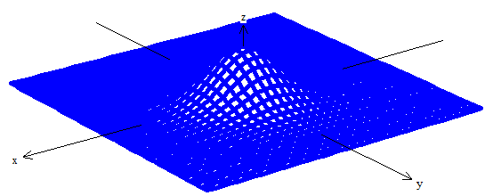

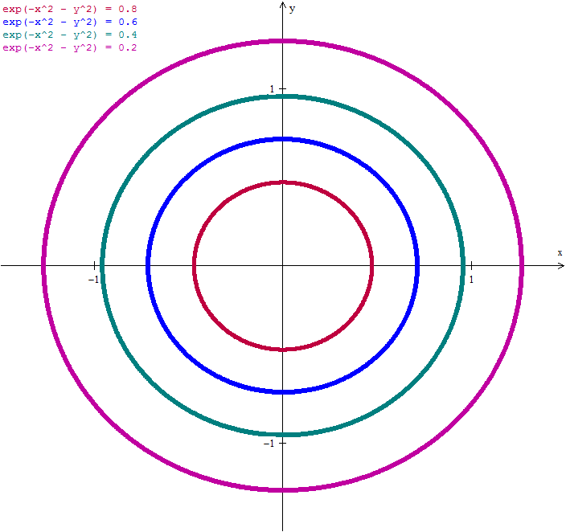

***Exercise***

For the function: 

1. Find the function’s domain
2. Find the function’s range
3. Find the function’s level curves
4. Find the boundary of the function’s domain
5. Determine if the domain is an open region, a closed region, or neither
6. Decide if the domain is bounded or unbounded

***Solution***



1. *Domain*: all points inside the circle 
2. *Range*: 
3. Level curves are circles centered at the origin and radii *r* < 9
4. Boundary: the circle 
5. Open
6. Bounded

***Exercise***

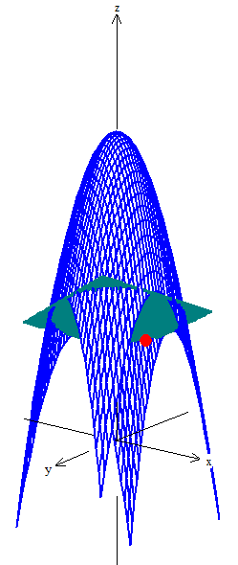Find an equation for  and sketch the graph of the level curve of the function  that passes through the point 

***Solution***











***Exercise***

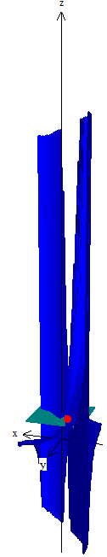Find an equation for  and sketch the graph of the level curve of the function  that passes through the point 

***Solution***













***Exercise***

Sketch a typical level surface for the function 

***Solution***

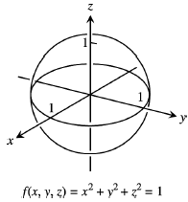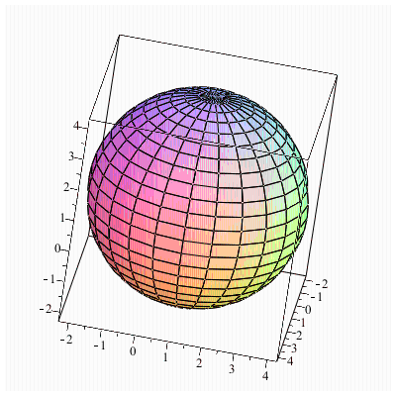

***Exercise***

Sketch a typical level surface for the function 

***Solution***

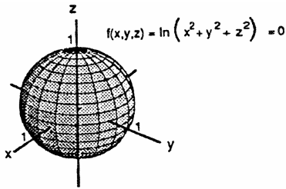

***Exercise***

Sketch a typical level surface for the function 

***Solution***



***Exercise***

Sketch a typical level surface for the function   
***Solution***

