***Section* 2.2 – Limits and Continuity**

***Definition***

We say that a function  approaches the limit *L*, as  approaches , and write



If, for every number , there exists a corresponding number  such that for all  in the domain of *f*.



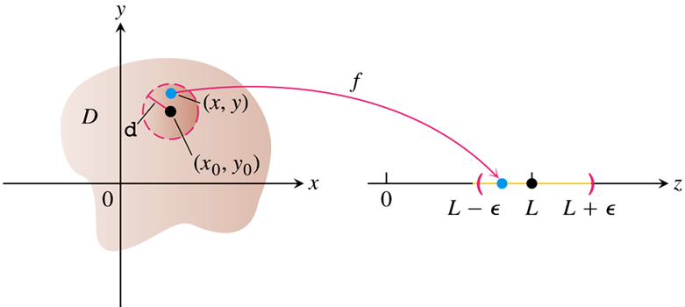

***Theorem***

The following rules hold if *L, M, K* are real numbers and



***Sum Rule***: 

***Difference Rule***: 

***Constant Multiple Rule***: 

***Product Rule***: 

***Quotient Rule***: 

***Power Rule***: 

***Root Rule***: 

***Example***

Find 

***Solution***





***Example***

Find 

***Solution***





***Example***

Find 

***Solution***









***Definition***

A function  is ***continuous at the point***  if

1.  is defined at 
2.  exists
3. 

A function is ***continuous*** if it is continuous at every point of its domain.

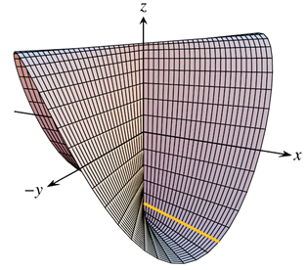 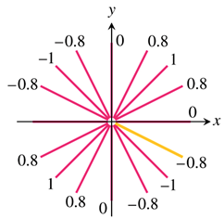

**Two-Path Test for Nonexistence of a Limit**

If a function  has different limits along two different paths in the domain of *f* as  approaches , then  does not exist.

***Example***

Show that the function  has no limit as  approaches 

***Solution***



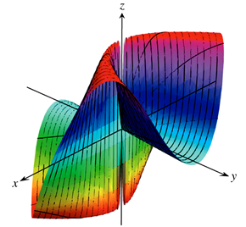 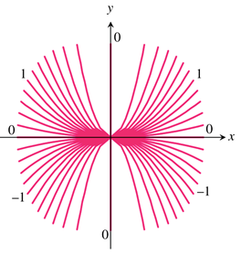

We examine the curve 











This limit varies with the path of approach. If  approaches (0, 0) along the parabola .

**Continuity of Composites**

If *f* is continuous at  and *g* is a single-variable function continuous at , then the composite function  defined by  is continuous at .

**Functions of More Than Two Variables**

The definitions of limit and continuity for functions of two variables and the conclusions about limits and continuity for sums, products, quotients, powers, and composites all extend to functions of three or more variables. Functions like



***Exercises*** ***Section* 2.2 – Limits and Continuity**

(**1 – 24**) Find the limit

|  |  |
| --- | --- |
|  |  |

(**25 – 30**) At what points (*x, y, z*) in space are the functions continuous

|  |  |
| --- | --- |
|  |  |