***Section* 2.3 – Partial Derivatives**

**Partial Derivatives of a Function of Two Variables**

We define the partial derivative of *f* with respect to *x* at the point  as the ordinary derivative of  with respect to *x* at the point .

To distinguish partial derivatives from ordinary derivatives we use the symbol **∂** ***rather*** than the **d** symbol.

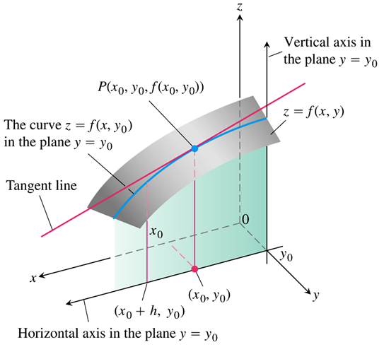

***Definition***

The ***partial derivative*** of  with ***respect to x*** at the point  is



provided the limit exists.

***Definition***

The ***partial derivative*** of  with ***respect to y*** at the point  is



provided the limit exists.

The partial derivative with respect to *y* is denoted:



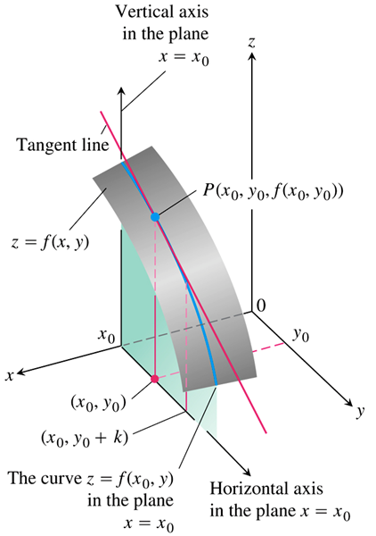

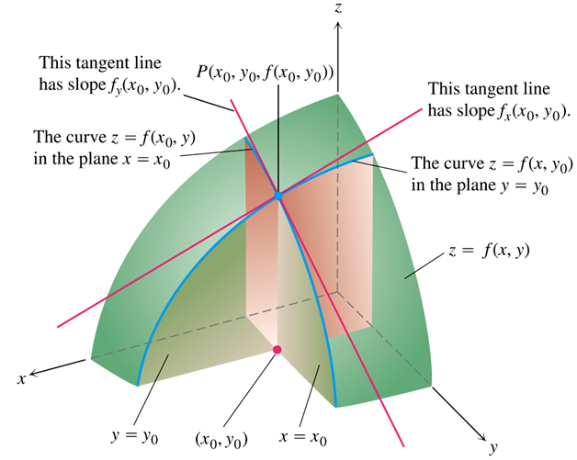

***Calculations***

***Example***

Find the values of  and  at the point  if 

***Solution***

















***Example***

Find  as a function if 

***Solution***









***Example***

Find  and  as a function if 

***Solution***

 







 







***OR***

 



 



***Example***

Find  if the equation  defines *z* as a function of the two independent variables *x* and *y* and the partial derivative exist.

***Solution***











***Example***

The plane  intersects the paraboloid  in a parabola. Find the slope of the tangent to the parabola at .

***Solution***

The slope is the value of the partial derivative  at 

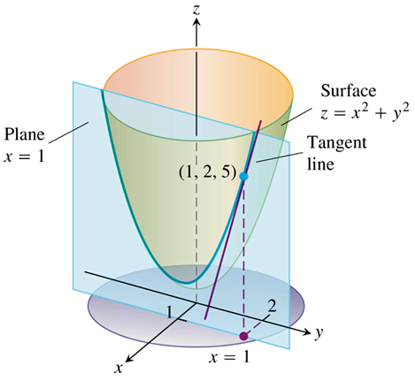





The plane  intersects the paraboloid  in a parabola. 







**Functions of More than Two Variables**

The partial derivatives of more than two variables are ordinary derivatives with respect to one variable, taken while the other independent variables are held constant.

***Example***

If *x, y*, and *z* are independent variables and .

Find 

***Solution***













***Example***

If resistors of  ohms are connected in parallel to make an *R*-ohm resistor, the value of *R* can be found from the equation.



Find the value of  when 

***Solution***

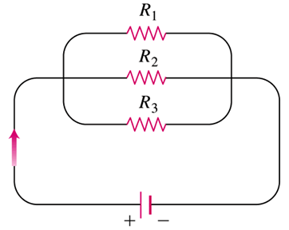















A small change in the resistance  leads to a change in *R* about  as large.

**Partial Derivatives and Continuity**

***Example***

Let 

1. Find the limit of *f* as (*x, y*) approaches (0, 0) along the line *y* = *x*.
2. Prove that *f* is not continuous at the origin.
3. Show that both partial derivatives  and  exist at the origin.

***Solution***

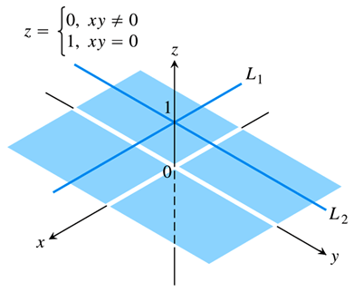

1. Since  is constantly zero along the line  (except at the origin)





1. Since , and the limit proves that *f* is ***not*** continuous at .
2.  is the slope of the line at any *x*.

The slope of the line at any *y*, 

**Second-Order Partial Derivatives**

The second-order derivatives are denoted by





 Differentiate first with respect to *x*, then with respect to *y*.

***Example***

If . Find the second derivatives 

***Solution***

 





















***Theorem* − The Mixed Derivative Theorem**

If  and its partial derivatives  are defined throughout an open region containing a point (*a, b*) and are all continuous at (*a, b*), then



***Example***

Find  if 

***Solution***







**Partial Derivatives of Still Higher Order**

***Example***

Find  if 

***Solution***









**Differentiability**

***Theorem* − The Increment Theorem for Functions of Two Variables**

Suppose that the first partial derivatives of  are defined throughout an open region *R* containing a point  and that  are continuous at . Then the change



In the value of *f* that results from moving from  to another point  in R satisfies an equation of the form



In which each of  as both 

***Definition***

A function  is ***differentiable at***  If  and  exist and  satisfies an equation of the form



In which each of  as both . We call *f* ***differentiable*** if it is differentiable at every point in its domain, and say that its graph is a ***smooth surface***.

***Exercises*** ***Section* 2.3 – Partial Derivatives**

(**1 – 17**) Find  and 

|  |  |
| --- | --- |
|  |  |

(**18 – 30**) Find 

|  |  |
| --- | --- |
|  |  |

(**31 – 34**) Find partial derivatives of the function with respect to each variable

|  |  |
| --- | --- |
|  |  |

(**35 – 43**) Find all the second-order partial derivatives of

|  |  |
| --- | --- |
|  |  |

(**44 – 45**) Verify that the function satisfies Laplace’s equation 

|  |  |
| --- | --- |
|  |  |

1. Let . Find the slope of the line tangent to this surface at the point  and lying in the
2. Plane 
3. Plane .
4. Let  be a function of three independent variables and writs the formal definition of the partial derivative  at . Use this definition to find  at  for .
5. Find the value of  at the point  if the equation  defines *x* as a function of the two independent variables *y* and *z* and the partial derivative exists.
6. Express *A* implicitly as a function of *a, b*, and *c* and calculate  and .

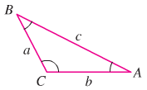

1. An important partial differential equation that describes the distribution of heat in a region at time *t* can be represented by the *one-dimensional heat equation*



Show that  satisfies the heat equation for constants *α* and *β*. What is the relationship between *α* and *β* for this function to be a solution?