***Section* 2.4 – Chain Rule**

**Functions of Two Variables**

***Theorem* − Chain Rule for Functions of Two Independent Variables**

If  is differentiable and if  are differentiable functions of *t*, then the composite  is a differentiable function of *t* and





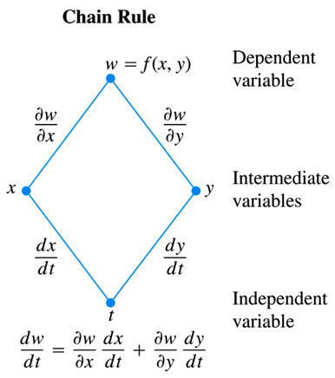

***Example***

Use the Chain Rule to find the derivative of  with respect to *t* along the path . What is the derivative’s value at ?

***Solution***





























**Functions of Three Variables**

***Theorem* − Chain Rule for Functions of Three Independent Variables**

If  is differentiable and if  are differentiable functions of *t*, then  is a differentiable function of *t* and



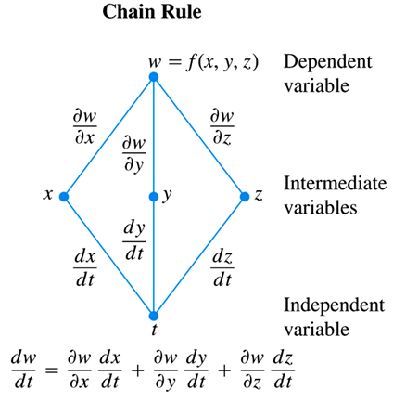

***Example***

Find  if 

In this example the values of  are changing along the path of a helix as *t* changes. What is the derivative’s value at *t* = 0?

***Solution***













**Functions Defined on Surfaces**

***Theorem* − Chain Rule for Two Independent Variables and Three Intermediate Variables**

Suppose that , , , and . If all four functions are differentiable, then *w* has partial derivatives with respect to *r* and *s*, given by the formulas





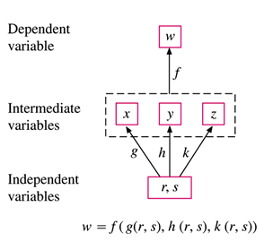

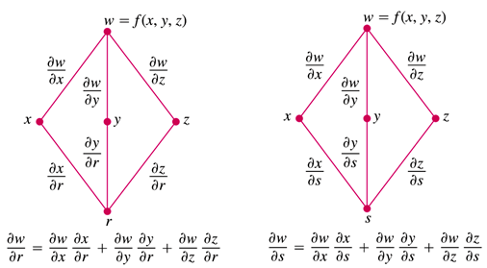

***Example***

Express  and  in terms of *r* and *s* if 

***Solution***















* If ,  and , then



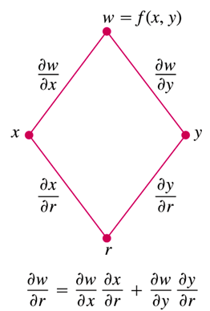

***Example***

Express  and  in terms of *r* and *s* if 

***Solution***





















* If , , then



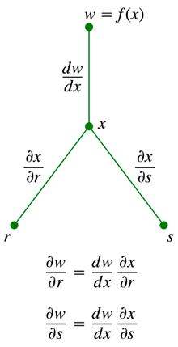 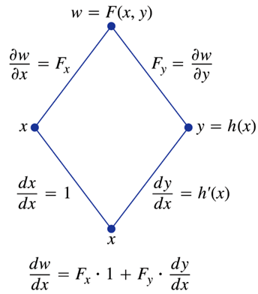

**Implicit Differentiation Revisited**

***Theorem* − A Formula for Implicit Differentiation**

Suppose that  is differentiable and that the equation  defines *y* as a differentiable function of *x*. Then at any point where ,





***Example***

Find  if 

***Solution***









***Example***

Find  and  at (0, 0, 0) if 

***Solution***























***Exercises Section* 2.4 – Chain Rule**

(**1 – 6**) Express as a function of *t*, then evaluate  at the given value of *t*.

1. 
2. 
3. 
4. 

1. 

1. 
2. Express  and  as functions of *u* and *v* if , then evaluate  and  at the point .
3. Express  and  as functions of *u* and *v* if , then evaluate  and  at the point .
4. Express ,  and  as functions of *x, y* and *z* if , then evaluate ,  and  at the point .
5. Find the values of  and if  at the point 
6. Find the values of  and if  at the point 
7. Find the values of  and if  at the point 
8. Find  when  if 
9. Find  when  if 
10. Find  and  when  if 
11. Find  and  when  if 
12. Find  and  when  and  if 
13. Assume that  and . Find  and 

(**19 – 22**) Evaluate the derivatives

1. , where 
2. , where 
3. and  , where 
4. , , and  , where 
5. The voltage *V* in a circuit that satisfies the law  is slowly dropping as the battery wears out. At the same time, the resistance *R* is increasing as the resistor heats up. Use the equation

|  |  |
| --- | --- |
|  |  |

To find how the current is changing at the instant when , , , and 

1. The lengths *a, b*, and *c* of the edges of a rectangular box are changing with time. At the instant in question, , , and . At what rates the box’s volume *V* and surface area *S* changing at that instant? Are the box’s interior diagonals increasing in length or decreasing?
2. Let  be the temperature at the point  on the circle  and suppose that



1. Find where the maximum and minimum temperatures on the circle occur by examining the derivatives  and .
2. Suppose that . Find the maximum and minimum values of *T* on the circle.

(**26 – 33**) Evaluate 

|  |  |  |
| --- | --- | --- |
|  |  |  |

(**34 – 37**) Find  and  at the given point.

1. 
2. 
3. 
4. 
5. Consider the surface and parameterized curves *C* in the *xy-*plane



1. Find  on *C*.
2. Imagine that you are walking on the surface directly above *C* consistent with the positive orientation of *C*. Find the values of ***t*** for which you are walking uphill.
3. Consider the surface and parameterized curves *C* in the *xy-*plane



1. Find  on *C*.
2. Imagine that you are walking on the surface directly above *C* consistent with the positive orientation of *C*. Find the values of ***t*** for which you are walking uphill.
3. Find the value of the derivative of  with respect to *t* on the curve  at 
4. Define *y* as a differentiable function of *x* for , find the values of  at point 