***Section* 2.5 – Directional Derivatives and the Gradient**

You notice that the streams flow perpendicular to the contours. The streams are following paths of steepest descent so the waters reach lower elevation as quickly as possible. Therefore, the fastest instantaneous rate of change in a stream’s elevation above the sea level has a particular direction.

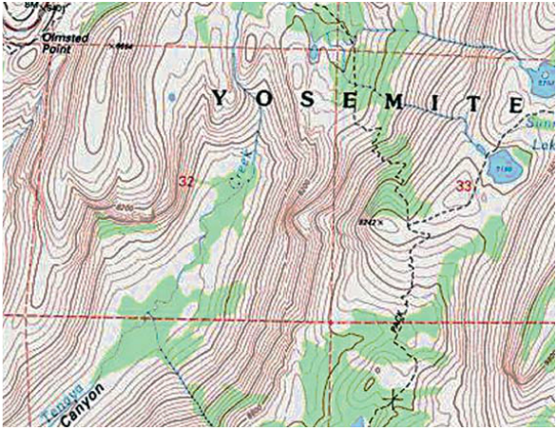

**Directional Derivatives in the Plane**

The rate at which *f* changes with respect to *t* along a differentiable curve  is

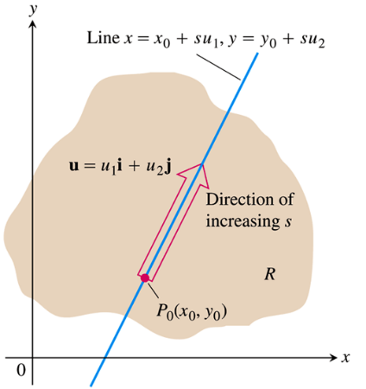

Suppose that the function  is defined throughout a region *R* in the *xy*-plane, that  is a point in *R*, and that  is a unit vector. Then the equations



***Definition***

The derivative of *f* at  in the direction of the unit vector  is the number



provided the limit exists.

The directional derivative is also noted by: 

***Example***

Find the derivative of  at  in the direction of the unit vector 

***Solution***















The rate of change of  at  in the direction  is 

**Interpretation of the Directional Derivative**

The equation  represents a surface *S* in space. If , then the point  lies on *S*. The vertical plane that passes through *P* and  parallel to  intersects *S* in a curve *C*.

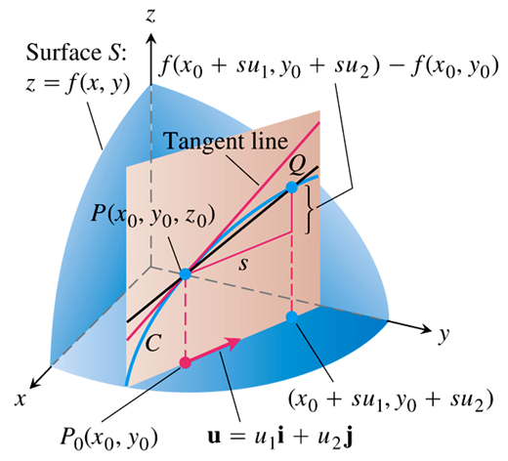

When , the directional derivative at  is  evaluated at .

When , the directional derivative at  is  evaluated at .

The directional derivative generalizes the two partial derivatives.

**Calculation and Gradients**







***Definition***

Gradient is an increase/decrease in the magnitude (change in the value) of an object such temperature or pressure with change in position in a given variable to another.

The ***gradient vector*** (*gradient*) of  at a point  is the vector



obtained by evaluating the partial derivatives of *f* at 

∴  pronounces “***del***”

***Theorem* – The directional Derivative is a Dot Product**

If  is differentiable in an open region containing , then



The dot product of the gradient  at  and .

***Example***

Find the derivative of  at the point (2, 0) in the direction of 

***Solution***





The partial derivatives of *f* are continuous and at (2, 0)

















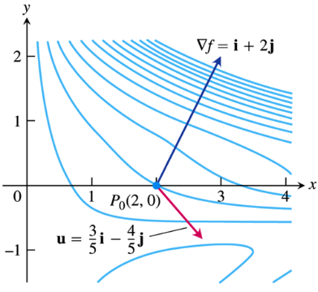

Therefore; the derivative of *f* at (2, 0) in the direction of  is









**Properties of the Directional Derivative** 

1. The function *f* increases most rapidly when  or when  and  is the direction of . That is, at each point *P* in its domain, *f* increases most rapidly in the direction of the gradient vector  at *P*. The derivative in this direction is 
2. Similarly, *f* decreases most rapidly in the direction of . The derivative in this direction is 
3. Any direction ***u*** orthogonal to a gradient  is a direction of zero change in *f* because *θ* then equals  and 

***Example***

Find the directions in which 

1. Increases most rapidly at the point (1, 1)
2. decreases most rapidly at the point (1, 1)
3. What are the directions of zero change in *f* at (1, 1)

***Solution***

1. The function increases most rapidly at the point (1, 1).

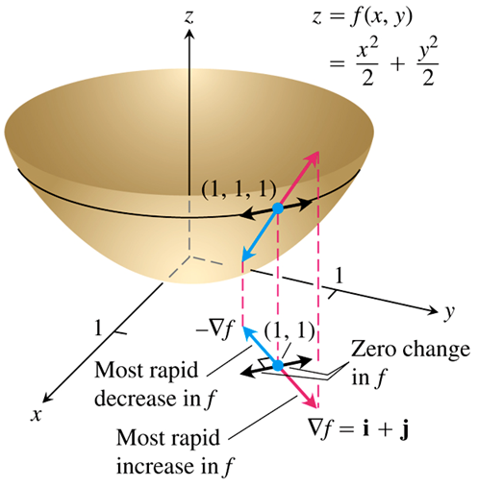The gradient is









Its direction is:





1. The function decreases most rapidly at the point (1, 1).

The gradient is 

Its direction is: 

1. The directions of zero change at (1, 1) are the direction orthogonal to :



**Gradients and Tangents to Level Curves**

If a differentiable function  has a constant value *c* along a smooth curve , then . Differentiating both sides of this equation with respect to *t* leads to the equations

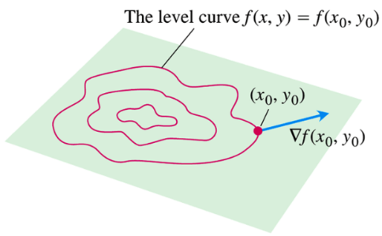







* At every point  in the domain of a differentiable function , the gradient of *f* is normal to the level curve through .

***Example***

Find an equation for the tangent to the ellipse  at the point 

***Solution***



The gradient of *f* at  is



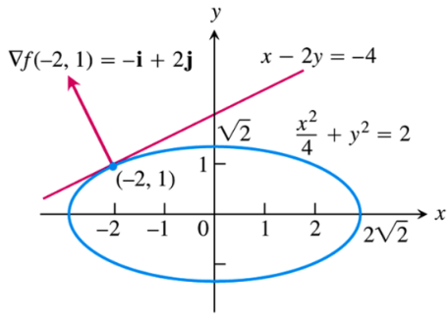 





The equation of the line is given by:











***Algebra Rules for Gradients***

***Sum Rule***: 

***Difference Rule***: 

***Constant Multiple Rule***: 

***Product Rule***: 

***Quotient Rule***: 

**Functions of Three Variables**

For a differentiable function  and a unit  in space, we have







The directional derivative can be written in the form







***Example***

1. Find the derivative of  at  in the direction of 
2. In what directions does *f* change most rapidly at , and what are the rates of change in these directions?

***Solution***

1. The direction of ***v*** is obtained by dividing ***v*** by its length:







The partial derivatives of *f* at are







The gradient of *f* at is





Therefore, the derivative of *f* at in the direction of ***v*** is









1. The function increases most rapidly in the direction of  and decreases most rapidly in the direction of .

The rates of change in the directions are



***Exercises*** ***Section* 2.5 – Directional Derivatives and the Gradient**

(**1 – 3**) Find the gradient of the function at the given point. Then sketch the gradient together with the level curve that passes through the point

1. 
2. 
3. 

(**4 – 6**) Find  at the given point

1. 
2. 
3. 
4. Find the derivative of the function  at  in the direction of 
5. Find the derivative of the function  at  in the direction of 
6. Find the derivative of the function  at  in the direction of 
7. Find the derivative of the function  at  in the direction of 
8. Find the derivative of the function  at  in the direction of 
9. Find the derivative of the function  at  in the direction of 
10. Find the directions in which the function  increase and decrease most rapidly at . Then find the derivatives of the function in these directions.
11. Find the directions in which the function  increase and decrease most rapidly at . Then find the derivatives of the function in these directions.
12. Find the directions in which the function  increase and decrease most rapidly at . Then find the derivatives of the function in these directions.
13. Find the directions in which the function  increase and decrease most rapidly at . Then find the derivatives of the function in these directions.
14. Sketch the curve  together with  and the tangent line at the point . Then write an equation for the tangent line.
15. Sketch the curve  together with  and the tangent line at the point . Then write an equation for the tangent line.
16. Sketch the curve  together with  and the tangent line at the point . Then write an equation for the tangent line.
17. In what direction is the derivative of  at  equal to zero?

(**21 – 26**) Compute the gradient of the function, evaluate it at the given point *P*, and evaluate the directional derivative at that point in the given direction

1. 

1. 

1. 

1. 

1. 

1. 

(**27 – 30**) Find the direction in which  increases and decreases most rapidly at  and find the derivative of  in each direction. Also, find the derivative of  at  in the direction of the vector ***v***.

1. 

1. 

1. 
2. 
3. Let 
4. Find the unit vectors that give the direction of steepest ascent and steepest descent at *P*.
5. Find a unit vector that points in ta direction of no change.
6. Let 
7. Find the unit vectors that give the direction of steepest ascent and steepest descent at *P*.
8. Find a unit vector that points in ta direction of no change.

(**33 – 34**) Let , for the level curves  and points , compute the slope of the line tangent to the level curve at  and verify that the tangent line is orthogonal to the gradient at that point.

|  |  |
| --- | --- |
|  |  |

1. Find the direction in which the function  has zero change at the point . Express the directions in terms of unit vectors.
2. An infinitely long charged cylinder of radius *R* with its axis along *z-*axis has an electric potential , where *r* is the distance between a variable point  and the axis of the cylinder  and *k* is a physical constant. The electric field at a point  in the *xy-*plane is given by , where  is the two-dimensional gradient. Compute the electric field at a point  with .