***Solution*** ***Section* 2.5 – Directional Derivatives and the Gradient**

***Exercise***

Find the gradient of the function at the given point. Then sketch the gradient together with the level curve that passes through the point 

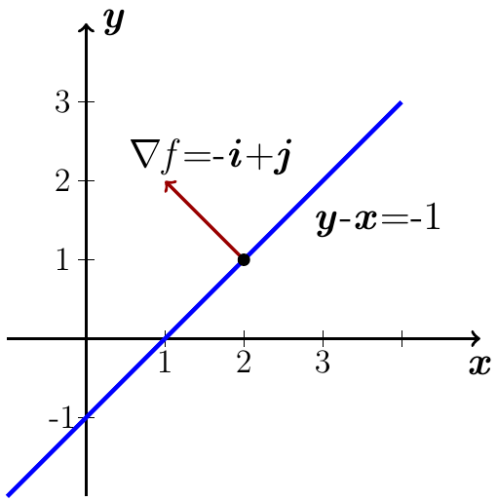***Solution***











 is the level curve

***Exercise***

Find the gradient of the function at the given point. Then sketch the gradient together with the level curve that passes through the point 

***Solution***

















 is the level curve

***Exercise***

Find the gradient of the function at the given point. Then sketch the gradient together with the level curve that passes through the point 

***Solution***















 is the level curve

***Exercise***

Find  at the given point 

***Solution***















***Exercise***

Find  at the given point 

***Solution***















***Exercise***

Find  at the given point 

***Solution***





















***Exercise***

Find the derivative of the function  at  in the direction of 

***Solution***

 









 







***Exercise***

Find the derivative of the function  at  in the direction of 

***Solution***

 























 





***Exercise***

Find the derivative of the function  at  in the direction of 

***Solution***

 



























***Exercise***

Find the derivative of the function  at  in the direction of 

***Solution***

 











 





***Exercise***

Find the derivative of the function  at  in the direction of 

***Solution***

 





























***Exercise***

Find the derivative of the function  at  in the direction of 

***Solution***

 































***Exercise***

Find the directions in which the function  increase and decrease most rapidly at . Then find the derivatives of the function in these directions.

***Solution***







 *increases* most rapidly in the direction 

 *decreases* most rapidly in the direction 











***Exercise***

Find the directions in which the function  increase and decrease most rapidly at . Then find the derivatives of the function in these directions.

***Solution***

















 *increases* most rapidly in the direction 

 *decreases* most rapidly in the direction 







***Exercise***

Find the directions in which the function  increase and decrease most rapidly at . Then find the derivatives of the function in these directions.

***Solution***



























 *increases* most rapidly in the direction 

 *decreases* most rapidly in the direction 











***Exercise***

Find the directions in which the function  increase and decrease most rapidly at . Then find the derivatives of the function in these directions.

***Solution***























 *increases* most rapidly in the direction 

 *decreases* most rapidly in the direction 











***Exercise***

Sketch the curve  together with  and the tangent line at the point . Then write an equation for the tangent line.

***Solution***





***Tangent line***:









***Exercise***

Sketch the curve  together with  and the tangent line at the point . Then write an equation for the tangent line.

***Solution***







Tangent line: 





***Exercise***

Sketch the curve  together with  and the tangent line at the point . Then write an equation for the tangent line.

***Solution***





Tangent line:







***Exercise***

In what direction is the derivative of  at  equal to zero?

***Solution***





A vector is orthogonal to  is 

 





and  are the directions where the derivatives are zero.

***Exercise***

Compute the gradient of the function, evaluate it at the given point *P*, and evaluate the directional derivative at that point in the given direction



***Solution***

 











***Exercise***

Compute the gradient of the function, evaluate it at the given point *P*, and evaluate the directional derivative at that point in the given direction



***Solution***

 













***Exercise***

Compute the gradient of the function, evaluate it at the given point *P*, and evaluate the directional derivative at that point in the given direction



***Solution***

 









***Exercise***

Compute the gradient of the function, evaluate it at the given point *P*, and evaluate the directional derivative at that point in the given direction



***Solution***

 















***Exercise***

Compute the gradient of the function, evaluate it at the given point *P*, and evaluate the directional derivative at that point in the given direction



***Solution***

 









***Exercise***

Compute the gradient of the function, evaluate it at the given point *P*, and evaluate the directional derivative at that point in the given direction



***Solution***

 













***Exercise***

Find the direction in which  increases and decreases most rapidly at  and find the derivative of  in each direction. Also, find the derivative of  at  in the direction of the vector ***v***.



***Solution***

 













→ *f* increases most rapidly in the direction of 

→ *f* decreases most rapidly in the direction of 

 











***Exercise***

Find the direction in which  increases and decreases most rapidly at  and find the derivative of  in each direction. Also, find the derivative of  at  in the direction of the vector ***v***.



***Solution***

 











→ *f* increases most rapidly in the direction of 

→ *f* decreases most rapidly in the direction of 

 











***Exercise***

Find the direction in which  increases and decreases most rapidly at  and find the derivative of  in each direction. Also, find the derivative of  at  in the direction of the vector ***v***.



***Solution***

 











→ *f* increases most rapidly in the direction of 

→ *f* decreases most rapidly in the direction of 

 











***Exercise***

Find the direction in which  increases and decreases most rapidly at  and find the derivative of  in each direction. Also, find the derivative of  at  in the direction of the vector ***v***.



***Solution***

 









→  increases most rapidly in the direction of 

→  decreases most rapidly in the direction of 

 













***Exercise***

Let 

1. Find the unit vectors that give the direction of steepest ascent and steepest descent at *P*.
2. Find a unit vector that points in ta direction of no change.

***Solution***

1.  









The direction of steepest ascent is the unit vector in the direction of 

The direction of steepest descent is the unit vector in the direction of 

1. The unit vectors that the point in the direction of no change are 

Since 

***Exercise***

Let 

1. Find the unit vectors that give the direction of steepest ascent and steepest descent at *P*.
2. Find a unit vector that points in ta direction of no change.

***Solution***

1.  







The direction of steepest ascent is the unit vector in the direction of 

The direction of steepest descent is the unit vector in the direction of 

1. The unit vectors that the point in the direction of no change are 

Since 

***Exercise***

Let , for the level curves  and points , compute the slope of the line tangent to the level curve at  and verify that the tangent line is orthogonal to the gradient at that point.



***Solution***

 







Tangent line has direction: 

 





 ***√***

The gradient is orthogonal to the tangent direction.

***Exercise***

Let , for the level curves  and points , compute the slope of the line tangent to the level curve at  and verify that the tangent line is orthogonal to the gradient at that point.



***Solution***

 





Slope: 

Tangent line has direction: 

 



 ***√***

The gradient is orthogonal to the tangent direction.

***Exercise***

Find the direction in which the function  has zero change at the point . Express the directions in terms of unit vectors.

***Solution***

 



The unit vectors in the direction of no change are







***Exercise***

An infinitely long charged cylinder of radius *R* with its axis along *z-*axis has an electric potential , where *r* is the distance between a variable point  and the axis of the cylinder  and *k* is a physical constant. The electric field at a point  in the *xy-*plane is given by , where  is the two-dimensional gradient. Compute the electric field at a point  with .

***Solution***















