***Section* 2.6 – Tangent Planes and Linear Approximation**

**Tangent Planes and Normal Lines**

If  is a smooth curve on the level surface  of a differentiable function *f*, then .

Differentiating both sides of this equation with respect to *t* leads to







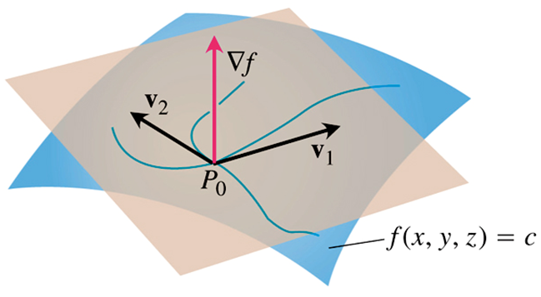

***Definition***

The ***tangent plane*** at the point  on the level surface  of a differentiable function *f* is the plane through  normal to .

The ***normal line*** of the surface at  is the line through  parallel to .

***Normal Line*** to  at 



***Tangent Plane*** to  at 



***Example***

Find the tangent plane and normal line of the surface  at the point 

***Solution***

The tangent plane is the plane through  perpendicular to the gradient of *f* at .

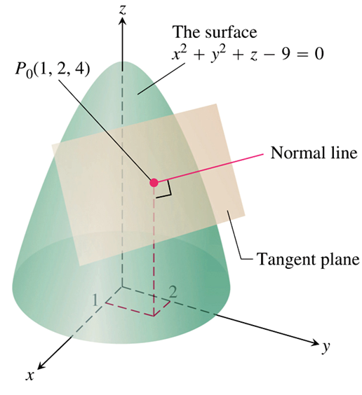

The gradient is:





The tangent plane is the plane





The line normal to the surface at  is



**Plane Tangent to a Surface  at **

The plane tangent to the surface of a differentiable function *f* at the point is



***Example***

Find the plane tangent and the normal line to the surface  at (0, 0, 0)

***Solution***







Therefore, the tangent plane is





The normal line:



***Example***

The surfaces  and  meet in an ellipse *E*. Find the parametric equations for the line tangent to *E* at the point 

***Solution***

The tangent line is orthogonal to both  and  at  and therefore parallel to .

The components of ***v*** and the coordinates of  give us equations for the line.

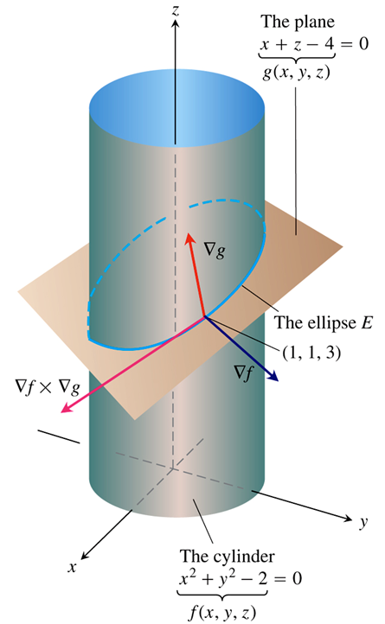 













The tangent line is



**Estimating Change in a Specific Direction**

How much the value of a function *f* changes if we move a small distance *ds* from a point  to another point neary.

 (*single variable*)

 (*two or more variables*)

  is the direction of the motion away from .

**Estimating the Change in *f* in a Direction 

To estimate the change in the value of a differentiable function *f* when we move a small distance *ds* from a point  in a paricular direction  is given by



***Example***

Estimate how much the value of  will change if the point  moves 0.1 unit from  straight toward 

***Solution***



The direction of the vector is:

















The change *df* in *f* that results from moving  unit away from  in the direction of  is







***Definition***

The ***linearization*** of a function  at a point  where *f* is differentiable is the function



The approximation 

is the ***standard linear*** approximation of *f* at 

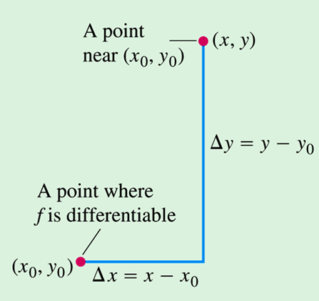

***Example***

Find the linearization of  at the point (3, 2)

***Solution***























**The Error in the Standard Linear Approximation**

If *f* has continuous first and second partial derivatives throughout an open set containing a rectangle *R* centered at  and if *M* is any upper bound for the values of , , and  on *R*, then the error  incurred in replacing on *R* by its linearization

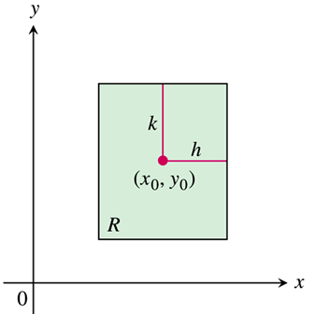



Satisfies the inequality:





***Example***

Find an upper bound for the error in the approximation of  over the rectangle



Express the upper bound as a percentage of , the value of *f* at the center of the rectangle.

***Solution***







The largest of these is 2, so let .







Since 





As a percentage of , the error is no greater than



**Differentials**

***Definition***

If we move from  to a point  nearby, the resulting change



In the linearization of *f* is called the ***total differential of f***.

***Example***

Suppose that a cylindrical can is designed to have a radius of 1 *in*. and a height of 5 *in*., but that the radius and height are off the amounts  and . Estimate the resulting absolute change in the volume of the can.

***Solution***

To estimate the absolute change in ,











***Example***

Your company manufactures right circular cylindrical molasses storage tanks that are 25 *ft* with a radius of 5 *ft*. How sensitive are the tanks’ volumes to small variations in height and radius?

***Solution***

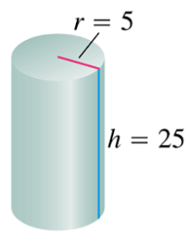









A 1-unit change in *r* will change *V* about 250π units.

A 1-unit change in *h* will change *V* about 25π units.

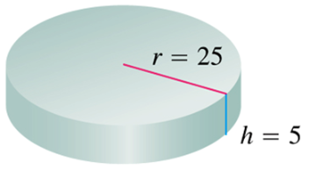The tanks’ volume is 10 times more sensitive to a small change in *r* than it is to a small change of equal size in *h*.





Now the volume is more sensitive to changes in *h* than to changes in *r*.

The general rule is that functions are most sensitive to small changes in the variables that generated the largest partial derivatives.

***Example***

The volume  of a right circular cylinder is to be calculated from measured values of *r* and *h*. Suppose that *r* is measured with an error of no more than 2% and *h* with an error of no more than 0.5%. Estimate the resulting possible percentage error in the calculation of *V*.

***Solution***















The error in the volume is at the most 4.5%

**Functions of More Than Two Variables**

* The linearization of  at a point  is



* Suppose that *R* is a closed rectangular solid centered at  and lying in an open region on which the second partial derivatives of *f* are continuous. Suppose also that , , , , , and  are all less than or equal to *M* throughout *R*. Then the error  in the approximation of *f* by *L* is bounded throughout *R* by the inequality



* If the second partial derivatives of *f* are continuous and if *x, y*, and *z* change from by small amounts *dx, dy*, and *dz*, the total differential



***Example***

Find the linearization  of  at the point (2, 1, 0).

Find the upper bound for the error incurred in replacing *f* by *L* on the rectangle



***Solution***



|  |  |  |
| --- | --- | --- |
|  |  |  |
|  |  |  |
|  |  |  |



Let *M* = 2.





***Exercises*** ***Section* 2.6 – Tangent Planes and Linear Approximation**

(**1 – 5**) Find the tangent plane and normal line of the surface

1.  at the point 
2.  at the point 
3.  at the point 
4.  at the point 
5.  at the point 

(**6 – 23**) Find an equation for the plane that is tangent to the surface

1.  at the point 
2.  at the point 
3.  at the point 
4. 
5. 
6. 
7. 
8. 
9. 
10.  at the point 

1. 
2. 
3. 
4. 
5. 
6. 
7. 
8. 

(**24 – 27**) Find parametric equation for the line tangent to the curve of intersection of the surfaces

1.  at the point 
2.  at the point 
3.  at the point 
4.  at the point 
5. Find an equation for the plane tangent to the level surface  at the point . Also, find parametric equations for the line is normal to the surface at .
6. By about how much will  change if the point  moves from  a distance of  unit in the direction of ?
7. By about how much will  change if the point  moves from the origin at distance of  *unit* in the direction of ?

(**31 – 38**) Find the linearization  of

1.  at the point (0, 0) and (1, 1)
2.  at the point (0, 0) and (1, 2)
3.  at the point (1, 1) and (0, 0)
4.  at the point (0, 0) and (1, 2)
5.  at the point (1, 1, 1)
6.  at the point (1, 2, 2)
7.  at the point 
8.  at the point 

(**39 – 46**) Find the linear approximation to the function *f* at the point  and estimate the given function value

1. ; estimate 
2. ; estimate 

1. ; estimate 
2. ; estimate 
3. ; estimate 
4. ; estimate 
5. ; estimate 
6. ; estimate 
7. Estimate the change in the function  when  changes from  to .
8. What is the largest value that the directional derivative of  can have at the point ?
9. You plan to calculate the volume inside a stretch of pipeline that is about 36 *in*. in diameter and 1 *mile* long. With which measurement should you be more careful, the length or the diameter? Why?
10. The volume of a cylinder with radius *r* and height *h* is . Find the approximate percentage change in the volume when the radius decreases by 3% and the height increases by 2%.
11. The volume of an ellipsoid with axes of length 2*a*, 2*b*, and 2*c* is . Find the percentage change in the volume when *a* increases by 2%, *b* increases by 1.5%, and *c* decreases by 2.5%.
12. A hemispherical tank with a radius of 1.50 *m* is filled with water to a depth of 1.00 *m*. Water level drops by 0.05 *m* (from 1.00 *m* to 0.95 *m*)

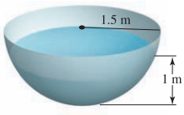

1. Approximate the change in the volume of water in the tank. The volume of a spherical cap is , where *r* is the radius of the sphere and *h* is the thickness of the cap (in this case, the depth of the water).
2. Approximate the change in the surface area of the water in the tank.
3. Consider a closed rectangular box with a square base. If *x* is measured with error at most 2% and *y* is measured with error at most 3% use a differential to estimate the corresponding percentage error in computing the box’s

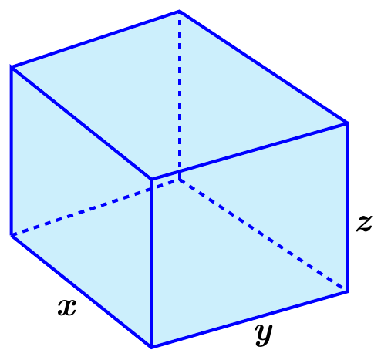

1. Surface area
2. Volume
3. Consider a closed container in the shape of a cylinder of radius 10 *cm* and height 15 *cm* with a hemisphere on each end.

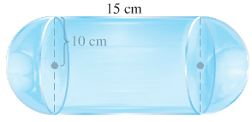

The container is coated with a layer of ice  *cm* thick. Use a differential to estimate the total volume of ice. (*Hint*: assume *r* is radius with  and *h* is height with )

1. A standard 12-*fl-oz* can of soda is essentially a cylinder of radius  and height 
2. At these dimensions, how sensitive is the can’s volume to a small change in radius versus a small change in height?
3. Could you design a soda can that appears to hold more soda but in fact holds the same 12-*fl-oz*? What might its dimensions be? (There is more than one correct answer.)
4. Consider the function , whose graph is shown

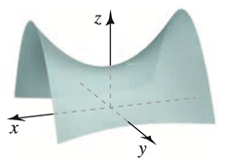

1. Fill in the table showing the value of the directional derivative at points  in the direction given by the unit vectors 

|  |  |  |  |
| --- | --- | --- | --- |
|  |  |  |  |
|  |  |  |  |
|  |  |  |  |
|  |  |  |  |

1. Interpret each of the directional derivatives computed in part(*a*) at the point 
2. Two spheres have the same center and radii *r* and *R*, where . The volume of the region between the sphere is .
3. First use your intuition. If *r* is held fixed, how does *V* change as *R* increases? What is the sign of ? If *R* is held fixed, how does *V* change as *r* increases (up to the value of *R*)? What is the sign of ?
4. Compute  and . Are the results consistent with part (*a*)?
5. Consider spheres with  and . Does the volume change more if *R* is increased by  (with *r* fixed) or if *r* is decreased by  (with *R* fixed)?
6. A company manufactures cylindrical aluminum tubes to rigid specifications. The tubes are designed to have an outside radius of , a height of , and a thickness of . The manufacturing process produces tubes with a maximum error of in the radius and height and a maximum error of  in the thickness. The volume of the material used to construct a cylindrical tube is . Estimate maximum error in the volume of the tube.

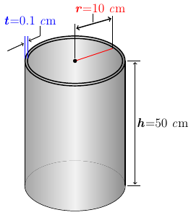

1. The volume of a right circular cone with radius *r* and height *h* is 
2. Approximate the change in the volume of the cone when the radius changes from  to  and the height changes from  to 
3. Approximate the change in the volume of the cone when the radius changes from  to  and the height changes from  to 
4. The area of an ellipse with axes of length 2*a* and 2*b* is . Approximate the percent change in the area when *a* increases by 2% and *b* increases by 1.5%.
5. The Volume of a segment of a circular paraboloid with radius *r* and height *h* is  .

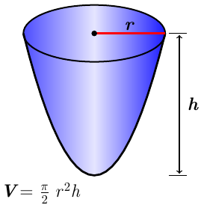

Approximate the percent change in the volume when the radius decreases by 1.5% and the height increases by 2.2%

1. Batting averages in baseball are defined by , where  is the total number of hits and  is the total number of at-bats. Treat *x* and *y* as positive real numbers and note that .
2. Estimate the change in the batting average if the number of hits increases from 60 to 62 and the number of at-bats increases from 175 to 180.
3. If a batter currently has a batting average of , does the average decrease if the batter fails to get a hit more than it increases if the batter gets a hit?
4. Does the answer in part (*b*) depend on the current batting average? Explain.
5. A conical tank with radius 0.50 *m* and height 2.0 *m* is filled with water.

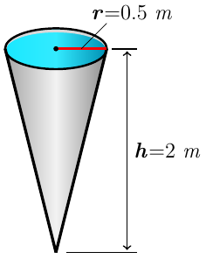

Water released from the tank, and the water level drops by 0.05 *m* (from 2.0 *m* to 1.95 *m*).

Approximate the change in volume of water in the tank.

(***Hint***: When the water level drops, both the radius and height of the cone of water change).

1. Poiseuille’s law is a fundamental law of fluid dynamics that describes the flow velocity of a viscous incompressible fluid in a cylinder (it is used to model blood flow through veins and arteries). It says that in a cylinder of radius *R* and length *L*, the velocity of the fluid  units from the centerline of the cylinder is , where *P* is the difference in the pressure between the ends of the cylinder and  is the viscosity of the fluid. Assuming that *P* and  are constant, the velocity *V* along the centerline of the cylinder  is , where *k* is a constant that we will take to be .

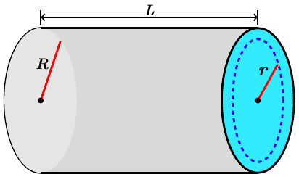

1. Estimate the change in the centerline velocity  if the radius of the flow cylinder increases from  to  and the length increases from  to .
2. Estimate the percent change in the centerline velocity if the radius of the flow cylinder *R* decreases by 1% and the length increases by 2%.
3. Suppose that in a large group of people a fraction  of the people have flu. The probability that in *n* random encounters, you will meet at least one person with flu is  . although *n* is a positive integer, regard it as a positive real number.
4. Compute  and .
5. How sensitive is the probability *P* to the flu rate *r*? Suppose you meet  people. Approximately how much does the probability *P* increase if the flu rate increases from  to  (with *n* fixed)?
6. Approximately how much does the probability *P* increase the flu rate increases from  to 
7. Interpret the results of parts (*b*) and (*c*).
8. When two electrical resistors with resistance  and  are wired in parallel in a circuit, the combined resistance *R* is given by



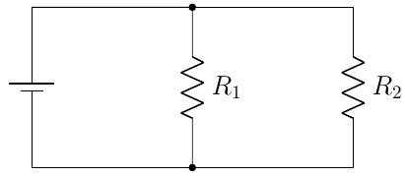

1. Estimate the change in *R* if  increases from 2 Ω to 2.05 Ω and decreases from 3 Ω to 2.95 Ω.
2. Is it true that if and increases by the same small amount as decreases, then *R* is approximately unchanged? Explain.
3. Is it true that if and  increase, then *R* increases? Explain.
4. Suppose and  increases by the same small amount as  decreases. Does *R* increase or decrease?
5. When three electrical resistors with resistance ,  and  are wired in parallel in a circuit, the combined resistance *R* is given by



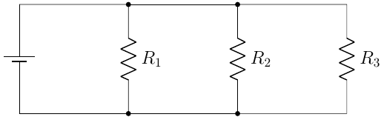

Estimate the change in *R* if  increases from 2 Ω to 2.05 Ω,  decreases from 3 Ω to 2.95 Ω, and  increases from 1.5 Ω to 1.55 Ω

1. Consider the ellipsoid  and the plane *P* given by . Let  and 
2. Find the equation of the plane tangent to the ellipsoid at the point .
3. Find the two points on the ellipsoid at which the tangent plane parallel to *P* and find equations of the tangent planes.
4. Show that the distance between the origin and the plane *P* is *h*.
5. Show that the distance between the origin and the tangent planes is *hm*.
6. Find a condition that guarantees the plane *P* does not intersect the ellipsoid.