***Solution*** ***Section* 2.6 – Tangent Planes and Linear Approximation**

***Exercise***

Find the tangent plane and normal line of the surface  at the point 

***Solution***









***Tangent Line***: 







***Normal Line***: 



***Exercise***

Find the tangent plane and normal line of the surface  at the point 

***Solution***









***Tangent Line***: 







***Normal Line***: 



***Exercise***

Find the tangent plane and normal line of the surface  at the point 

***Solution***









***Tangent Line***: 





***Normal Line***: 



***Exercise***

Find the tangent plane and normal line of the surface  at the point 

***Solution***









***Tangent Line***: 





***Normal Line***: 



***Exercise***

Find the tangent plane and normal line of the surface  at the point 

***Solution***









***Tangent Line***: 





***Normal Line***: 



***Exercise***

Find an equation for the plane that is tangent to the surface  at the point 

***Solution***





***Tangent Line***:  



***Exercise***

Find an equation for the plane that is tangent to the surface  at the point 

***Solution***





***Tangent Line***:  



***Exercise***

Find an equation for the plane that is tangent to the surface  at the point 

***Solution***





***Tangent Line***: 





***Exercise***

Find an equation of the plane tangent to the surface at the given point



***Solution***



 



The equation of the tangent plane:







The equation of the tangent plane:





***Exercise***

Find an equation of the plane tangent to the surface at the given point



***Solution***



 



The equation of the tangent plane:







The equation of the tangent plane:









***Exercise***

Find an equation of the plane tangent to the surface at the given point



***Solution***



 





The equation of the tangent plane:











The equation of the tangent plane:







***Exercise***

Find an equation of the plane tangent to the surface at the given point



***Solution***



 



The equation of the tangent plane:







The equation of the tangent plane:





***Exercise***

Find an equation of the plane tangent to the surface at the given point



***Solution***



 



The equation of the tangent plane:







The equation of the tangent plane:





***Exercise***

Find an equation of the plane tangent to the surface at the given point



***Solution***



 



The equation of the tangent plane:











The equation of the tangent plane:









***Exercise***

Find an equation of the plane tangent to the surface at the given point

 at the point 

***Solution***

















***Tangent plane***:







***Exercise***

Find an equation of the plane tangent to the surface at the given points



***Solution***





At :



***Tangent plane***:





At :



***Tangent plane***:





***Exercise***

Find an equation of the plane tangent to the surface at the given points



***Solution***





At:



***Tangent plane***:







At:



***Tangent plane***:





***Exercise***

Find an equation of the plane tangent to the surface at the given points



***Solution***





At :



***Tangent plane***:





At :



***Tangent plane***:





***Exercise***

Find an equation of the plane tangent to the surface at the given points



***Solution***





At :



***Tangent plane***:





At :



***Tangent plane***:





***Exercise***

Find an equation of the plane tangent to the surface at the given points



***Solution***





At :



***Tangent plane***:





At :



***Tangent plane***:





***Exercise***

Find an equation of the plane tangent to the surface at the given points



***Solution***





At :



***Tangent plane***:





At :



***Tangent plane***:





***Exercise***

Find an equation of the plane tangent to the surface at the given points



***Solution***





At :



***Tangent plane***:





At :



***Tangent plane***:





***Exercise***

Find an equation of the plane tangent to the surface at the given points



***Solution***





At :



***Tangent plane***:





At :



***Tangent plane***:





***Exercise***

Find parametric equation for the line tangent to the curve of intersection of the surfaces

 at the point 

***Solution***















***Tangent Line***: 

***Exercise***

Find parametric equation for the line tangent to the curve of intersection of the surfaces  at the point 

***Solution***



















***Tangent Line***: 

***Exercise***

Find parametric equation for the line tangent to the curve of intersection of the surfaces  at the point 

***Solution***





















 



***Tangent Line***: 

***Exercise***

Find parametric equation for the line tangent to the curve of intersection of the surfaces  at the point 

***Solution***











 



***Tangent Line***: 

***Exercise***

Find an equation for the plane tangent to the level surface  at the point . Also, find parametric equations for the line is normal to the surface at .

***Solution***





***Tangent Plane***:







***Normal Line***:



***Exercise***

By about how much will  change if the point  moves from  a distance of  unit in the direction of ?

***Solution***

 























 















***Exercise***

By about how much will  change if the point  moves from origin a distance of  unit in the direction of ?

***Solution***





 













 

***Exercise***

Find the linearization  of  at the point (0, 0) and (1, 1)

***Solution***



















***Exercise***

Find the linearization  of  at the point (0, 0) and (1, 2)

***Solution***



















***Exercise***

Find the linearization  of  at the point (1, 1) and (0, 0)

***Solution***

















***Exercise***

Find the linearization  of  at the point (0, 0) and (1, 2)

***Solution***



















***Exercise***

Find the linearization  of  at the point (1, 1, 1)

***Solution***











***Exercise***

Find the linearization  of  at the point (1, 2, 2)

***Solution***



























***Exercise***

Find the linearization  of  at the point 

***Solution***





















***Exercise***

Find the linearization  of  at the point 

***Solution***





















***Exercise***

Find the linear approximation to the function *f* at the point  and estimate the given function value

; estimate 

***Solution***



















 















***Exercise***

Find the linear approximation to the function *f* at the point  and estimate the given function value

; estimate 

***Solution***













 









***Exercise***

Find the linear approximation to the function *f* at the point  and estimate the given function value

; estimate 

***Solution***













 













***Exercise***

Find the linear approximation to the function *f* at the point  and estimate the given function value

; estimate 

***Solution***













 







***Exercise***

Find the linear approximation to the function *f* at the point  and estimate the given function value

; estimate 

***Solution***













 







***Exercise***

Find the linear approximation to the function *f* at the point  and estimate the given function value

; estimate 

***Solution***













 











***Exercise***

Find the linear approximation to the function *f* at the point  and estimate the given function value

; estimate 

***Solution***











 





***Exercise***

Find the linear approximation to the function *f* at the point  and estimate the given function value

; estimate 

***Solution***











 







***Exercise***

Estimate the change in the function  when  changes from  to .

***Solution***

















***Exercise***

What is the largest value that the directional derivative of  can have at the point ?

***Solution***





The ***maximum value***: 



***Exercise***

You plan to calculate the volume inside a stretch of pipeline that is about 36 *in*. in diameter and 1 *mile* long. With which measurement should you be more careful, the length or the diameter? Why?

***Solution***













We have to be more careful with the diameter, since it has a greater effect on d*V*.

***Exercise***

The volume of a cylinder with radius *r* and height *h* is . Find the approximate percentage change in the volume when the radius decreases by 3% and the height increases by 2%.

***Solution***









 Approximate change volume.

***Exercise***

The volume of an ellipsoid with axes of length 2*a*, 2*b*, and 2*c* is . Find the percentage change in the volume when *a* increases by 2%, *b* increases by 1.5%, and *c* decreases by 2.5%.

***Solution***







 Approximate change volume.

***Exercise***

A hemispherical tank with a radius of 1.50 *m* is filled with water to a depth of 1.00 *m*. Water level drops by 0.05 *m* (from 1.00 *m* to 0.95 *m*)

1. Approximate the change in the volume of water in the tank. The volume of a spherical cap is , where *r* is the radius of the sphere and *h* is the thickness of the cap (in this case, the depth of the water).
2. Approximate the change in the surface area of the water in the tank.

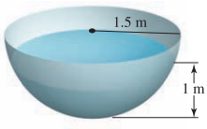***Solution***

1. 











1. 







***Exercise***

Find the linearization  of  at the point 

Consider a closed rectangular box with a square base. If *x* is measured with error at most 2% and *y* is measured with error at most 3% use a differential to estimate the corresponding percentage error in computing the box’s

1. Surface area
2. Volume

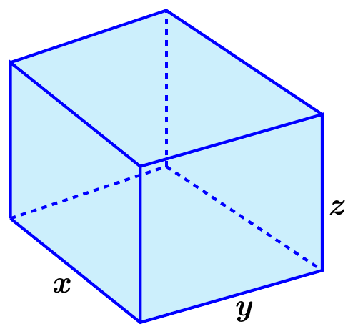***Solution***

***Given***: 

1. 



















1. 











***Exercise***

Consider a closed container in the shape of a cylinder of radius 10 *cm* and height 15 *cm* with a hemisphere on each end.

The container is coated with a layer of ice  *cm* thick. Use a differential to estimate the total volume of ice.

(*Hint*: assume *r* is radius with  and *h* is height with )

***Solution***

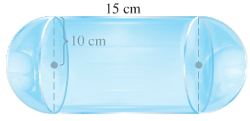









***Exercise***

A standard 12-*fl-oz* can of soda is essentially a cylinder of radius  and height 

1. At these dimensions, how sensitive is the can’s volume to a small change in radius versus a small change in height?
2. Could you design a soda can that appears to hold more soda but in fact holds the same 12-fl-oz? What might its dimensions be? (There is more than one correct answer.)

***Solution***

Given: 

1. 





The volume is about 10 times more sensitive to a change in *r*.

1. 





Assume , then 



 is one solution for 

***Exercise***

Consider the function , whose graph is shown

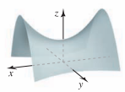

1. Fill in the table showing the value of the directional derivative at points  in the direction given by the unit vectors 
2. Interpret each of the directional derivatives computed in part(a) at the point 

***Solution***

1. 





|  |  |  |  |
| --- | --- | --- | --- |
|  |  |  |  |
|  | 0 |  |  |
|  | 0 |  |  |
|  | 0 |  |  |

1. The function is ***increasing*** @  in the direction of 

The function is ***decreasing*** @  in the direction of 

***Exercise***

Two spheres have the same center and radii *r* and *R*, where . The volume of the region between the sphere is .

1. First use your intuition. If *r* is held fixed, how does *V* change as *R* increases? What is the sign of ? If *R* is held fixed, how does *V* change as *r* increases (up to the value of *R*)? What is the sign of ?
2. Compute  and . Are the results consistent with part (*a*)?
3. Consider spheres with  and . Does the volume change more if *R* is increased by  (with *r* fixed) or if *r* is decreased by  (with *R* fixed)?

***Solution***

1.  is fixed, then 

∴ If *R* increases then *V* increases.

 is fixed, then 

∴ If *r* increases then *V* decreases.

1. Yes, 
2. If , , , and 



If *r* is decreased by 0.1



∴ Volume changes more if *R* is increased.

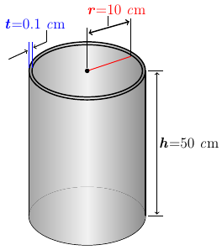***Exercise***

A company manufactures cylindrical aluminum tubes to rigid specifications. The tubes are designed to have an outside radius of , a height of , and a thickness of . The manufacturing process produces tubes with a maximum error of in the radius and height and a maximum error of  in the thickness. The volume of the material used to construct a cylindrical tube is . Estimate maximum error in the volume of the tube.

***Solution***











The maximum error in the volume is approximately.

The volume is far more sensitive to errors in the thickness, since for the thickness  is more than for the radius  and height 

***Exercise***

The volume of a right circular cone with radius *r* and height *h* is 

1. Approximate the change in the volume of the cone when the radius changes from  to  and the height changes from  to 
2. Approximate the change in the volume of the cone when the radius changes from  to  and the height changes from  to 

***Solution***





1. 





1. 



***Exercise***

The area of an ellipse with axes of length 2*a* and 2*b* is . Approximate the percent change in the area when *a* increases by 2% and *b* increases by 1.5%.

***Solution***











***Exercise***

The Volume of a segment of a circular paraboloid with radius *r* and height *h* is  .

Approximate the percent change in the volume when the radius decreases by 1.5% and the height increases by 2.2%

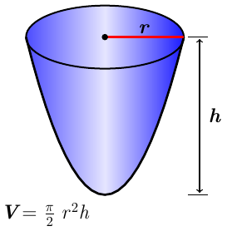***Solution***











***Exercise***

Batting averages in baseball are defined by , where  is the total number of hits and  is the total number of at-bats. Treat *x* and *y* as positive real numbers and note that .

1. Estimate the change in the batting average if the number of hits increases from 60 to 62 and the number of at-bats increases from 175 to 180.
2. If a batter currently has a batting average of , does the average decrease if the batter fails to get a hit more than it increases if the batter gets a hit?
3. Does the answer in part (*b*) depend on the current batting average? Explain.

***Solution***

1. 











1. If the batter fails to get a hit, the average decreases by





If the batter gets a hit, the average increases by







If , the second of these quantities is larger, therefore the answer is no; the batting average changes more if the batter gets a hit than if he fails to get a hit.

1. The answer depends on whether *A* is less than or greater than 0.50.

***Exercise***

A conical tank with radius 0.50 *m* and height 2.0 *m* is filled with water. Water released from the tank, and the water level drops by 0.05 *m* (from 2.0 *m* to 1.95 *m*).

Approximate the change in volume of water in the tank.

(***Hint***: When the water level drops, both the radius and height of the cone of water change).

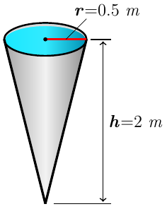***Solution***

































***Exercise***

Poiseuille’s law is a fundamental law of fluid dynamics that describes the flow velocity of a viscous incompressible fluid in a cylinder (it is used to model blood flow through veins and arteries). It says that in a cylinder of radius *R* and length *L*, the velocity of the fluid  units from the centerline of the cylinder is , where *P* is the difference in the pressure between the ends of the cylinder and  is the viscosity of the fluid. Assuming that *P* and  are constant, the velocity *V* along the centerline of the cylinder  is , where *k* is a constant that we will take to be .

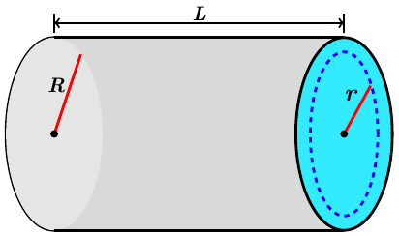

1. Estimate the change in the centerline velocity  if the radius of the flow cylinder increases from  to  and the length increases from  to .
2. Estimate the percent change in the centerline velocity if the radius of the flow cylinder *R* decreases by 1% and the length increases by 2%.

***Solution***



1. 











1. 

 *R* decreases by 1% and the length increases by 2%.





*V* will decrease by approximately 4%.

***Exercise***

Suppose that in a large group of people a fraction  of the people have flu. The probability that in *n* random encounters, you will meet at least one person with flu is  . Although *n* is a positive integer, regard it as a positive real number.

1. Compute  and .
2. How sensitive is the probability *P* to the flu rate *r*? Suppose you meet  people. Approximately how much does the probability *P* increase if the flu rate increases from  to  (with *n* fixed)?
3. Approximately how much does the probability *P* increase the flu rate increases from  to 
4. Interpret the results of parts (*b*) and (*c*).

***Solution***

1. 















1. 

 





1. 

 





1. Small changes in the flu rate have a greater effect on the probability of catching the flu when the flu rate is small compared to when the flu rate is large.

***Exercise***

When two electrical resistors with resistance  and  are wired in parallel in a circuit, the combined resistance *R* is given by



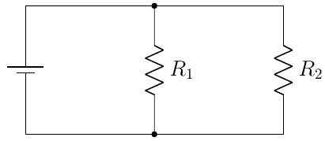

1. Estimate the change in *R* if  increases from 2 Ω to 2.05 Ω and decreases from 3 Ω to 2.95 Ω.
2. Is it true that if and increases by the same small amount as decreases, then *R* is approximately unchanged? Explain.
3. Is it true that if and  increase, then *R* increases? Explain.
4. Suppose and  increases by the same small amount as  decreases. Does *R* increase or decrease?

***Solution***

1. .





 

















1. If 

increases by the same small amount as decreases.









1. If and  increase



Therefore, *R* increases

1. *Given*: 



*R* is more sensitive to changes in , so if  increases by the same small amount as  decreases, then *R* will decrease.

***Exercise***

When three electrical resistors with resistance ,  and  are wired in parallel in a circuit, the combined resistance *R* is given by



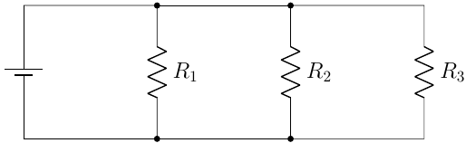

Estimate the change in *R* if  increases from 2 Ω to 2.05 Ω,  decreases from 3 Ω to 2.95 Ω, and  increases from 1.5 Ω to 1.55 Ω

***Solution***

.



























***Exercise***

Consider the ellipsoid  and the plane *P* given by . Let  and 

1. Find the equation of the plane tangent to the ellipsoid at the point .
2. Find the two points on the ellipsoid at which the tangent plane parallel to *P* and find equations of the tangent planes.
3. Show that the distance between the origin and the plane *P* is *h*.
4. Show that the distance between the origin and the tangent planes is *hm*.
5. Find a condition that guarantees the plane *P* does not intersect the ellipsoid.

***Solution***

1. 





Equation of the ***plane tangent*** to the ellipsoid at the point  is:











1. ***Given***:  → The vector will be  and  must be proportional.











 







Equations of the tangent planes: 

1. The distance between the plane  to the origin:

Let  be the point on the plane, then







 *Distance from a Point to a Plane:* 

 





 ***√***

1. The tangent plane at  has an equation 







 

  

 ***√***

1. For the plane *P* does not intersect the ellipsoid if and only if the 2 tangent planes parallel to *P* are closer to the origin than *P*; this is equivalent to the condition .