***Section* 2.7 – Maximum/Minimum Problems**

**Derivative Tests for Local Extreme Values**

***Definition***

Let  be defined on a region R containing the point . Then

*  is a local maximum value of *f* if  for all domain points  in an open disk centered at .
*  is a local minimum value of *f* if  for all domain points  in an open disk centered at .

|  |  |
| --- | --- |
|  |  |

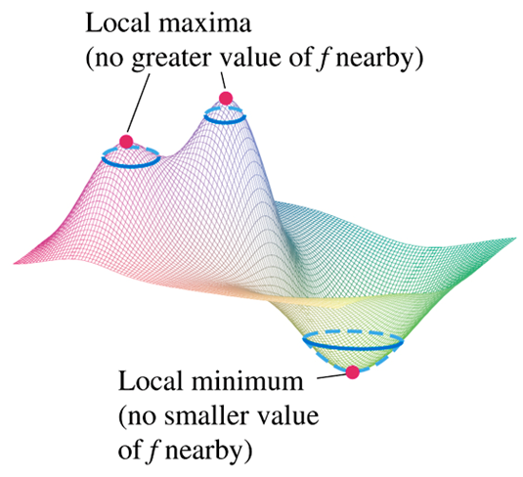

***Theorem* − First derivative Test for Local Extreme Values**

If  has a local maximum or minimum value at an interior point  of its domain and if the first partial derivatives exist there, then 

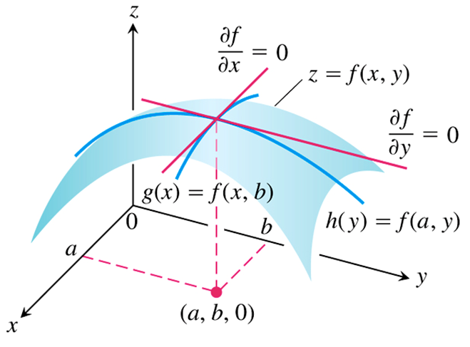

***Definition***

An interior point of the domain  where both  and  are zero or where one or both of  and  do not exist is a ***critical point*** of *f*.

***Definition***

A differentiable function  has a ***saddle point*** at a critical point  if in every open disk centered at  there are domain points  where  and domain points  where . The corresponding point  on the surface  is called a saddle point of the surface.

|  |  |
| --- | --- |
|  |  |

***Example***

Find the local extreme values of 

***Solution***

The domain of *f* is the entire plane. The local extreme values occur:



Therefore, the critical point is  and the value .

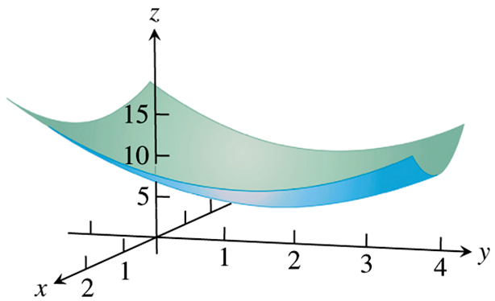

The critical point is a local minimum.

***Example***

Find the local extreme values of 

***Solution***

The domain of *f* is the entire plane.



Therefore, the local extreme is the origin  and the value .



The function has a saddle point at the origin and no local extreme values.

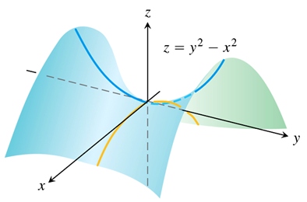 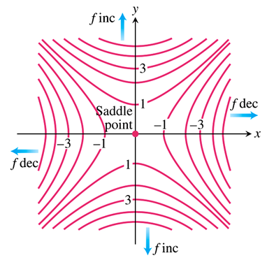

***Theorem* − Second Derivative Test for Local Extreme Values**

Suppose that  and its first and second partial derivatives are continuous throughout a disk centered at  and that . Then

*  has a ***local maximum*** at  if  and  at .
*  has a ***local minimum*** at  if  and  at .
*  has a ***saddle point*** at  if  at .
* ***The test is inconclusive*** at  if  at . In this case, we must find some other way to determine the behavior of *f* at .

***Example***

Find the local extreme values of 

***Solution***





Therefore, the critical point is 







The function *f* has a local maximum at  and the value is 



***Example***

Find the local extreme values of 

***Solution***





 are the critical points









At 



So, the function has a saddle point at the origin.

At 

 and 

So, the function has a local maximum at  with a value of





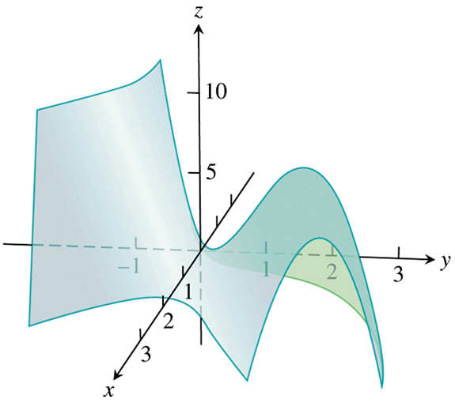

**Absolute Maxima and Minima on Closed Bounded Regions**

The absolute extrema of a continuous function  on a closed and bounded region *R* into three steps

1. *List the interior points of* *R* where *f* may have local maxima and minima and evaluate *f* at these points. These are the critical points of *f*.
2. *List the boundary points* of *R* where *f* may have local maxima and minima and evaluate *f* at these points.
3. *Look through the lists* for the maximum and minimum values of *f*. These will be the absolute maximum and minimum values of *f* on *R*. Since absolute maxima and minima are also local maxima and minima, the absolute maximum and minimum values of appear somewhere in the lists made in Steps 1 and 2

***Example***

Find the absolute maximum and minimum values of  on the triangular region in the first quadrant bounded by the lines 

***Solution***

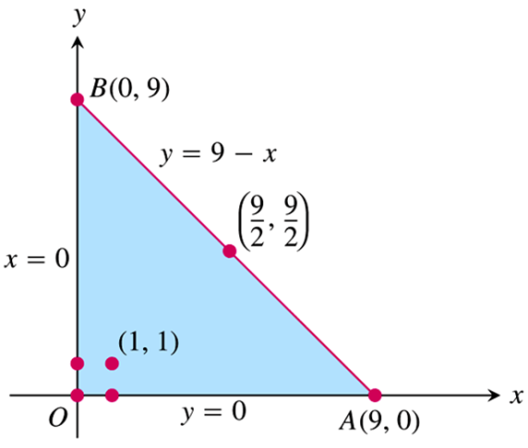





The critical point is . The value of *f* is



Boundary points:

1. On the segment *OA*, *y* = 0. The function



This function is defined on the closed interval .



At the interior points where. The only point is  where 

1. On the segment *OB*, *x* = 0. The function





1. Left the interior points of the segment *AB*. With , then









At 





∴ .

The maximum is 4, which *f* assumes at (1, 1). The minimum is −61, which *f* assumes at (0, 9) and (9, 0).

***Example***

A delivery company accepts only rectangular boxes the sum of whose length and girth (perimeter of a cross-section) does not exceed 108 *in*. Find the dimensions of an acceptable box of largest volume.

***Solution***

Let *x, y*, and *z* represent the length, width, and height.

The girth is: 

Volume: 

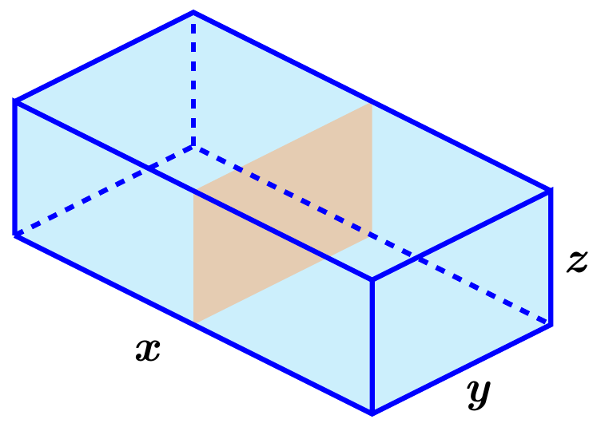We want to maximize the volume of the box satisfying:























∴ The critical points are: 

At (0, 0):



At (0, 54):



At (54, 0):



At (18, 18):















That implies (18, 18) give a maximum volume.







The dimensions of the package are: ***x*** = 36 *in*., ***y*** = 18 *in*, ***z*** = 18 *in*.

The maximum volume is 

**Summary of *Max*−*Min* Tests**

The extreme values of  can occur only at

1. ***Boundary points*** of the domain of *f*.
2. ***Critical points*** (interior points where  or points where  fail to exist)

If the first- and second-order partial derivatives of *f* are continuous throughout a disk centered at a point and , the nature of  can be tested with the ***Second Derivative Test***:

1.  and  at  ⇒ ***local maximum***
2.  and  at  ⇒ ***local minimum***
3.  at  ⇒ ***saddle point***
4.  at  ⇒ ***test is inconclusive.***

***Exercises*** **2.7 – Maximum/Minimum Problems**

(**1 – 30**) Find all the local maxima, local minima, and saddle points of the function

|  |  |
| --- | --- |
|  |  |

(**31 – 34**) Identify the critical points of the functions. Then determine whether each critical point corresponds to a local maximum, local minimum, or saddle point. State when your analysis is inconclusive.

|  |  |
| --- | --- |
|  |  |

(**35 – 53**) Find the absolute maximum and minimum values of the function on the specified region *R*.

1.  on the rectangle 
2.  on the square 
3.  on the triangle 
4.  on the semicircular disk 
5. 
6. 
7. 
8. 
9. 
10. 
11. 
12.  *R* is the closed region bounded by the lines , , and 
13.  *R* is the closed region bounded by the ellipse 
14. 
15. 
16. 
17.  on the closed triangular plate bounded by the lines  in the first quadrant.
18.  on the closed triangular plate bounded by the lines  in the first quadrant.
19.  on the triangular plate .
20. Find the point on the graph of  nearest the plane 
21. Find the minimum distance from the point  to the plane 
22. Find the maximum value of  where 
23. Find the absolute maxima and minima of the function  on the triangular plate .

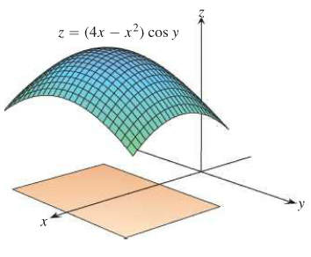

1. Among all triangles with a perimeter of 9 *units*, find the dimensions of the triangle with the maximum area. It may be easiest to use Heron’s formula, which states that the area of a triangle with side length *a*, *b*, and *c* is , where 2*s* is the perimeter of the triangle.
2. Let *P* be a plane tangent to the ellipsoid  at a point in the first octane. Let *T* be the tetrahedron in the first octant bounded by *P* and the coordinate planes , , and . Find the minimum volume *T*. (the volume of a tetrahedron in one-third the area of the base times the height.)
3. Given three distinct noncollinear points *A*, *B*, and *C* in the plane, find the point *P* in the plane such the sum of the distances  is a minimum. Here is how to procees with three points, assuming that the triangle formed by the three points has no angle greater than 
4. Assume the coordinates of the threee given points are , , and . Let  be the distance between  and a variable point . Compute the gradient of and show that it is a unit vector pointing along the line between the two points.
5. Define  and  in a similar way and show that  and  are also unit vectors in the direction of line between the two points.
6. The goal is to minimize . Show that the condition  implies that .
7. Explain why part (c) implies that the optimal point *P* has the property the the three line segments , , and  all intersect symmetrically in angles of .
8. What is the optimal solution if one of the angles in the triangle is greater than  (draw a picture)?
9. Estimate the Steiner point for the three points , , 

(**61 – 62**) Show that the following two functions have two local maxima but no other extreme points (thus no saddle or basin between the mountains).

|  |  |
| --- | --- |
|  |  |