***Solution*** ***Section* 2.7 – Maximum/Minimum Problems**

***Exercise***

Find all the local maxima, local minima, and saddle points of the function



***Solution***





Therefore, the critical point is 





The function *f* has a ***local minimum*** at  and the value is 



***Exercise***

Find all the local maxima, local minima, and saddle points of the function



***Solution***



 



Therefore, the critical point is 



At : 



The function *f* has a ***local minimum*** at  and the value is





***Exercise***

Find all the local maxima, local minima, and saddle points of the function



***Solution***



 





Therefore, the critical point is 



At 





The function *f* has a ***saddle point*** at  and the value is 

At 





The function *f* has a ***local minimum*** at  and the value is 

***Exercise***

Find all the local maxima, local minima, and saddle points of the function



***Solution***





Therefore, the critical point is 



At 





The function *f* has a ***saddle point*** at  and the value is 

At 





The function *f* has a ***local minimum*** at  and the value is 

At 





The function *f* has a ***local minimum*** at  and the value is 

***Exercise***

Find all the local maxima, local minima, and saddle points of the function



***Solution***





Therefore, the critical point is 





The function  has a local maximum at  and the value is 



***Exercise***

Find all the local maxima, local minima, and saddle points of the function



***Solution***





Therefore, the critical point is 





***Exercise***

Find all the local maxima, local minima, and saddle points of the function



***Solution***





Therefore, the critical point is 





The function  has a local minimum at  and the value is 



***Exercise***

Find all the local maxima, local minima, and saddle points of the function



***Solution***





Therefore, the critical point is 





***Exercise***

Find all the local maxima, local minima, and saddle points of the function



***Solution***





Therefore, the critical point is 













The function  has a local maximum at  and the value is



***Exercise***

Find all the local maxima, local minima, and saddle points of the function 

***Solution***









There are no solutions to the system  , however, this occurs when  . The critical point is 

We cannot use the second derivative test, but this is the only possible local maximum, local minimum, or saddle point.  has a local maximum of  since 

***Exercise***

Find all the local maxima, local minima, and saddle points of the function



***Solution***





Therefore, the critical point is , , , and 



For  



For  



The function  has a local minimum at  and the value is 

For  



The function  has a local maximum at  and the value is 

For  



***Exercise***

Find all the local maxima, local minima, and saddle points of the function 

***Solution***





Therefore, the critical point is , , and 



For  



For  



The function has a local maximum at  and the value is 

For  



The function  has a local maximum at  and the value is 

***Exercise***

Find all the local maxima, local minima, and saddle points of the function 

***Solution***



 Therefore, the critical point is 





















The function  has a local maximum at  and the value is 

***Exercise***

Find all the local maxima, local minima, and saddle points of the function 

***Solution***





Therefore, the critical point is 





The function  has a local minimum at  and the value is 

***Exercise***

Find all the local maxima, local minima, and saddle points of the function 

***Solution***



 Therefore, the critical point is 







If *n* is even: 

If *n* is odd: 

***Exercise***

Find all the local maxima, local minima, and saddle points of the function 

***Solution***



Since , the functions  and  cannot equal to zero for the same *y*.

∴ No critical points ⇒ no extrema and no saddle points.

***Exercise***

Find all the local maxima, local minima, and saddle points of the function 

***Solution***





∴ The critical point is 









***Exercise***

Find all the local maxima, local minima, and saddle points of the function 

***Solution***







∴ The critical point is  and 







For  



The function  has a local minimum at  and the value is 

For  



***Exercise***

Find all the local maxima, minima, and saddle points of the function 

***Solution***





∴ The critical point is 









The function  has a local maximum at  and the value is 

***Exercise***

Find all the local maxima, minima, and saddle points of the function 

***Solution***







∴ The critical point is 











***Exercise***

Find all the local maxima, minima, and saddle points of the function 

***Solution***





∴ The critical point is 





The function  has a local minimum at  and the value is 

***Exercise***

Find all the local maxima, minima, and saddle points of the function 

***Solution***





∴ The critical point is 





The function  has a local minimum at  and the value is



***Exercise***

Find all the local maxima, minima, and saddle points of the function 

***Solution***





∴ The critical point is 





The function  has a local minimum at  and the value is 

***Exercise***

Find all the local maxima, minima, and saddle points of the function 

***Solution***





∴ The critical point is 





***Exercise***

Find all the local maxima, minima, and saddle points of the function 

***Solution***











∴ The critical point is , , 





@ 



@ 



The function  has a local minimum at  and the value is 

@ 



The function  has a local minimum at  and the value is 

***Exercise***

Find all the local maxima, minima, and saddle points of the function 

***Solution***











∴ The critical point is , 





@ 



@ 



The function  has a local minimum at  and the value is



***Exercise***

Find all the local maxima, minima, and saddle points of the function 

***Solution***





∴ The critical point is , , 





@ 



@ 



The function  has a local minimum at  and the value is



@ 



The function  has a local minimum at  and the value is



***Exercise***

Find all the local maxima, minima, and saddle points of the function 

***Solution***







∴ The critical point is 





***Exercise***

Find all the local maxima, minima, and saddle points of the function 

***Solution***





∴ The critical point is 





The function  has a local minimum at  and the value is



***Exercise***

Find all the local maxima, minima, and saddle points of the function 

***Solution***







∴ The critical point is , , 

@ 



















Inconclusive. No extreme values.

***Exercise***

Identify the critical points of the functions. Then determine whether each critical point corresponds to a local maximum, local minimum, or saddle point. State when your analysis is inconclusive.



***Solution***













***C.P***: 

  







 is a ***saddle point***.





 has a ***local Min*** @ 

***Exercise***

Identify the critical points of the functions. Then determine whether each critical point corresponds to a local maximum, local minimum, or saddle point. State when your analysis is inconclusive.



***Solution***











 

***C.P***: 

  







 is a ***saddle point***.





 has a ***local Min*** @ 

***Exercise***

Identify the critical points of the functions. Then determine whether each critical point corresponds to a local maximum, local minimum, or saddle point. State when your analysis is inconclusive.



***Solution***

























***C.P***: 













 is a ***saddle point***.





 is a ***saddle point***.





 is a ***saddle point***.





 is a ***saddle point***.



 

Function has a ***local max*** @ 

***Exercise***

Identify the critical points of the functions. Then determine whether each critical point corresponds to a local maximum, local minimum, or saddle point. State when your analysis is inconclusive.



***Solution***













***C.P***: 















 is a ***saddle point***.



 

Function has a ***local min*** @ 



 

Function has a ***local max*** @ 





 is a ***saddle point***.

***Exercise***

Find the absolute maximum and minimum values of the function on the specified region *R*.

 on the rectangle 

***Solution***



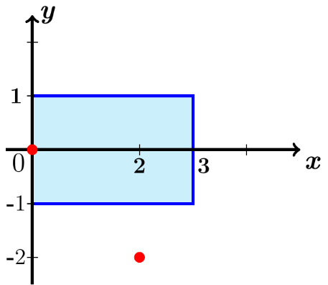



 



***C.P***:  neither in the interior of *R*.































Absolute minimum: 

Absolute maximum: 

***Exercise***

Find the absolute maximum and minimum values of the function on the specified region *R*.

 on the square 

***Solution***

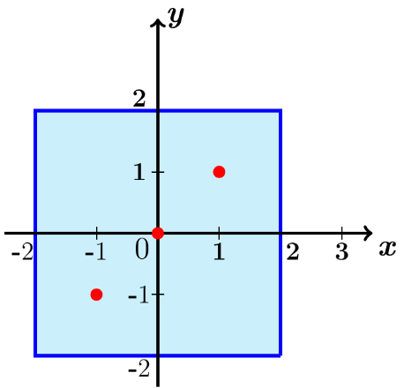











***C.P***: 

|  |  |
| --- | --- |
|  |  |
|  | 1 |
|  |  |
|  |  |
|  |  |
|  |  |
|  |  |
|  |  |

Absolute minimum: 

Absolute maximum: 

***Exercise***

Find the absolute maximum and minimum values of the function on the specified region *R*.

 on the triangle 

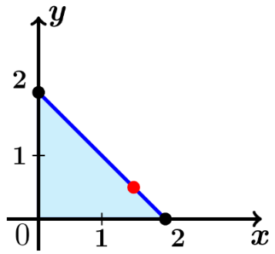***Solution***





***C.P***: ***None*** inside the triangle







|  |  |
| --- | --- |
|  |  |
|  | 0 |
|  |  |
|  |  |
|  |  |









Absolute minimum: 

Absolute maximum: 

***Exercise***

Find the absolute maximum and minimum values of the function on the specified region *R*.

 on the semicircular disk 

***Solution***





***C.P***.: 

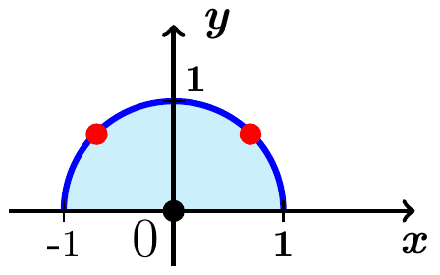















Absolute minimum: 

Absolute maximum: 

***Exercise***

Find the absolute maximum and minimum values of the function on the specified region *R*.



***Solution***





***C.P***.: 

















Absolute minimum: 

Absolute maximum: 

***Exercise***

Find the absolute maximum and minimum values of the function on the specified region *R*.



***Solution***





***C.P***.: 

|  |  |  |
| --- | --- | --- |
| ***t*** |  |  |
|  |  |  |
| 0 |  | 32 |
|  |  | 16 |
|  |  | 32 |
|  |  | 16 |

 











Absolute minimum: 

Absolute maximum: 

***Exercise***

Find the absolute maximum and minimum values of the function on the specified region *R*.



***Solution***

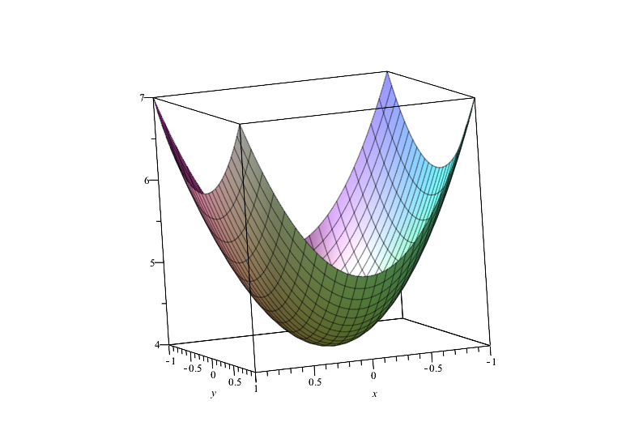



***C.P***.: 

|  |  |
| --- | --- |
|  |  |
|  | 4 |
|  |  |

Absolute minimum: 

Absolute maximum: 

***Exercise***

Find the absolute maximum and minimum values of the function on the specified region *R*.



***Solution***

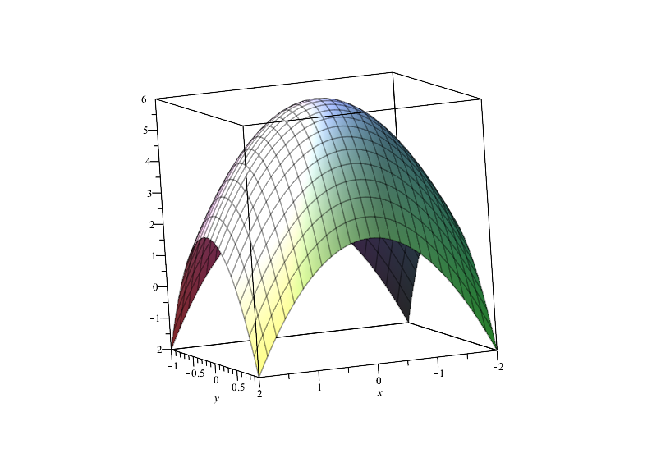



***C.P***.: 

|  |  |
| --- | --- |
|  |  |
|  | 6 |
|  |  |

Absolute minimum: 

Absolute maximum: 

***Exercise***

Find the absolute maximum and minimum values of the function on the specified region *R*.



***Solution***





***C.P***.: 

 













|  |  |  |
| --- | --- | --- |
| ***t*** |  |  |
|  |  |  |
| 0 |  | 2 |
|  |  | 3 |
|  |  | 2 |
|  |  | 3 |

Absolute minimum: 

Absolute maximum: 

***Exercise***

Find the absolute maximum and minimum values of the function on the specified region *R*.



***Solution***





***C.P***.: 

 













|  |  |  |
| --- | --- | --- |
| ***t*** |  |  |
|  |  |  |
| 0 |  |  |
|  |  |  |
|  |  |  |
|  |  |  |

Absolute ***minimum***: 

Absolute ***maximum***: 

***Exercise***

Find the absolute maximum and minimum values of the function on the specified region *R*.



***Solution***







***C.P***.: 

 









|  |  |  |
| --- | --- | --- |
| ***t*** |  |  |
|  |  |  |
| 0 |  |  |
|  |  |  |

Absolute ***minimum***: 

Absolute ***maximum***: 

***Exercise***

Find the absolute maximum and minimum values of the function on the specified region *R*.

 *R* is the closed region bounded by the lines , , and 

***Solution***

 



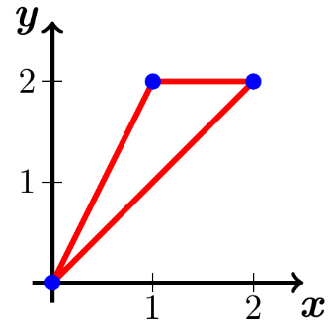



***C.P***.: 

***@***  









***@***  







***@***  

 





Absolute ***minimum***: 

Absolute ***maximum***: 

***Exercise***

Find the absolute maximum and minimum values of the function on the specified region *R*.

 *R* is the closed region bounded by the ellipse 

***Solution***





***C.P***.: 

 











|  |  |  |
| --- | --- | --- |
| ***t*** |  |  |
|  |  |  |
| 0 |  |  |
|  |  |  |
|  |  |  |
|  |  |  |

Absolute ***minimum***: 

Absolute ***maximum***: 

***Exercise***

Find the absolute maximum and minimum values of the function on the specified region *R*.



***Solution***





***C.P***.: 



 



 No extreme points.



Absolute ***minimum***: 

***Exercise***

Find the absolute maximum and minimum values of the function on the specified region *R*.



***Solution***





***C.P***.: *None*



|  |  |
| --- | --- |
|  |  |
|  |  |
|  |  |
|  |  |
|  |  |

The range of the function  on *R* is the interval .

∴  has ***neither*** an absolute minimum or maximum on *R*.

***Exercise***

Find the absolute maximum and minimum values of the function on the specified region *R*.



***Solution***





***C.P***.: *None*







Absolute ***minimum***: 

Absolute ***maximum***: 

***Exercise***

Find the absolute maxima and minima of the function  on the closed triangular plate bounded by the lines  in the first quadrant.

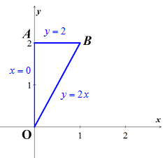***Solution***





The critical point is  and the value is 

1. On the segment *OA*. The function 

This function is defined on the closed interval .





1. On the segment *OB*





 ∴  is not interior point of *OB*

1. On the segment *AB*







⇒  is not interior point of triangular region.

Therefore; the absolute ***maximum*** is 1 at (0, 0) and the absolute ***minimum*** is −5 at 

***Exercise***

Find the absolute maxima and minima of the function  on the closed triangular plate bounded by the lines  in the first quadrant.

***Solution***



The critical point is  and the value is 

1. On the segment *OA*.







1. On the segment *OB*

 



1. On the segment *AB*







⇒  is not interior point of triangular region.

Therefore; the absolute ***maximum*** is 11 at  and the absolute ***minimum*** is 1 at 

***Exercise***

Find the absolute maxima and minima of the function  on the triangular plate .

***Solution***





The critical point is  and the value is 

1. On the segment *OA*.





 

1. On the segment *AB*







1. On the segment *BC*







1. On the segment *CO*







Therefore; the absolute ***maximum*** is 11 at  and the absolute ***minimum*** is −10 at 

***Exercise***

Find the absolute maxima and minima of the function  on the triangular plate .

***Solution***







The critical point is  and the value is 

Values of all 4 corner points:

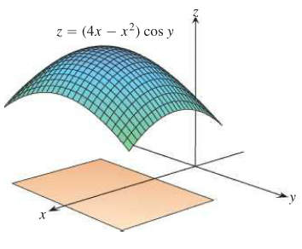







1. On the segment *AB*





 

1. On the segment *BC*







1. On the segment *CD*





1. On the segment *DA*





Therefore; the absolute ***maximum*** is 4 at  and the absolute ***minimum*** is at 

***Exercise***

Find the point on the graph of  nearest the plane 

***Solution***

The point on  where the tangent plane is parallel to the plane .

Let  is normal to  at .

The vector  is parallel to  which is normal to the plane if 

, 

Thus, the point  is the point on the surface  nearest the plane 

***Exercise***

Find the minimum distance from the point  to the plane 

***Solution***





Let: 





|  |  |
| --- | --- |
|  |  |



∴ The critical point is .







Therefore, the local ***minimum*** of the distance is





***Exercise***

Find the maximum value of  where 

***Solution***











 



∴ The critical point is .







Therefore, the local *maximum* of the distance is





***Exercise***

Among all triangles with a perimeter of 9 *units*, find the dimensions of the triangle with the maximum area. It may be easiest to use Heron’s formula, which states that the area of a triangle with side length *a*, *b*, and *c* is , where 2*s* is the perimeter of the triangle.

***Solution***

The semi-perimeter is: 























 







 ∴ Equilateral triangle

The maximum area is obtained when all three sides are equal with each side length is 3 *units* (since the perimeter is 9 *units*).

***Exercise***

Let *P* be a plane tangent to the ellipsoid  at a point in the first octane. Let *T* be the tetrahedron in the first octant bounded by *P* and the coordinate planes , , and . Find the minimum volume *T*. (the volume of a tetrahedron in one-third the area of the base times the height.)

***Solution***

Let  be a point on the ellipsoid.

The tangent plane *P* at the point *Q* has an equation:



The intersection points of the plane with the axes are:

, , and 

∴ The tetrahedron *T* has base area



Height: 







































***Exercise***

Given three distinct noncollinear points *A*, *B*, and *C* in the plane, find the point *P* in the plane such the sum of the distances  is a minimum. Here is how to procees with three points, assuming that the triangle formed by the three points has no angle greater than 

1. Assume the coordinates of the threee given points are , , and . Let  be the distance between  and a variable point . Compute the gradient of and show that it is a unit vector pointing along the line between the two points.
2. Define  and  in a similar way and show that  and  are also unit vectors in the direction of line between the two points.
3. The goal is to minimize . Show that the condition  implies that .
4. Explain why part (*c*) implies that the optimal point *P* has the property the three line segments , , and  all intersect symmetrically in angles of .
5. What is the optimal solution if one of the angles in the triangle is greater than  (draw a picture)?
6. Estimate the Steiner point for the three points , , 

***Solution***

1. 











∴ The gradient of  is a unit vector

1. 









∴  is a unit vector











∴  is a unit vector

1. 



Given that 





 ***√***

1. Since  that implies all the 3 *unit* vectors add to 0.

Therefore, all three divide the unit circle into 3 equal sectors, they must make angles of .

1. The optimal point is the vertex at the large angle.

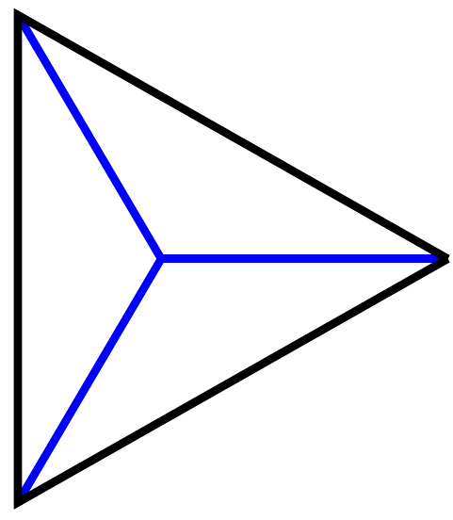 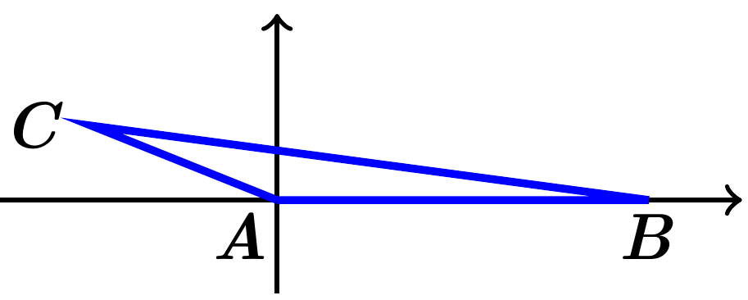

1. Three points , , 









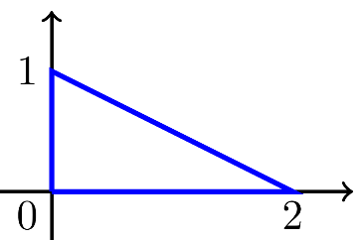



Using maple:







***Exercise***

Show that the following two functions have two local maxima but no other extreme points (thus no saddle or basin between the mountains).



***Solution***



















∴ ***C.P***.: 















 has a ***local Max*** @ 







 has a ***local Max*** @ 

***Exercise***

Show that the following two functions have two local maxima but no other extreme points (thus no saddle or basin between the mountains).



***Solution***













∴ ***C.P***.: 















 has a ***local Max*** @ 







 has a ***local Max*** @ 