***Section* 2.8 – Lagrange Multipliers**

**Constrained Maxima and Minima**

We consider a problem where a constrained minimum can be found by eliminating a variable.

***Example***

Find the point  on the plane  that is closest to the origin.

***Solution***





Subject to the constraint that 

Since  has a minimum value wherever the function  has a minimum value.







|  |  |
| --- | --- |
|  |  |





Therefore, the closest point to the origin is: 

The distance from *P* to the origin is:





***Example***

Find the points on the hyperbolic cylinder  that are closest to the origin.

***Solution***

The points closest to the origin are the points whose coordinates minimize the value of the function  subject to the constraint that 

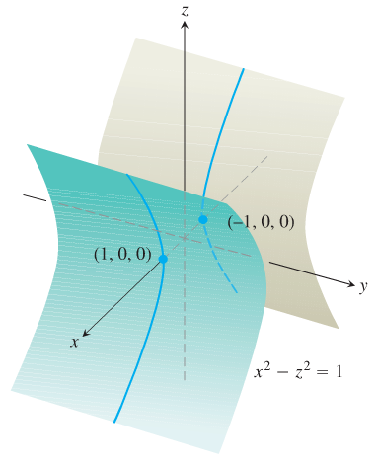







|  |  |
| --- | --- |
|  |  |

That is, at the point (0, 0) ????

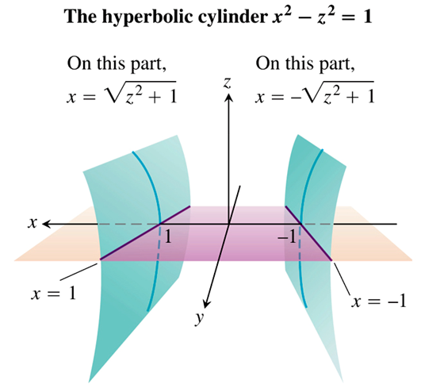The domain of *h* is the entire *xy*-plane, the domain from which we can select the first two coordinates of the points  on the cylinder is restricted to the shadow of the cylinder on the xy-plane; it does not include the band between the lines  and .









|  |  |
| --- | --- |
|  |  |

That implies to  and which leads to 

The corresponding points on the cylinder are .

 gives a minimum value for *k*. We can also see that the minimum distance from the origin to a point on the cylinder is 1 unit.

***Solution*****2**

Another way to find the points on the cylinder closet to the origin is to imagine a small sphere centered at the origin expanding until it touches the cylinder

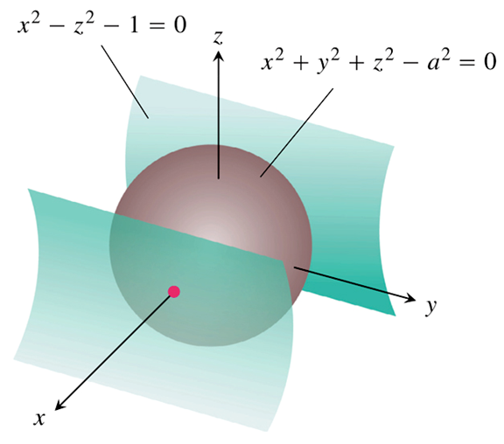





 



Since that no point on the surface has a zero *x*-coordinate to conclude that .

Hence,  only if



For , for this to satisfies, *z* must be zero.

Also 

We conclude that the points have coordinates of the form 



The points on the cylinder closest to the origin are the points .

**The Method of *Lagrange* Multipliers**

The method of Lagrange multipliers:



For some scalar λ (called a ***Lagrange multiplier***)

***Theorem* − The orthogonal Gradient Theorem**

Suppose that  is differentiable in a region whose interior contains a smooth curve



If  is a point on *C* where *f* has a local maximum or minimum relative to the values on *C*, then  is orthogonal to *C* at .

***Corollary***

At the points on a smooth curve  where differentiable function  takes on its local maxima and minima relative to its values on the curve,  where .

**The Method of Lagrange Multipliers**

Suppose that  and  are differentiable and  when . To find the local maximum and minimum values of *f* subject to the constraint  (if these exist), find the values of *x, y, z*, and λ that simultaneously satisfy the equations



For functions of two independent variables, the condition is similar, but without the variables *z*.

***Example***

Find the greatest and smallest values that the function  takes on the ellipse

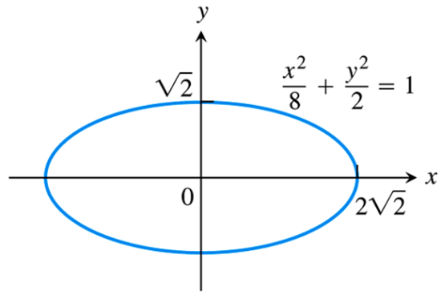

***Solution***

 subject to the constraint



We need to find: 

 









Consider these two cases:

***Case* 1**: If , then . But (0, 0) is not on the ellipse. Hence, .

***Case* 2**: If , then  and .







Therefore,  takes on its extreme values on the ellipse at the points . The extreme values are 

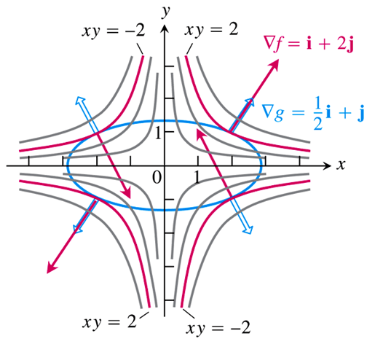

***The Geometry of the solution***: The level curves of the function  are the hyperbolas 

At the point (2, 1): 

At the point (−2, 1): 

***Example***

Find the maximum and minimum values that the function  on the circle 

***Solution***

 

 



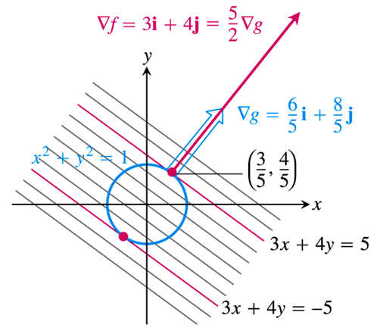

















Therefore,  has extreme values 





***The Geometry of the solution***:

The level curves of the function  are the lines 

At the point : 

**Lagrange Multipliers with Two Constraints**

To find the extreme values of a differentiable function  whose variables are subject to two constraints. If the constraints are



 are differentiable, with  not parallel to 

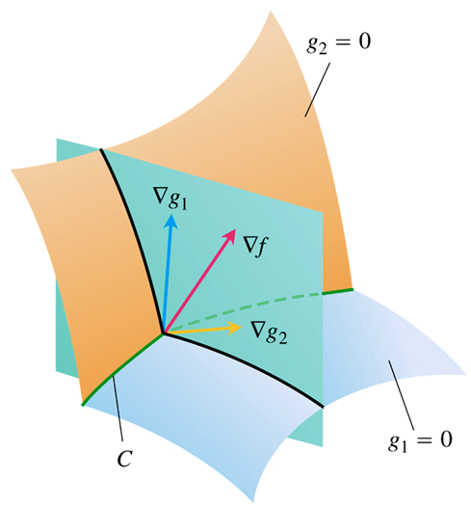



***Example***

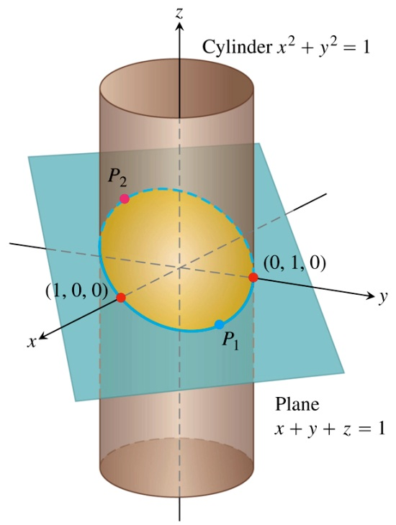The plane  cuts the cylinder  in an ellipse.

Find the points on the ellipse that lie closet to and farthest from the origin.

***Solution***













|  |  |  |
| --- | --- | --- |
|  |  |  |



These satisfy if either λ = 1 and *z* = 0 or λ ≠ 1 and 

If *z* = 0,









The points are:  and 

If ,

|  |  |
| --- | --- |
|  |  |
|  |  |

The points are:  and 

The points on the ellipse closest to the origin are  and . The point on the farthest from the origin is .

***Exercises*** ***Section* 2.8 – Lagrange Multipliers**

1. Find the points on the ellipse  where  has its extreme values.
2. Find the extreme values of  subject to the constraint .
3. Find the extreme values of  on the circle 
4. Find the extreme values of  on the circle 
5. Find the maximum value of  on the line .
6. Find the points on the curve  nearest the origin.
7. Use the method of Lagrange multipliers to find
8. The minimum value of , subject to the constraints 
9. The maximum value of , subject to the constraints 
10. Find the radius and height of the open right circular cylinder of largest surface area that can be inscribed in a sphere of radius *a*. What is the largest surface area?
11. Use the method of Lagrange multipliers to find the dimensions of the rectangle of greatest area that can be inscribed in the ellipse  with sides parallel to the coordinate axes.
12. Find the maximum and minimum values of  subject to the constraint 
13. The temperature at a point  on a metal plate is . An ant on the plate walks around the circle of radius 5 centered at the origin. What are the highest and lowest temperatures encountered by the ant?
14. Your firm has been asked to design a storage tank for liquid petroleum gas. The customer’s specifications call for a cylindrical tank with hemispherical ends, and the tank is to hold  of gas. He customer also wants to use the smallest amount of material possible in building the tank. What radius and height do you recommend for the cylindrical portion of the tank?
15. A closed rectangular box is to have volume . The cost of the material used in the box is a for top and bottom,  for front and back, and  for the remaining sides. What dimensions minimize the total cost of materials?
16. Find the extreme values of  on the curve of intersection of the right circular cylinder  and the hyperbolic cylinder .
17. Find the point closest to the origin on the curve of intersection of the plane  and the cone 
18. Find the point on the plane  closest to the point 
19. Find the point on the sphere  farthest from the point 
20. Find the minimum distance from the surface  to the origin
21. Find the maximum and minimum values of  on the sphere 
22. Find three real numbers whose sum is 9 and the sum of whose squares is as small as possible.
23. A space probe in the shape of the ellipsoid  enters Earth’s atmosphere and its surface begins to heat. After 1 *hour*, the temperature at the point  on the probe’s surface is .

Find the hottest point on the probe’s surface.

1. What point on the plane  is closest to the origin? Give an argument showing you have found an absolute minimum of the distance function.

(**23 – 46**) Use Lagrange multipliers to find the maximum and minimum values of *f* (when they exist) subject to the given constraint

1. 
2. 
3. 
4. 
5. 
6. 
7. 
8. 
9. 
10. 
11. 
12. 
13. 
14. 
15. 
16. 
17. 
18. 
19. 
20. 
21. 
22. 
23. 
24. 
25. Use Lagrange multipliers to find the dimensions of the rectangle with the maximum perimeter that can be inscribed with sides parallel to the coordinate axes in the ellipse .
26. Use Lagrange multipliers to find the dimensions of the right circular cylinder of minimum surface area (including the circular ends) with a volume of 
27. Find the point(s) on the cone  that are closest to the point . Give an argument showing you have found an absolute minimum of the distance function.
28. Let  be a fixed point in  and let  be the distance between  and a variable point .
29. Compute 
30. Show that  points in the direction from  to  and has magnitude 1 for all .
31. Describe the level surfaces of *d* and give the direction of  relative to the level surfaces of *d*.
32. Discuss 
33. A shipping company requires that the sum of length plus girth of rectangular boxes must not exceed 108 in. Find the dimensions of the box with maximum volume that meets this condition. (the girth is the perimeter of the smallest base of the box).
34. Find the rectangular box with a volume of  that has minimum surface area.
35. Find the minimum and maximum distances between the ellipse  and the origin.
36. Find the dimensions of the rectangle of maximum area with sides parallel to the coordinate axes that can be inscribed in the ellipse 
37. Find the dimensions of the rectangle of maximum perimeter with sides parallel to the coordinate axes that can be inscribed in the ellipse 
38. Find the point on the plane 
39. Find the point on the surface 
40. Find the points on the cone 
41. Find the minimum and maximum distances between the sphere



1. Find the maximum value of 
2. Find the maximum value of 
3. Find the maximum value of  for the given positive real numbers 
4. The planes  and  intersect in a line *L*. Find the point on *L* nearest the origin.
5. Find the maximum and minimum values of



1. The paraboloid  and the plane  intersect in a curve *C*. Find the points on *C* that have minimum and maximum distance from the origin.
2. Find the maximum and minimum values of  on the curve on which the cone  and the plane  intersect.
3. The temperature of points on a elliptical plate  is given by . Find the hottest and coldest temperatures on the edge of the elliptical plate.