***Solution*** ***Section* 2.8 – Lagrange Multipliers**

***Exercise***

Find the points on the ellipse  where  has its extreme values.

***Solution***









 







***Case*** 1: If  . But (0, 0) is not on the ellipse so 

***Case*** 2: If 













Therefore,  has extreme values at 

The extreme values of  on the ellipse are 

***Exercise***

Find the extreme values of  subject to the constraint .

***Solution***









 





***Case*** 1: If  . But (0, 0) is not on the circle so 

***Case*** 2: If 













Therefore,  has extreme values at 

The extreme values of  on the circle are 

***Exercise***

Find the extreme values of  on the circle 

***Solution***

 

 

 





For 











For 























Absolute Max. is 1 @ 

Absolute Min. is −1 @ 

***Exercise***

Find the extreme values of  on the circle 

***Solution***

 

 

 

















For 



∴ 

For 



∴ 



∴  ***C.P***.













Absolute Max. is  @ 

Absolute Min. is  @ 

***Exercise***

Find the maximum value of  on the line .

***Solution***







 

 















Therefore,  has extreme values at .

The extreme values of  is 

***Exercise***

Find the points on the curve  nearest the origin.

***Solution***

Let , the square of the distance to the origin subject to the constraint 







 

 









∴  are the points on the curve  nearest the origin.

***Exercise***

Use the method of Lagrange multipliers to find

1. The minimum value of , subject to the constraints 
2. The maximum value of , subject to the constraints 

***Solution***

1. 













For  

For 

The minimum value is .

 is a branch of a hyperbola in the first quadrant with *x*- and *y*-axes as asymptotes.

The equations  give a family of parallel lines with . Thus the minimum value of ***c*** occurs where  is tangent to the hyperbola’s branch.

1. 











For 

The maximum value is .

The equations  give a family of hyperbolas in the first and third quadrants with *x*- and *y*-axes as asymptotes. Thus the maximum value of ***c*** occurs where  is tangent to the line .

***Exercise***

Find the radius and height of the open right circular cylinder of largest surface area that can be inscribed in a sphere of radius *a*. What is the largest surface area?

***Solution***

For a cylinder of radius *r* and height *h*, to maximize the surface area  subject to the constraint 



























***Exercise***

Use the method of Lagrange multipliers to find the dimensions of the rectangle of greatest area that can be inscribed in the ellipse  with sides parallel to the coordinate axes.

***Solution***

The area of a rectangle is  subject to the constraint .





















Since *x* and *y* represents distance, then



∴ The length is  and the width is 

***Exercise***

Find the maximum and minimum values of  subject to the constraint 

***Solution***









 

 

  











∴  is the minimum value, and  is the maximum value.

***Exercise***

The temperature at a point  on a metal plate is . An ant on the plate walks around the circle of radius 5 centered at the origin. What are the highest and lowest temperatures encountered by the ant?

***Solution***





















***Case*** 1: , but (0, 0) is not on the circle 

***Case*** 2: 



***Case*** 3: 











∴ The minimum temperature is 0° at 

The maximum temperature is 125° at 

***Exercise***

Your firm has been asked to design a storage tank for liquid petroleum gas. The customer’s specifications call for a cylindrical tank with hemispherical ends, and the tank is to hold  of gas. He customer also wants to use the smallest amount of material possible in building the tank. What radius and height do you recommend for the cylindrical portion of the tank?

***Solution***

The surface area is:  subject to the constraint .















The tank is a sphere, there is no cylindrical part, and







***Exercise***

A closed rectangular box is to have volume . The cost of the material used in the box is a for top and bottom,  for front and back, and  for the remaining sides. What dimensions minimize the total cost of materials?

***Solution***

The cost is given by: 

Subject to the constraint 









 



 

















***Exercise***

Find the extreme values of  on the curve of intersection of the right circular cylinder  and the hyperbolic cylinder .

***Solution***











 



For  ⇒ impossible since 

For 









If 

 

If 





















***Abs. Max*** is  @  & 

***Abs. Min*** is  @  & 

***Exercise***

Find the point closest to the origin on the curve of intersection of the plane  and the cone 

***Solution***

 

 

 

 













If  







If  







But , therefore 

∴ The point  on the curve of intersection is closest to the origin.

***Exercise***

Find the point on the plane  closest to the point 

***Solution***

Let  (be the square of the distance from )















∴ The point  is closet.

***Exercise***

Find the point on the sphere  farthest from the point 

***Solution***

Let  (be the square of the distance from )



















∴ The largest value of *f* occurs at  on the sphere.

***Exercise***

Find the minimum distance from the surface  to the origin

***Solution***

Let  (be the square of the distance from origin)









***Case*** 1: 

***Case*** 2: 

∴ The points on the unit circle  are the points on the surface  closest to the origin.

***Exercise***

Find the maximum and minimum values of  on the sphere 

***Solution***

























∴ The maximum value  and the minimum is 

***Exercise***

Find three real numbers whose sum is 9 and the sum of whose squares is as small as possible.

***Solution***

















***Exercise***

A space probe in the shape of the ellipsoid  enters Earth’s atmosphere and its surface begins to heat. After 1 hour, the temperature at the point  on the probe’s surface is . Find the hottest point on the probe’s surface.

***Solution***









***Case*** 1: 







***Case*** 2: 





























∴  are the hottest points on the space probe.

***Exercise***

Find the extreme values of 

Subject to the constraint 

***Solution***

|  |  |  |
| --- | --- | --- |
|  |  |  |





 



***Case*** 1:

If  

***Case*** 2:

If  



The extreme point is  with a value of 1024.

***Exercise***

Find the extreme values of 

Subject to the constraint 

***Solution***

|  |  |  |
| --- | --- | --- |
|  |  |  |





  







 





The extreme point is  with a value of 72.

***Exercise***

What point on the plane  is closest to the origin? Give an argument showing you have found an absolute minimum of the distance function.

***Solution***

It suffices to minimize the function 













 





∴ The closest point is 

***Exercise***

Use Lagrange multipliers to find the maximum and minimum values of *f* (when they exist) subject to the given constraint



***Solution***



 





 

 











For 

 

For 

 





Maximum is  @ 

Minimum is  @ 

***Exercise***

Use Lagrange multipliers to find the maximum and minimum values of *f* (when they exist) subject to the given constraint



***Solution***

 





 











For 

 







Maximum is  @ 

Minimum is  @ 

***Exercise***

Use Lagrange multipliers to find the maximum and minimum values of *f* (when they exist) subject to the given constraint



***Solution***

 





 









The points: 













Maximum is  @ 

Minimum is  @ 

***Exercise***

Use Lagrange multipliers to find the maximum and minimum values of *f* (when they exist) subject to the given constraint



***Solution***

 





 



For 



The points: 

For 











The points: 

|  |  |
| --- | --- |
|  |  |
|  |  |
|  |  |
|  |  |
|  |  |
|  |  |
|  |  |

Maximum is  @ 

Minimum is  @ 

***Exercise***

Use Lagrange multipliers to find the maximum and minimum values of *f* (when they exist) subject to the given constraint



***Solution***

 





 













The points: 

|  |  |
| --- | --- |
|  |  |
|  |  |
|  |  |

***Maximum*** is  @ 

***Minimum*** is  @ 

***Exercise***

Use Lagrange multipliers to find the maximum and minimum values of *f* (when they exist) subject to the given constraint



***Solution***

 





 







For 









The points: 

For 







The points: 

|  |  |
| --- | --- |
|  |  |
|  |  |
|  |  |
|  |  |
|  |  |

***Maximum*** is  @ 

***Minimum*** is  @ 

***Exercise***

Use Lagrange multipliers to find the maximum and minimum values of *f* (when they exist) subject to the given constraint



***Solution***

 





 







For 









The points: 

For 









The points: 

|  |  |
| --- | --- |
|  |  |
|  |  |
|  |  |
|  |  |
|  |  |

***Maximum*** is  @ 

***Minimum*** is  @ 

***Exercise***

Use Lagrange multipliers to find the maximum and minimum values of *f* (when they exist) subject to the given constraint



***Solution***

 





 







For 









The points: 

|  |  |
| --- | --- |
|  |  |
|  |  |
|  |  |

***Maximum*** is  @ 

***Minimum*** is  @ 

***Exercise***

Use Lagrange multipliers to find the maximum and minimum values of *f* (when they exist) subject to the given constraint



***Solution***

 





 





For 









The points: 

For 







The points: 

|  |  |
| --- | --- |
|  |  |
|  |  |
|  |  |
|  |  |
|  |  |

***Maximum*** is  @ 

***Minimum*** is  @ 

***Exercise***

Use Lagrange multipliers to find the maximum and minimum values of *f* (when they exist) subject to the given constraint



***Solution***

 





 





For 







The points: 

For 





The points: 

For 





The points: 

For 



The points: 

|  |  |
| --- | --- |
|  |  |
|  |  |
|  |  |
|  |  |
|  |  |
|  |  |
|  |  |

***Maximum*** is  @ 

***Minimum*** is  @ 

***Exercise***

Use Lagrange multipliers to find the maximum and minimum values of *f* (when they exist) subject to the given constraint



***Solution***

 





 





For 



The points: 

For 



The points: 

For  contradiction

|  |  |
| --- | --- |
|  |  |
|  |  |
|  |  |

***Maximum*** is  @ 

***Minimum*** is  @ 

***Exercise***

Use Lagrange multipliers to find the maximum and minimum values of *f* (when they exist) subject to the given constraint



***Solution***

 





 









For  & 



For 



The points: 

|  |  |
| --- | --- |
|  |  |
|  |  |
|  |  |

***Maximum*** is  @ 

***Minimum*** is  @ 

***Exercise***

Use Lagrange multipliers to find the maximum and minimum values of *f* (when they exist) subject to the given constraint



***Solution***

 





 







For  & 







The points: 

|  |  |
| --- | --- |
|  |  |
|  |  |
|  |  |

***Maximum*** is  @ 

***Minimum*** is  @ 

***Exercise***

Use Lagrange multipliers to find the maximum and minimum values of *f* (when they exist) subject to the given constraint



***Solution***

 





 







For 









The points: 

|  |  |
| --- | --- |
|  |  |
|  |  |
|  |  |

***Maximum*** is  @ 

***Minimum*** is  @ 

***Exercise***

Use Lagrange multipliers to find the maximum and minimum values of *f* (when they exist) subject to the given constraint



***Solution***

 





 





For 





The points: 

|  |  |
| --- | --- |
|  |  |
|  |  |
|  |  |

***Maximum*** is  @ 

***Minimum*** is  @ 

***Exercise***

Use Lagrange multipliers to find the maximum and minimum values of *f* (when they exist) subject to the given constraint



***Solution***

 





 







For 





The points: 

|  |  |
| --- | --- |
|  |  |
|  |  |
|  |  |

***Maximum*** is  @ 

***Minimum*** is  @ 

***Exercise***

Use Lagrange multipliers to find the maximum and minimum values of *f* (when they exist) subject to the given constraint



***Solution***

 





 





For 









For 





For 







The points: 

For 









The points: 

|  |  |
| --- | --- |
|  |  |
|  |  |
|  |  |
|  |  |

***Maximum*** is  @ 

***Minimum*** is  @ 

***Exercise***

Use Lagrange multipliers to find the maximum and minimum values of *f* (when they exist) subject to the given constraint



***Solution***

 





 









For 











The points: 

|  |  |
| --- | --- |
|  |  |
|  |  |
|  |  |

***Maximum*** is  @ 

***Minimum*** is  @ 

***Exercise***

Use Lagrange multipliers to find the maximum and minimum values of *f* (when they exist) subject to the given constraint



***Solution***

 





 





For 







The points: 

For 



The points: 

|  |  |
| --- | --- |
|  |  |
|  |  |
|  |  |
|  |  |

***Maximum*** is  @ 

***Minimum*** is  @ 

***Exercise***

Use Lagrange multipliers to find the maximum and minimum values of *f* (when they exist) subject to the given constraint



***Solution***

 





 





For 



The points: 

For 









The points: 

|  |  |
| --- | --- |
|  |  |
|  |  |
|  |  |

***Maximum*** is  @ , , , 

***Minimum*** is  @ 

***Exercise***

Use Lagrange multipliers to find the maximum and minimum values of *f* (when they exist) subject to the given constraint



***Solution***

 





 











For 



The point: 

For 



The point: 





|  |  |
| --- | --- |
|  |  |
|  |  |
|  |  |
|  |  |
|  |  |

***Maximum*** is  @ 

***Minimum*** is  @ , , 

***Exercise***

Use Lagrange multipliers to find the maximum and minimum values of *f* (when they exist) subject to the given constraint



***Solution***

 





 











For 













The point: , 

For 







The point: 

|  |  |
| --- | --- |
|  |  |
|  |  |
|  |  |
|  |  |

***Maximum*** is  @ 

***Minimum*** is  @ , 

***Exercise***

Use Lagrange multipliers to find the maximum and minimum values of *f* (when they exist) subject to the given constraint



***Solution***

 





 









For 

 

For 

 





***Maximum*** is  @ 

***Minimum*** is  @ 

***Exercise***

Use Lagrange multipliers to find the maximum and minimum values of *f* (when they exist) subject to the given constraint



***Solution***

 





 

























***Maximum*** is  @ 

***Minimum*** is  @ 

***Exercise***

Use Lagrange multipliers to find the dimensions of the rectangle with the maximum perimeter that can be inscribed with sides parallel to the coordinate axes in the ellipse .

***Solution***

Let  be the corner of the rectangle in *Q*I.

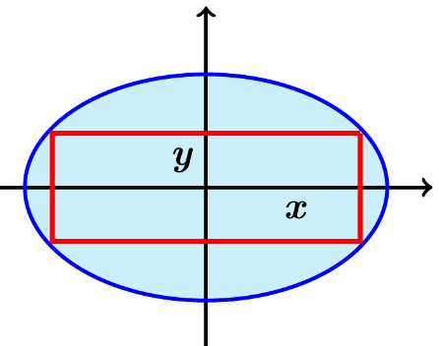Perimeter: 

 subject to 

 





 













Dimension of rectangle with greatest perimeter are 

***Exercise***

Use Lagrange multipliers to find the dimensions of the right circular cylinder of minimum surface area (including the circular ends) with a volume of 

***Solution***



Circular cylinder: Let *r*: radius *h*: height

Surface area: 

Volume: 

Suffices to Minimize  subject to 









 

















***Exercise***

Find the point(s) on the cone  that are closest to the point . Give an argument showing you have found an absolute minimum of the distance function.

***Solution***



Subject to 





























For 





















For 





















Therefore, there are 3 solutions to the Lagrange conditions:

 & 





























The closest point is 

***Exercise***

Let  be a fixed point in  and let  be the distance between  and a variable point .

1. Compute 
2. Show that  points in the direction from  to  and has magnitude 1 for all .
3. Describe the level surfaces of *d* and give the direction of  relative to the level surfaces of *d*.
4. Discuss 

***Solution***





1. 
2. 





 is a unit vector.

1. The level surfaces of *d* are spheres centered at *a, b, c* and  is  to these spheres, pointing outwards.
2. 

Because of  in the direction of a unit vector .

, but the limit must be the same in all directions.

***Exercise***

A shipping company requires that the sum of length plus girth of rectangular boxes must not exceed 108 *in*. Find the dimensions of the box with maximum volume that meets this condition. (the girth is the perimeter of the smallest base of the box).

***Solution***

Let *x, y*, and *z* represent the length, width, and height.

The girth is: 

Volume: 

We want to maximize the volume of the box satisfying: 



 



 

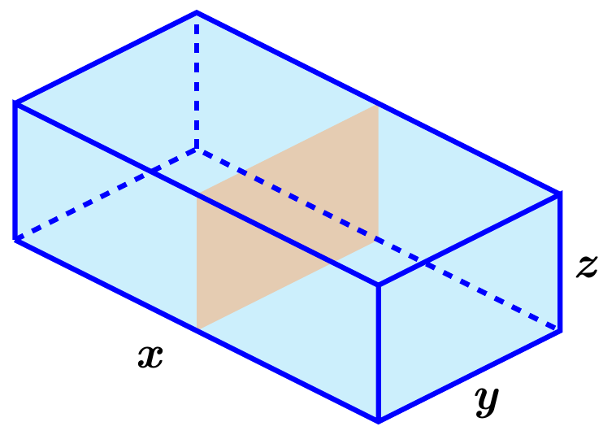





For 







For 



For 



For 



∴ The critical points are: 













The dimensions of the package are: ***x*** = 36 *in*., ***y*** = 18 *in*, ***z*** = 18 *in*.

The maximum volume is 

***Exercise***

Find the rectangular box with a volume of  that has minimum surface area.

***Solution***

Let *x, y*, and *z* represent the length, width, and height (positive values)

Volume: 

We want to minimum surface area: 



 



 

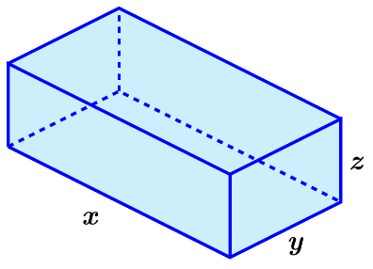

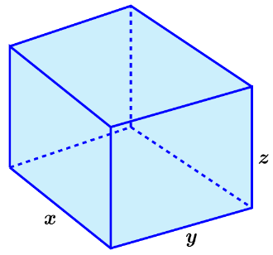



For 



The box is a cube shape box with length of 

***Exercise***

Find the minimum and maximum distances between the ellipse  and the origin.

***Solution***



 





 

























 ***Maximum*** value



 ***Minimum*** value

***Exercise***

Find the dimensions of the rectangle of maximum area with sides parallel to the coordinate axes that can be inscribed in the ellipse 

***Solution***

















For  (only positive since its length)











Maximum area of the rectangle is:





***Exercise***

Find the dimensions of the rectangle of maximum perimeter with sides parallel to the coordinate axes that can be inscribed in the ellipse 

***Solution***



















For 







Dimensions of the rectangle of maximum perimeter is: 

***Exercise***

Find the point on the plane 

***Solution***























The closest point is 







The distance is 1.

***Exercise***

Find the point on the surface 

***Solution***























The closest point is 

***Exercise***

Find the points on the cone 

***Solution***

















For 



For 







The closest point is 

***Exercise***

Find the minimum and maximum distances between the sphere



***Solution***





























For 



The points are: 





















∴ ***Minimum*** distance: 

∴ ***Maximum*** distance: 

***Exercise***

Find the maximum value of 

***Solution***





















 ***Maximum*** value

 ***Minimum*** value

***Exercise***

Find the maximum value of 

***Solution***























 ***Maximum*** value

***Exercise***

Find the maximum value of  for the given positive real numbers 

***Solution***



































The negative values of *x*’s will give us the minimum



 ***Maximum*** value

***Exercise***

The planes  and  intersect in a line *L*. Find the point on *L* nearest the origin.

***Solution***









 



















The point  is the pint on the line closet to the rogin.

***Exercise***

Find the maximum and minimum values of 

***Solution***







 









For 



For 



For 



∴ Points: 

For 





















***Using Maple***: evalf (solve (, *x* ))



|  |  |  |
| --- | --- | --- |
| ***x*** | ***y*** |  |
|  | .912 | 1.868 |
|  | −.912 | 3.692 |
| −.42 | 1.955 | −.535 |
|  | −1.955 | 3.375 |
| .912 | 1.78 | −1.692 |
|  | −1.78 | 1.868 |
| 1.955 | .42 | −1.375 |
|  | −.42 | −.535 |

|  |  |
| --- | --- |
|  |  |
|  |  |
|  |  |
|  | −3.032 |
|  | 5.99 |
|  | 0.439 |
|  | 2.77 |
|  | −2.747 |
|  | −3.032 |
|  | −1.129 |
|  | 0.439 |

***Minimum*** value of  @ 

***Maximum*** value of  @ 

***Exercise***

The paraboloid  and the plane  intersect in a curve *C*. Find the points on *C* that have minimum and maximum distance from the origin.

***Solution***









 















































***Using Maple***: Ploy1:= ;

fsolve(Poly1)

***Using Maple***: Ploy2:= ;

fsolve(Poly2)



The points on *C* are: 

Minimum distance from the origin: 

Maximum distance from the origin: 

***Exercise***

Find the maximum and minimum values of  on the curve on which the cone  and the plane  intersect.

***Solution***









 



For 



For 





Point: 

For 





Point: 

For 





 (impossible)

There are no solutions to the Lagrange conditions.

|  |  |
| --- | --- |
|  |  |
|  |  |
|  |  |

The maximum value of  is  @ 

The minimum value of  is  @ 

***Exercise***

The temperature of points on a elliptical plate  is given by . Find the hottest and coldest temperatures on the edge of the elliptical plate.

***Solution***







 











For 





Points: 

For 



Points: 

|  |  |
| --- | --- |
|  |  |
|  |  |
|  |  |
|  |  |
|  |  |

The hottest temperature on the edge of the plate is  @ 

The coldest temperature on the edge of the plate is  @ 