***Lecture Three* – Multiple Integrals**

***Section* 3.1 – Double Integrals over Rectangular Regions**

**Double Integrals**

Consider a function  defined on a rectangular region *R*,



A small rectangular piece of width  and height  has area .

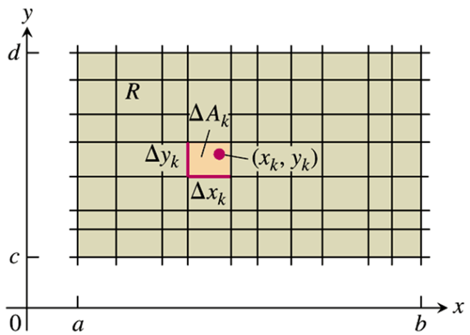

To form a Riemann sum over *R*, select a point  in the k*th* small rectangle, multiply the value of *f* at that point by the area  and add together the products:



As the rectangles get narrow and short, their number *n* increases, therefore



Then the function  is said to be integrable and the limit is called double integral of  over *R*,



**Double Integrals as Volumes**

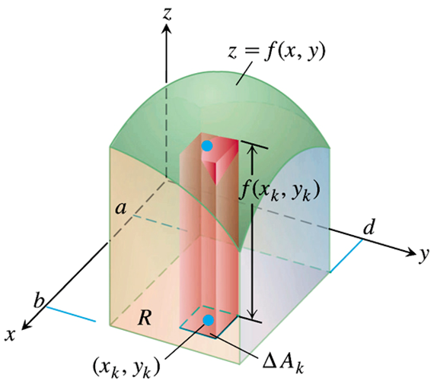

 

|  |  |  |
| --- | --- | --- |
|  |  |  |

As *n* increases, the ***Riemann*** ***sum*** approximations approach the total volume of the solid

***Example***

Calculate the volume under the plane  over the rectangular region  in the *xy*-plane.

***Solution***

















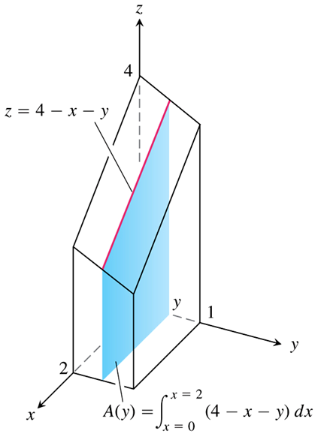 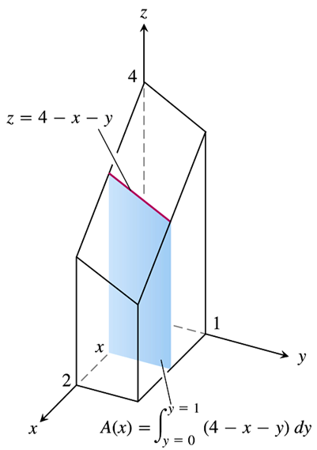



***Theorem* – Fubini’s Theorem**

If  is continuous throughout the rectangular region *R*: , then



***Example***

Calculate  for 

**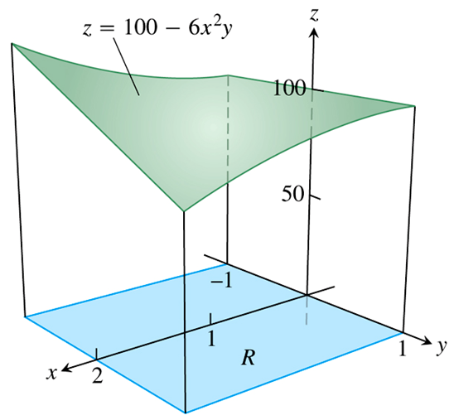*Solution***











***Example***

Evaluate 

***Solution***







***Example***

Find the volume of the region bounded above the elliptical paraboloid  and below the rectangle 

***Solution***

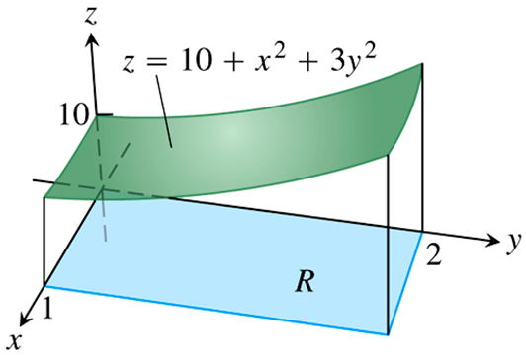











***Example***

Evaluate 

***Solution***























***Exercises*** ***Section* 3.1 – Double Integrals over Rectangular Regions**

(**1 – 18**) Evaluate the iterated integral

|  |  |
| --- | --- |
|  |  |

(**19 – 26**) Evaluate the double integral over the given region *R*.

1. 
2. 
3. 
4. 
5. 
6. ; *R* is the region bounded by , , , and 
7. ; *R* is the region 
8.  
9. Integrate  over the ***square*** 
10. Integrate  over the ***rectangle*** 
11. Find the volume of the region bounded above the paraboloid  and below by the square 
12. Find the volume of the region bounded above the plane  and below by the rectangle 
13. Find the volume of the region bounded above the surface  and below by the rectangle 
14. Find the volume of the region bounded above the ellipitical paraboloid  and below by the square 
15. Evaluateby converting it to a double integral.
16. Find the volume of the solid beneath the cylinder  and above the region 

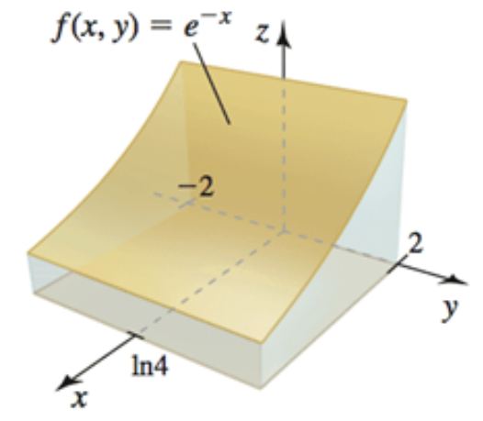

1. Find the volume of the solid beneath the plane  and above the region 

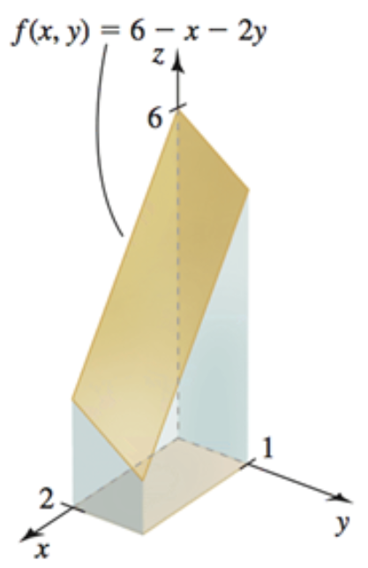

1. Find the volume of the solid beneath the plane  and above the region 

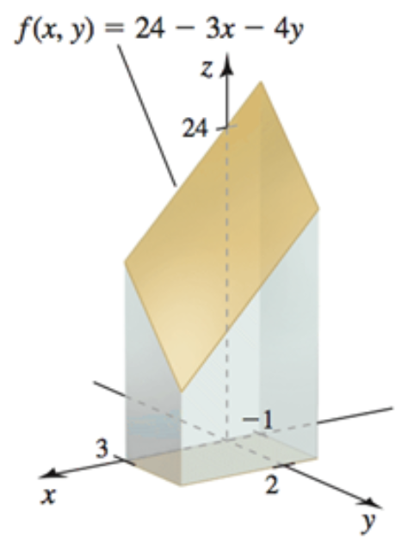

1. Find the volume of the solid beneath the paraboloid  and above the region 

