***Solution*** ***Section* 3.1 – Integrals over Rectangular Regions**

***Exercise***

Evaluate the iterated integral 

***Solution***











***Exercise***

Evaluate the iterated integral 

***Solution***











***Exercise***

Evaluate the iterated integral 

***Solution***















***Exercise***

Evaluate the integral 

***Solution***











***Exercise***

Evaluate the integral 

***Solution***

 



 

 





***Exercise***

Evaluate the integral 

***Solution***











***Exercise***

Evaluate the integral 

***Solution***











***Exercise***

Evaluate the double integral 

***Solution***











***Exercise***

Evaluate the double integral 

***Solution***

















***Exercise***

Evaluate the double integral 

***Solution***









***Exercise***

Evaluate the double integral 

***Solution***















***Exercise***

Evaluate the double integral 

***Solution***

 











***Exercise***

Evaluate the double integral 

***Solution***















***Exercise***

Evaluate the double integral 

***Solution***













***Exercise***

Evaluate the double integral 

***Solution***













***Exercise***

Evaluate the double integral 

***Solution***











***Exercise***

Evaluate the double integral 

***Solution***















***Exercise***

Evaluate the double integral 

***Solution***

















***Exercise***

Evaluate the double integral over the given region *R* 

***Solution***











***Exercise***

Evaluate the double integral over the given region *R* 

***Solution***













***Exercise***

Evaluate the double integral over the given region *R* 

***Solution***

|  |  |  |
| --- | --- | --- |
|  |  |  |
| **+** |  |  |
| **−** |  |  |













***Exercise***

Evaluate the double integral over the given region *R*. 

***Solution***









 





***Exercise***

Evaluate the double integral over the given region *R*. 

***Solution***

 



 







***Exercise***

Evaluate ; *R* is the region bounded by , , , and 

***Solution***

















***Exercise***

Evaluate ; *R* is the region 

***Solution***













***Exercise***

Evaluate  

***Solution***













***Exercise***

Integrate  over the ***square*** 

***Solution***













***Exercise***

Integrate  over the ***rectangle*** 

***Solution***











***Exercise***

Find the volume of the region bounded above the paraboloid  and below by the square 

***Solution***















***Exercise***

Find the volume of the region bounded above the plane  and below by the rectangle 

***Solution***











***Exercise***

Find the volume of the region bounded above the surface  and below by the rectangle 

***Solution***













***Exercise***

Find the volume of the region bounded above the ellipitical paraboloid  and below by the square 

***Solution***















***Exercise***

Evaluate  by converting it to a double integral.

***Solution***





















***Exercise***

Find the volume of the solid beneath the cylinder  and above the region 

***Solution***

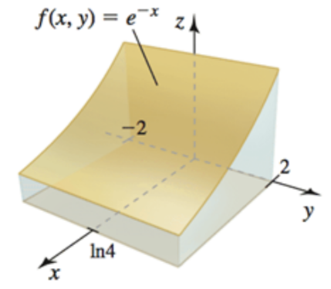









***Exercise***

Find the volume of the solid beneath the plane  and above the region 

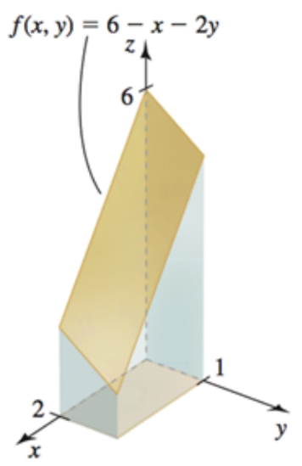***Solution***











***Exercise***

Find the volume of the solid beneath the plane  and above the region 

***Solution***

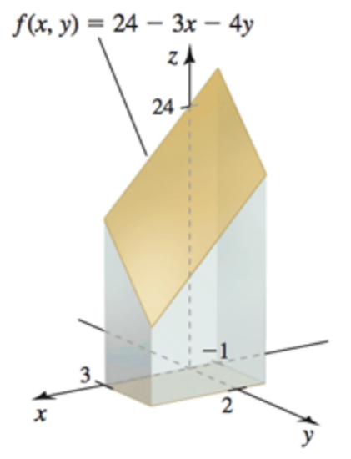













***Exercise***

Find the volume of the solid beneath the paraboloid  and above the region 

***Solution***





