***Section* 3.2 – Double Integrals over General Regions**

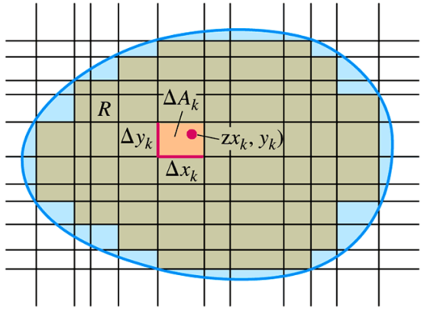

***Volumes***

If  is positive and continuous over *R*, we define the volume of the solid region between *R* and the surface  to be .

If *R* is a region in the *xy*-plane, bounded ***above*** and ***below*** by the curves  and  and on the sides by the lines . Calculate the cross-sectional area



Then integrate  from  to get the volume as an iterated integral



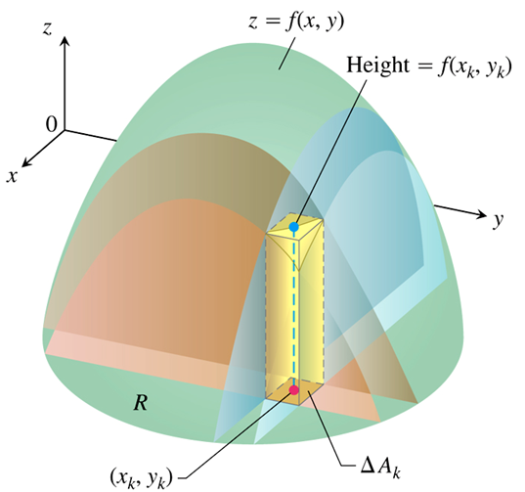 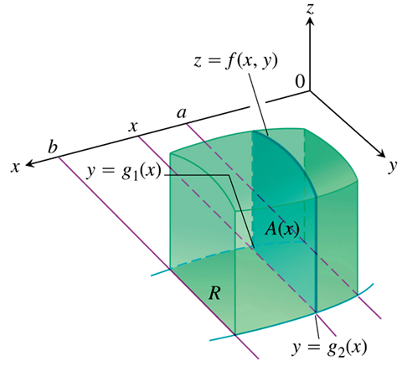

Similarly, if *R* is a region bounded by the curves  and  and the lines , then the volume calculated by slicing is given by the iterated integral .



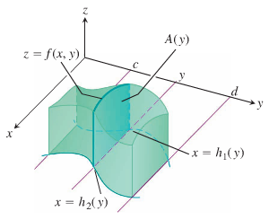





***Theorem* – Fubini’s Theorem**

Let  is continuous on a region *R*,

1. If *R* is defined by : , with and continuous on [*a, b*], then



1. If *R* is defined by : , with and continuous on [*c, d*], then



***Example***

Find the volume of the prism whose base is the triangle in the *xy*-plane bounded by the *x*-axis and the lines  and  and whose top lies in the plane 

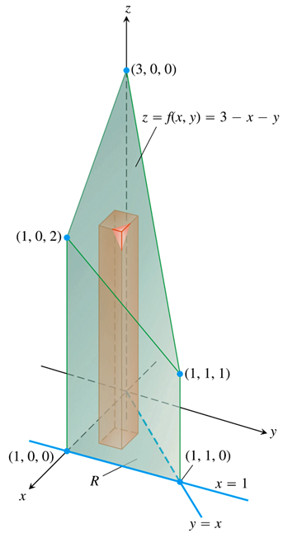***Solution***



















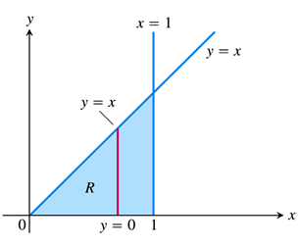 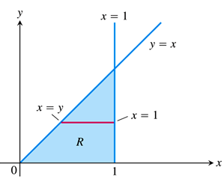

***Example***

Calculate  where *R* is the triangle in the xy-plane bounded by the *x*-axis, the line , and the line .

**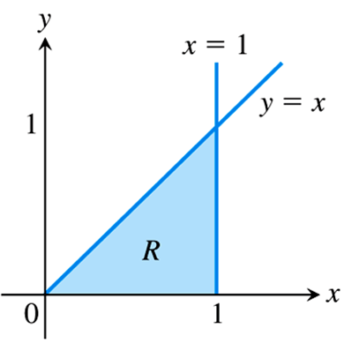*Solution***











, we run into a problem because  cannot be expressed in terms of elementary functions.

***Finding Limits on Intergration***

***Using Vertical Cross-sections***

1. Sketch the region of Integration and label the bounding curves

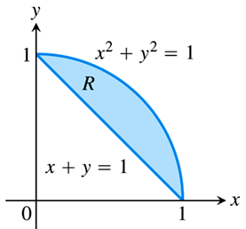

1. *Find the y-limits of integration*. Imagine a vertical line *L* cutting through *R* in the direction of increasing *y*. Mark the *y*-values where *L* enters and leaves. These are the *y*-limits of integration and are usually functions of *x* (instead of constants).

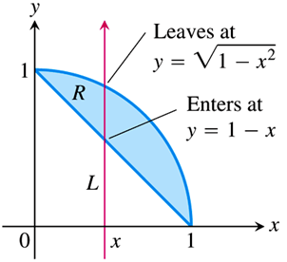

1. *Find the x-limits of integration*. Choose *x*-limits that include all the vertical lines through *R*. The integral is



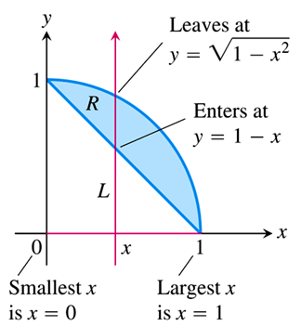

***Using Horizontal Cross-sections***

To evaluate the same double integral as an iterated integral with the order of integration reversed, use horizontal lines instead of vertical lines.



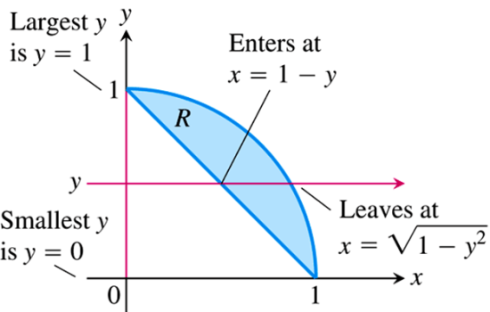

***Example***

Sketch the region of integration for the integral  and write an equivalent integral with the order of integration reversed.

***Solution***

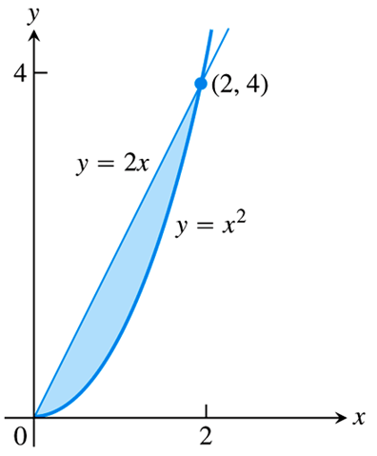 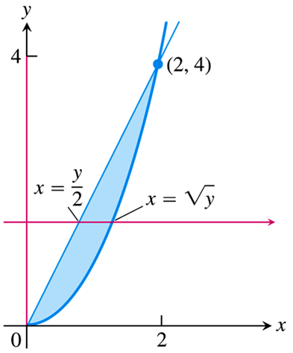

The given inequalities are: 

 

The integral is 

* If  and  are continuous on the bounded region *R*, then the following properties hold

1. *Constant Multiple*: 
2. *Sum and Difference*: 
3. *Domination*:
4. 
5. 
6. *Additivity*: 

If *R* is the union of two non-overlapping regions and .

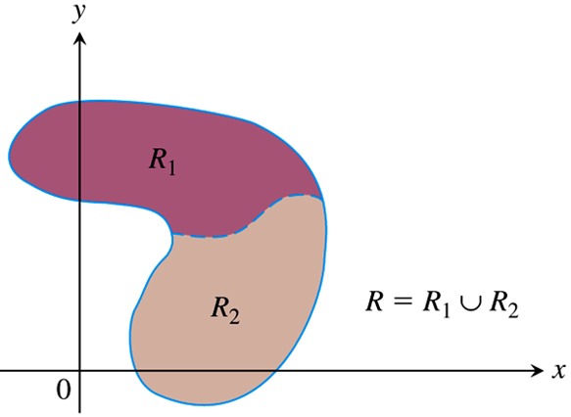 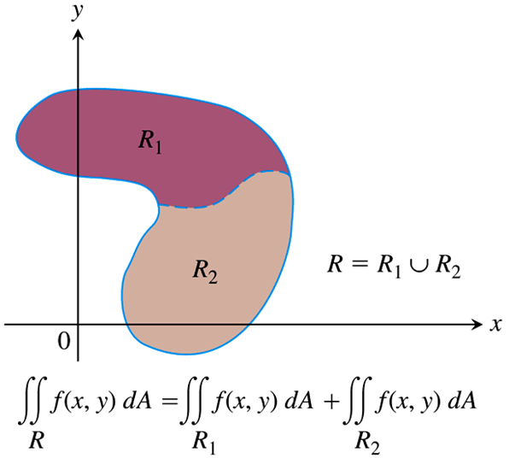

***Example***

Find the volume of the wedge like solid that lies beneath the surface  and above the region *R* bounded by the curve , the line , and the *x*-axis.

***Solution***

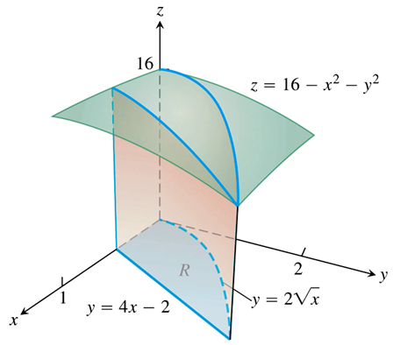 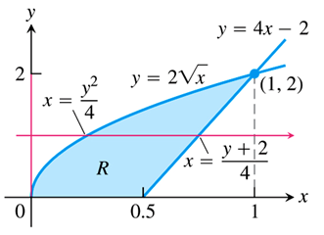























 

***Definition***

The area of a closed, bounded plane region *R* is 

***Example***

Find the area of the region *R* bounded by  and  in the first quadrant.

***Solution***



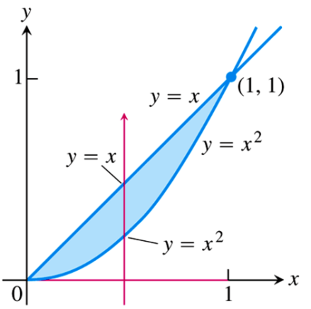











***Example***

Find the area of the region *R* enclosed by the parabola  and the line .

***Solution***

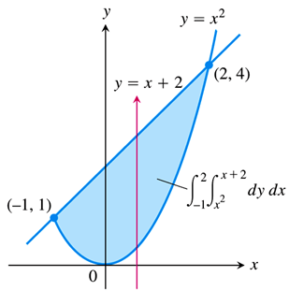 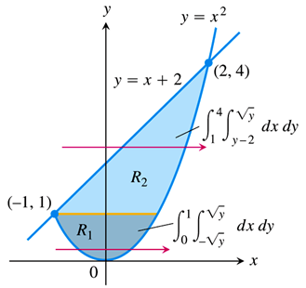



















***Example***

Find the area of the region *R* between  and .

***Solution***

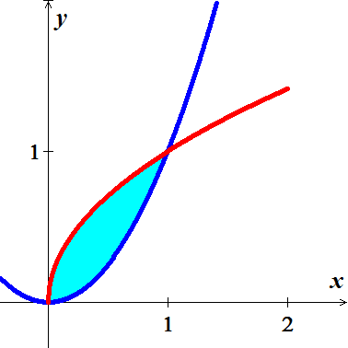





















**Average values of  over *R*** 

* Average value of  over *R* 

***Example***

Find the average value of  over the rectangle .

***Solution***

 











***Exercises*** ***Section* 3.2 – Double Integrals over General Regions**

(**1 − 4**) Sketch the region of integration and evaluate the integral

|  |  |
| --- | --- |
|  |  |

1. Integrate  over the region in the first quadrant bounded by the lines 
2. Integrate  over the triangular region with vertices 
3. Integrate  over the region in the first quadrant of the *st*-plane that lies above the curve  from  to .
4. Evaluate
5. Evaluate 

(**10 − 13**) Sketch the region of integration, reverse the order of integration, and evaluate the integral

|  |  |
| --- | --- |
|  |  |

1. Find the volume of the region bounded above the paraboloid  and below by the triangle enclosed by the lines , , and  in the *xy*-plane
2. Find the volume of the solid that is bounded above the cylinder  and below by the region enclosed by the parabola  and the line  in the *xy*-plane
3. Find the volume of the solid in the first octant bounded by the coordinate planes, the cylinder  and the plane 
4. Find the volume of the solid that is bounded on the front and back by the planes , and , on the sides by the cylinders  and above and below the planes  and .
5. Find the volume under the parabolic cylinder  above the region enclosed by the parabola  and the line  in the *xy*-plane
6. Find the area of the region enclosed by the line  and the parabola  in the *xy*-plane.
7. Find the area of the region enclosed by the coordinate axes and the line .
8. Find the area of the region enclosed by the lines , , and 
9. Find the area of the region enclosed by the parabola  and the line .
10. Find the area of the region enclosed by the curve  and the lines ,  and 
11. Find the area of the region enclosed by the curve  and  and the lines  in the first quadrant.
12. Find the area of the region enclosed by the lines , , and 
13. Find the area of the region enclosed by the lines  and  and the curve 
14. Find the area of the region enclosed by the parabolas  and 
15. Find the area of the region bounded by the lines , , and  . Make a sketch of the region.
16. Find the area of the region bounded by the lines  and  . Make a sketch of the region.
17. Find the area of the region bounded by the lines  and  . Make a sketch of the region.

(**31 − 34**) Find the area of the region

|  |  |
| --- | --- |
|  |  |

1. Find the average height of the paraboloid  over the square 
2. Find the average height of  over the square 

(**37 − 40**) Evaluate the integral over the given region

1. 
2. 
3. 
4. 
5. Consider the region 

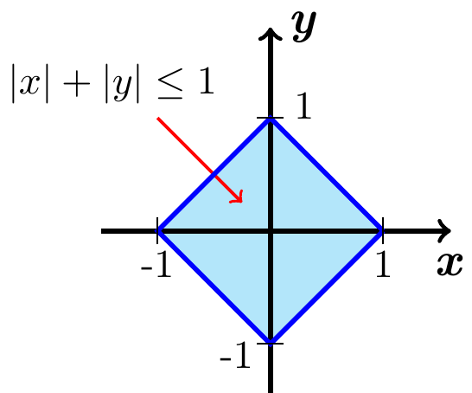

1. Use a double integral to show that the area of *R* is 2.
2. Find the volume of the square column whose base is *R* and whose upper surface is .
3. Find the volume of the solid above *R* and beneath the cylinder .
4. Find the volume of the pyramid whose base is *R* and whose vertex is on the *z-*axis at 