***Solution*** ***Section* 3.2 – Double Integrals over General Regions**

***Exercise***

Sketch the region of integration and evaluate the integral 

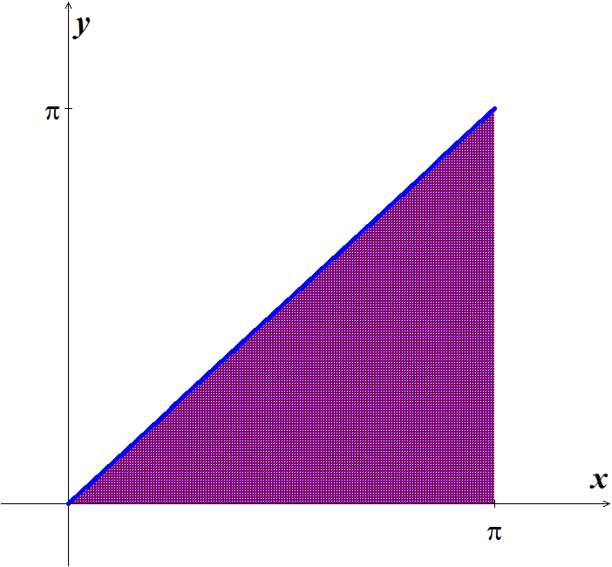***Solution***









|  |  |  |
| --- | --- | --- |
|  |  |  |
| **+** |  |  |
| **−** |  |  |



***Exercise***

Sketch the region of integration and evaluate the integral 

***Solution***

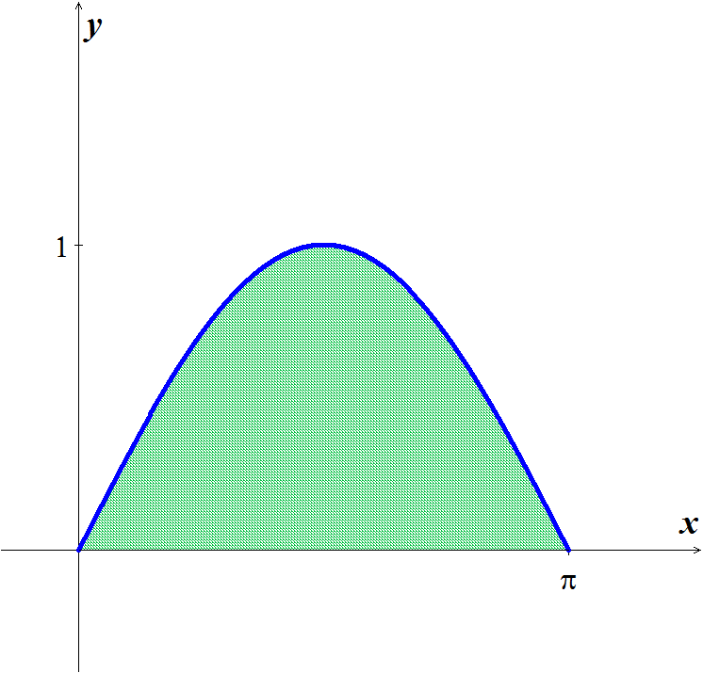









***Exercise***

Sketch the region of integration and evaluate the integral 

***Solution***





|  |  |  |
| --- | --- | --- |
|  |  |  |
| **+** |  |  |
| **−** |  |  |











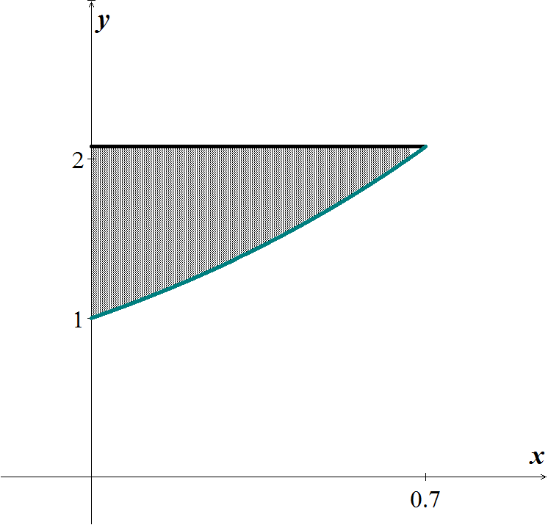





***Exercise***

Sketch the region of integration and evaluate the integral 

***Solution***



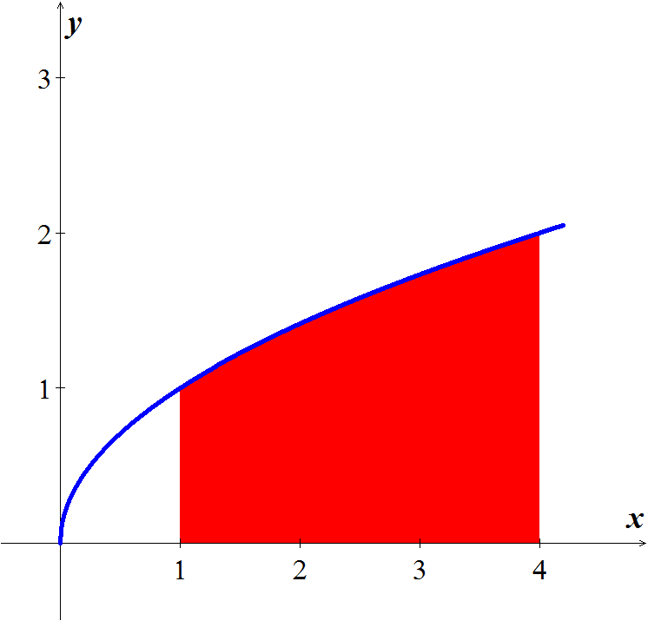 











***Exercise***

Integrate  over the region in the first quadrant bounded by the lines 

***Solution***





 ***Quotient Rule***: 









***Exercise***

Integrate  over the triangular region with vertices 

***Solution***













***Exercise***

Integrate  over the region in the first quadrant of the *st*-plane that lies above the curve  from  to .

***Solution***















***Exercise***

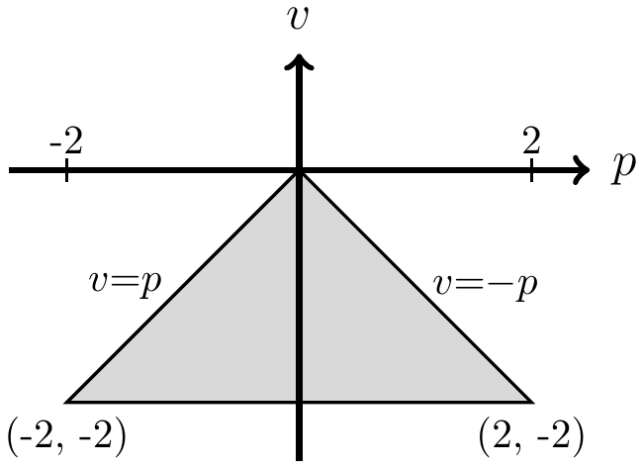Evaluate 

***Solution***









***Exercise***

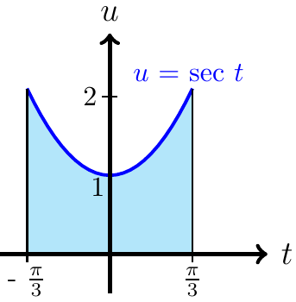Evaluate 

***Solution***



 









***Exercise***

Sketch the region of integration, reverse the order of integration, and evaluate the integral



***Solution***

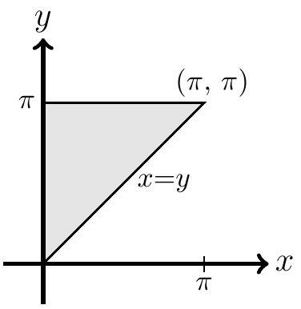













***Exercise***

Sketch the region of integration, reverse the order of integration, and evaluate the integral

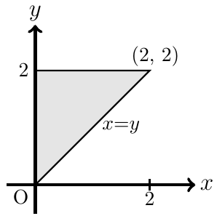

***Solution***





 







***Exercise***

Sketch the region of integration, reverse the order of integration, and evaluate the integral



***Solution***







 









***Exercise***

Sketch the region of integration, reverse the order of integration, and evaluate the integral



***Solution***















***Exercise***

Find the volume of the region bounded above the paraboloid  and below by the triangle enclosed by the lines , , and  in the *xy*-plane

***Solution***

 















***Exercise***

Find the volume of the solid that is bounded above the cylinder  and below by the region enclosed by the parabola  and the line  in the *xy*-plane

***Solution***















***Exercise***

Find the volume of the solid in the first octant bounded by the coordinate planes, the cylinder  and the plane 

***Solution***





 







***Exercise***

Find the volume of the solid that is bounded on the front and back by the planes , and , on the sides by the cylinders  and above and below the planes  and .

***Solution***















***Exercise***

Find the volume under the parabolic cylinder  above the region enclosed by the parabola  and the line  in the *xy*-plane

***Solution***





















***Exercise***

Find the area of the region enclosed by the line  and the parabola  in the *xy*-plane.

***Solution***







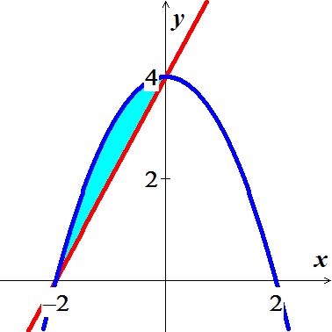 











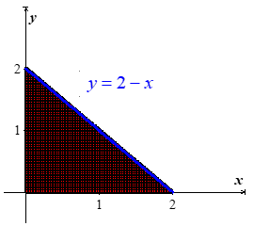***Exercise***

Find the area of the region enclosed by the coordinate axes and the line .

***Solution***











***Exercise***

Find the area of the region enclosed by the lines , , and 

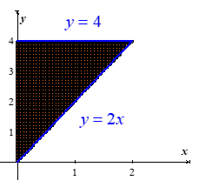***Solution***









***Exercise***

Find the area of the region enclosed by the parabola  and the line .

***Solution***

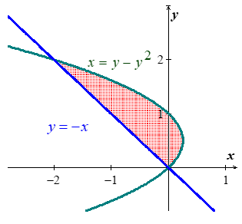

















***Exercise***

Find the area of the region enclosed by the curve  and the lines

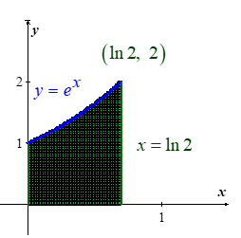 ,  and .

***Solution***











***Exercise***

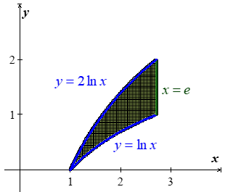Find the area of the region enclosed by the curve  and  and the lines  in the first quadrant.

***Solution***











***Exercise***

Find the area of the region enclosed by the lines , , and 

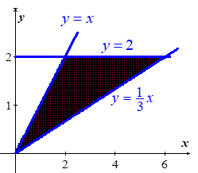***Solution***









***Exercise***

Find the area of the region enclosed by the lines  and  and the curve 

***Solution***

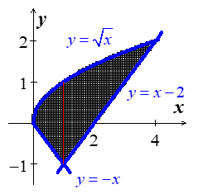











***Exercise***

Find the area of the region enclosed by the parabolas  and 

***Solution***

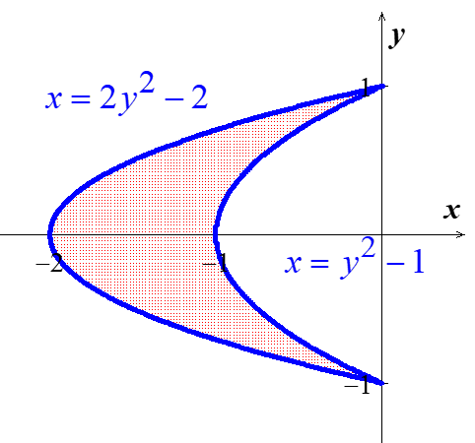













***Exercise***

Find the area of the region bounded by the lines , , and  . Make a sketch of the region.

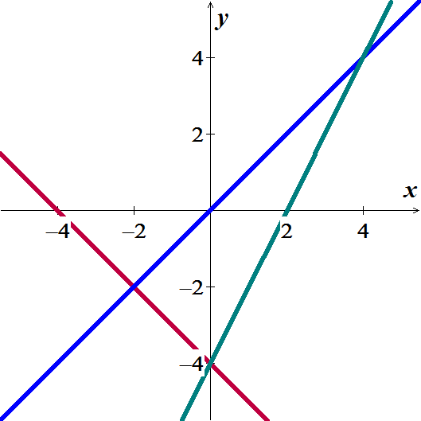***Solution***































***Exercise***

Find the area of the region bounded by the lines  and  . Make a sketch of the region.

***Solution***





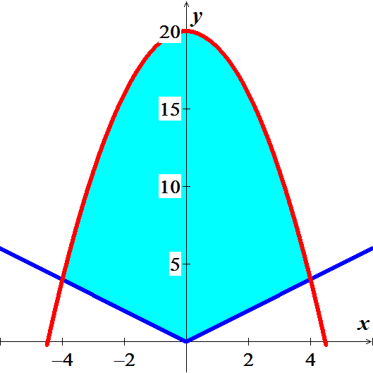











***Exercise***

Find the area of the region bounded by the lines  and  . Make a sketch of the region.

***Solution***





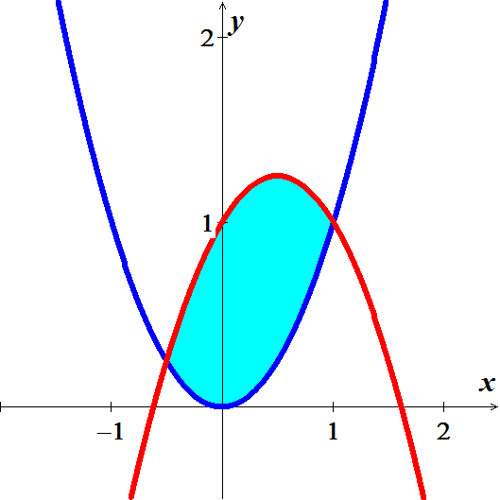













***Exercise***

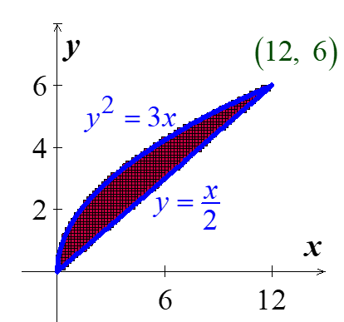Find the area of the region 

***Solution***











***Exercise***

Find the area of the region 

***Solution***

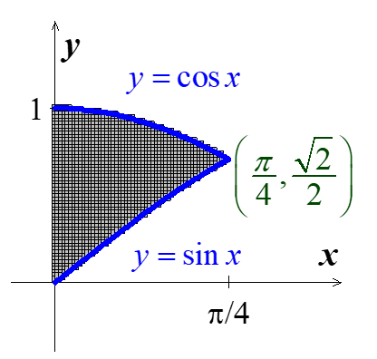









***Exercise***

Find the area of the region 

***Solution***









***Exercise***

Find the area of the region 

***Solution***



 







***Exercise***

Find the average height of the paraboloid  over the square 

***Solution***

*Average height* 













***Exercise***

Find the average height of  over the square 

***Solution***

Average height 













***Exercise***

Evaluate the integral over the given region



***Solution***











***Exercise***

Evaluate the integral over the given region



***Solution***























***Exercise***

Evaluate the integral over the given region



***Solution***



 



















***Exercise***

Evaluate the integral over the given region



***Solution***

















***Exercise***

Consider the region 

1. Use a double integral to show that the area of *R* is 2.
2. Find the volume of the square column whose base is *R* and whose upper surface is .
3. Find the volume of the solid above *R* and beneath the cylinder .
4. Find the volume of the pyramid whose base is *R* and whose vertex is on the *z-*axis at 

***Solution***



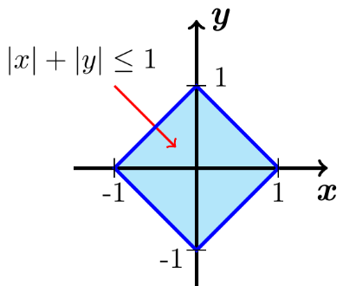

1. 











1. 













1. 

 *due to the symmetry*















1. 



Using symmetry











