***Section* 3.3 – Double Integrals in Polar Coordinates**

**Integrals in Polar Coordinates**

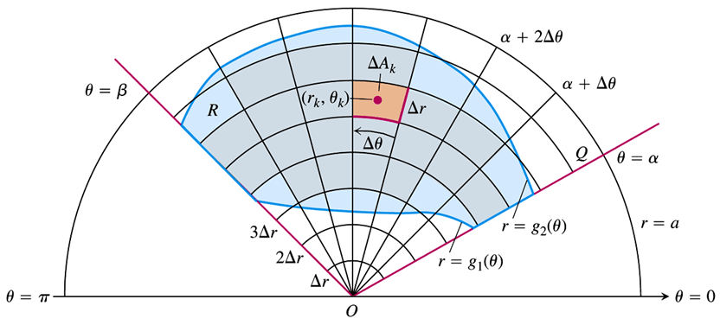



If *f* is continuous throughout *R*, this sum will approach a limit as and  go to zero. The limit is called the double integral of *f* over *R*.



However, the area of a wedge-shaped sector of a circle having radius *r* and angle *θ* is



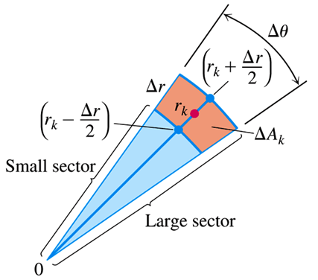

*Inner radius*: 

*outer radius*: 



Leads to the formula: 

***Example***

Find the limits of integration for integrating  over the region *R* that lies inside the cardioid  and outside the circle .

***Solution***

The sketch of the region:

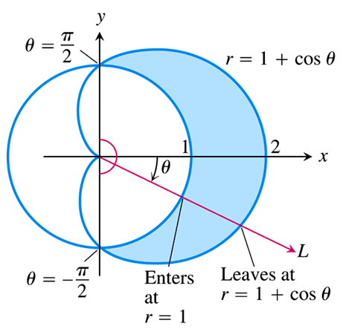

From the graph, we can find the *r - limits of integration*. A typical ray from the origin enters *R* where  and leaves where 

*θ - limits of integration*: The rays from the origin that intersects *R* run from  to . The integral is



***Area in Polar Coordinates***

The area of a closed and bounded region *R* in the polar coordinate plane is



***Example***

Find the area enclosed by the lemniscate 

***Solution***

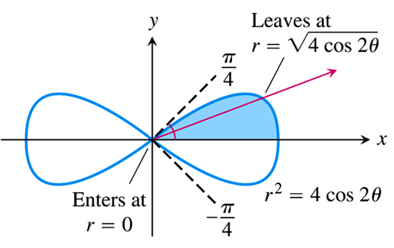

From the graph, we can determine the lemniscate limits of integration, and the total area is 4 times the first-quadrant portion, since it has a form of symmetry.















**Changing Cartesian Integrals into Polar Integrals**



***Example***

Evaluate 

Where *R* is the semicircular region bounded by the *x*-axis and the curve 

***Solution***

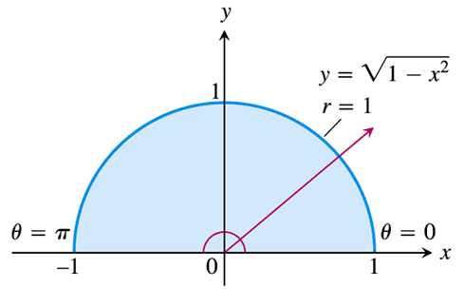

 









***Example***

Evaluate the integral 

***Solution***



Since: 

Let: 









* Or we can use the integral table to solve it



***Example***

Find the volume of the solid region bounded above by the paraboloid  and below by the unit circle in the *xy*-plane.

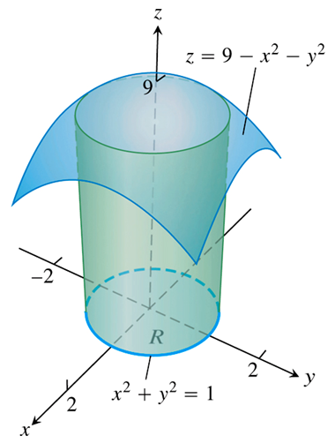***Solution***

The region of integration *R* is the unit circle:













***Example***

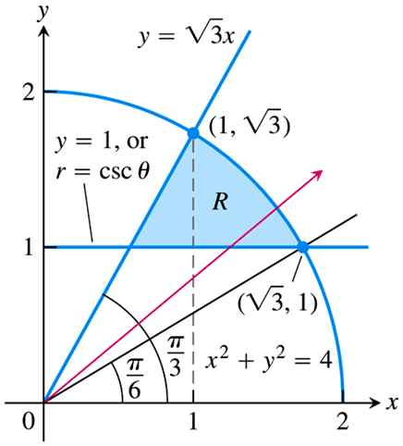Using the polar integration, find the area of the region *R* in the *xy*-plane enclosed by the circle , above the line , and below the line .

***Solution***

The  has a slope of 

Line  intersects 

when .

A line from origin to  has a slope of



∴ 

The polar coordinate *r* varies from the horizontal line  to the circle .

Substituting  for *y*:





The radius of the circle is 2.

∴ 

















***Example***

Evaluate the double integral: 

In the first quadrant and bounded by the circle  and the coordinate axes.

***Solution***





In *Q*I: 











***Exercises Section* 3.3 – Double Integrals in Polar Coordinates**

(**1 − 16**) Change the Cartesian integral into an equivalent polar integral. Then integrate the polar integral

|  |  |
| --- | --- |
|  |  |

1. Find the area of the region cut from the first quadrant by the curve 
2. Find the area of the region lies inside the cardioid  and outside the circle 
3. Find the area enclosed by one leaf of the rose 
4. Find the area of the region common to the interiors of the cardioids  and 
5. Find the area of the region bounded by all leaves of the rose 
6. Find the area of the region inside both the circles  and 
7. Find the area of the region that lies inside both the cardioids  and 
8. Find the area of the annular region 
9. Find the area of the region bounded by the cardioid 
10. Find the area of the region bounded by all leaves of the rose 
11. Find the area of the region inside both the cardioid  and the circle 
12. Find the area of the region inside both the cardioid  and the cardioid 
13. Find the area of the region bounded by the spiral , for , and the *x-*axis.
14. Find the area of the region inside the limaçon 
15. Find the area of the region bounded by 
16. Find the area of the region bounded by 
17. Find the area of the region outside the circle  and inside the rose  in *Q*I
18. Find the area of the region outside the circle  and inside the circle 
19. Integrate  over the region 
20. The region enclosed by the lemniscates  is the base of a solid right cylinder whose top is bounded by the sphere . Find the cylinder’s volume.

1. Evaluate ; *R* is the disk bounded by circle 
2. Find the volume of the solid bounded above by the paraboloid  and below by the plane 
3. Find the volume of the solid bounded above by the paraboloid  and below by the hyperbolic paraboloid 

(**40 − 51**) Evaluate the integral over *R* using polar coordinates

1. 
2. 
3. 
4. 
5. 
6. 
7. 
8. 
9. 
10. 
11. 
12. 
13. Which bowl holds more water if it is filled to a depth of four units?
14. The paraboloid , for 
15. The cone , for 
16. The hyperboloid , for 
17. To what weight (above the bottom of the bowl) must the cone and paraboloid bowls be filled to hold the same volume of water as the hyperboloid bowl filled to a depth of 4 units 
18. Consider the surface 
19. Find the region in the *xy*-plane in polar coordinates for which .
20. Let , which is a sector of a circle of radius a. Find the volume of the region below the hyperbolic paraboloid and above the region *R*.
21. A cake is shaped like a hemisphere of radius 4 with its base on the *xy*-plane. A wedge of the cake is removed by making two slices from the center of the cake outward, perpendicular to the *xy*-plane and separated by an angle of *φ*.
22. Use a double integral to find the volume of the slice for .
23. Suppose the cake is sliced by a plane perpendicular to the *xy*-plane at . Let *D* be the smaller of the two pieces produced. For what value of *a* is the volume of *D* equal to the volume in part (*a*)?
24. Suppose the density of a thin plate represented by the region *R* is  (in units of mass per area). The mass of the plate is . Find the mass of the thin half annulus

 with a density 

1. An important integral in statistics associated with the normal distribution is . It is evaluated in the following steps.
2. Assume that 

Where we have chosen the variables of integration to be *x* and *y* and then written the product as an iterated integral. Evaluate this integral in polar coordinates and show that . Why is the solution  rejected?

1. Evaluate , , and .
2. For what values of *p* does the integral  exist in the following cases?
3. 
4. 
5. Consider the integral  where 
6. Evaluate *I* for .
7. Evaluate *I* for arbitrary .
8. Let  in part (b) to find *I* over the infinite strip 
9. In polar coordinates an equation of an ellipse with eccentricity  and semimajor axis *a* is



1. Write the integral that gives the area of the ellipse.
2. Show that the area of an ellipse is , where 

(**60 − 63**) Find the volume of the solid below the paraboloid  and above

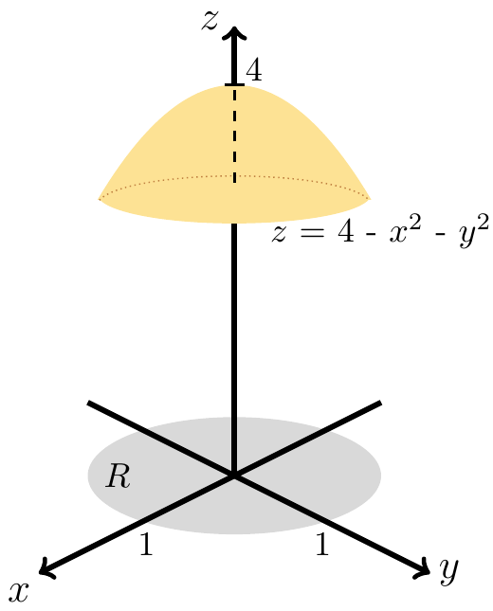

1. 
2. 
3. 
4. 

(**64 − 67**) Find the volume of the solid below the hyperboloid  and above

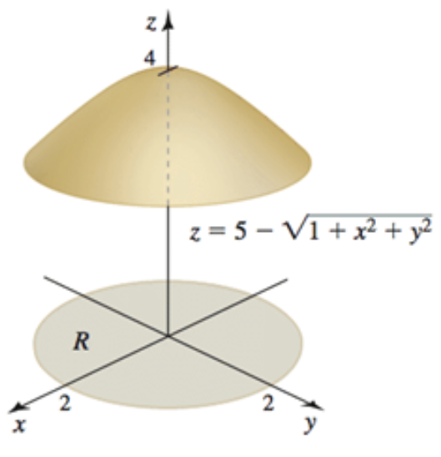

1. 
2. 
3. 
4. 
5. Find the volume of the solid between the paraboloids  and 

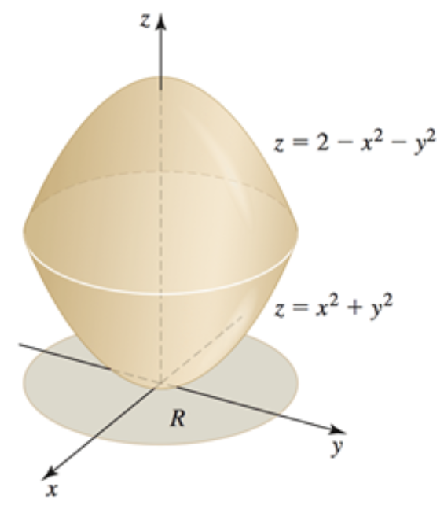

1. Find the volume of the solid between the paraboloids  and 

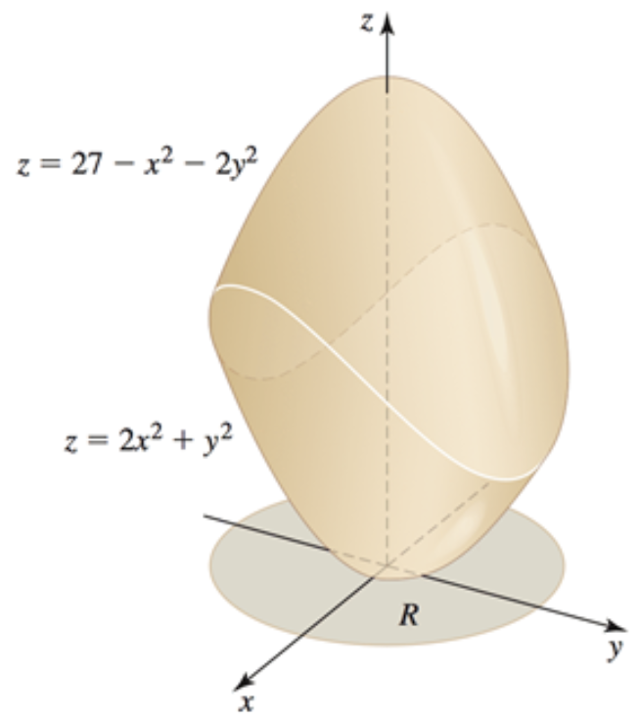

1. Find the volume of island 

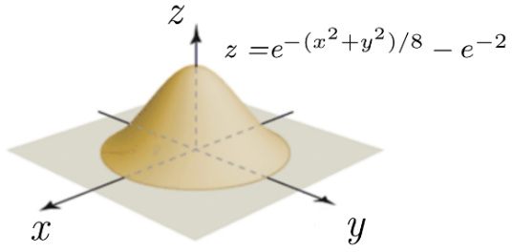

1. Find the volume of island 

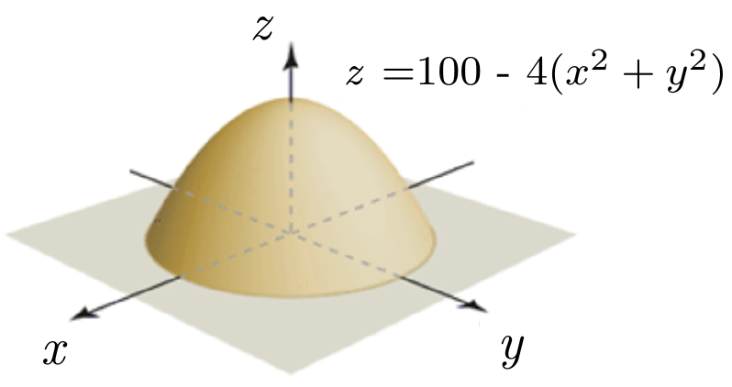

1. Find the volume of island 

