***Solution Section* 3.3 – Double Integrals in Polar Coordinates**

***Exercise***

Change the Cartesian integral into an equivalent polar integral. Then integrate the polar integral



***Solution***











***Exercise***

Change the Cartesian integral into an equivalent polar integral. Then integrate the polar integral



***Solution***







***Exercise***

Change the Cartesian integral into an equivalent polar integral. Then integrate the polar integral

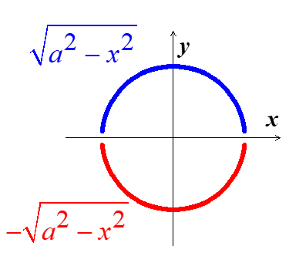 

***Solution***







***Exercise***

Change the Cartesian integral into an equivalent polar integral. Then integrate the polar integral



***Solution***











 









***Exercise***

Change the Cartesian integral into an equivalent polar integral. Then integrate the polar integral



***Solution***









***Exercise***

Change the Cartesian integral into an equivalent polar integral. Then integrate the polar integral



***Solution***

|  |  |  |
| --- | --- | --- |
|  |  |  |
| **+** |  |  |
| **−** |  |  |









***Exercise***

Change the Cartesian integral into an equivalent polar integral. Then integrate the polar integral



***Solution***



 







***Exercise***

Change the Cartesian integral into an equivalent polar integral. Then integrate the polar integral

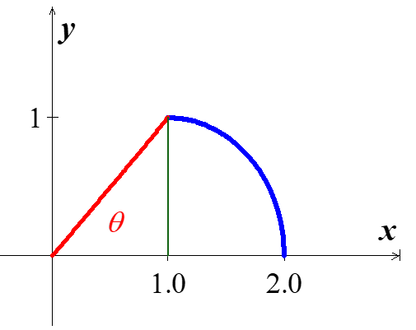

***Solution***

















 









***Exercise***

Evaluate the integral by changing to polar coordinates 

***Solution***











***Exercise***

Evaluate the integral by changing to polar coordinates 

***Solution***







 











***Exercise***

Evaluate the integral 

***Solution***

 



 



***Exercise***

Evaluate the integral 

***Solution***









***Exercise***

Evaluate the integral 

***Solution***









***Exercise***

Evaluate the integral 

***Solution***











***Exercise***

Evaluate the integral 

***Solution***















***Exercise***

Evaluate the integral 

***Solution***





 



***Exercise***

Find the area of the region cut from the first quadrant by the curve 

***Solution***











***Exercise***

Find the area of the region lies inside the cardioid  and outside the circle 

***Solution***



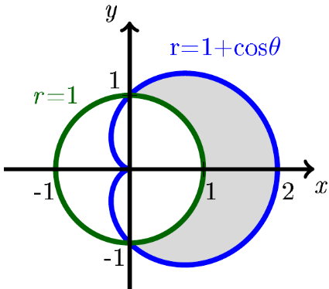 





 





***Exercise***

Find the area enclosed by one leaf of the rose 

***Solution***





 







***Exercise***

Find the area of the region common to the interiors of the cardioids  and 

***Solution***







 







***Exercise***

Find the area of the region bounded by all leaves of the rose 

***Solution***

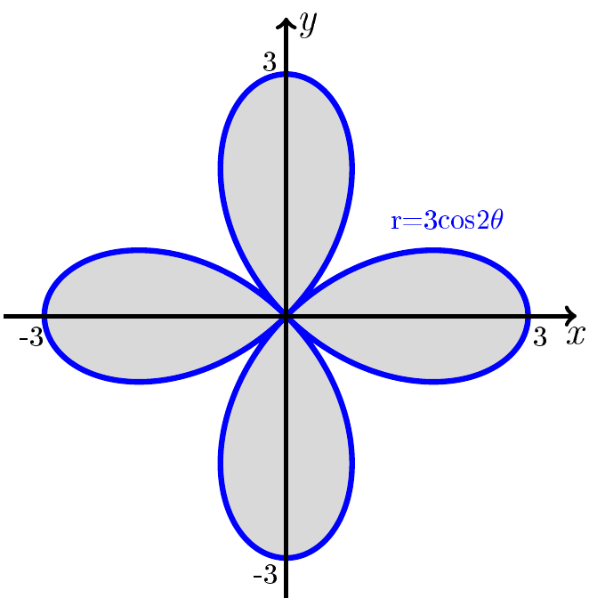













***Exercise***

Find the area of the region inside both the circles  and 

***Solution***



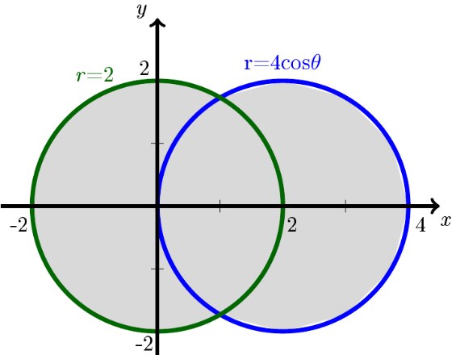

















***Exercise***

Find the area of the region that lies inside both the cardioids  and 

***Solution***



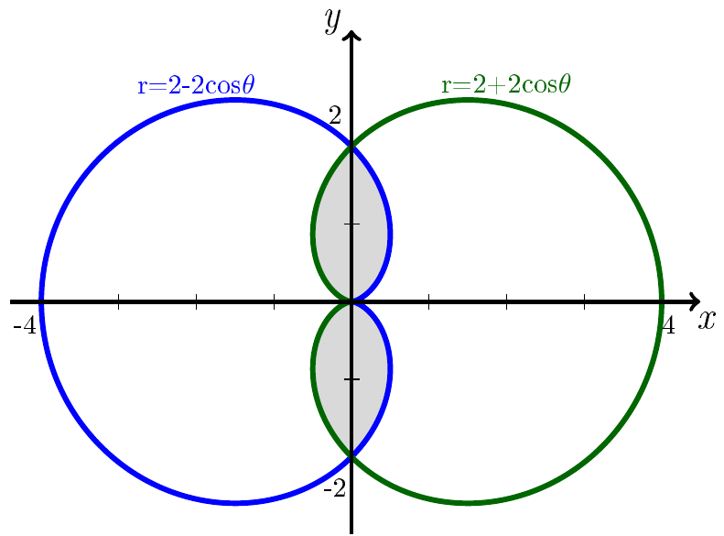 













***Exercise***

Find the area of the annular region 

***Solution***







***Exercise***

Find the area of the region bounded by the cardioid 

***Solution***

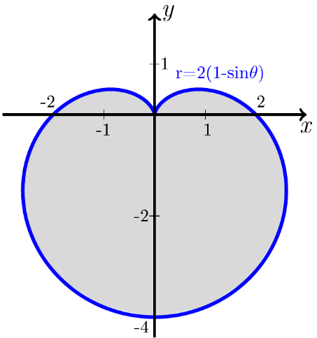













***Exercise***

Find the area of the region bounded by all leaves of the rose 

***Solution***







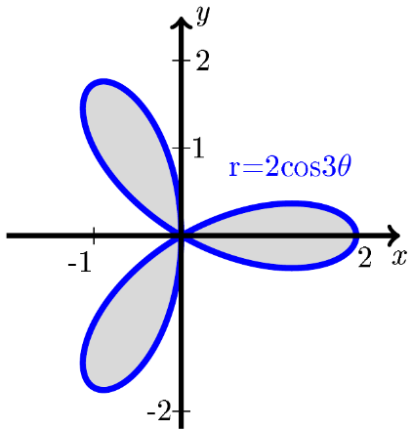 











***Exercise***

Find the area of the region inside both the cardioid  and the circle 

***Solution***



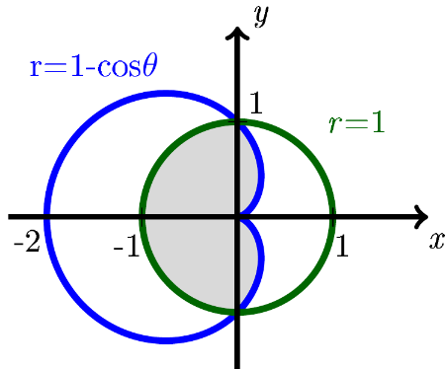

















***Exercise***

Find the area of the region inside both the cardioid  and the cardioid 

***Solution***

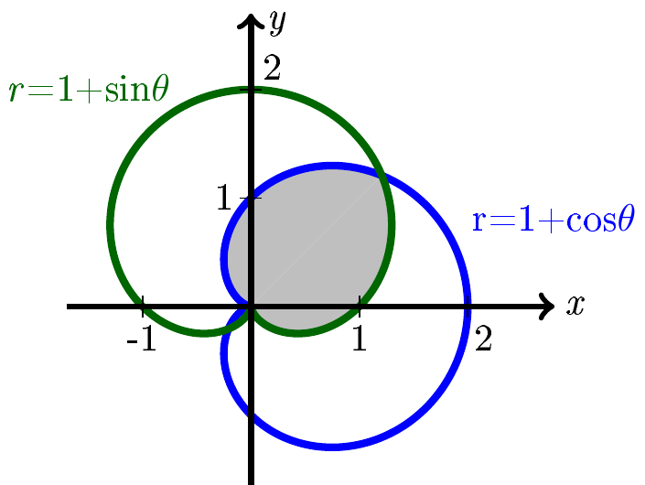

, and due to the symmetry;

















***Exercise***

Find the area of the region bounded by the spiral , for , and the *x-*axis.

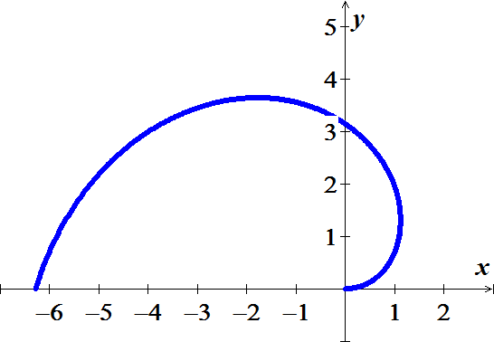***Solution***











***Exercise***

Find the area of the region inside the limaçon 

***Solution***

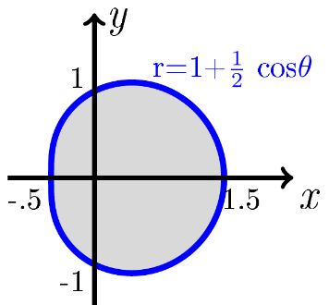













***Exercise***

Find the area of the region bounded by  in *Q*I.

***Solution***

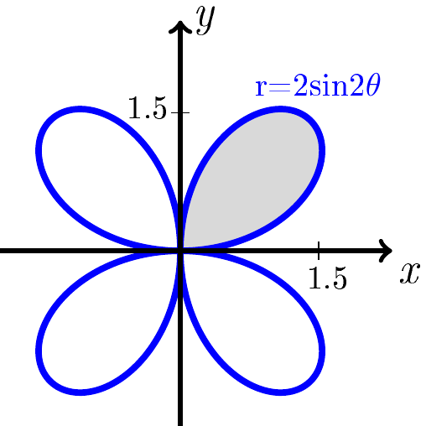













***Exercise***

Find the area of the region bounded by  in *Q*I.

***Solution***



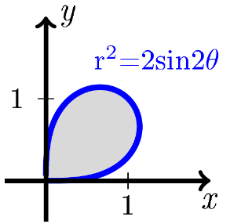











***Exercise***

Find the area of the region outside the circle  and inside the rose  in *Q*I.

***Solution***



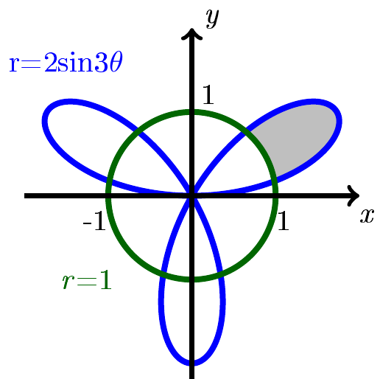















***Exercise***

Find the area of the region outside the circle  and inside the circle 

***Solution***

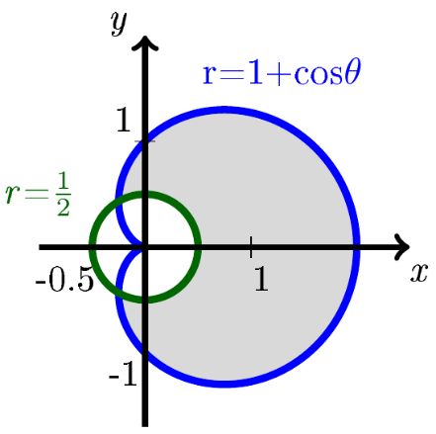













***Exercise***

Integrate  over the region 

***Solution***













***Exercise***

The region enclosed by the lemniscates  is the base of a solid right cylinder whose top is bounded by the sphere . Find the cylinder’s volume.

***Solution***

 





























***Exercise***

Evaluate ; *R* is the disk bounded by circle 

***Solution***

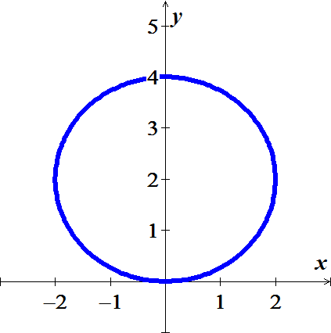



















***Exercise***

Find the volume of the solid bounded above by the paraboloid  and below by the plane 

***Solution***

















***Exercise***

Find the volume of the solid bounded above by the paraboloid  and below by the hyperbolic paraboloid 

***Solution***



















***Exercise***

Evaluate the integral over *R* using polar coordinates



***Solution***









***Exercise***

Evaluate the integral over *R* using polar coordinates



***Solution***











***Exercise***

Evaluate the integral over *R* using polar coordinates



***Solution***















***Exercise***

Evaluate the integral over *R* using polar coordinates



***Solution***











***Exercise***

Evaluate the integral over *R* using polar coordinates



***Solution***















***Exercise***

Evaluate the integral over *R* using polar coordinates



***Solution***



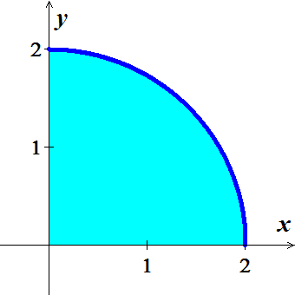











***Exercise***

Evaluate the integral over *R* using polar coordinates



***Solution***











***Exercise***

Evaluate the integral over *R* using polar coordinates



***Solution***

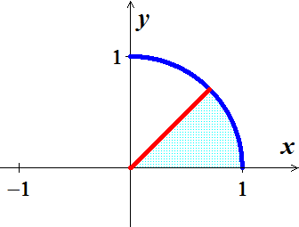













***Exercise***

Evaluate the integral over *R* using polar coordinates

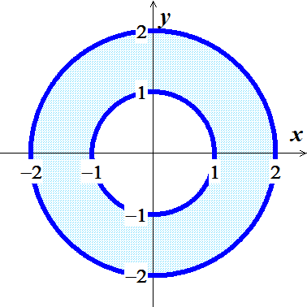 

***Solution***









***Exercise***

Evaluate the integral over *R* using polar coordinates



***Solution***











***Exercise***

Evaluate the integral over *R* using polar coordinates



***Solution***











***Exercise***

Evaluate the integral over *R* using polar coordinates



***Solution***











***Exercise***

Find the volume of a bowl holds water if it is filled to a depth of four units?

1. The paraboloid , for 
2. The cone , for 
3. The hyperboloid , for 
4. Which bowl holds more water?
5. To what weight (above the bottom of the bowl) must the cone and paraboloid bowls be filled to hold the same volume of water as the hyperboloid bowl filled to a depth of 4 units 

***Solution***

1. 











1. 















1. 

















1. The hyperboloid bowl holds most water of .
2. Let the height = *h*

*Paraboloid*: 











*Cone*: 









***Exercise***

Consider the surface 

1. Find the region in the *xy*-plane in polar coordinates for which .
2. Let , which is a sector of a circle of radius a. Find the volume of the region below the hyperbolic paraboloid and above the region *R*.

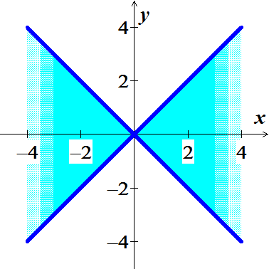***Solution***

1. 





1. 













***Exercise***

A cake is shaped like a hemisphere of radius 4 with its base on the *xy*-plane. A wedge of the cake is removed by making two slices from the center of the cake outward, perpendicular to the *xy*-plane and separated by an angle of *φ*.

1. Use a double integral to find the volume of the slice for .
2. Suppose the cake is sliced by a plane perpendicular to the *xy*-plane at . Let *D* be the smaller of the two pieces produced. For what value of *a* is the volume of *D* equal to the volume in part (*a*)?

***Solution***

1. 











Geometrically, this slice is  of the hemispherical cake.

The formula for the volume of a sphere is  , them the volume of the slice is

 *√*

1. 









***Exercise***

Suppose the density of a thin plate represented by the region *R* is  (in units of mass per area). The mass of the plate is . Find the mass of the thin half annulus

 with a density 

***Solution***

















***Exercise***

An important integral in statistics associated with the normal distribution is . It is evaluated in the following steps.

1. Assume that 

Where we have chosen the variables of integration to be *x* and *y* and then written the product as an iterated integral. Evaluate this integral in polar coordinates and show that . Why is the solution  rejected?

1. Evaluate , , and .

***Solution***

1. 









The integrand is positive everywhere, so the integral of a positive function is positive.

1. 



















***Exercise***

For what values of *p* does the integral  exist in the following cases?

1. 
2. 

***Solution***

1. 







If  the integral diverges.

If  the integral converges.







1. 







If  the integral diverges.

If  the integral converges.





***Exercise***

Consider the integral  where 

1. Evaluate *I* for .
2. Evaluate *I* for arbitrary .
3. Let  in part (*b*) to find *I* over the infinite strip 

***Solution***







1. 













 







1. 

























1. 





***Exercise***

In polar coordinates an equation of an ellipse with eccentricity  and semimajor axis *a* is



1. Write the integral that gives the area of the ellipse.
2. Show that the area of an ellipse is , where 

***Solution***

1. 



1. 









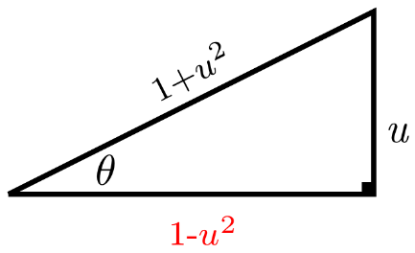







 





















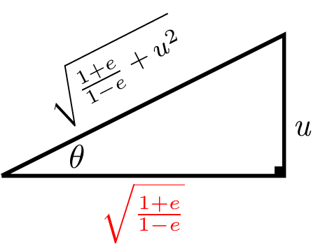 

















 



















 





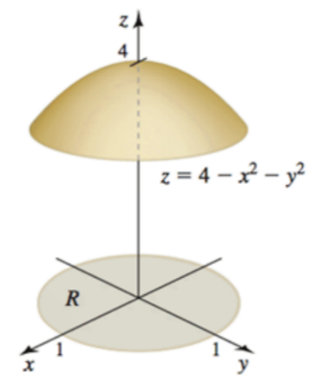***Exercise***

Find the volume of the solid below the paraboloid  and above



***Solution***













***Exercise***

Find the volume of the solid below the paraboloid  and above



***Solution***













***Exercise***

Find the volume of the solid below the paraboloid  and above



***Solution***



 









***Exercise***

Find the volume of the solid below the paraboloid  and above



***Solution***













***Exercise***

Find the volume of the solid below the hyperboloid  and above



***Solution***

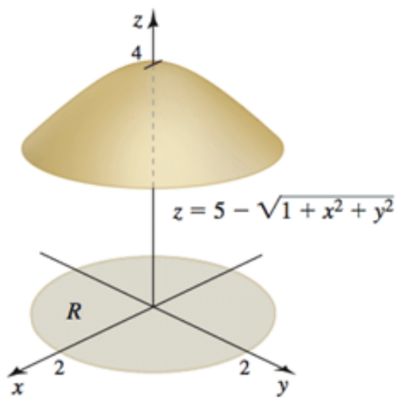

















***Exercise***

Find the volume of the solid below the hyperboloid  and above

 

***Solution***



















***Exercise***

Find the volume of the solid below the hyperboloid  and above



***Solution***

















***Exercise***

Find the volume of the solid below the hyperboloid  and above

 

***Solution***

















***Exercise***

Find the volume of the solid between the paraboloids  and 

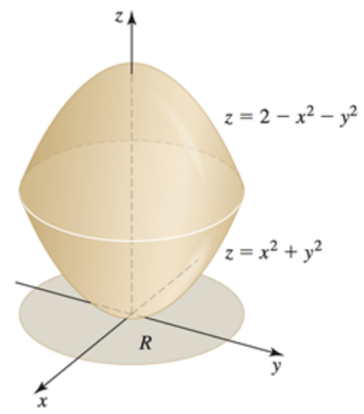***Solution***



















***Exercise***

Find the volume of the solid between the paraboloids  and 

***Solution***



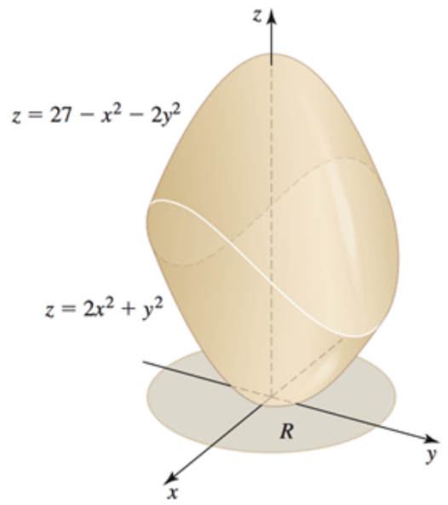

















***Exercise***

Find the volume of island 

***Solution***

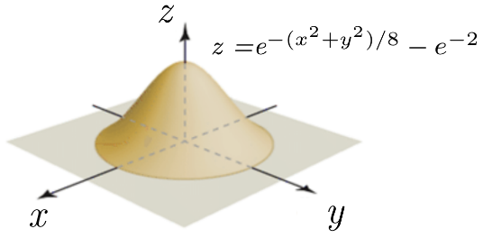

















***Exercise***

Find the volume of island 

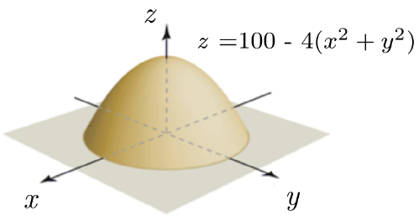***Solution***













***Exercise***

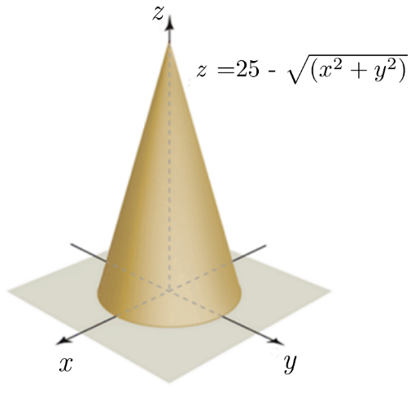Find the volume of island 

***Solution***











