***Section* 3.4 – Triple Integrals**

**Triple Integrals**

If  is a function defined on a closed, bounded region *D* in space, such a solid ball or a lump of clay, then the integral of *F* over *D* may be defined in the following way.

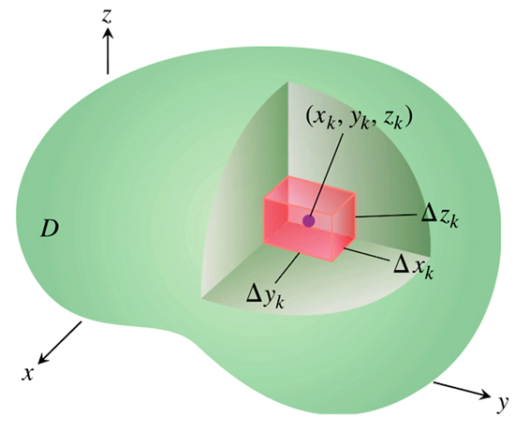



The limit of this summation is the triple integral of *F* over *D*



**Volume of a region in Space**

***Definition***

The volume of a closed, bounded region *D* in space is



**Find Limits of Integration in the Order *dz dy dx***

To evaluate 

1. ***Sketch***: Sketch the region *D* along with its “shadow” *R* (vertical projection) in the *xy*-plane. Label the upper and lower bounding surfaces of *D* and *R*.

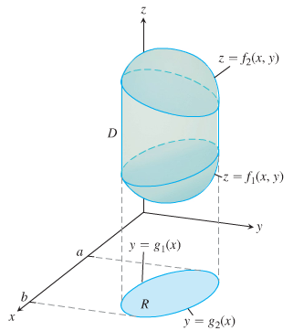

1. ***Find the z-limits of integration***: Draw a line *M* passing through  in *R* parallel to the *z*-axis. As *z* increases, *M* enters *D* at  and leaves at .

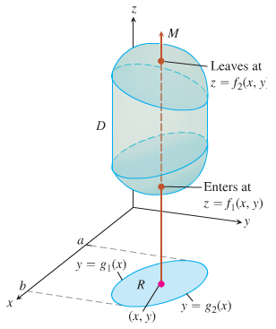

1. ***Find the y-limits of integration***: Draw a line *L* passing through  parallel to the *y*-axis. As *y* increases, *L* enters *R* at  and leaves at .

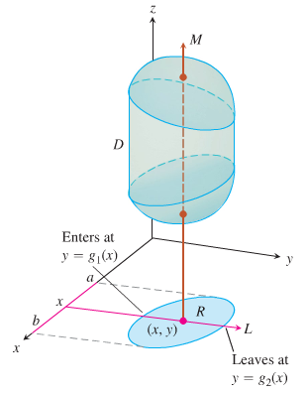

1. ***Find the x-limits of integration***: Choose *x*-limits that include all lines through *R* parallel to the *y*-axis .



***Example***

Find the volume of the region *D* enclosed by the surfaces  and .

***Solution***

***z*-limits**: 

***y*-limits**: 



***x*-limits**: 

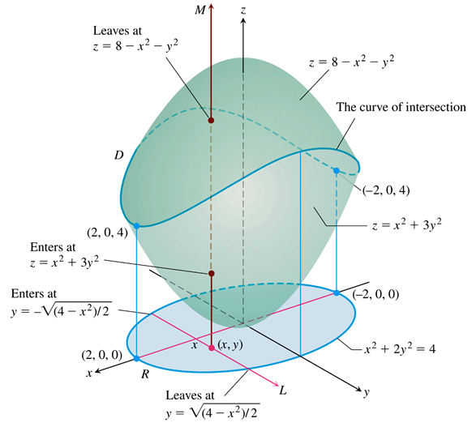





















 



























***Example***

Set up the limits of integration for evaluating the triple integral of a function  over the tetrahedron *D* with vertices (0, 0, 0), (1, 1, 0), (0, 1, 0), and (0, 1, 1). Use the order of integration .

***Solution***

From the sketch, the upper (right-hand) bounding surface of *D* lies in the plane .

The lower (left-hand) bounding surface lies in the plane .

The upper boundary of *R* is the line .

The lower boundary is the line .

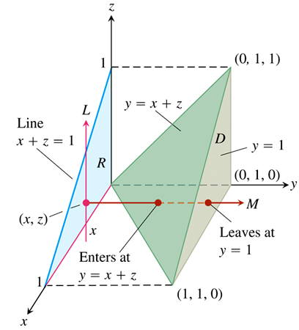

***y*-limits**: The line through  in *R* parallel to the *y*-axis enters *D* at  and leaves at .

***z*-limits**: The line through  in *R* parallel to the *z*-axis enters *R* at  and leaves at .

***x*-limits**: 



***Example***

Integrate  over the tetrahedron *D* in the previous example in the order , and then integrate in the order .

***Solution***

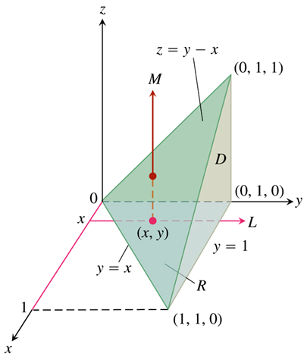

***z-limits*** of integration: A line *M* parallel to the *z*-axis through a typical point (*x, y*) in the *xy*-plane “shadow” enters the tetrahedron at *z* = 0 and exists through the upper plane where  

Line is given by:  passes through the 2 points:



and 





***y-limits*** of integration: On the *xy*-plane, where *z* = 0, the sloped side of the tetrahedron crosses the plane along the line . A line *L* through (*x, y*) parallel to the *y*-axis enters the shadow in the *xy*-plane at  and exists at *y* = 1. 

***x-limits*** of integration: A line *L* parallel to the *y*-axis through a typical point (*x, y*) in the *xy*-plane sweeps out the shadow, where  at the point 

The integral is: 







































***Example***

Evaluate the integral 

***Solution***



















***Example***

Evaluate the integral 

***Solution***





























***Example***

Find the volume bounded by the cylinder  , bounded by the planes 

***Solution***























**Average Value of a Function in Space**

The average value of a function *F* over a region *D* in space is defined by the formula

***Average value*** of *F* over *D* 

***Example***

Find the average of  throughout the cubical region *D* bounded by the coordinate planes and the planes , , and  in the first octant.

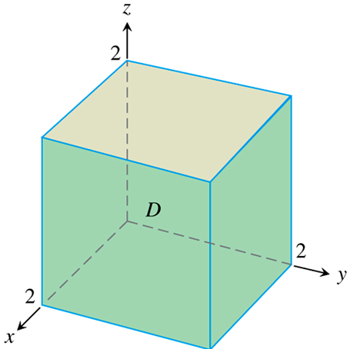***Solution***





The value of the integral of *F* over the cube is











***Average value*** of *xyz* over *cube* 





***Exercises*** ***Section* 3.4 – Triple Integrals**

(**1 − 31**) Evaluate the integral

|  |  |  |
| --- | --- | --- |
|  |  | |
|  | | |  | |

1. Here is the region of integration of the integral 

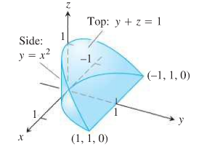

|  |  |  |  |  |
| --- | --- | --- | --- | --- |
|  |  |  |  |  |

(**33 − 37**) Use another order to evaluate

|  |  |
| --- | --- |
|  |  |

(**38 − 39**) Evaluate

1. ; 
2. ; 
3. Let 
4. Use a triple integral to find the volume of *D*.
5. In theory, how many other possible orderings of the variables (besides the one used in part (*a*)) can be used to find the volume of *D*? Verify the result of part (*a*) using one of these other ordering.
6. What is the volume of the region , where *p* and *q* are positive real numbers?
7. Find the volume the parallelepiped (slanted box) with vertices , , , , , , , 
8. Find the volume the larger of two solids formed when the parallelepiped with vertices , , , , , , ,  is sliced by the plane .
9. Find the volume of the pyramid with vertices , , , , 
10. Two different tetrahedrons fill the region in the first octant bounded by the coordinate planes and the plane. Both solids have densities that vary in the *z-*direction between  and , according to the functions  and . Find the mass of each solid
11. Suppose a wedge of cheese fills the region in the first octant bounded by the planes ,  and . You could divide the wedge into two equal pieces (by volume) if you sliced the wedge with the plane . Instead find *a* with  such that slicing the wedge with the plane  divides the wedge into two pieces of equal volume
12. Find the volumes of the region between the cylinder  and the *xy*-plane that is bounded by the planes 

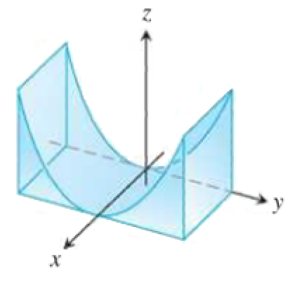

1. Find the volumes of the region in the first octant bounded by the coordinate planes and the planes 

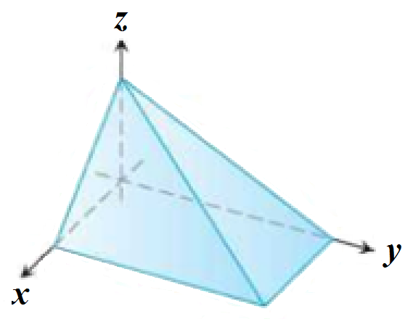

1. Find the volumes of the region in the first octant bounded by the coordinate planes and the plane , and the cylinder 

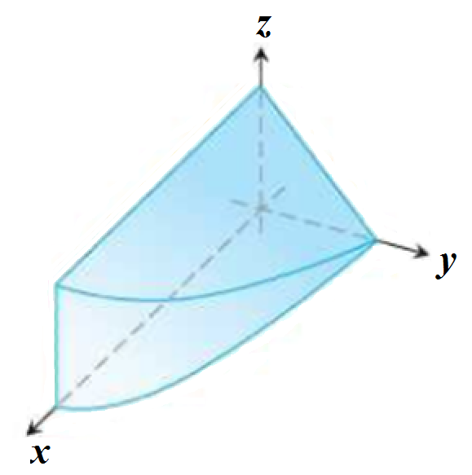

1. Find the volumes of the wedge cut from the cylinder  by the planes 

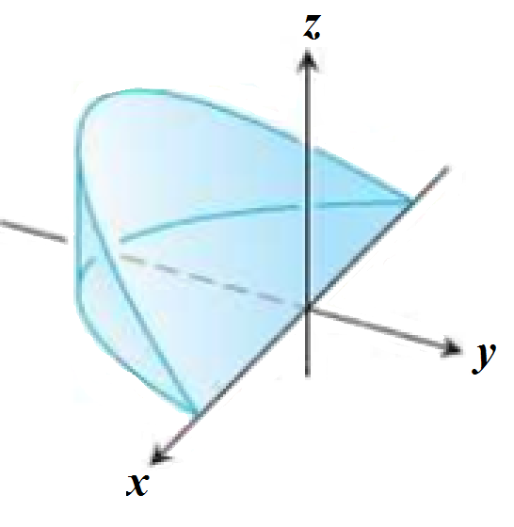

1. Find the volumes of the region cut from the cylinder  by the plane  and the plane 

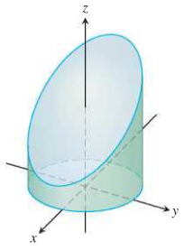

1. Find the volumes of the region common to the interiors of the cylinders  and , one-eighth of which is shown below

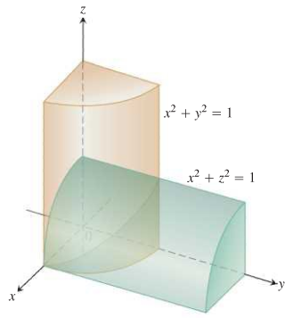

1. Find the volume of the solid in the first octant bounded by the plane  and the coordinate planes

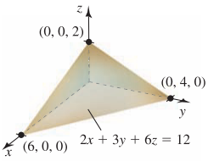

1. Find the volume of the solid in the first octant formed when the cylinder , for , is sliced by the planes  and 

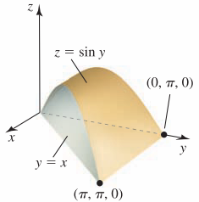

1. Find the volume of the solid bounded below by the cone  and bounded above the sphere 

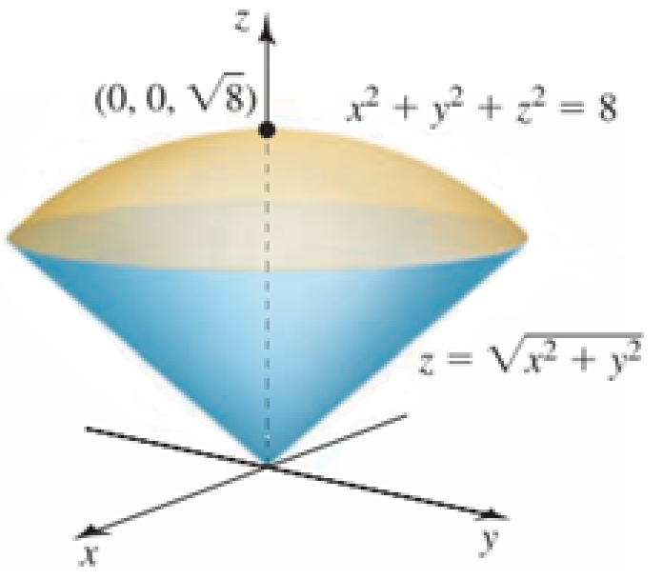

1. The solid between the sphere  and the hyperboloid  , for 

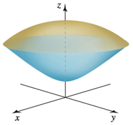

1. Find the volume of the prism in the first octant bounded below by  and 

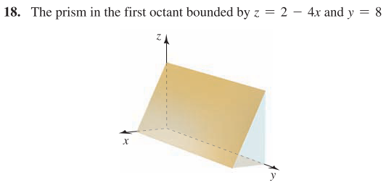

1. Find the volume of the wedge above the *xy-*plane formed when the cylinder  is cut by the planes  and 

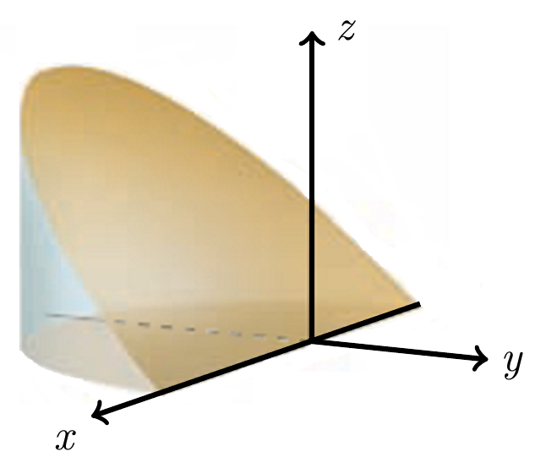

1. The wedge bounded by the parabolic cylinder  and the planes  and 

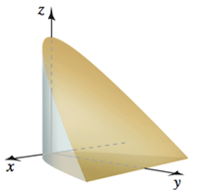

1. Find the volume of the solid bounded by the surfaces  and  over the rectangle 

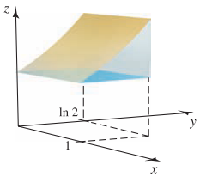

1. Find the volume of the wedge of the cylinder  created by the planes  and 

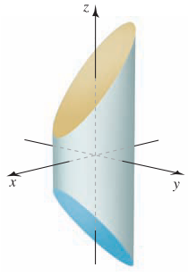

1. Find the volume of the solid in the first octant bounded by the cone  and the plane 

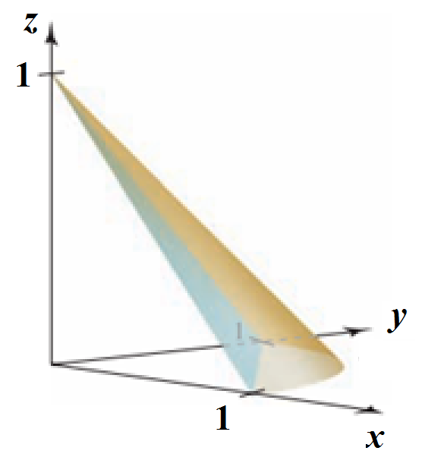

1. Find the volume of the solid bounded by , , , , and 

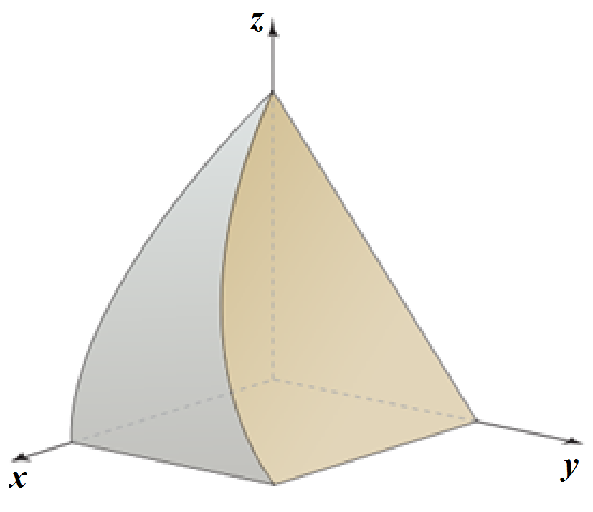

1. Find the volume of the solid bounded by , , , ,, and 

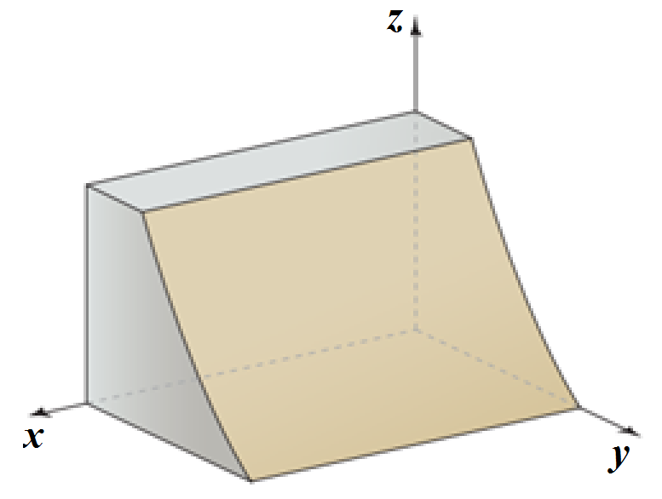

1. Find the volume of the solid bounded by , , , ,, and 

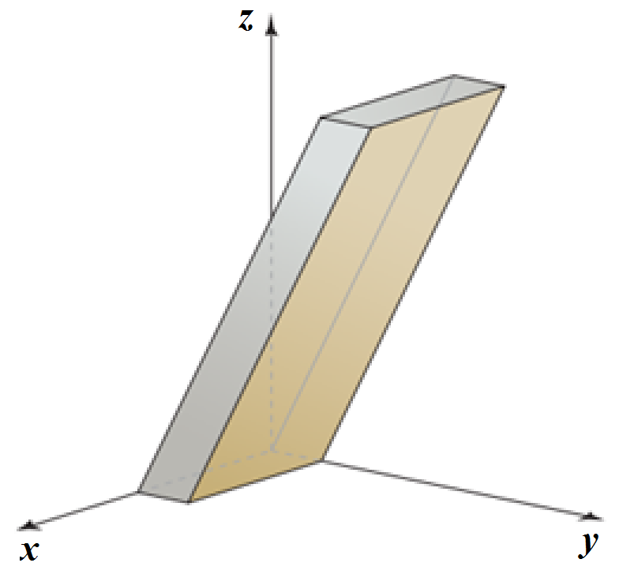

1. Find the volume of the solid bounded by , , , and 

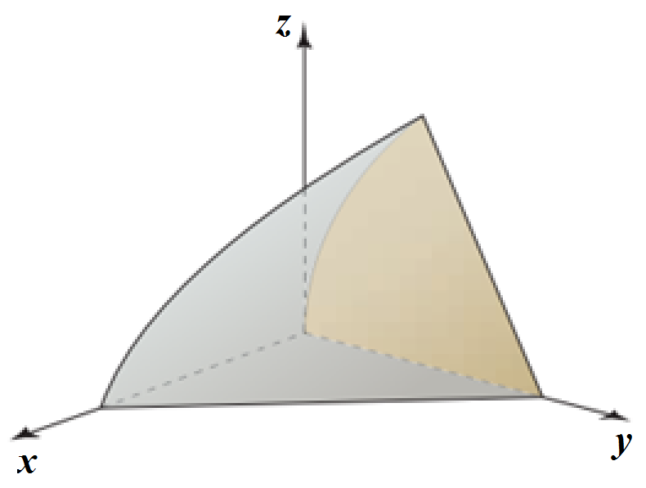

1. Find the volume of the solid common to the cylinders  and  over the square 

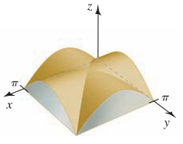

1. Find the volume of the wedge of the square column  created by the planes  and 

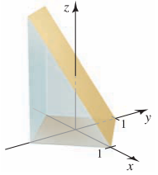

1. Find the volume of a right circular cone with height *h* and base radius *r*.
2. Find the volume of a tetrahedron whose vertices are located at , , , and 
3. Find the volume of a truncated cone of height *h* whose ends have radii *r* and *R*.

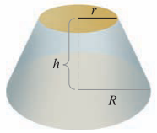

1. Find the volume of the solid that is bounded above by the cylinder , on the sides by the cylinder , and below by the *xy*-plane.

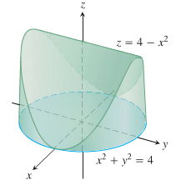

1. Find the volume of the prism in the first octant bounded by the planes 

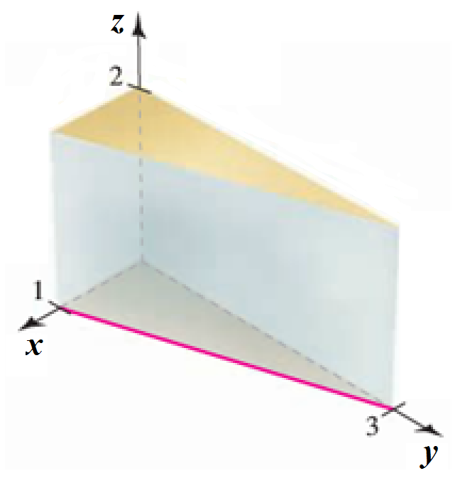

1. Find the volume of the prism in the first octant bounded by the planes 

