***Solution*** ***Section* 3.4 – Triple Integrals**

***Exercise***

Evaluate the integral 

***Solution***















***Exercise***

Evaluate the integral 

***Solution***

















***Exercise***

Evaluate the integral 

***Solution***















***Exercise***

Evaluate the integral 

***Solution***

















***Exercise***

Evaluate the integral 

***Solution***











***Exercise***

Evaluate the integral 

***Solution***











 









***Exercise***

Evaluate the integral 

***Solution***

















***Exercise***

Evaluate the integral 

***Solution***





 





 









***Exercise***

Evaluate the integral 

***Solution***



 





 









***Exercise***

Evaluate the integral 

***Solution***













***Exercise***

Evaluate the integral 

***Solution***

















***Exercise***

Evaluate the integral 

***Solution***







 







***Exercise***

Evaluate the integral 

***Solution***







 









***Exercise***

Evaluate the integral 

***Solution***







 



***Exercise***

Evaluate the integral 

***Solution***





















***Exercise***

Evaluate the integral 

***Solution***









***Exercise***

Evaluate the integral 

***Solution***









***Exercise***

Evaluate the integral 

***Solution***









***Exercise***

Evaluate the integral 

***Solution***











***Exercise***

Evaluate the integral 

***Solution***









***Exercise***

Evaluate the integral 

***Solution***









***Exercise***

Evaluate the integral 

***Solution***













***Exercise***

Evaluate the integral 

***Solution***









*Switching* 



















***Exercise***

Evaluate the integral 

***Solution***











 

































































***Exercise***

Evaluate the integral 

***Solution***





















***Exercise***

Evaluate the integral 

***Solution***



 Let 









***Exercise***

Evaluate the integral 

***Solution***













***Exercise***

Evaluate the integral 

***Solution***























***Exercise***

Evaluate the integral 

***Solution***















***Exercise***

Evaluate the integral 

***Solution***











***Exercise***

Evaluate the integral 

***Solution***





















***Exercise***

Here is the region of integration of the integral



    

***Solution***

1. 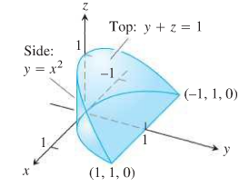
2. 
3. 
4. 
5. 

***Exercise***

Use another order to evaluate 

***Solution***

















***Exercise***

Use another order to evaluate 

***Solution***



















***Exercise***

Use another order to evaluate 

***Solution***













***Exercise***

Use another order to evaluate 

***Solution***











 Let 











***Exercise***

Use another order to evaluate 

***Solution***









 











***Exercise***

Evaluate ; 

***Solution***













***Exercise***

Evaluate ; 

***Solution***













***Exercise***

Let 

1. Use a triple integral to find the volume of *D*.
2. In theory, how many other possible orderings of the variables (besides the one used in part (*a*)) can be used to find the volume of *D*? Verify the result of part (*a*) using one of these other ordering.
3. What is the volume of the region , where *p* and *q* are positive real numbers?

***Solution***

1. 













1. There are total of 6: 



 

 

















 

1. , 















***Exercise***

Find the volume the parallelepiped (slanted box) with vertices , , , , , , , 

***Solution***

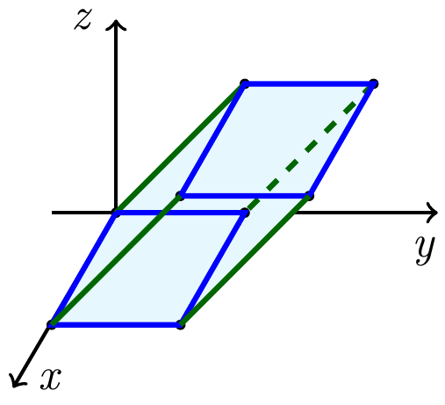











***Exercise***

Find the volume the larger of two solids formed when the parallelepiped with vertices , , , , , , ,  is sliced by the plane .

***Solution***

















***Exercise***

Find the volume of the pyramid with vertices , , , , 

***Solution***





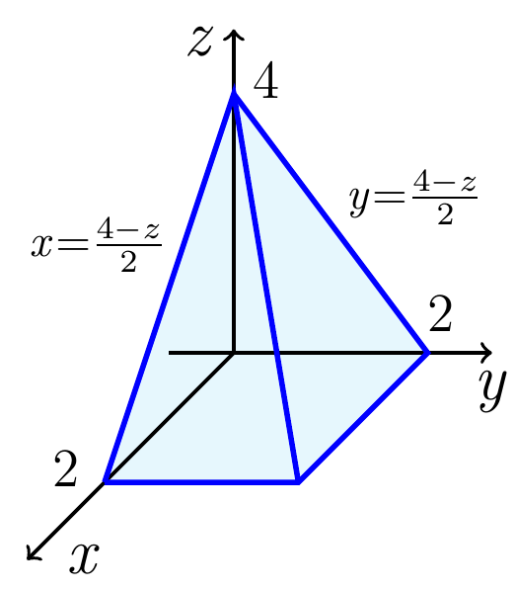

















***Exercise***

Two different tetrahedrons fill the region in the first octant bounded by the coordinate planes and the plane. Both solids have densities that vary in the *z−*direction between  and , according to the functions  and . Find the mass of each solid

***Solution***































Solid 1 has ***greater mass***.

***Exercise***

Suppose a wedge of cheese fills the region in the first octant bounded by the planes ,  and . You could divide the wedge into two equal pieces (by volume) if you sliced the wedge with the plane . Instead find *a* with  such that slicing the wedge with the plane  divides the wedge into two pieces of equal volume

***Solution***



























***Exercise***

Find the volumes of the region between the cylinder  and the *xy*-plane that is bounded by the planes 

***Solution***

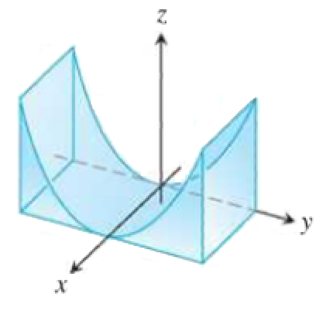









***Exercise***

Find the volumes of the region in the first octant bounded by the coordinate planes and the planes 

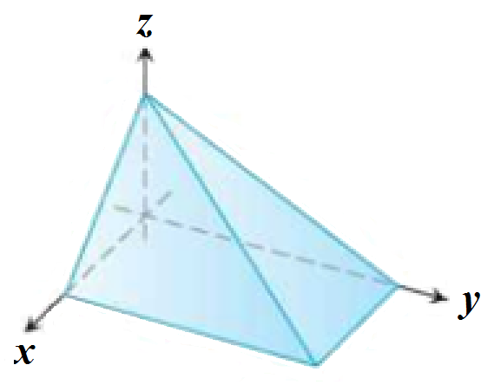***Solution***





















***Exercise***

Find the volumes of the region in the first octant bounded by the coordinate planes and the plane , and the cylinder 

***Solution***

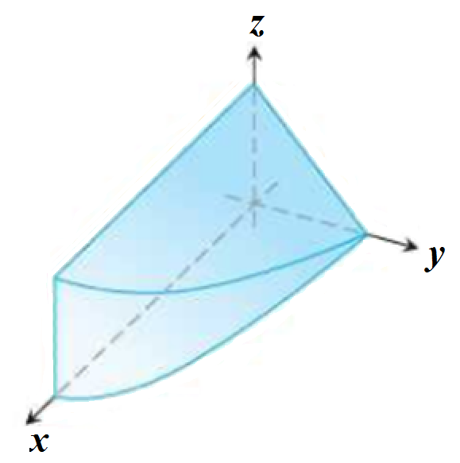















***Exercise***

Find the volumes of the wedge cut from the cylinder  by the planes 

***Solution***

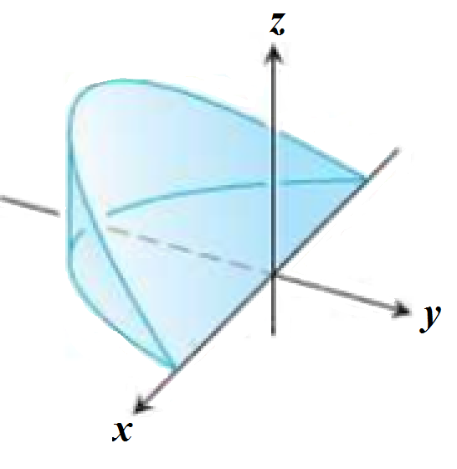













***Exercise***

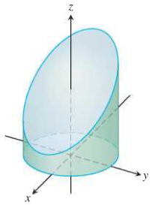Find the volumes of the region cut from the cylinder  by the plane  and the plane 

***Solution***







 











***Exercise***

Find the volumes of the region common to the interiors of the cylinders  and , one-eighth of which is shown below

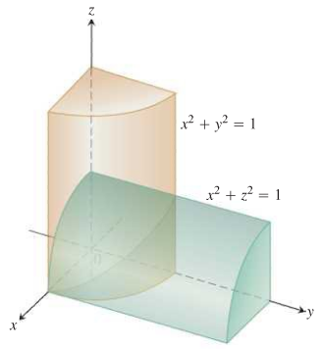***Solution***













***Exercise***

Find the volume of the solid in the first octant bounded by the plane  and the coordinate planes

***Solution***











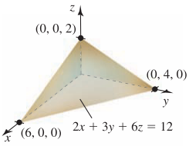















***Exercise***

Find the volume of the solid in the first octant formed when the cylinder , for , is sliced by the planes  and 

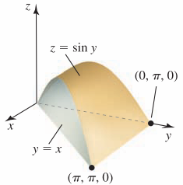***Solution***















***Exercise***

Find the volume of the solid bounded below by the cone  and bounded above the sphere 

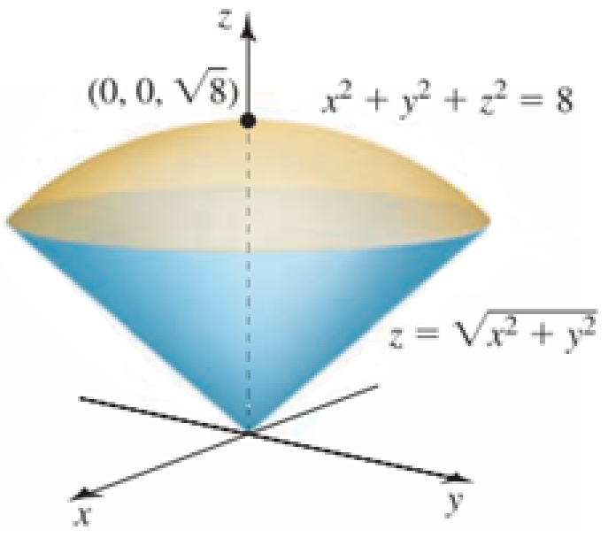***Solution***













 *Convert to* ***Polar coordinates***















***Exercise***

The solid between the sphere  and the hyperboloid  , for 

***Solution***

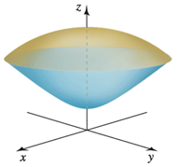

The intersection of the sphere and hyperboloid:























***Exercise***

Find the volume of the prism in the first octant bounded below by  and 

***Solution***

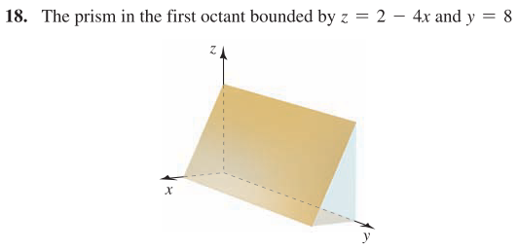















***Exercise***

Find the volume of the wedge above the *xy-*plane formed when the cylinder  is cut by the planes  and 

***Solution***



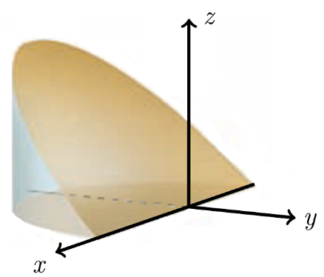













***Exercise***

The wedge bounded by the parabolic cylinder  and the planes  and 

***Solution***







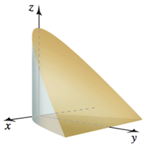 













***Exercise***

Find the volume of the solid bounded by the surfaces  and  over the rectangle 

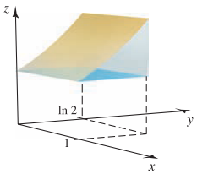***Solution***









***Exercise***

Find the volume of the wedge of the cylinder  created by the planes  and 

***Solution***

v

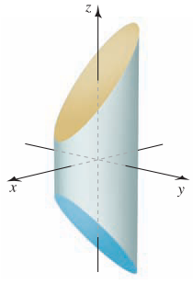

































***Exercise***

Find the volume of the solid in the first octant bounded by the cone  and the plane 

***Solution***





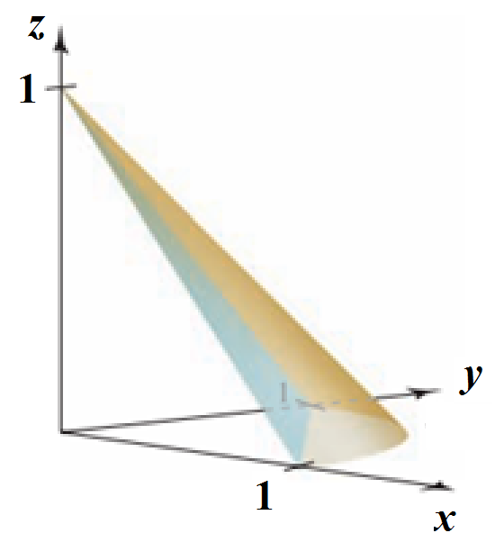







































***Exercise***

Find the volume of the solid bounded by , , , , and 

***Solution***





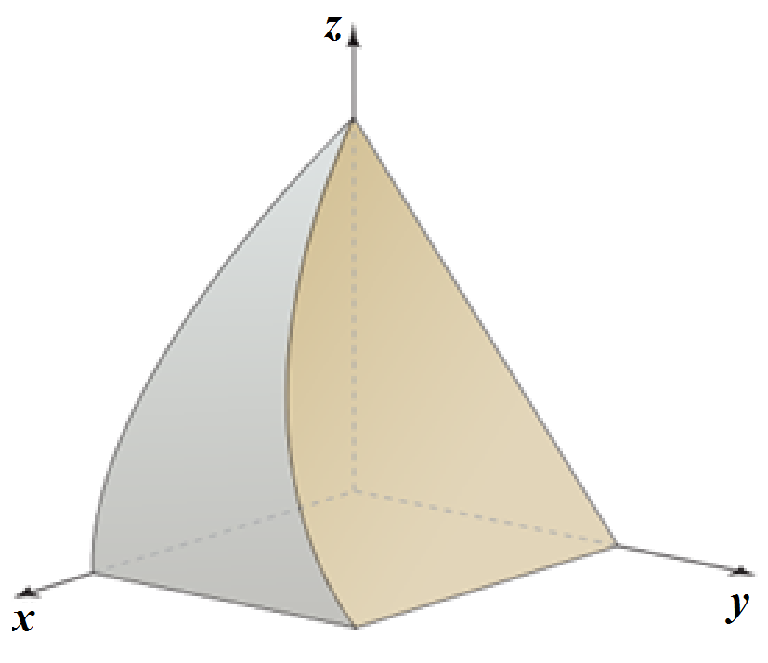 











***Exercise***

Find the volume of the solid bounded by , , , ,, and 

***Solution***



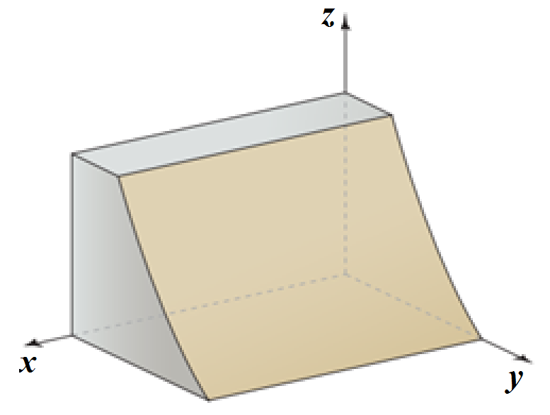 









***Exercise***

Find the volume of the solid bounded by , , , ,, and 

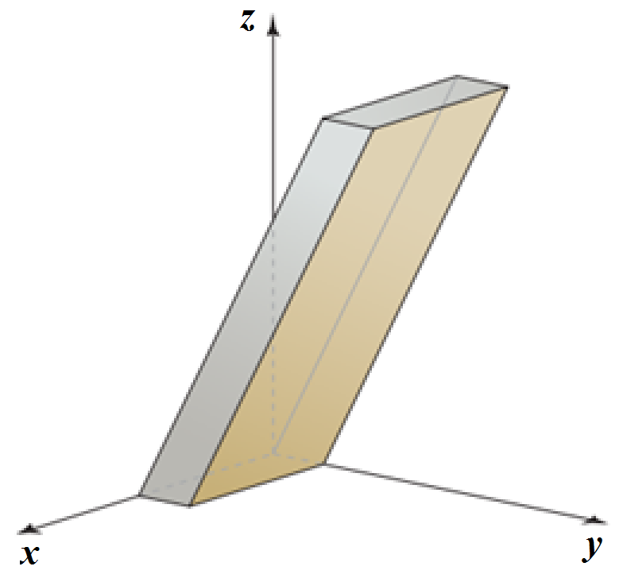***Solution***











***Exercise***

Find the volume of the solid bounded by , , , and 

***Solution***

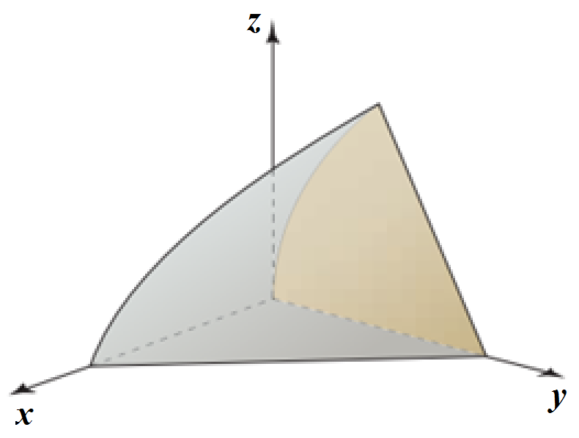





















***Exercise***

Find the volume of the solid common to the cylinders  and  over the square



***Solution***





 **4:** *by symmetry, volume –* **4** *times*

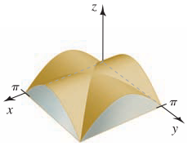 











***Exercise***

Find the volume of the wedge of the square column  created by the planes  and 

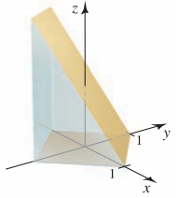***Solution***

























***Exercise***

Find the volume of a right circular cone with height *h* and base radius *r*.

***Solution***

The equation of a circle is centered at the origin with radius *r*: 







The equation of a cone with height *h*: 



 Let  (*Polar Coordinates*)











***Exercise***

Find the volume of a tetrahedron whose vertices are located at , , , and 

***Solution***

The equation of the plane through the vertices: 



















***Exercise***

Find the volume of a truncated cone of height *h* whose ends have radii *r* and *R*.

***Solution***

There are 2 volumes to consider:

1. Volume of the cylinder: 
2. Volume  that remains when cylinder is removed.

is the annulus centered at the origin with inner radius *r*

and outer radius *R*.

Using Polar Coordinates: the equation of the frustum is: 

























***Exercise***

Find the volume of the solid that is bounded above by the cylinder, on the sides by the cylinder, and below by the *xy*-plane.

***Solution***

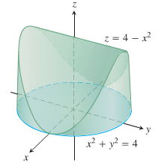



Since it is symmetric, then 

 































***Exercise***

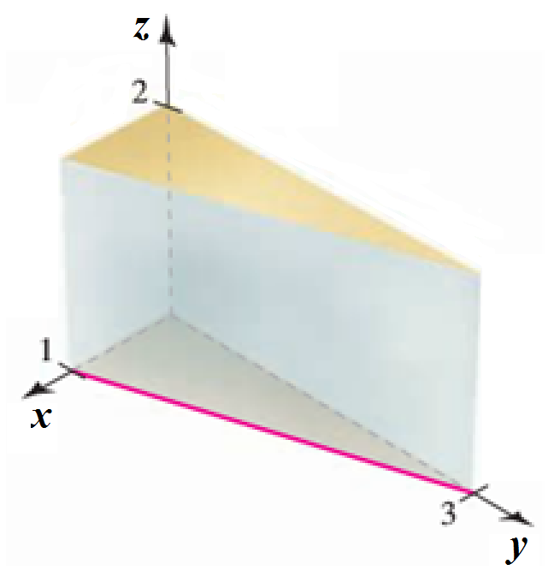Find the volume of the prism in the first octant bounded by the planes 

***Solution***

















***Exercise***

Find the volume of the prism in the first octant bounded by the planes 

***Solution***







