***Section* 3.5 – Triple Integrals in Cylindrical and Spherical Coordinates**

**Integration in Cylindrical Coordinates**

***Definition***

***Cylindrical coordinates*** represent a point *P* in space by ordered triples  in which

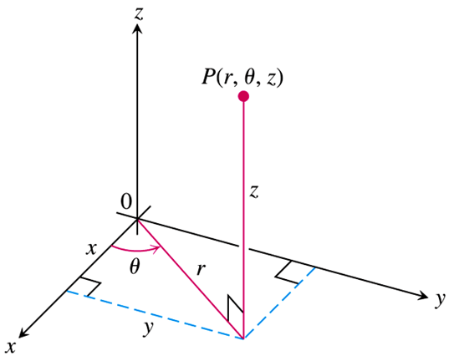

1.  are polar coordinates for the vertical projection of *P* on the *xy*-plane
2. *z* is the rectangular vertical coordinate.

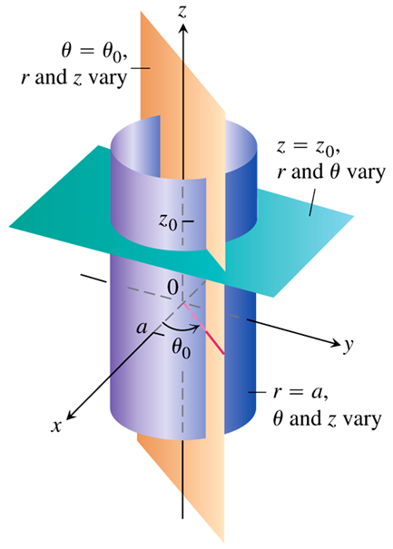**Transformation Between Rectangular  and Cylindrical  Coordinates**





The triple integral of a function f over *D* is obtained by taking a limit of such Riemann sums with partitions whose norms approach zero:



***Example***

Find the limits of integration in cylindrical coordinates for integrating a function  over the region *D* bounded below by the plane , laterally by the circular cylinder , and above by the paraboloid .

***Solution***

Base of *D* is the region’s projection *R* on the *xy*-plane.

The boundary of *R* is the circle .

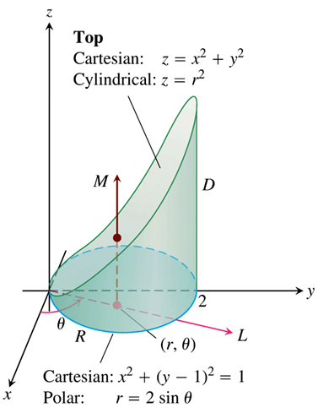

The polar coordinate equation is











***z−limits***: A line *M* through a typical point  in

*R* // *z*-axis enters *D* at  and leaves at 

***r−limits***: starts at  and ends at 

***θ−limits***: From  to 



**How to integrate in Cylindrical Coordinates**

To evaluate 

1. ***Sketch***: Sketch the region *D* along with its projection *R* on the *xy*-plane. Label the upper and lower bounding surfaces of *D* and *R*.

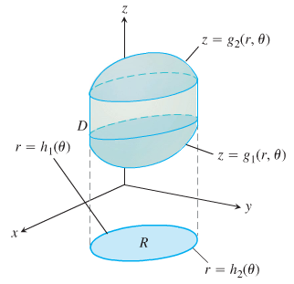

1. ***Find the z−limits of integration***: Draw a line *M* passing through  in *R* // *z*-axis. As *z* increases, *M* enters *D* at  to .

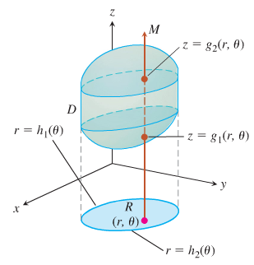

1. ***Find the r−limits of integration***: Draw a line *L* passing through  from the origin. From  to .

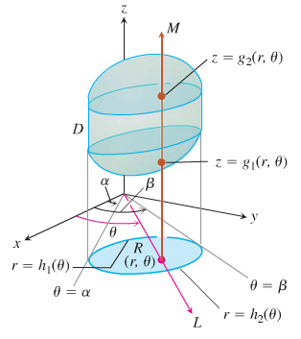

1. ***Find the θ−limits of integration***: As *L* sweeps across *R*, the angle *θ* it makes with the positive *x*-axis runs from .



***Example***

Find the volume bounded by the sphere  and the paraboloid 

***Solution***



































***Definition***

***Spherical coordinates*** represent a point *P* in space by ordered triple  in which

1.  is the distance from P to the origin
2.  is the angle  makes with positive *z*-axis .
3.  is the angle from the cylindrical coordinates 

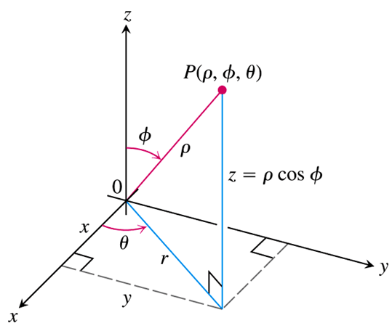

**Equations Relating Spherical Coordinates to Cartesian and Cylindrical Coordinates**





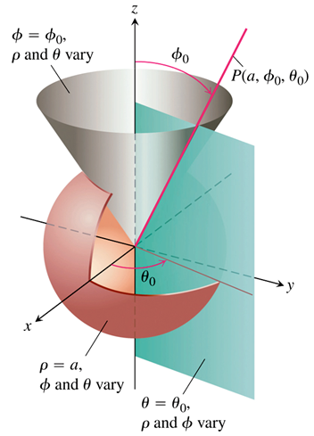

***Example***

Find a spherical coordinate equation for the sphere 

***Solution***





 









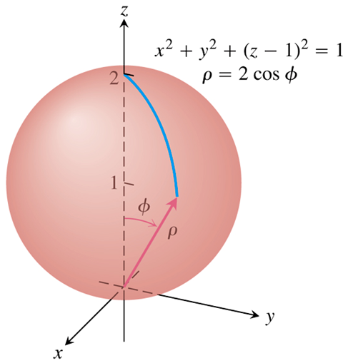

The angle *φ* varies from 0 to the north pole of the sphere to  at the south pole; the angle *θ* doesn’t appear in the expression for *ρ*, reflecting the symmetry about the *z*-axis.

***Example***

Find a spherical coordinate equation for the sphere 

***Solution***

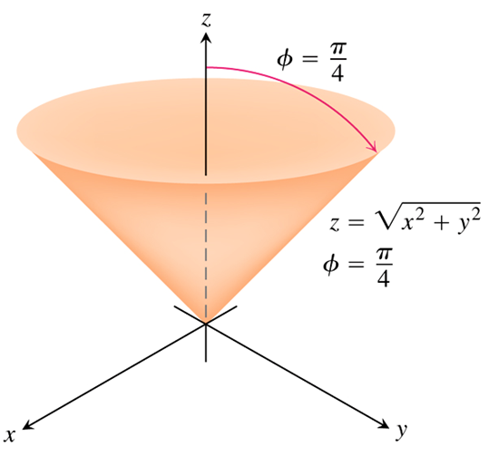The cone is symmetric with respect to the *z*-axis and cuts the first quadrant of the yz-plane along the line . The angle between the cone and the positive *z*-axis is therefore  rad. The cone consists of the points whose spherical coordinates have .









**Volume Differential in Spherical Coordinates**



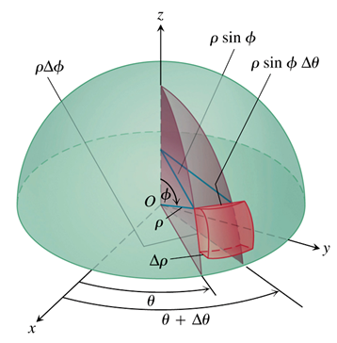



**How to integrate in Spherical Coordinates**

To evaluate 

|  |  |
| --- | --- |
| 1. ***Sketch***: Sketch the region *D* along its projection *R* on the *xy*-plane. Label the surface that bound of *D*. | |
| 1. ***Find the ρ−limits of integration***: Draw a ray *M* from the origin through *D* making an angle *φ* with the positive *z*-axis. Also draw the projection of *M* on the *xy*-plane (call the projection *L*). The ray *L* makes an angle *θ* with the positive *x*-axis. As *ρ* increases, *M* enters *D* at  to . |  |
| 1. ***Find the φ−limits of integration***: For the given *θ*, the angle *φ* that *M* makes with the *z*-axis runs  to . |  |
| 1. ***Find the*** θ−***limits of integration***: As *L* sweeps over *R* as θ runs from . | |

***Example***

Find the volume of the “ice cream cone” *D* cut from the solid sphere  by the cone 

***Solution***





***ρ−limits***: Draw a ray *M* from the origin through *D* making an angle *φ* with the positive *z*-axis. And *L*, the projection of *M* on the *xy*-plane, along with the angle *θ* that *L* makes with the positive *x*-axis. Ray *M* enters *D* form  to 

***φ−limits***: The cone  makes with the positive *z*-axis. 

***θ−limits***: 

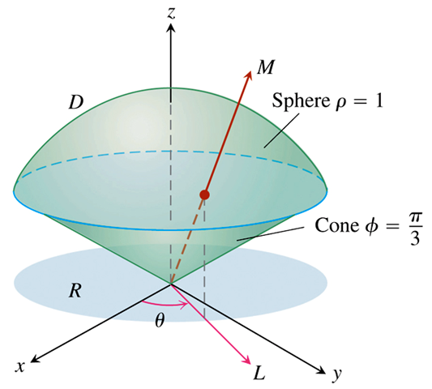











***Example***

Find the volume cut from the cone , by the sphere 

***Solution***





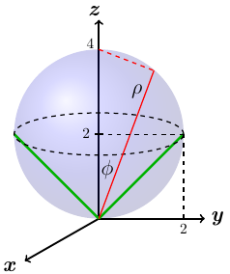































***Example***

Evaluate the integral  over the region *D*.

Where the region *D* in the first octant between 2 spheres of radius 1 and 2 centered at the origin.

***Solution***













***Example***

Evaluate the integral 

***Solution***

























***Coordinate Conversion Formulas***

|  |  |  |
| --- | --- | --- |
| ***Cylindrical to Rectangular*** | ***Spherical to Rectangular*** | ***Spherical to Cylindrical*** |
|  |  |  |
|  |  |  |
|  |  |  |

Corresponding formulas for  in triple integrals:







***Exercises*** ***Section* 3.5 – Triple Integrals in Cylindrical and Spherical Coordinates**

(**1 − 16**) Evaluate the cylindrical coordinate integral

|  |  |
| --- | --- |
|  |  |

1. Convert 
2. Rectangular coordinates with order of integration d*z*d*x*d*y*.
3. Spherical coordinates
4. Evaluate one of the integrals.
5. Convert the integral  to an equivalent integral in cylindrical coordinates and evaluate the result.
6. Set up an integral in rectangular coordinates equivalent to the integral



Arrange the order of integration to be *z* first, then *y*, then *x*.

1. Set up the iterated integral for evaluating  over the region *D* that is the right circular cylinder whose base is the circle  in the *xy*-plane and whose top lies in the plane 

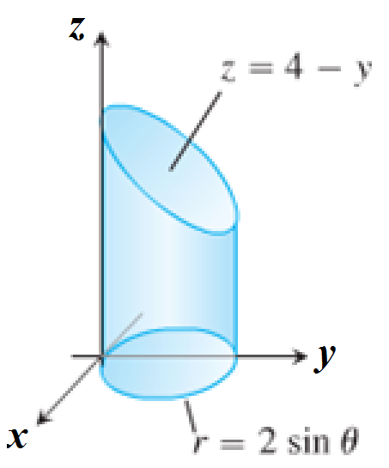

1. Set up the iterated integral for evaluating  over the region *D* which is the solid right cylinder whose base is the region in the *xy*-plane that lies inside the cardioid  and outside the circle  and whose top lies in the plane 

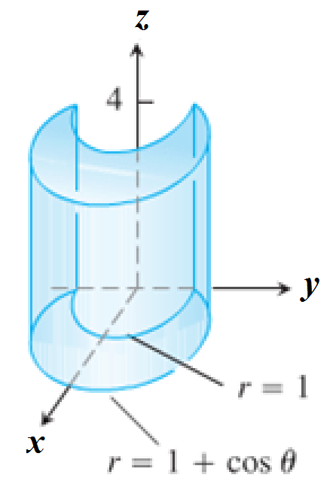

1. Set up the iterated integral for evaluating  over the region *D* which is the solid right cylinder whose base is the region between the circles  and  and whose top lies in the plane 

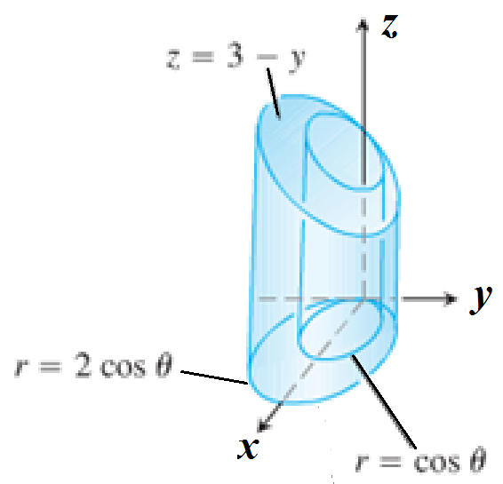

1. Set up the iterated integral for evaluating  over the region *D* which is the prism whose base is the triangle in the *xy*-plane bounded by the *y*-axis and the lines  and  and whose top lies in the plane 

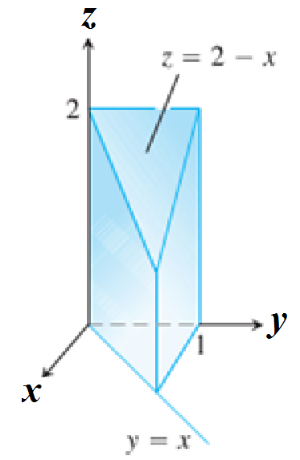

(**24 − 25**) Evaluate the integrals in cylindrical coordinates.

|  |  |
| --- | --- |
|  |  |

(**26 − 41**) Evaluate the spherical coordinate integral

|  |  |
| --- | --- |
|  |  |

(**42 − 45**) Evaluate the integrals

|  |  |
| --- | --- |
|  |  |

1. Evaluate ; *D* is the unit ball.
2. Evaluate ; *D* is the unit ball.
3. Evaluate ; *D* is the solid between the spheres of radius 1 and 2 centered at the origin.
4. Evaluate , where *D* is the region in the first octant between two spheres of radius 1 and 2 centered at the origin.
5. Evaluate ; 
6. Evaluate ; 
7. Evaluate ; 
8. Evaluate ; 
9. Evaluate ; 
10. Evaluate ; 
11. Evaluate ; 
12. Evaluate ; 
13. Evaluate ; 
14. Evaluate ; 
15. Find the volume of the solid whose height is 4 and whose base is the disk 
16. Find the volume of the solid in the first octant bounded by the cylinder  and the plane 
17. Find the volume of the solid bounded by the cylinder  and  and the planes  and 
18. Find the volume of the solid *D* between the cone  and the inverted paraboloid 
19. Find the volume of the solid region *D* that lies inside the cone  and inside the sphere 

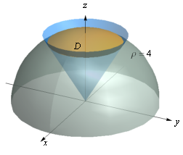

1. Find the volume of the solid between the sphere  and the hemisphere 

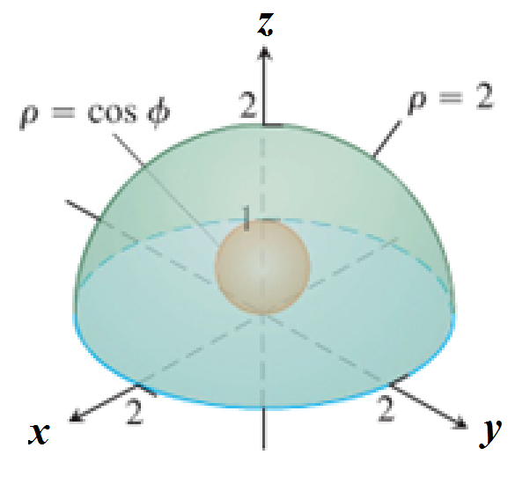

1. Find the volume of the solid bounded below by the hemisphere , and above the cardioid of revolution 

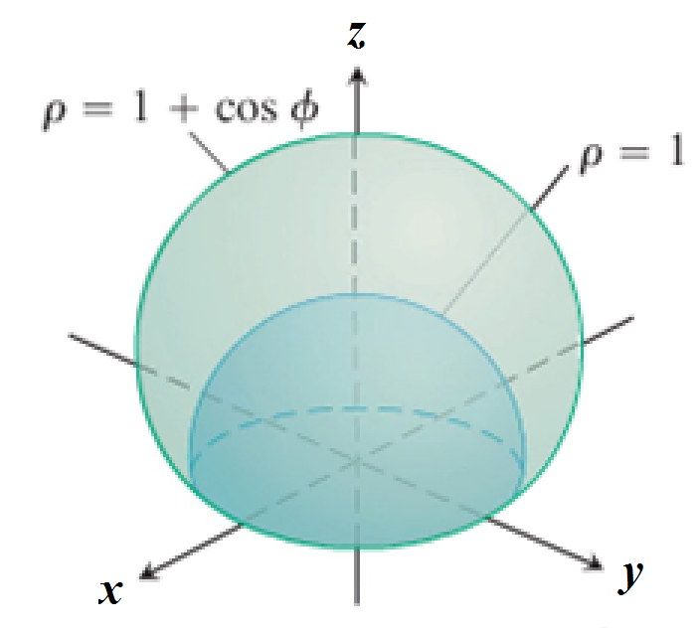

1. Find the volume of the solid

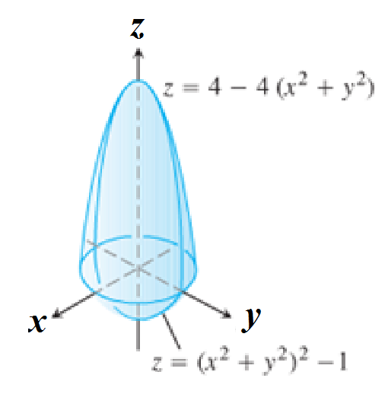

1. Find the volume of the solid

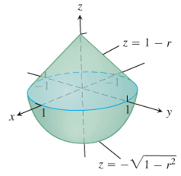

1. Find the volume of the solid

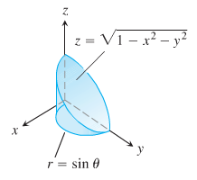

1. Find the volume of the solid

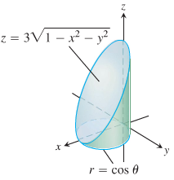

1. Find the volume of the smaller region cut from the solid sphere  by the plane 
2. Find the volume of the region bounded below by the paraboloid , laterally by the cylinder , and above by the paraboloid 
3. Find the volume of the region that lies inside the sphere  and outside the cylinder 
4. Find the volume of the solid between the sphere  and the hyperboloid  for 

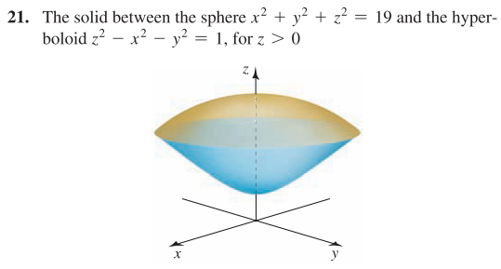

1. Evaluate the integral in cylindrical coordinates

|  |  |
| --- | --- |
|  |  |

1. Evaluate the integral in cylindrical coordinates 

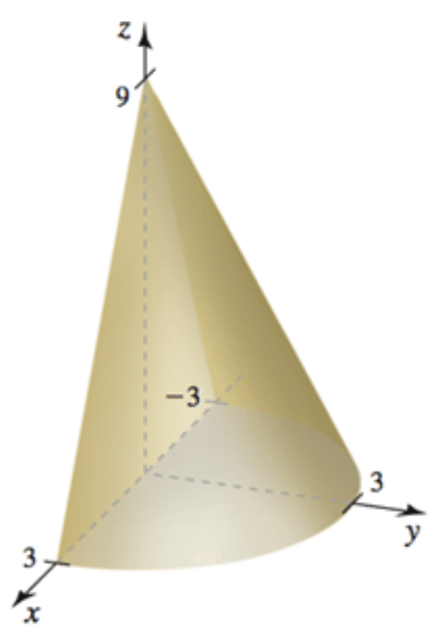

1. Evaluate the integral in cylindrical coordinates 

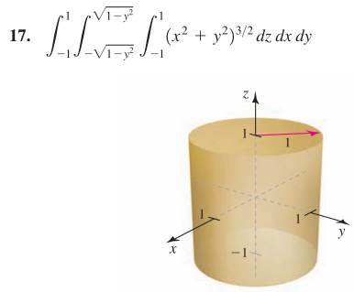

1. Evaluate the integral in cylindrical coordinates 

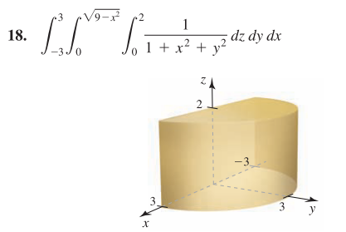

1. Evaluate the integral in cylindrical coordinates to find the volume of the solid bounded by the plane  and the hyperboloid 

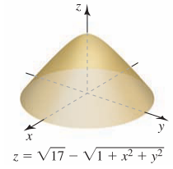

1. Evaluate the integral in cylindrical coordinates to find the volume of the solid bounded by the plane  and the paraboloid 

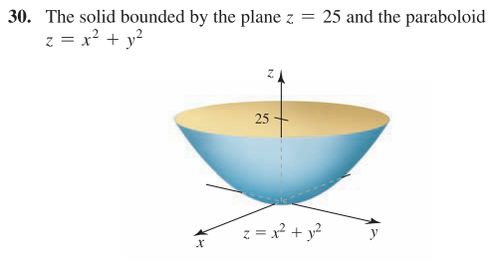

1. Evaluate the integral in cylindrical coordinates to find the volume of the solid bounded by the parabolic cylinders  and 

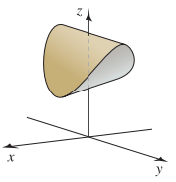

1. Evaluate the integral 

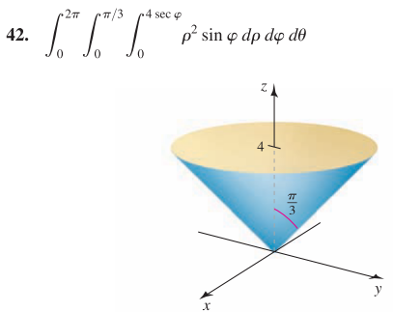

1. Evaluate the integral 

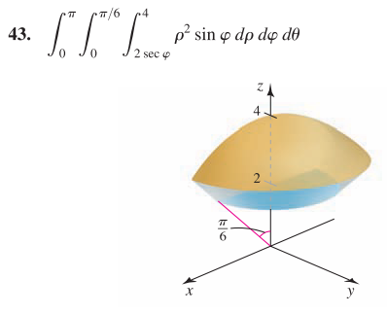

1. Evaluate the integral 

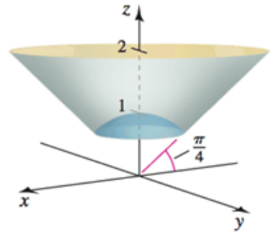

1. Evaluate the integral 

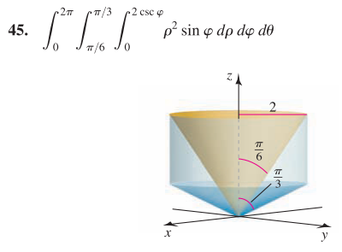

1. Use the spherical coordinates to find the volume of a ball of radius 
2. Use the spherical coordinates to find the volume of the solid bounded by the sphere  and the hemisphere 

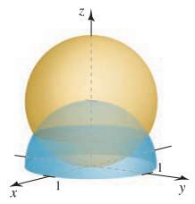

1. Use the spherical coordinates to find the volume of the solid of revolution



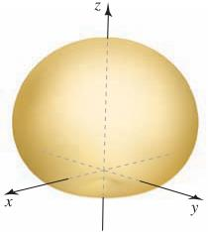

1. Use the spherical coordinates to find the volume of the solid outside the cone  and inside the sphere 

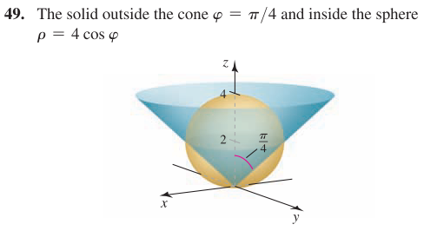

1. Use the spherical coordinates to find the volume of the solid bounded by the cylinders  and , and the cone  and 

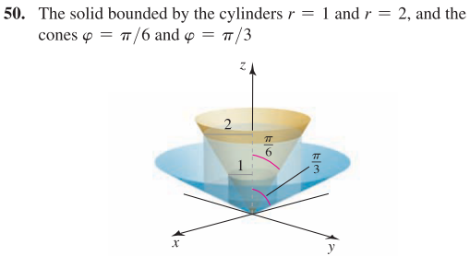

1. Use the spherical coordinates to find the volume of the ball  that lies between the planes  and 

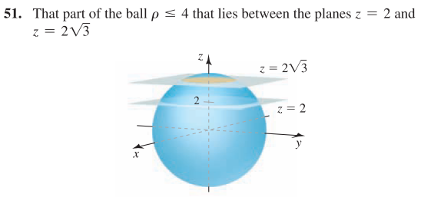

1. Use the spherical coordinates to find the volume of the solid inside the cone  that lies between the planes  and 

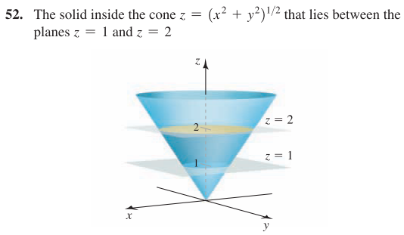

1. The *x-* and *y-*axes from the axes of two right circular cylinders with radius 1.

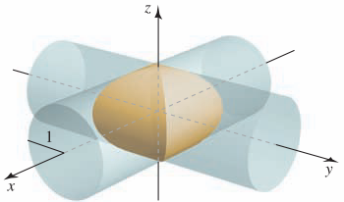

Find the volume of the solid that is common to the two cylinders.

1. The coordinate axes from the axes of three right circular cylinders with radius 1.

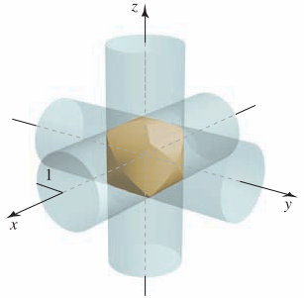

Find the volume of the solid that is common to the three cylinders.

1. Find the volume of one of the wedges formed when the cylinder  is cut by the planes  and 

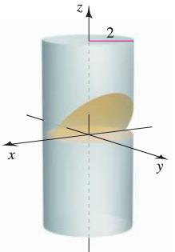

1. Find the volume of the region inside the parabolic cylinder  between the planes  and 

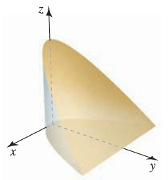

1. Find the volume of the tetrahedron with vertices , , , and 

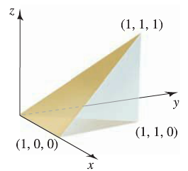

1. Find the volume of the region bounded by the plane  and the hyperboloid . Use integration in cylindrical coordinates.

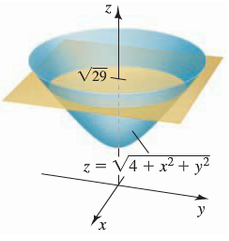

1. Find the volume of the solid cylinder whose height is 4 and whose base is the disk . Use integration in cylindrical coordinates

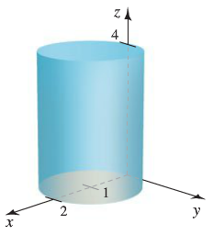

1. Use integration in spherical coordinates to find the volume of the rose petal of revolution



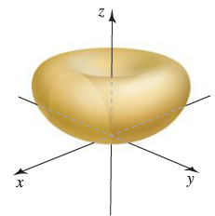

1. Use integration in spherical coordinates to find the volume of the region above the cone and inside the sphere .

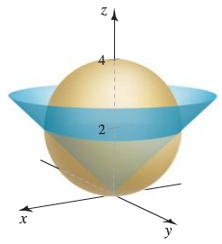

1. Find the volume of the cardioid of revolution



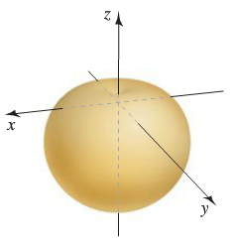

1. A cake is shaped like a solid cone with radius 4 and height 2, with its base on the *xy-*plane. A wedge of the cake is removed by making two slices from the axis of the cone outward, perpendicular to the *xy-*plane separated by an angle of *Q* radians, where 
2. Find the volume of the slice for . Use geometry to check your answer.
3. Find the volume of the slice for . Use geometry to check your answer.
4. A spherical fish tank with a radius of 1 *ft* is filled with water to a level 6 *in*. below the top of the tank.
5. Determine the volume and weight of the water in the fish tank. (The weight density of water is about 62.5 .)
6. How much additional water must be added to completely fill the tank?
7. A spherical cloud of electric charge has known charge density , where *ρ* is the spherical coordinate. Find the total charge in the cloud in the following cases.
8. 
9. 
10. 
11. A point mass *m* is a distance *d* from the center of a thin spherical shell of mass *M* and radius *R*. The magnitude of the gravitational force on the point mass is given by the integral



Where *G* is the gravitational constant.

1. Use the change of variable  to evaluate the integral and show that if , then , which means the force is the same as if the mass of the shell were concentrated at its center.
2. Show that is  (the point mass is inside the shell), then .
3. Before a gasoline-powered engine is started, water must be drained from the bottom of the fuel tank. Suppose the tank is a right circular cylinder on its side with a length of 2 *ft* and a radius of 1 *ft*. If the water level is 6 *in*. above the lowest part of the tank, determine how much water must be drained from the tank.

