***Solution*** ***Section* 3.5 – Triple Integrals in Cylindrical and Spherical Coordinates**

***Exercise***

Evaluate the cylindrical coordinate integral 

***Solution***



 













***Exercise***

Evaluate the cylindrical coordinate integral 

***Solution***

















***Exercise***

Evaluate the cylindrical coordinate integral 

***Solution***























***Exercise***

Evaluate the cylindrical coordinate integral 

***Solution***











 









***Exercise***

Evaluate the integral 

***Solution***













***Exercise***

Evaluate the integral 

***Solution***

















***Exercise***

Evaluate the integral 

***Solution***











 









***Exercise***

Evaluate the integral 

***Solution***









***Exercise***

Evaluate the integral 

***Solution***











***Exercise***

Evaluate the integral 

***Solution***















***Exercise***

Evaluate the integral 

***Solution***

|  |  |  |
| --- | --- | --- |
|  |  |  |
| **+** |  |  |
| **−** |  |  |

















***Exercise***

Evaluate the integral 

***Solution***











***Exercise***

Evaluate the integral 

***Solution***











***Exercise***

Evaluate the integral 

***Solution***





















***Exercise***

Evaluate the integral 

***Solution***





























***Exercise***

Evaluate the integral 

***Solution***

























***Exercise***

Convert 

1. Rectangular coordinates with order of integration d*z*d*x*d*y*.
2. Spherical coordinates
3. Evaluate one of the integrals.

***Solution***

1. 











1. Spherical coordinates















1. 

















***Exercise***

Convert the integral  to an equivalent integral in cylindrical coordinates and evaluate the result.

***Solution***















***Exercise***

Set up an integral in rectangular coordinates equivalent to the integral



Arrange the order of integration to be *z* first, then *y*, then *x*.

***Solution***





























***Exercise***

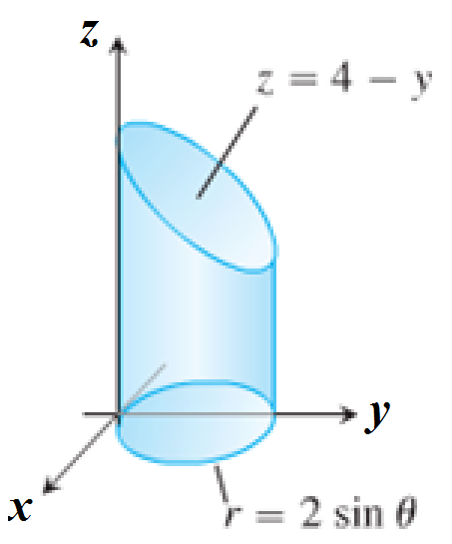Set up the iterated integral for evaluating  over the region *D* that is the right circular cylinder whose base is the circle  in the *xy*-plane and whose top lies in the plane 

***Solution***





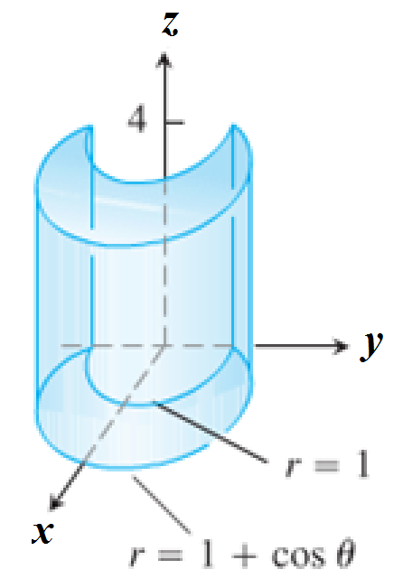***Exercise***

Set up the iterated integral for evaluating  over the region *D* which is the solid right cylinder whose base is the region in the *xy*-plane that lies inside the cardioid  and outside the circle  and whose top lies in the plane 

***Solution***





***Exercise***

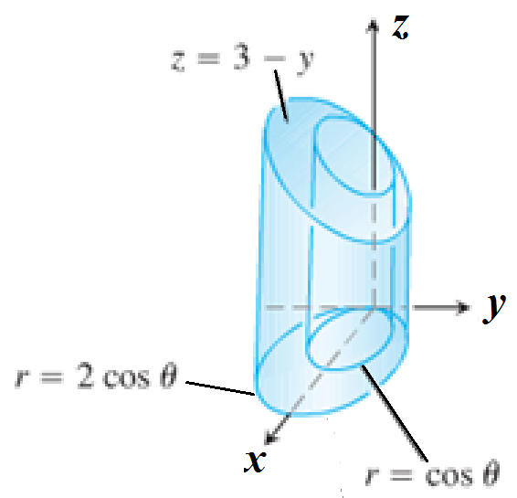Set up the iterated integral for evaluating  over the region *D* which is the solid right cylinder whose base is the region between the circles  and  and whose top lies in the plane 

***Solution***



***Exercise***

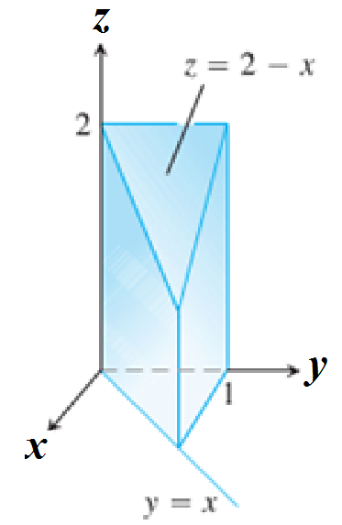Set up the iterated integral for evaluating  over the region *D* which is the prism whose base is the triangle in the *xy*-plane bounded by the y-axis and the lines  and  and whose top lies in the plane 

***Solution***







***Exercise***

Evaluate the integrals in cylindrical coordinates. 

***Solution***

















***Exercise***

Evaluate the integrals in cylindrical coordinates. 

***Solution***















***Exercise***

Evaluate the spherical coordinate integral 

***Solution***























***Exercise***

Evaluate the spherical coordinate integral 

***Solution***













***Exercise***

Evaluate the spherical coordinate integral 

***Solution***



 













***Exercise***

Evaluate the spherical coordinate integral 

***Solution***











***Exercise***

Evaluate the spherical coordinate integral 

***Solution***















***Exercise***

Evaluate the integral 

***Solution***













***Exercise***

Evaluate the integral 

***Solution***





















***Exercise***

Evaluate the spherical coordinate integral 

***Solution***









***Exercise***

Evaluate the spherical coordinate integral 

***Solution***









***Exercise***

Evaluate the spherical coordinate integral 

***Solution***

















***Exercise***

Evaluate the spherical coordinate integral 

***Solution***









***Exercise***

Evaluate the spherical coordinate integral 

***Solution***













***Exercise***

Evaluate the spherical coordinate integral 

***Solution***













***Exercise***

Evaluate the spherical coordinate integral 

***Solution***







***Exercise***

Evaluate the spherical coordinate integral 

***Solution***







***Exercise***

Evaluate the spherical coordinate integral 

***Solution***















***Exercise***

Evaluate the integral 

***Solution***



 













***Exercise***

Evaluate the integral 

***Solution***





















***Exercise***

Evaluate the integral 

***Solution***



 

 











***Exercise***

Evaluate the integral 

***Solution***



 

 











***Exercise***

Evaluate ; *D* is the unit ball.

***Solution***











***Exercise***

Evaluate ; *D* is the unit ball.

***Solution***











***Exercise***

Evaluate ; *D* is the solid between the spheres of radius 1 and 2 centered at the origin.

***Solution***











***Exercise***

Evaluate, where *D* is the region in the first octant between two spheres of radius 1 and 2 centered at the origin.

***Solution***

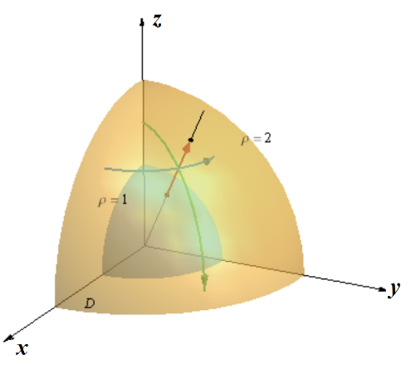









***Exercise***

Evaluate ; 

***Solution***











***Exercise***

Evaluate ; 

***Solution***















***Exercise***

Evaluate ; 

***Solution***

















***Exercise***

Evaluate ; 

***Solution***

















***Exercise***

Evaluate ; 

***Solution***













***Exercise***

Evaluate ; 

***Solution***





















***Exercise***

Evaluate ; 

***Solution***

















***Exercise***

Evaluate ; 

***Solution***

















***Exercise***

Evaluate ; 

***Solution***

























***Exercise***

Evaluate ; 

***Solution***















***Exercise***

Find the volume of the solid whose height is 4 and whose base is the disk 

***Solution***

Base is the disk 















***Exercise***

Find the volume of the solid in the first octant bounded by the cylinder  and the plane 

***Solution***

 

first octant 











***Exercise***

Find the volume of the solid bounded by the cylinder  and  and the planes  and 

***Solution***

 and  

























***Exercise***

Find the volume of the solid *D* between the cone  and the inverted paraboloid 

***Solution***



















***Exercise***

Find the volume of the solid region *D* that lies inside the cone  and inside the sphere 

***Solution***

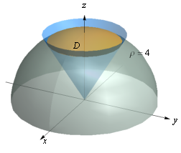









***Exercise***

Find the volume of the solid between the sphere  and the hemisphere 

***Solution***



 

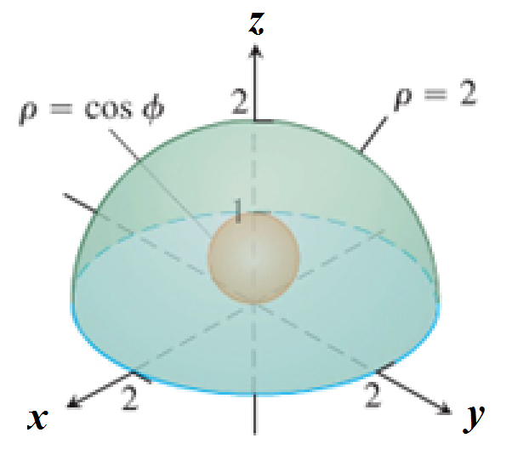 









***Exercise***

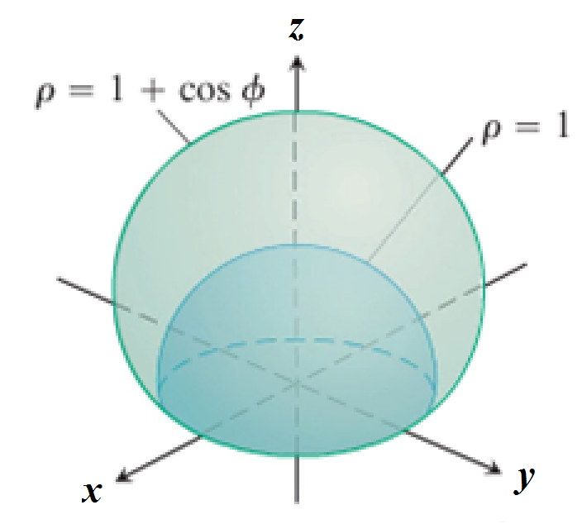Find the volume of the solid bounded below by the hemisphere , and above the cardioid of revolution 

***Solution***



















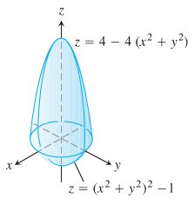***Exercise***

Find the volume of the solid

***Solution***

1. 























1. 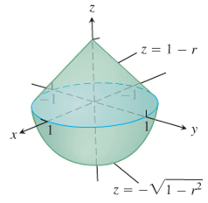









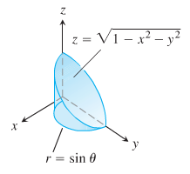 





1. 



 











 











1. 

 

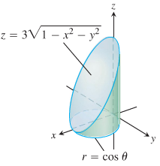 







 









***Exercise***

Find the volume of the smaller region cut from the solid sphere  by the plane 

***Solution***









 













***Exercise***

Find the volume of the region bounded below by the paraboloid , laterally by the cylinder , and above by the paraboloid 

***Solution***























***Exercise***

Find the volume of the region that lies inside the sphere  and outside the cylinder 

***Solution***





 













***Exercise***

Find the volume of the solid between the sphere  and the hyperboloid  for 

***Solution***



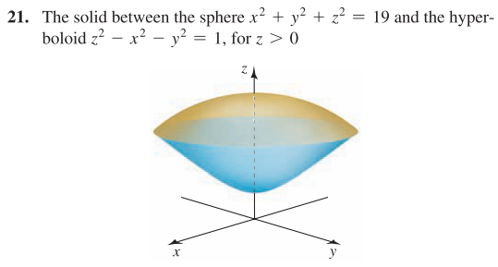





 *Convert to* ***Polar coordinates***











***Exercise***

Evaluate the integral in cylindrical coordinates 

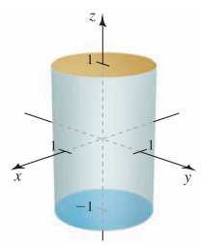***Solution***









***Exercise***

Evaluate the integral in cylindrical coordinates 

***Solution***

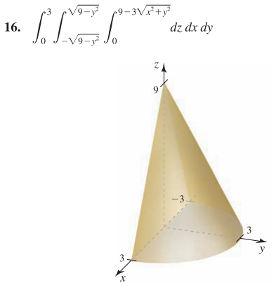











***Exercise***

Evaluate the integral in cylindrical coordinates 

***Solution***

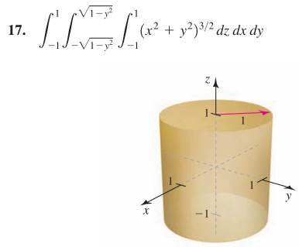







***Exercise***

Evaluate the integral in cylindrical coordinates 

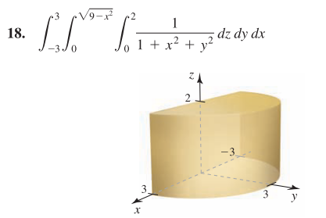

***Solution***









***Exercise***

Evaluate the integral in cylindrical coordinates to find the volume of the solid bounded by the plane  and the hyperboloid 

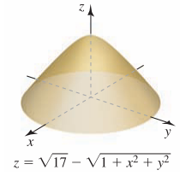***Solution***





















***Exercise***

Evaluate the integral in cylindrical coordinates to find the volume of the solid bounded by the plane  and the paraboloid 

***Solution***





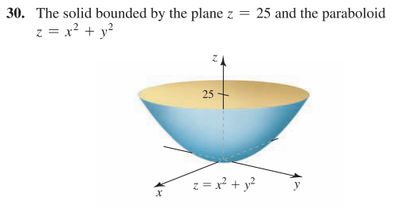 











***Exercise***

Evaluate the integral in cylindrical coordinates to find the volume of the solid bounded by the parabolic cylinders  and 

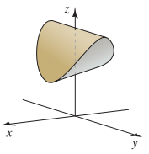***Solution***















***Exercise***

Evaluate the integral 

***Solution***



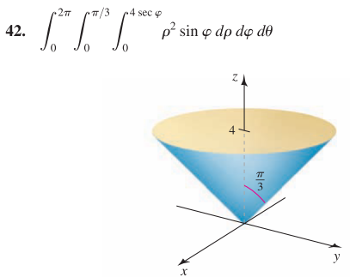 









***Exercise***

Evaluate the integral 

***Solution***

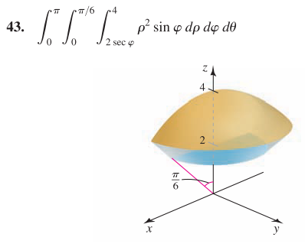













***Exercise***

Evaluate the integral 

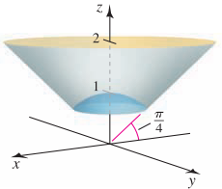

***Solution***

















***Exercise***

Evaluate the integral 

***Solution***







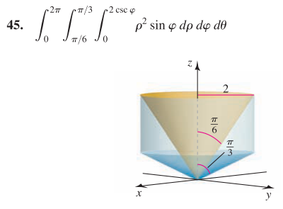 









***Exercise***

Use the spherical coordinates to find the volume of a ball of radius 

***Solution***









***Exercise***

Use the spherical coordinates to find the volume of the solid bounded by the sphere  and the hemisphere 

***Solution***



 



 











***Exercise***

Use the spherical coordinates to find the volume of the solid of revolution

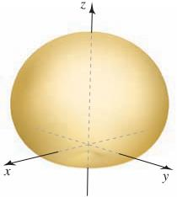

***Solution***















***Exercise***

Use the spherical coordinates to find the volume of the solid outside the cone  and inside the sphere 

***Solution***

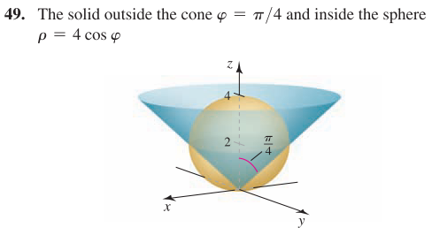













***Exercise***

Use the spherical coordinates to find the volume of the solid bounded by the cylinders  and , and the cone  and 

***Solution***

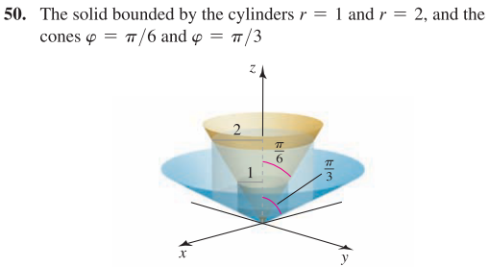















***Exercise***

Use the spherical coordinates to find the volume of the ball  that lies between the planes  and 

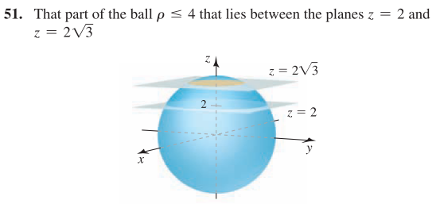

***Solution***





















***Exercise***

Use the spherical coordinates to find the volume of the solid inside the cone  that lies between the planes  and 

***Solution***



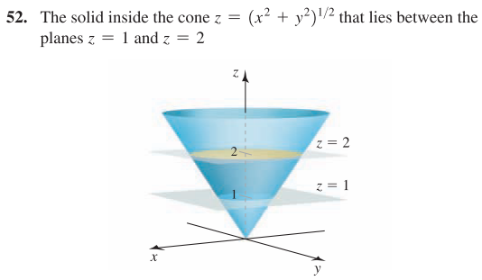









***Or***: 

***Exercise***

The *x-* and *y-*axes from the axes of two right circular cylinders with radius 1.

Find the volume of the solid that is common to the two cylinders.

***Solution***

Due to symmetry, this region is made up of *eight* identical pieces, one in each octant.

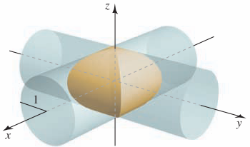















***Exercise***

The coordinate axes from the axes of three right circular cylinders with radius 1.

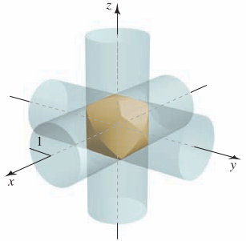

Find the volume of the solid that is common to the three cylinders.

***Solution***

|  |  |  |
| --- | --- | --- |
| SteinmetzCylinders3 | SteinmetzSolid3 | SteinmetzSolid3Exploded |

Due to symmetry, this region is made up of *eight* identical pieces, one in each octant.





If the particle starts at a point on the *xz-*plane for which , then 







 





























***Exercise***

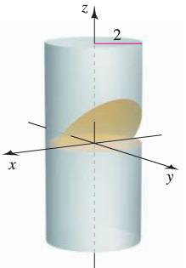Find the volume of one of the wedges formed when the cylinder  is cut by the planes  and 

***Solution***



















***Exercise***

Find the volume of the region inside the parabolic cylinder  between the planes  and 

***Solution***





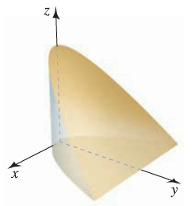

















***Exercise***

Find the volume of the tetrahedron with vertices , , , and 

***Solution***









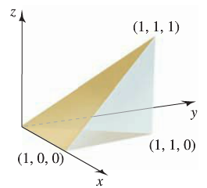 











***Exercise***

Find the volume of the region bounded by the plane  and the hyperboloid . Use integration in cylindrical coordinates.

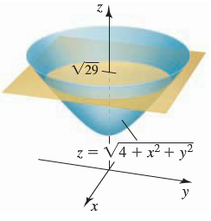***Solution***



























***Exercise***

Find the volume of the solid cylinder whose height is 4 and whose base is the disk . Use integration in cylindrical coordinates

***Solution***

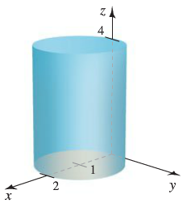











***Exercise***

Use integration in spherical coordinates to find the volume of the rose petal of revolution



***Solution***





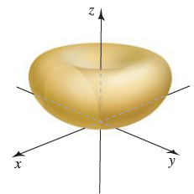 

















***Exercise***

Use integration in spherical coordinates to find the volume of the region above the cone and inside the sphere .

***Solution***

  



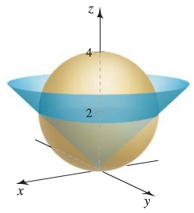 











***Exercise***

Find the volume of the cardioid of revolution 

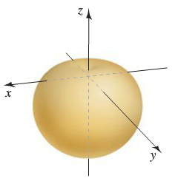***Solution***















***Exercise***

A cake is shaped like a solid cone with radius 4 and height 2, with its base on the *xy-*plane. A wedge of the cake is removed by making two slices from the axis of the cone outward, perpendicular to the *xy-*plane separated by an angle of *Q* radians, where 

1. Find the volume of the slice for . Use geometry to check your answer.
2. Find the volume of the slice for . Use geometry to check your answer.

***Solution***

Volume of a cone  



Equation of the cone in cylindrical coordinates is:







1. 











Since , then the volume of the slice is equal to  of the cone volume



1. 











Geometrically, since *Q* in radians, then  of a circle.

∴ Volume of the slice is  times of the curve.

***Exercise***

A spherical fish tank with a radius of 1 *ft* is filled with water to a level 6 *in*. below the top of the tank.

1. Determine the volume and weight of the water in the fish tank. (The weight density of water is about 62.5 .)
2. How much additional water must be added to completely fill the tank?

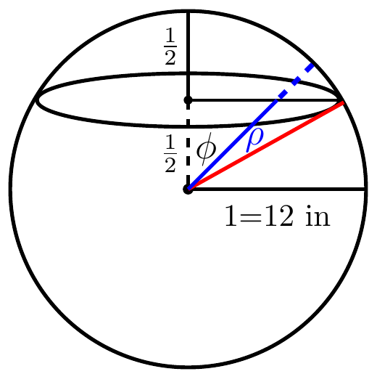***Solution***









1. Volume of empty spherical cap:



















Volume of a sphere is 

∴ Volume of water 

Weights 

1. The addition water to fill the tank is 

***Exercise***

A spherical cloud of electric charge has known charge density , where *ρ* is the spherical coordinate. Find the total charge in the cloud in the following cases.

1. 
2. 
3. 

***Solution***

1. 



 



1. 



 

1. 





 



***Exercise***

A point mass *m* is a distance *d* from the center of a thin spherical shell of mass *M* and radius *R*. The magnitude of the gravitational force on the point mass is given by the integral



Where *G* is the gravitational constant.

1. Use the change of variable  to evaluate the integral and show that if , then , which means the force is the same as if the mass of the shell were concentrated at its center.
2. Show that is  (the point mass is inside the shell), then .

***Solution***

1. 



































If , then





1. If , then





***Exercise***

Before a gasoline-powered engine is started, water must be drained from the bottom of the fuel tank. Suppose the tank is a right circular cylinder on its side with a length of 2 *feet* and a radius of 1 *foot*. If the water level is 6 *inches*. above the lowest part of the tank, determine how much water must be drained from the tank.

***Solution***

