***Section* 3.6 – Integrals for Mass Calculations**

**One-Dimensional Center of Mass**

If two objects with masses  and  sit at distances  and  from the pivot point (with no mass), then the balances provided 

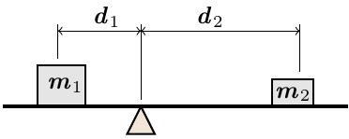

Solving the equation for , the balance point or center of mass of the two-mass system is located at



The quantities  and  are called moments about the origin (or just moments). The location of the center of mass is the sum of moments divided by the sum of the masses.



***Mass and Moment Calculations***

We treat coil springs and wires as masses distributed along smooth curves in space. The distribution is described by a continuous density function  representing mass per unit length. When a curve *C* is parametrized by , the density is the function , and then the arc length differential is given by



The formula of mass is



|  |
| --- |
| ***Mass and moment formulas for coil springs, wires, and thin rods lying along a smooth curve C in space*** |
| ***Mass***: |
| ***First moments about the coordinates planes***: |
| ***Coordinates of the center of mass***: |
| ***Moments of inertia about axes and other lines***: |

***Example***

A slender metal arch, denser at the bottom than top, lies along the semicircle , in the *yz*-plane. Find the center of the arch’s mass if the density at the point  on the arch is 

***Solution***

, because the arch lies in the *yz*-plane with its mass distributed symmetrically about the *z*-axis.

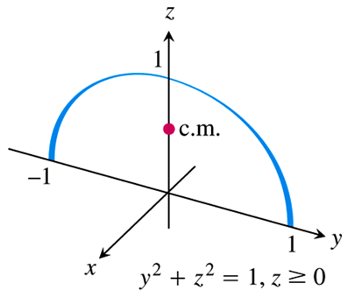









































 

The center mass is 

**Two-Dimensional Objects**

***Definition***

Let *ρ* be an integrable area density function defined over a closed bounded region ***R*** in . The coordinates of the center of mass of the object represented by ***R*** are:



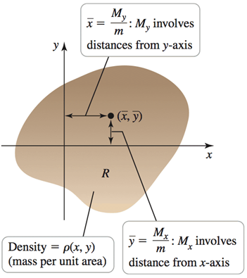

Where  is the mass, and  and  are the moments with respect to the *y*-axis and *x-*axis, respectively. If *ρ* is constant, the center of mass is called the ***centroid*** and is independent of the density,

***Example***

Find the centroid (center of mass) of the constant density, dart-shaped region bounded by the *y-*axis and the curves 

***Solution***

Assume: 









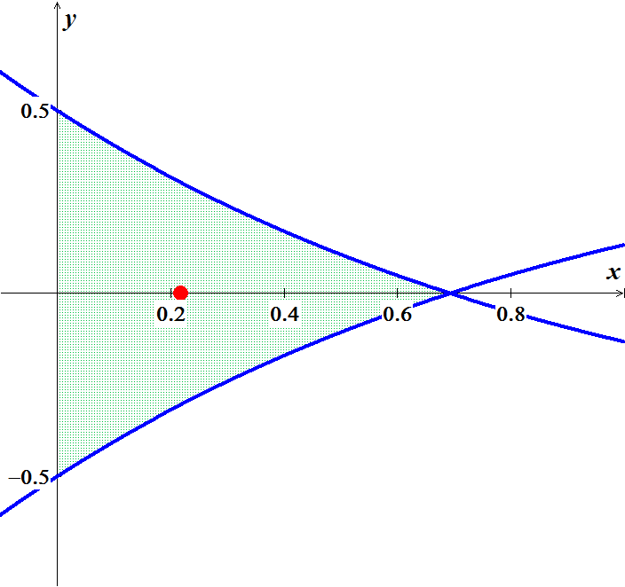













|  |  |  |
| --- | --- | --- |
|  |  |  |
| **+** | *x* |  |
| **−** | 1 |  |







 







 





The center of mass is located approximately at 

**Three-Dimensional Objects**

***Definition***

Let *ρ* be an integrable area density function defined over a closed bounded region ***D*** in . The coordinates of the center of mass of the object represented by ***D*** are:







Where  is the mass.

 are the moments with respect to the coordinates planes.

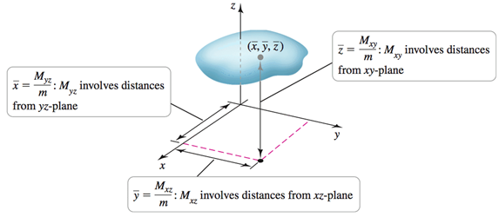

***Example***

Find the center of mass of the constant density solid cone ***D*** bounded by the surface



***Solution***

The one is symmetric about the *z-*axis and has uniform density, the center of mass lies on the *z-*axis, that is, .

The disk has a radius of 4 and centered at the origin. Therefore, the cone has height 4 and radius 4; by the volume formula is .

The cone has a constant density, so we assume that  and its mass is 





















∴ The center of mass is located at 

***Example***

Find the center of mass of the interior of the hemisphere ***D*** of a radius *a* with its base on the *xy-*plane. The density of the objects is  (heavy near the center and light near the outer surface.)

***Solution***

The one is symmetric about the *z-*axis and has uniform density, the center of mass lies on the *z-*axis, that is .

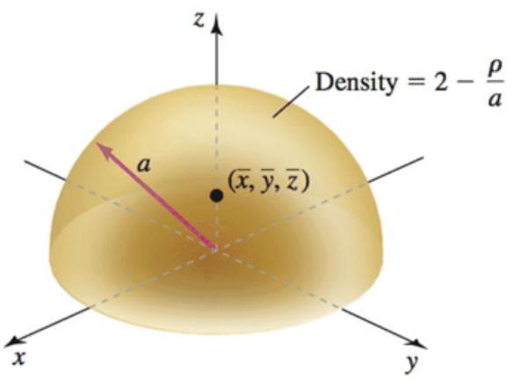









In spherical coordinate: 

 

 











However; the center of mass of a uniform-density hemisphere solid of radius *a* is  units above the base. In this particular case, the variable density shifts the center of mass.

***Example***

Find the moment of inertia about the *x-*axis of the curve:  from  to 

***Solution***





 



















***Exercises Section* 3.6 – Integrals for Mass Calculations**

Find the location of the center of mass

1.  located at ;  located at 
2.  located at ;  located at ;  located at 

(**3 – 6**) Find the mass of the following objects with given density functions

1. The solid cylinder  with density 
2. The solid cylinder  with density 
3. The solid cylinder  with density 
4. The solid cylinder  with density 

(**7 – 12**) Find the mass and center of mass of the thin rods with the following density functions.

1. 
2. 
3. 
4. 
5. 

1. 

(**13 – 27**) Find the mass and centroid (center of mass) of the following thin plates, assuming a constant density. Sketch the region corresponding to the plate and indicate the location of the center of mass. Use symmetry when possible to simplify your work.

1. The region bounded by  and  between 
2. The region bounded by  and the *x-*axis
3. The region bounded by 
4. The region bounded by 
5. The region bounded by 
6. The region bounded by  and  between  and .
7. The region bounded by  and  between  and .
8. The half annulus 
9. The region bounded by  and 
10. The semicircular disk 
11. The quarter-circular disk 
12. The region bounded by the cardioid 
13. The region bounded by the cardioid 
14. The region bounded by one leaf of the rose  for 
15. The region bounded by the limaçon 

(**28 – 42**) Find the coordinates of the center of mass of the following plane regions with variable density. Describe the distribution of mass in the region

1. 
2. 
3. 
4. 
5. The triangular plate in the first quadrant bounded by  with 
6. The upper half  of the disk bounded by the circle  with 
7. The upper half  of the disk bounded by the ellipse  with 
8. The quarter disk in the first quadrant bounded by  with 
9. The upper half of a ball  with density 
10. The region bounded by the upper half of the sphere  and  with density 
11. The cube in the first octant bounded by the planes , , , with 
12. The interior of the cube in the first octant formed by the planes , ,  with 
13. The region bounded by the paraboloid  and  with 
14. The interior of the prism formed by , , , and the coordinate planes with 
15. The region bounded by the cone  and  with 

(**43 – 51**) Find the center of mass of the following solids, assuming a constant density of 1. Sketch the region and indicate the location of the centroid. Use symmetry when possible and choose a convenient coordinate system.

1. The upper half of the ball 
2. The region bounded by the paraboloid  and the plane 
3. The tetrahedron in the first octant bounded by  and the coordinate planes
4. The solid bounded by the cone  and the plane 
5. The paraboloid bowl bounded by  and 
6. The tetrahedron bounded by  and the coordinate planes.
7. The solid bounded by the cone  and the plane 
8. The sliced solid cylinder bounded by 
9. The solid bounded by the upper half  of the ellipsoid 

(**52 – 60**) Consider the following two- and three- dimensional regions. Compute the center of mass assuming constant density. All parameters are positive real numbers.

1. A region is bounded by a paraboloid with a circular base of radius *R* and height *h*. How far from the base is the center of mass?
2. Let *R* be the region enclosed by an equilateral triangle with sides of length *s*. what is the perpendicular distance between the center of mass of *R* and the edges of *R*?
3. An isosceles triangle has two sides of length *s* and a base of length *b*. how far from the base is the center of mass of the region enclosed by the triangle?
4. A tetrahedron is bounded by the coordinate planes and the plane . What are the coordinates of the center of mass?
5. A solid box has sides of length *a*, *b*, and *c*. Where is the center of mass relative to the faces of the box?
6. A solid cone has a base with a radius of *r* and a height of *h*. How far from the base is the center of mass?
7. A solid is enclosed by a hemisphere of radius *a*. How far from the base is the center of mass?
8. A tetrahedron is bounded by the coordinate planes and the plane . What are the coordinates.
9. A solid is enclosed by the upper half of an ellipsoid with a circular base of radius *r* and a height of *a*. How far from the base is the center of mass?
10. A thin (one-dimensional) wire of constant density is bent into the shape of a semicircular of radius *r*. Find the location of its center of mass.
11. A thin plate of constant density occupies the region between the parabola  and the horizontal line , where  and . Show that the center of mass is , independent of *a*.
12. Find the center of mass of the region in the first quadrant bounded by the circle  and the lines  and , where 

Find the mass and center of mass of the thin constant-density of the plate

|  |  |
| --- | --- |
|  |  |

1. A thin rod of length *L* has a linear density given by  on the interval . Find the mass and center of mass of the rod. How does the center of mass change as ?
2. A thin rod of length *L* has a linear density given by  on the interval . Find the mass and center of mass of the rod. How does the center of mass change as ?
3. A thin plate is bounded by the graphs of , , , and . Find its center of mass. How does the center of mass change as ?
4. Consider the thin constant-density plate  bounded by two semicircles and the *x-*axis.
5. Find the graph the *y-*coordinate of the center of mass of the plate as a function of *a*.
6. For what value of *a* is the center of mass on the edge of the plate?
7. Consider the thin constant-density plate  bounded by two hemispheres and the *xy-*axis.
8. Find the graph the *z-*coordinate of the center of mass of the plate as a function of *a*.
9. For what value of *a* is the center of mass on the edge of the solid?
10. A cylindrical soda can has a radius of 4 *cm* and a height of 12 *cm*. When the can is full of soda, the center of mass of the contents of the can is 6 cm above the base on the axis of the can (halfway along the axis of the can). As the can is drained, the center of mass descends for a while. However, when the can is empty (filled only with air), the center of mass is once again 6 *cm* above the base on the axis of the can. Find the depth of soda in the can for which the center of mass is at its lowest point. Neglect the mass of the can, and assume the density of the soda is  and the density of air is 
11. For , the solid bounded by the cone  and the solid bounded by the paraboloid  have the same base in the *xy*-plane and the same height. Which object has the greater mass if the density of both objects is 
12. For , the solid bounded by the cone  and the solid bounded by the paraboloid  have the same base in the *xy*-plane and the same height. Which object has the greater mass if the density of both objects is 
13. A right circular cylinder with height 8 *cm* and radius 2 *cm* is filled with water. A heated filament running along its axis produces a variable density in the water given by  (*ρ* stands for density, not the radial spherical coordinate). Find the mass of the water in the cylinder. Neglect the volume of the filament.
14. A triangular region has a base that connects the vertices  and , and a third vertex at , where , and 
15. Show that the centroid of the triangle is 
16. Recall that the three medians of a triangle extend from each vertex to the midpoint of the opposite side. Knowing that the medians of a triangle intersect in a point *M* and that each median bisects the triangle, conclude that the centroid of the triangle is *M*.
17. Geographers measure the geographical center of a country (which is the centroid) and the population center of a country (which is the center of mass computed with the population density).A hypothetical country is shown below with the location and population of five towns.

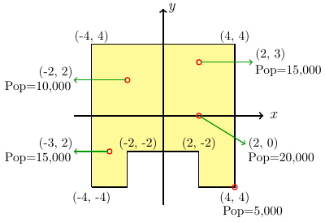

Assuming no one lives outside the towns, find the geographical center of the country and the population center of the country,

1. A disk radius *r* is removed from a larger disk of radius *R* to from an earring. Assume the earing is a thin plate of uniform density.

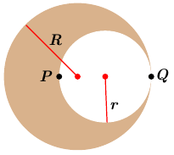

1. Find the center of mass of the earring in terms of *r* and *R*. (Hint: Place the origin of a coordinate system either at the center of the larger disk or at *Q*; either way, the earring is symmetric about the *x-*axis.)
2. Show that the ratio  such that the center of mass lies at the point *P* (on the edge of the inner disk) is the golden mean .