***Solution*** ***Section* 3.6 – Integrals for Mass Calculations**

***Exercise***

Find the location of the center of mass

 located at ;  located at 

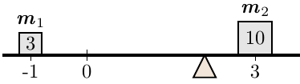***Solution***

 



***Exercise***

Find the location of the center of mass

 located at ;  located at ;  located at 

***Solution***

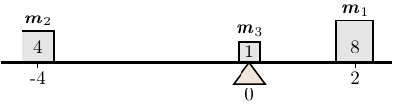

 



***Exercise***

Find the mass of the following objects with given density functions

The solid cylinder  with density 

***Solution***











***Exercise***

Find the mass of the following objects with given density functions

The solid cylinder  with density 

***Solution***















***Exercise***

Find the mass of the following objects with given density functions

The solid cylinder  with density 

***Solution***















***Exercise***

Find the mass of the following objects with given density functions

The solid cylinder  with density 

***Solution***

















***Exercise***

Find the mass and center of mass of the thin rods with the following density functions.



***Solution***



|  |  |  |
| --- | --- | --- |
|  |  |  |
| ***+*** | *x* | − cos*x* |
| **−** | 1 | −sin*x* |













Center of mass:  



***Exercise***

Find the mass and center of mass of the thin rods with the following density functions.



***Solution***















Center of mass:

 



***Exercise***

Find the mass and center of mass of the thin rods with the following density functions.



***Solution***









Center of mass:

 







***Exercise***

Find the mass and center of mass of the thin rods with the following density functions.



***Solution***







Center of mass:

|  |  |  |
| --- | --- | --- |
|  |  |  |
| **+** | *x* | sin*x* |
| **−** | 1 | −cos*x* |

 





***Exercise***

Find the mass and center of mass of the thin rods with the following density functions.



***Solution***









Center of mass:

 







***Exercise***

Find the mass and center of mass of the thin rods with the following density functions.



***Solution***









Center of mass:

 











***Exercise***

Find the mass and centroid (center of mass) of the following thin plates, assuming a constant density. Sketch the region corresponding to the plate and indicate the location of the center of mass. Use symmetry when possible to simplify your work.

The region bounded by  and  between 

***Solution***

|  |  |
| --- | --- |
|  |  |
| *x* | − cos*x* |
| 1 | −sin*x* |







Center of mass:

 





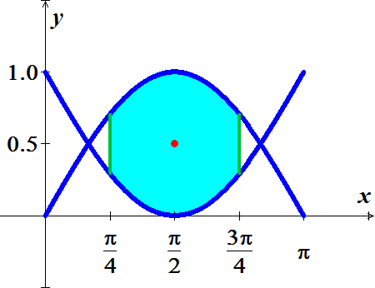 









***Centroid***: 

***Exercise***

Find the mass and centroid (center of mass) of the following thin plates, assuming a constant density. Sketch the region corresponding to the plate and indicate the location of the center of mass. Use symmetry when possible to simplify your work.

The region bounded by  and the *x-*axis

***Solution***

By symmetry: 

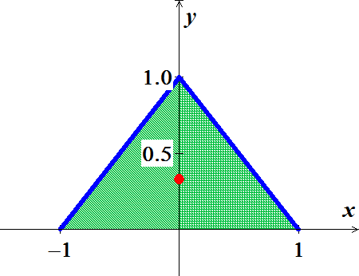





Center of mass:







 



***Exercise***

Find the mass and centroid (center of mass) of the following thin plates, assuming a constant density. Sketch the region corresponding to the plate and indicate the location of the center of mass. Use symmetry when possible to simplify your work.

The region bounded by 

***Solution***

Assuming: 

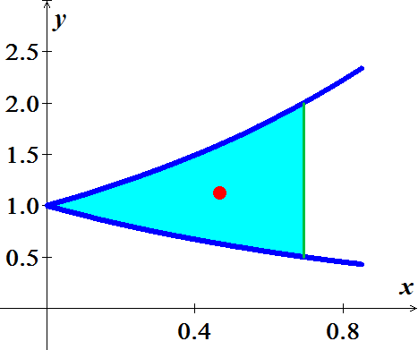











 













 



So, the center of mass is 

***Exercise***

Find the mass and centroid (center of mass) of the following thin plates, assuming a constant density. Sketch the region corresponding to the plate and indicate the location of the center of mass. Use symmetry when possible to simplify your work.

The region bounded by 

***Solution***

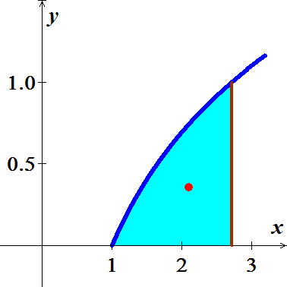Assume: 











 

|  |  |
| --- | --- |
|  |  |











So, the center of mass is 

***Exercise***

Find the mass and centroid (center of mass) of the following thin plates, assuming a constant density. Sketch the region corresponding to the plate and indicate the location of the center of mass. Use symmetry when possible to simplify your work.

The region bounded by 

***Solution***

Assume: 

 



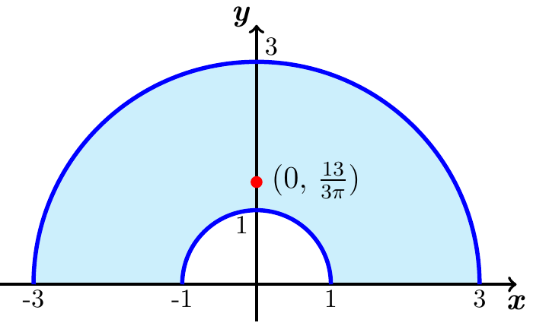 



By symmetry  (*clearly*).





 



∴ The center of mass is 

***Exercise***

Find the mass and centroid (center of mass) of the following thin plates, assuming a constant density. Sketch the region corresponding to the plate and indicate the location of the center of mass. Use symmetry when possible to simplify your work.

The region bounded by  and  between  and 

***Solution***







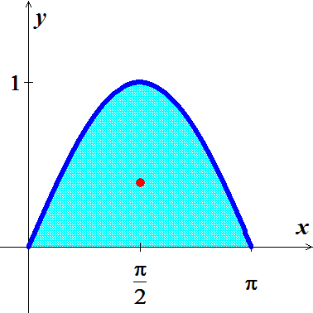 (*Symmetry*)













***Centroid***: 

***Exercise***

Find the mass and centroid (center of mass) of the following thin plates, assuming a constant density. Sketch the region corresponding to the plate and indicate the location of the center of mass. Use symmetry when possible to simplify your work.

The region bounded by  and  between  and 

***Solution***





























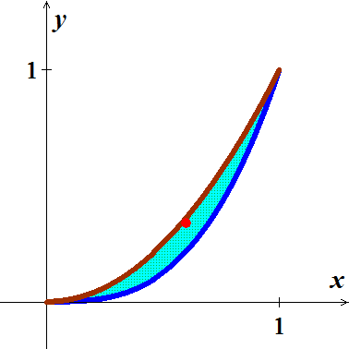 









***Centroid***: 

***Exercise***

Find the mass and centroid (center of mass) of the following thin plates, assuming a constant density. Sketch the region corresponding to the plate and indicate the location of the center of mass. Use symmetry when possible to simplify your work.

The half annulus 

***Solution***









 (*By Symmetry*)





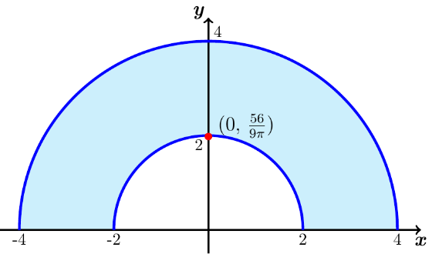 





***Centroid***: 

***Exercise***

Find the mass and centroid (center of mass) of the following thin plates, assuming a constant density. Sketch the region corresponding to the plate and indicate the location of the center of mass. Use symmetry when possible to simplify your work.

The region bounded by  and 

***Solution***







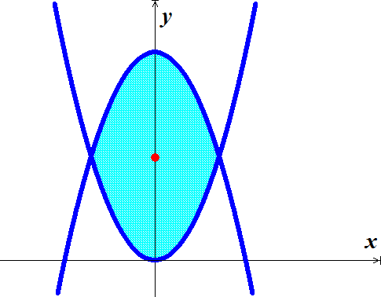 









 (*By Symmetry*)

 













***Centroid***: 

***Exercise***

Find the mass and centroid (center of mass) of the following thin plates, assuming a constant density. Sketch the region corresponding to the plate and indicate the location of the center of mass. Use symmetry when possible to simplify your work

The semicircular disk 

***Solution***







Since, , by symmetry 

 

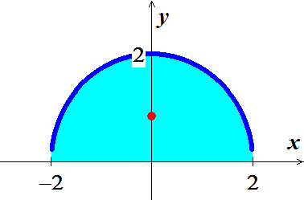 







∴ The center of mass is at 

***Exercise***

Find the mass and centroid (center of mass) of the following thin plates, assuming a constant density. Sketch the region corresponding to the plate and indicate the location of the center of mass. Use symmetry when possible to simplify your work

The quarter-circular disk 

***Solution***







 







 

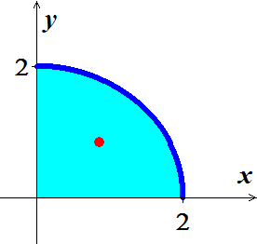 





∴ The center of mass is at 

***Exercise***

Find the mass and centroid (center of mass) of the following thin plates, assuming a constant density. Sketch the region corresponding to the plate and indicate the location of the center of mass. Use symmetry when possible to simplify your work

The region bounded by the cardioid 

***Solution***













 





























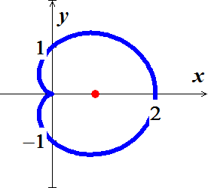 





By symmetry 

∴ The center of mass is at 

***Exercise***

Find the mass and centroid (center of mass) of the following thin plates, assuming a constant density. Sketch the region corresponding to the plate and indicate the location of the center of mass. Use symmetry when possible to simplify your work

The region bounded by the cardioid 

***Solution***













 





























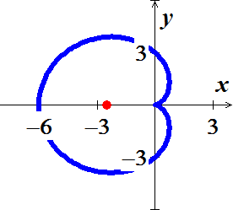 





By symmetry 

∴ The center of mass is at 

***Exercise***

Find the mass and centroid (center of mass) of the following thin plates, assuming a constant density. Sketch the region corresponding to the plate and indicate the location of the center of mass. Use symmetry when possible to simplify your work

The region bounded by one leaf of the rose  for 

***Solution***













 









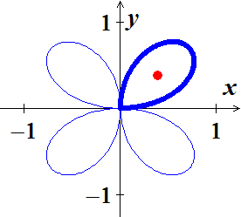 













By symmetry 

∴ The center of mass is at 

***Exercise***

Find the mass and centroid (center of mass) of the following thin plates, assuming a constant density. Sketch the region corresponding to the plate and indicate the location of the center of mass. Use symmetry when possible to simplify your work

The region bounded by the limaçon 

***Solution***













 





















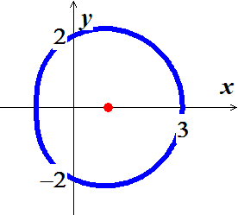 

















By symmetry 

∴ The center of mass is at 

***Exercise***

Find the coordinates of the center of mass of the following plane regions with variable density. Describe the distribution of mass in the region



***Solution***









 









 









∴ The center of mass is 

The density of the plate increases as you move toward the right.

***Exercise***

Find the coordinates of the center of mass of the following plane regions with variable density. Describe the distribution of mass in the region



***Solution***

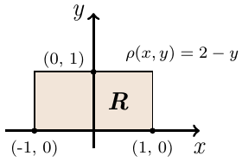









 









 (due to the symmetry)

∴ The center of mass is 

***Exercise***

Find the coordinates of the center of mass of the following plane regions with variable density. Describe the distribution of mass in the region



***Solution***









 











 

|  |  |  |
| --- | --- | --- |
|  |  |  |
| **+** |  |  |
| **−** | 1 |  |











∴ The center of mass is 

The density of the plate decreases as you move up the plate.

***Exercise***

Find the coordinates of the center of mass of the following plane regions with variable density. Describe the distribution of mass in the region



***Solution***







 









 









By symmetry 

∴ The center of mass is 

***Exercise***

Find the coordinates of the center of mass of the following plane regions with variable density. Describe the distribution of mass in the region

The triangular plate in the first quadrant bounded by  with 

***Solution***









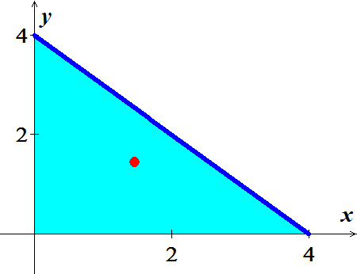 

 



By symmetry 









 



∴ The ***center of mass*** is 

***Exercise***

Find the coordinates of the center of mass of the following plane regions with variable density. Describe the distribution of mass in the region

The upper half  of the disk bounded by the circle  with 

***Solution***

 







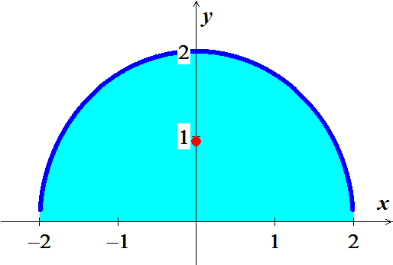 





By symmetry 





 









∴ The ***center of mass*** is 

The density increases as the plate is moved up.

***Exercise***

Find the coordinates of the center of mass of the following plane regions with variable density. Describe the distribution of mass in the region

The upper half  of the disk bounded by the ellipse  with 

***Solution***





 

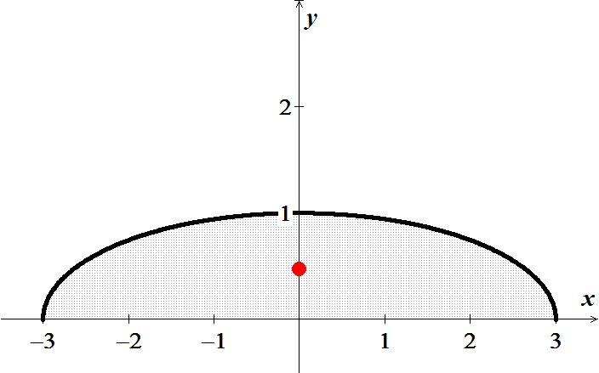 





By symmetry 





























∴ The center of mass is , the density increases as the plate is moved up.

***Exercise***

Find the coordinates of the center of mass of the following plane regions with variable density. Describe the distribution of mass in the region

The quarter disk in the first quadrant bounded by  with 

***Solution***





























By symmetry, 

∴ The center of mass is , the density of the plate increases as you move away from the origin.

***Exercise***

Find the coordinates of the center of mass of the following plane regions with variable density. Describe the distribution of mass in the region:

The upper half of a ball  with density 

***Solution***













By symmetry of the region of the density function around *z-*axis, then 

















∴ The ***center of mass*** is 

***Exercise***

Find the coordinates of the center of mass of the following plane regions with variable density. Describe the distribution of mass in the region

The region bounded by the upper half of the sphere  and  with density 

***Solution***













By symmetry of the region of the density function around *z-*axis, then 















∴ The ***center of mass*** is 

***Exercise***

Find the coordinates of the center of mass of the following plane regions with variable density. Describe the distribution of mass in the region:

The cube in the first octant bounded by the planes , , , with 

***Solution***















Since it is cube, by symmetry: 



















∴ The ***center of mass*** is 

***Exercise***

Find the coordinates of the center of mass of the following plane regions with variable density. Describe the distribution of mass in the region

The interior of the cube in the first octant formed by the planes , ,  with 

***Solution***

















Since it is cube, by symmetry: 





















∴ The ***center of mass*** is 

***Exercise***

Find the coordinates of the center of mass of the following plane regions with variable density. Describe the distribution of mass in the region

The region bounded by the paraboloid  and  with 

***Solution***

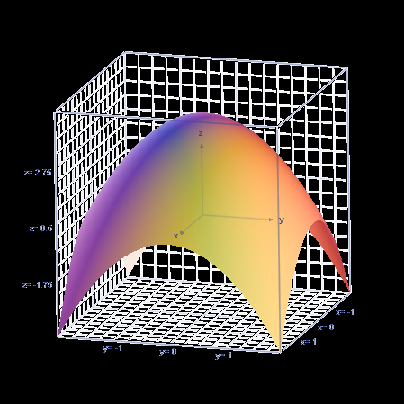

















By symmetry,  (since it depends on *z*.)





















∴ The center of mass is 

***Exercise***

Find the coordinates of the center of mass of the following plane regions with variable density. Describe the distribution of mass in the region

The interior of the prism formed by , , , and the coordinate planes with 

***Solution***













































∴ The center of mass is 

***Exercise***

Find the coordinates of the center of mass of the following plane regions with variable density. Describe the distribution of mass in the region

The region bounded by the cone  and  with 

***Solution***





















By symmetry,  (since it depends on *z*.)























∴ The center of mass is 

***Exercise***

Find the center of mass of the following solids, assuming a constant density of 1. Sketch the region and indicate the location of the centroid. Use symmetry when possible and choose a convenient coordinate system.

The upper half of the ball 

***Solution***

Assume: 

The mass is the volume of a half-sphere of radius 4: 

In spherical coordinates 



 







∴ The center of mass is 

***Exercise***

Find the center of mass of the following solids, assuming a constant density of 1. Sketch the region and indicate the location of the centroid. Use symmetry when possible and choose a convenient coordinate system.

The region bounded by the paraboloid  and the plane 

***Solution***

***Given***: 

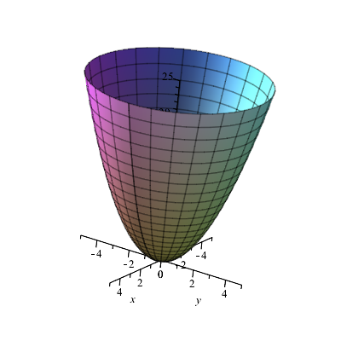













By symmetry 







 



∴ The center of mass is 

***Exercise***

Find the center of mass of the following solids, assuming a constant density of 1. Sketch the region and indicate the location of the centroid. Use symmetry when possible and choose a convenient coordinate system.

The tetrahedron in the first octant bounded by  and the coordinate planes

***Solution***

***Given***: 

The mass is the volume of a pyramid:



The region is symmetric with respect to the line 















 



∴ The center of mass is 

***Exercise***

Find the center of mass of the following solids, assuming a constant density of 1. Sketch the region and indicate the location of the centroid. Use symmetry when possible and choose a convenient coordinate system.

The solid bounded by the cone  and the plane 

***Solution***

***Given***: 

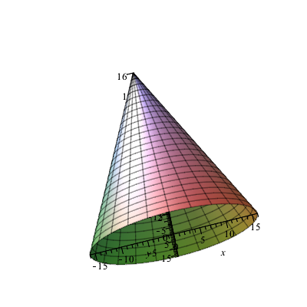











By symmetry 











∴ The center of mass is 

***Exercise***

Find the center of mass of the following solids, assuming a constant density of 1. Sketch the region and indicate the location of the centroid. Use symmetry when possible and choose a convenient coordinate system.

The paraboloid bowl bounded by  and 

***Solution***

***Given***: 

Since it is cylinder  , therefore the center of mass is 





















***Exercise***

Find the center of mass of the following solids, assuming a constant density of 1. Use symmetry when possible and choose a convenient coordinate system.

The tetrahedron bounded by  and the coordinate planes.

***Solution***

***Given***: 

























***Or*** 

By symmetry: 















































***Center of mass***: 

***Exercise***

Find the center of mass of the following solids, assuming a constant density of 1. Use symmetry when possible and choose a convenient coordinate system.

The solid bounded by the cone  and the plane 

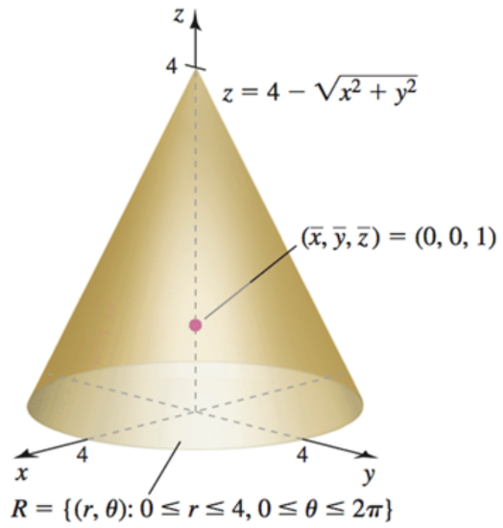***Solution***

















By symmetry,  (since it depends on *z*.)

















*∴ The center of mass is*: 

***Exercise***

Find the center of mass of the following solids, assuming a constant density of 1. Use symmetry when possible and choose a convenient coordinate system.

The sliced solid cylinder bounded by 

***Solution***























Since the region is symmetric around *yz-*plane, then 









































*∴ The center of mass is*: 

***Exercise***

Find the center of mass of the following solids, assuming a constant density of 1. Use symmetry when possible and choose a convenient coordinate system.

The solid bounded by the upper half  of the ellipsoid 

***Solution***





















By symmetry, 

















*∴ The center of mass is*: 

***Exercise***

Consider the following two- and three- dimensional regions. Compute the center of mass assuming constant density. All parameters are positive real numbers.

A region is bounded by a paraboloid with a circular base of radius *R* and height *h*. How far from the base is the center of mass?

***Solution***

Equation of the paraboloid: 



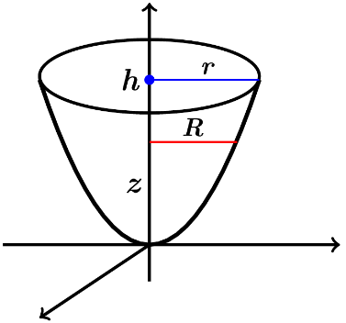













By symmetry; 















∴ The ***center of mass*** is  which is of the way from the base to the vertex.

***Exercise***

Consider the following two- and three- dimensional regions. Compute the center of mass assuming constant density. All parameters are positive real numbers.

Let *R* be the region enclosed by an equilateral triangle with sides of length *s*. what is the perpendicular distance between the center of mass of *R* and the edges of *R*?

***Solution***



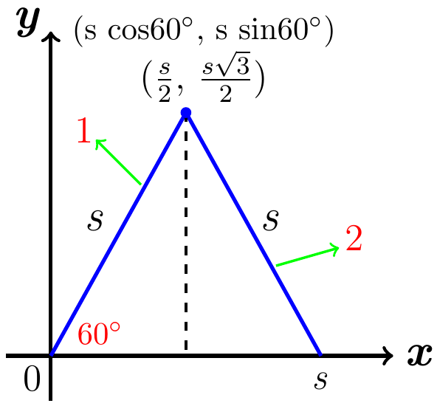





The area of the triangle:























Which is  of the triangle height.

***Exercise***

Consider the following two- and three- dimensional regions. Compute the center of mass assuming constant density. All parameters are positive real numbers.

An isosceles triangle has two sides of length *s* and a base of length *b*. how far from the base is the center of mass of the region enclosed by the triangle?

***Solution***

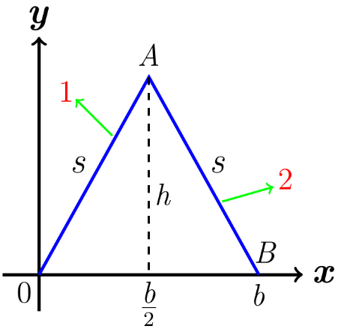







The area of the triangle:





















Which is  of the triangle height.

***Exercise***

Consider the following two- and three- dimensional regions. Compute the center of mass assuming constant density. All parameters are positive real numbers.

A tetrahedron is bounded by the coordinate planes and the plane . What are the coordinates of the center of mass?

***Solution***







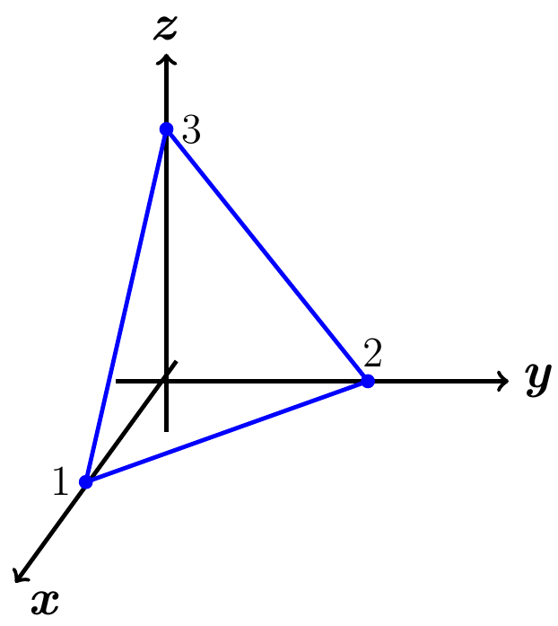

































































∴ *Center of mass*: 

***Exercise***

Consider the following two- and three- dimensional regions. Compute the center of mass assuming constant density. All parameters are positive real numbers.

A solid box has sides of length *a*, *b*, and *c*. Where is the center of mass relative to the faces of the box?

***Solution***

Obviously, the center of mass is at the center of the box.

If we let he center of the box be the origin point, then the distances will half of each side.



If we let *m* be the mass.

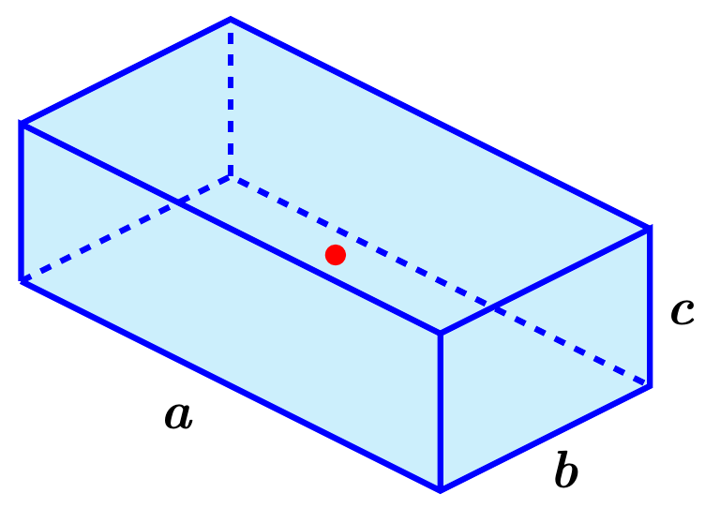

















***Exercise***

Consider the following two- and three- dimensional regions. Compute the center of mass assuming constant density. All parameters are positive real numbers.

A solid cone has a base with a radius of *r* and a height of *h*. How far from the base is the center of mass?

***Solution***

The mass of the cone is .

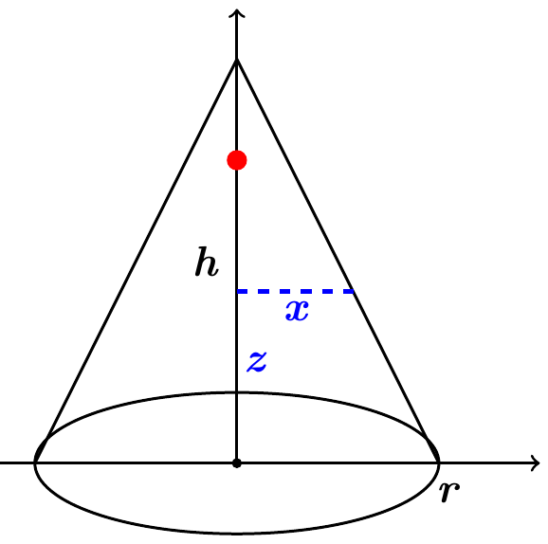



By symmetry, .











∴ The center of mass is 

***Exercise***

Consider the following two- and three- dimensional regions. Compute the center of mass assuming constant density. All parameters are positive real numbers.

A solid is enclosed by a hemisphere of radius *a*. How far from the base is the center of mass?

***Solution***

The mass of the hemisphere is .





By symmetry, .











∴ The center of mass is 

***Exercise***

Consider the following two- and three- dimensional regions. Compute the center of mass assuming constant density. All parameters are positive real numbers.

A tetrahedron is bounded by the coordinate planes and the plane . What are the coordinates of the center of mass?

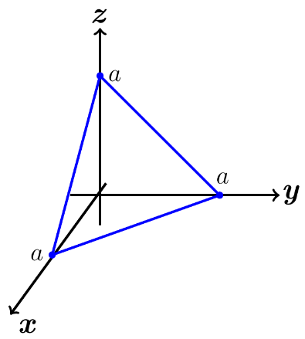***Solution***

























By symmetry, 























∴ The center of mass is 

***Exercise***

Consider the following two- and three- dimensional regions. Compute the center of mass assuming constant density. All parameters are positive real numbers.

A solid is enclosed by the upper half of an ellipsoid with a circular base of radius *r* and a height of *a*. How far from the base is the center of mass?

***Solution***







Using the cylindrical coordinates , then

























∴ The center of mass is  above the base toward the top of the ellipsoid.

***Exercise***

A thin (one-dimensional) wire of constant density is bent into the shape of a semicircular of radius *r*. Find the location of its center of mass.

***Solution***

The mass of the wire is equal to its length, which is half the circumference.



Assuming the density , then

By symmetry; 

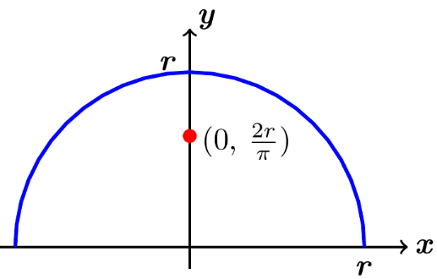















***Exercise***

A thin plate of constant density occupies the region between the parabola  and the horizontal line , where  and . Show that the center of mass is , independent of *a*.

***Solution***





Assuming the density , then

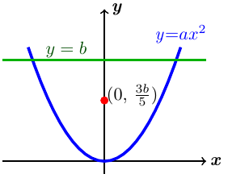













By symmetry; 

















∴ The center of mass is 

***Exercise***

Find the center of mass of the region in the first quadrant bounded by the circle  and the lines  and , where 

***Solution***





Assuming the density , then

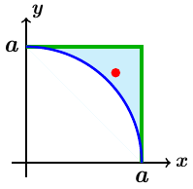















Or: ***mass*** = (*Area of the square*) – 



By symmetry; 



















∴ The center of mass is 

***Exercise***

Find the mass and center of mass of the thin constant-density of the plate

***Solution***

Let the density .

Line cross : 

Mass of the plate is the total area of the plate.



By symmetry; 





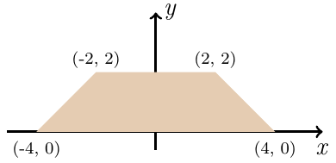 









∴ The center of mass is 

***Exercise***

Find the mass and center of mass of the thin constant-density of the plate

***Solution***

Mass = (Area of the large rectangle) − (Area of the small white rectangle)



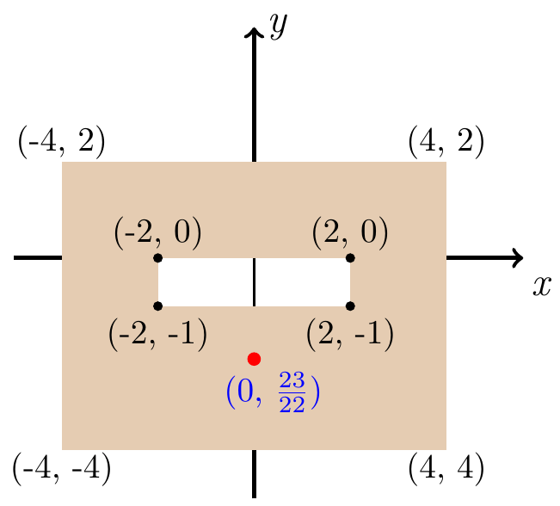 

By symmetry; 











∴ The center of mass is 

***Exercise***

A thin rod of length *L* has a linear density given by  on the interval . Find the mass and center of mass of the rod. How does the center of mass change as ?

***Solution***









|  |  |  |
| --- | --- | --- |
|  |  |  |
| **+** |  |  |
| **−** | 1 |  |











 

∴ The center of mass approaches 3 as 

***Exercise***

A thin rod of length *L* has a linear density given by  on the interval . Find the mass and center of mass of the rod. How does the center of mass change as ?

***Solution***

















∴ The center of mass approaches ∞ as 

***Exercise***

A thin plate is bounded by the graphs of , , , and . Find its center of mass. How does the center of mass change as ?

***Solution***













|  |  |  |
| --- | --- | --- |
|  |  |  |
| **+** |  |  |
| **−** | 1 |  |













 











As , the center of mass approaches 

***Exercise***

Consider the thin constant-density plate  bounded by two semicircles and the *x-*axis.

1. Find the graph the *y-*coordinate of the center of mass of the plate as a function of *a*.
2. For what value of *a* is the center of mass on the edge of the plate?

***Solution***

1. 

 



By symmetry  (*clearly*).







 



1. Since the center of mass has , therefore it lies on *y-*axis on the edge of the plate exactly when 





















 outside the range 

***Exercise***

Consider the thin constant-density plate  bounded by two hemispheres and the *xy-*axis.

1. Find the graph the *z-*coordinate of the center of mass of the plate as a function of *a*.
2. For what value of *a* is the center of mass on the edge of the solid?

***Solution***

1. 







By symmetry  (*clearly*).









1. Since the center of mass has , therefore it lies on *z-*axis on the edge of the plate exactly when 

|  |  |
| --- | --- |
|  | outside the range |

***Exercise***

A cylindrical soda can has a radius of 4 *cm* and a height of 12 *cm*. When the can is full of soda, the center of mass of the contents of the can is 6 cm above the base on the axis of the can (halfway along the axis of the can). As the can is drained, the center of mass descends for a while. However, when the can is empty (filled only with air), the center of mass is once again 6 *cm* above the base on the axis of the can. Find the depth of soda in the can for which the center of mass is at its lowest point. Neglect the mass of the can, and assume the density of the soda is  and the density of air is 

***Solution***

Volume of a full soda can: 



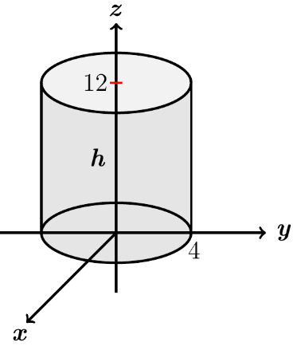Volume of air in can: 





Mass: 





***OR***





















For the lowest center of mass point when the derivative of the function is zero.









∴ The depth of soda in the can for which the center of mass is at its lowest point 

***Exercise***

For , the solid bounded by the cone  and the solid bounded by the paraboloid  have the same base in the *xy*-plane and the same height. Which object has the greater mass if the density of both objects is 

***Solution***





























∴ The paraboloid  has the greater mass.

***Exercise***

For , the solid bounded by the cone  and the solid bounded by the paraboloid  have the same base in the *xy*-plane and the same height. Which object has the greater mass if the density of both objects is 

***Solution***



|  |  |  |
| --- | --- | --- |
|  |  |  |
| **+** |  |  |
| **−** | 1 |  |



























 ∴ The paraboloid  has the greater mass.

***Exercise***

A right circular cylinder with height 8 *cm* and radius 2 *cm* is filled with water. A heated filament running along its axis produces a variable density in the water given by  (*ρ* stands for density, not the radial spherical coordinate). Find the mass of the water in the cylinder. Neglect the volume of the filament.

***Solution***















***Exercise***

A triangular region has a base that connects the vertices  and , and a third vertex at , where , and 

1. Show that the centroid of the triangle is 
2. Recall that the three medians of a triangle extend from each vertex to the midpoint of the opposite side. Knowing that the medians of a triangle intersect in a point *M* and that each median bisects the triangle, conclude that the centroid of the triangle is *M*.

***Solution***

1. Area of a triangle is 



Line between *O* and (*a, h*): 

Line between (*b,* 0) and (*a, h*): 

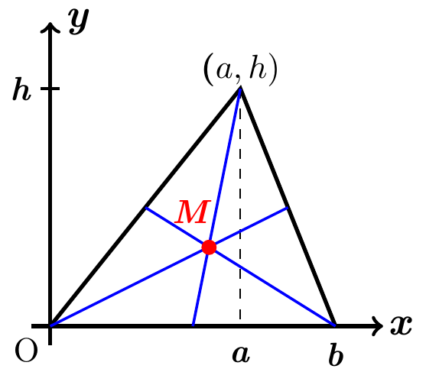











































The centroid of the triangle is 

In case , then

Line between *O* and line : 

Line between (*b,* 0) and (*a, h*): 



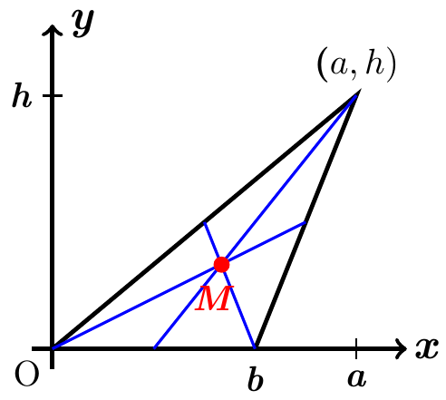 















































In both cases, the centroid of the triangle is 

1. Geometrically,

Line between  and line (*a, h*): 

Line between (0*,* 0) and  : 







 ***√***



 ***√***

The median point 

***Or***

Since each median bisects the triangle, the centroid must lie on each median since the triangle will be balanced with the respect to the axis determined by the median. Then the centroid must be at the intersection of the 3 medians.

***Exercise***

Geographers measure the geographical center of a country (which is the centroid) and the population center of a country (which is the center of mass computed with the population density).A hypothetical country is shown below with the location and population of five towns.

Assuming no one lives outside the towns, find the geographical center of the country and the population center of the country,

***Solution***

Mass = (area of the outside rectangle with the gap) – (area of the gap)





Since it is symmetric about the , then 





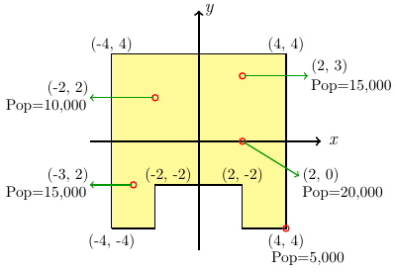 



∴ The centroid is 

The population center:













∴ The population center is at 

***Exercise***

A disk radius *r* is removed from a larger disk of radius *R* to from an earring. Assume the earing is a thin plate of uniform density.

1. Find the center of mass of the earring in terms of *r* and *R*. (Hint: Place the origin of a coordinate system either at the center of the larger disk or at *Q*; either way, the earring is symmetric about the *x-*axis.)
2. Show that the ratio  such that the center of mass lies at the point *P* (on the edge of the inner disk) is the golden mean .

***Solution***

1. Let *Q* be the origin point.

Mass = (mass of large circle) − (mass of large circle)



Using the polar coordinates 

For the small circle:









For the large circle, the same 













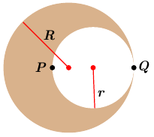 









∴ The center of mass is at  from *Q*.

1. If the center of the mass lies at the point *P*, then











Since , then 