***Solution*** ***Section* 3.7 – Change of Variables in Multiple Integrals**

***Exercise***

Let  be a unit square in the *uv-*plane. Find the image of *S* in the *xy-*plane under the following transformations. 

***Solution***

|  |  |  |
| --- | --- | --- |
|  | ⇔ |  |

The transformation just switches the coordinates. Image *xy* is unit square.

***Exercise***

Let  be a unit square in the *uv-*plane. Find the image of *S* in the *xy-*plane under the following transformations. 

***Solution***

|  |  |  |
| --- | --- | --- |
|  | ⇔ |  |







*T* is a unit square in *Q*II with one vertex at origin.

***Exercise***

Let  be a unit square in the *uv-*plane. Find the image of *S* in the *xy-*plane under the following transformations. 

***Solution***



|  |  |
| --- | --- |
|  |  |
|  |  |
|  |  |
|  |  |

|  |  |  |
| --- | --- | --- |
|  | ⇔ | Diamond shape |

***Exercise***

Let  be a unit square in the *uv-*plane. Find the image of *S* in the *xy-*plane under the following transformations. 

***Solution***



|  |  |
| --- | --- |
|  |  |
|  |  |
|  |  |
|  |  |

|  |  |  |
| --- | --- | --- |
|  | ⇔ |  |

***Exercise***

*a*) Solve the system  for *x* and *y* in terms of *u* and *v*. Then find the value of

the Jacobian 

*b*) Find the image under the transformation  of the triangular region with vertices (0, 0), (1, 1), and (1, −2) in the *xy*-plane. Sketch the transformed region in the *uv*-plane.

***Solution***

1. 







1. From (0, 0) to (1, 1)  

From (0, 0) to (1, −2)  

From (1, 1) to (1, −2) 





OR: 





***Exercise***

Let *R* be the region in the first quadrant of the *xy*-plane bounded by the hyperbolas  and the lines . Use the transformation  with  to rewrite



As an integral over an appropriate region *G* in the *uv*-plane. Then evaluate the *uv*-integral over *G*.

***Solution***





 

















***Exercise***

The area  of the ellipse  can be found by integrating the function  over the region bounded by the ellipse in the *xy*-plane. Evaluating the integral directly requires a trigonometric substitution. An easier way to evaluate the integral is to use the transformation  and evaluate the transformed integral over the disk *G*:  in the *uv*-plane. Find the area this way.

***Solution***













 











***Exercise***

Use the transformation  to evaluate the integral



By first writing it as an integral over a region *G* in the *uv*-plane.

***Solution***











|  |  |  |
| --- | --- | --- |
|  |  |  |
|  |  |  |
|  |  |  |
|  |  |  |

 











***Exercise***

Use the transformation  to evaluate the integral



***Solution***





|  |  |  |
| --- | --- | --- |
|  |  |  |
|  |  |  |
|  |  |  |
|  |  |  |

















***Exercise***

Find the Jacobian  of the transformation

1. 
2. 

***Solution***

1. 





1. 





***Exercise***

Find the Jacobian  of the transformation

1. 
2. 

***Solution***

1. 





1. 

***Exercise***

Evaluate the appropriate determinant to show that the Jacobian of the transformation from Cartesian *ρφθ*−space to Cartesian *xyz*−space is 

***Solution***















***Exercise***

How can substitutions in single definite integrals be viewed as transformations of regions? What is the Jacobian in such a case? Illustrate with an example.

***Solution***

Let 



 represents the Jacobian of the transformation 

***Exercise***

Find the volume of the ellipsoid 

(***Hint***: Let . Then find the volume of an appropriate region in *uvw*-space)

***Solution***















***Exercise***

Use the transformation  to evaluate the integral



(Hint: Show that the image of the triangular region *G* with vertices (0, 0), (1, 0), (1, 1) in the uv-plane is the region of integration *R* in the *xy-*plane defined by the limits of integration.)

***Solution***



 





|  |  |  |
| --- | --- | --- |
|  |  |  |
|  |  |  |
|  |  |  |























***Exercise***

Evaluate ; *R* is the region bounded by the hyperbolas  and  and the lines , and 

***Solution***

Let 







 





|  |  |  |
| --- | --- | --- |
|  |  |  |
|  |  |  |
|  |  |  |
|  |  |  |

 











***Exercise***

Evaluate ; *R* is the region bounded by the lines , , , and 

***Solution***



Let 



 



|  |  |  |
| --- | --- | --- |
|  |  |  |
|  |  |  |
|  |  |  |
|  |  |  |

















***Exercise***

Evaluate ; *R* is bounded by the planes , , , ,  and 

***Solution***

Let 































***Exercise***

Let *R* be the region bounded by the lines 

Evaluate the integral 

***Solution***

Let 









 



|  |  |  |
| --- | --- | --- |
|  |  |  |
|  |  |  |
|  |  |  |
|  |  |  |



















***Exercise***

Let *R* be the region bounded by the square with vertices (0, 1), (1, 2), (2, 1), & (1, 0).

Evaluate the integral 

***Solution***



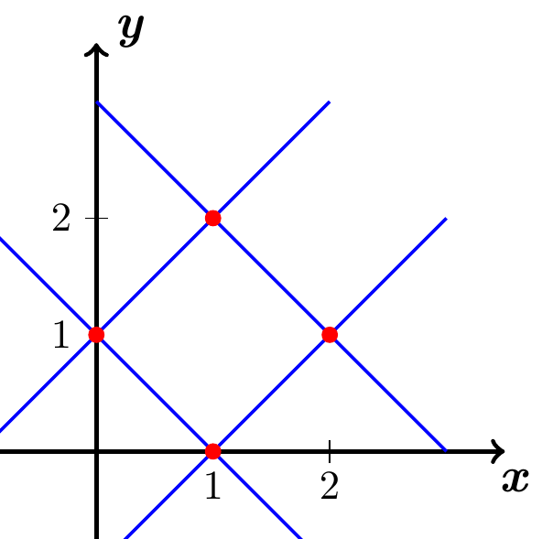







Let 







 



|  |  |  |
| --- | --- | --- |
|  |  |  |
|  |  |  |
|  |  |  |
|  |  |  |













***Exercise***

Evaluate  *D* is bounded by the planes:    and 

***Solution***

Let 















|  |  |  |
| --- | --- | --- |
|  |  |  |
|  |  |  |
|  |  |  |
|  |  |  |
|  |  |  |
|  |  |  |





















***Exercise***

Evaluate ; *R* is the square with vertices , , , and 

***Solution***

 &   

 &  

 &   

 &   

 &  

 &   

Let 

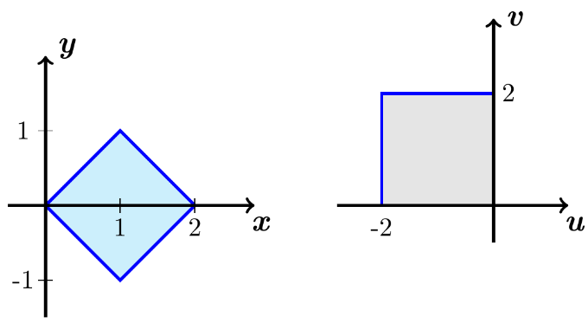 









|  |  |  |
| --- | --- | --- |
|  |  |  |
|  |  |  |
|  |  |  |
|  |  |  |

 





















***Exercise***

Evaluate ; 

***Solution***





Let  



 



|  |  |  |
| --- | --- | --- |
|  |  |  |
|  |  |  |
|  |  |  |
|  |  |  |















***Exercise***

Evaluate ; 

***Solution***





Let 



 



|  |  |  |
| --- | --- | --- |
|  |  |  |
|  |  |  |
|  |  |  |
|  |  |  |











Let 



















***Exercise***

Evaluate ; where *R* is bounded by the ellipse .

***Solution***



























***Exercise***

Evaluate 

***Solution***











|  |  |  |
| --- | --- | --- |
|  |  |  |
|  |  |  |
|  |  |  |
|  |  |  |











***Exercise***

Evaluate ; where *R* is the diamond bounded by   , and 

***Solution***







|  |  |  |
| --- | --- | --- |
|  |  |  |
|  |  |  |
|  |  |  |
|  |  |  |



















***Exercise***

Evaluate ; where *R* is the parallelogram bounded by   , and 

***Solution***

Let 





|  |  |  |
| --- | --- | --- |
|  |  |  |
|  |  |  |
|  |  |  |
|  |  |  |















***Exercise***

Evaluate ; where *R* is the region bounded by   , and 

***Solution***

Let 









|  |  |  |
| --- | --- | --- |
|  |  |  |
|  |  |  |
|  |  |  |
|  |  |  |









***Exercise***

Evaluate ; where *R* is the region bounded by the hyperbolas   , and 

***Solution***

Let 





|  |  |
| --- | --- |
|  |  |
|  |  |
|  |  |
|  |  |









***Exercise***

Evaluate ; where *R* is the triangular region bounded by   and 

***Solution***

Let 





|  |  |  |
| --- | --- | --- |
|  |  |  |
|  |  |  |
|  |  |  |



















***Exercise***

Evaluate : *D* is bounded by the planes:      and 

***Solution***

Let:  





|  |  |
| --- | --- |
|  |  |
|  |  |
|  |  |
|  |  |
|  |  |
|  |  |



















***Exercise***

Evaluate : *D* is bounded by the planes:      and 

***Solution***

Let: 











|  |  |
| --- | --- |
|  |  |
|  |  |
|  |  |
|  |  |
|  |  |
|  |  |







***Exercise***

Evaluate : *D* is bounded by the paraboloid  and the *xy-*plane.

***Solution***



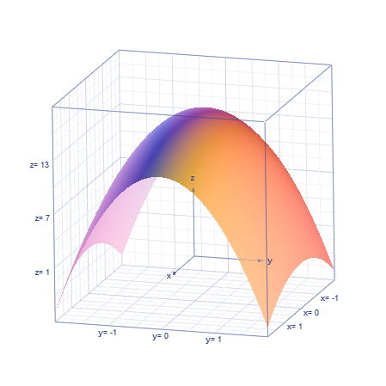

Let:  























































***Exercise***

Evaluate : *D* is bounded by the upper half of the ellipsoid  and the *xy-*plane.

***Solution***



Let:  



























***Exercise***

Evaluate : *D* is bounded by the planes:      and 

***Solution***





Let:  





|  |  |  |
| --- | --- | --- |
|  |  |  |
|  |  |  |
|  |  |  |
|  |  |  |
|  |  |  |
|  |  |  |















***Exercise***

Let *R* be the region bounded by the ellipse , where  and  are real numbers.

Find the area of *R*.

***Solution***



Let: 









Since,  is a unit circle, then the area . Therefore, the area of the ellipse is 





















***Exercise***

Let *R* be the region bounded by the ellipse , where  and  are real numbers.

Evaluates 

***Solution***



Let: 

























***Exercise***

Let *R* be the region bounded by the ellipse , where  and  are real numbers.

Find the center of mass of the upper half of *R*  assuming it has a constant density.

***Solution***

Let: 









Since,  is a unit circle, then the area . Therefore, the area of the ellipse is 

Mass of the upper half is given by:



By symmetry, 















∴ the center of mass of the upper half of *R* is 

***Exercise***

Let *R* be the region bounded by the ellipse , where  and  are real numbers.

Find the average square of the distance between points of *R* and the origin.

***Solution***

Let: 

The distance between points of *R* and the origin is 











Average square of the distance is:





































***Exercise***

Let *R* be the region bounded by the ellipse , where  and  are real numbers.

Find the average distance between points in the upper half of *R* and the *x-*axis.

***Solution***

Let: 

The distance between points in the upper half of *R* and the *x-*axis is 





















***Exercise***

Let *D* be the region bounded by the ellipsoid , where ,  and  are real numbers. Find the Volume of *D*.

***Solution***

Let: 







Since,  is a unit sphere, then the volume . Therefore, the volume of the ellipsoid is 

***Exercise***

Let *D* be the region bounded by the ellipsoid , where ,  and  are real numbers. Evaluates 

***Solution***

Let: 































***Exercise***

Let *D* be the region bounded by the ellipsoid , where ,  and  are real numbers. Find the center of mass of the upper half of *D*  assuming it has a constant density.

***Solution***

Let: 







Since,  is a unit sphere, then the volume . Therefore, the volume of the ellipsoid is 

 (upper half of *D*)



By symmetry 

































***Exercise***

Let *D* be the region bounded by the ellipsoid , where ,  and  are real numbers. Find the average square of the distance between points of *D* and the origin.

***Solution***

Let: 







The distance between a point on *D* and the origin is





Since,  is a unit sphere, then the volume . Therefore, the volume of the ellipsoid is 

 (upper half of *D*)







Let 































