***Solution*** ***Section* 4.2 – Line Integrals**

***Exercise***

Evaluate  where *C* is the straight-line segment  from (0, 1, 0) to .

***Solution***

















***Exercise***

Evaluate  where *C* is the straight-line segment  from  to .

***Solution***



















***Exercise***

Evaluate  along the curve 

***Solution***



















***Exercise***

Evaluate  *C*: is the line segment from  to .

***Solution***

Equation of the line is:























***Exercise***

Evaluate ; *C*: is the unit circle 

***Solution***















***Exercise***

Evaluate  *C*: is the circle of radius 1 centered at 

***Solution***

















***Exercise***

Evaluate  *C*: is the line 

***Solution***















***Exercise***

Evaluate  *C*: is the line 

***Solution***

















***Exercise***

Evaluate  *C*: is the circle of radius 4 centered at 

***Solution***















***Exercise***

Evaluate  *C*: is the line segment from  to 

***Solution***

















***Exercise***

Evaluate  *C*: is the line segment from  to 

***Solution***

















***Exercise***

Evaluate  *C*: is the curve 

***Solution***

















***Exercise***

Evaluate  *C*: is a portion of the ellipse  in the first quadrant, oriented counterclockwise.

***Solution***





















***Exercise***

Evaluate  *C*: is the line segment from  to  followed by the line segment from  to 

***Solution***

 to 







 to 





















***Exercise***

Evaluate ; C is the circle 

***Solution***













***Exercise***

Evaluate ; C is the circle 

***Solution***















***Exercise***

Evaluate ; C is the circle 

***Solution***















***Exercise***

Evaluate ; C is the line segment from  to 

***Solution***

 













***Exercise***

Evaluate ; C is the line segment from  to 

***Solution***

 













***Exercise***

Evaluate ; C is the helix 

***Solution***















***Exercise***

Evaluate ; C is 

***Solution***

















***Exercise***

Find the integral of  over the straight−line segment from  to 

***Solution***



















***Exercise***

Find the integral of  over the curve 

***Solution***















***Exercise***

Evaluate  where *C* is

1. The straight-line segment , from (0, 0) to (4, 2).
2. The parabolic curve , from (0, 0) to (2, 4).

***Solution***

1.  











1.  





 









***Exercise***

Evaluate  where *C* is

1. The straight-line segment , from (0, 0) to (1, 4).
2.   is the line segment (0, 0) to (1, 0) and  is the line segment (1, 0) to (1, 2).

***Solution***

1.  













1. 





 















***Exercise***

Find the line integral of  along the curve 

***Solution***







 









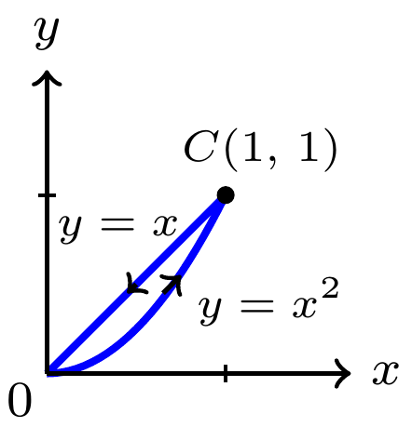***Exercise***

Evaluate  where *C* is

***Solution***







 















***Exercise***

Evaluate  where *C* is

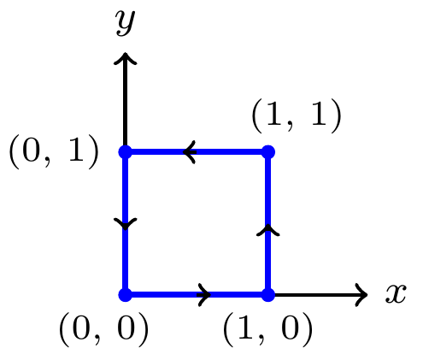***Solution***





 



 



 













***Exercise***

Find the line integral of  over the curve 

***Solution***

 





 









***Exercise***

Find the line integral of  over the curve  in the first quadrant from (0, 2) to 

*********Solution***









 











***Exercise***

Evaluate the line integral  *C* is the upper half of a circle 

***Solution***



















***Exercise***

Evaluate the line integral  *C* is the path 

***Solution***















***Exercise***

Integrate  over the circle 

***Solution***























***Exercise***

Integrate  over the involute curve



***Solution***

























***Exercise***

Find the average of the function on the given curves

 on the line segment from  to 

***Solution***

















The length of the line segment is 

∴ The average value is 

***Exercise***

Find the average of the function on the given curves

 on the circle of radius 9 centered at the origin.

***Solution***



















The circumference of the circle is 

∴ The average value is 

***Exercise***

Find the average of the function on the given curves

 on the circle of radius 1 centered at the origin.

***Solution***



















∴ The average value is 

***Exercise***

Find the average of the function on the given curves

 on the curve , for 

***Solution***





















The length of the curve is











∴ The average value is 

***Exercise***

Find the length of the curve 

***Solution***















***Exercise***

Find the length of the curve 

***Solution***









