***Solution*** ***Section* 4.3 – Conservative Vector Fields**

***Exercise***

Find the gradient field of the function 

***Solution***

















***Exercise***

Find the gradient field of the function 

***Solution***





















***Exercise***

Find the gradient field of the function 

***Solution***

  



***Exercise***

Find the line integral of  where 

***Solution***















***Exercise***

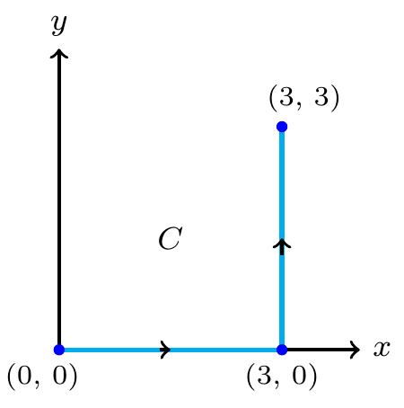Find the line integral of  where *C* is

***Solution***

 

 









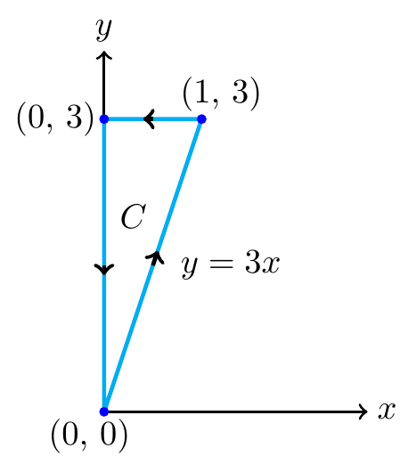***Exercise***

Find the line integral of  where *C* is

***Solution***































***Exercise***

Find the work done by the force field  over the curve .

***Solution***





















***Exercise***

Find the work done by the force field  over the curve .

***Solution***

















 







***Exercise***

Find the work done by the force field  over the curve .

***Solution***

















|  |  |  |
| --- | --- | --- |
|  |  |  |
| **+** |  |  |
| **−** |  |  |







***Exercise***

Find the work required to move an object with given force field  on the path consisting of the line segments from  to  followed by the line segment from  to 

***Solution***

 to  

 to  









 



***Exercise***

Find the work required to move an object with given force field  on the path  for 

***Solution***



 













***Exercise***

Evaluate  for the vector field  along the curve  from  to 

***Solution***

























***Exercise***

Find the circulation and flux of the fields  around and across each of the following curves.

1. The circle 
2. The ellipse 

***Solution***

1. 

























































1. 

























 









































***Exercise***

Find the circulation and flux of the fields  across the circle 

***Solution***

















































 























***Exercise***

Find a field  in the *xy*-plane with the property that at each point , points toward the origin and  is

1. The distance from (*x, y*) to the origin
2. Inversely proportional to the distance from (*x, y*) to the origin. (The field is undefined at (0, 0).)

***Solution***

1. The slope of the line through the origin and a point  is: 

The vector parallel to the line is given by: 

Pointing away from the origin:  is the unit vector pointing toward the origin.







1. 





***Exercise***

A fluid’s velocity field is . Find the flow along the curve 

***Solution***



















***Exercise***

A fluid’s velocity field is . Find the flow along the curve 

***Solution***













 





***Exercise***

Find the circulation of  around the closed path consisting of the following three curves traversed in the direction of increasing *t*.

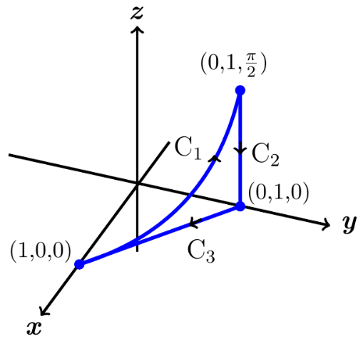 





***Solution***

















|  |  |  |
| --- | --- | --- |
|  |  |  |
| **+** |  |  |
| **−** |  |  |



















































***Exercise***

The field  is the velocity field of a flow in space. Find the flow from  to  along the curve of intersection of the cylinder  and the plane . (***Hint***: Use  as the parameter.)

***Solution***

Let 





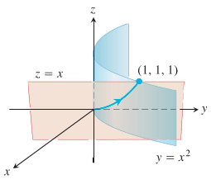 

















***Exercise***

Evaluate the line integral  for the vector fields  and curves *C*.



***Solution***





















***Exercise***

Evaluate the line integral  for the vector fields  and curves *C*.



***Solution***















|  |  |  |
| --- | --- | --- |
|  |  |  |
| + |  |  |
| − | 1 |  |







***Or***











***Exercise***

Evaluate the line integral .for the vector fields  and curves *C*.

 *C* is the square with vertices  with counterclockwise orientation.

***Solution***





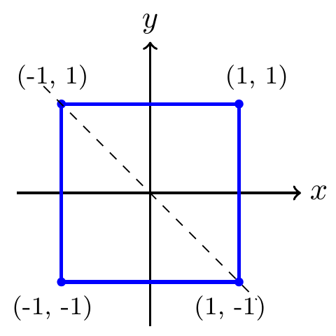



















































Or







Since the integral around any closed curve is 0.

***Exercise***

Evaluate the line integral  for the vector fields  and curves *C*.



***Solution***

















***Exercise***

Evaluate the line integral  for the vector fields  and curves *C*

 where *C* is the arc of the parabola  from  to 

***Solution***

Let 





















***Exercise***

Evaluate the line integral  for the vector fields  and curves *C*

 where *C* is the straight line segment from  to 

***Solution***





















***OR***

 to  is just a straight parallel to the *x-*axis.















***Exercise***

Evaluate the line integral  for the vector fields  and curves *C*.

 on the parabola 

***Solution***

















***Exercise***

Evaluate the line integral  for the vector fields  and curves *C*.

 on the semicircle 

***Solution***

















***Exercise***

Evaluate the line integral  for the vector fields  and curves *C*.

 on the line segment from  to 

***Solution***























***Exercise***

Evaluate the line integral  for the vector fields  and curves *C*.

 on the parabola  from  to 

***Solution***

 















***Exercise***

Evaluate the line integral  for the vector fields  and curves *C*.

 on the curve 

***Solution***

























***Exercise***

Evaluate the line integral  for the vector fields  and curves *C*.

 on the line 

***Solution***



















***Exercise***

Find the work required to move an object on the given oriented curve

 on the path consisting of the line segment from  to  followed by the line segment from  to 

***Solution***

 to 













 to 















***Exercise***

Find the work required to move an object on the given oriented curve

 on the path consisting of the line segment from  to  followed by the line segment from  to 

***Solution***

 to 













 to 





o















***Exercise***

Find the work required to move an object on the given oriented curve

 on runs from  to  along the unit circle and then from  to  along the *y-*axis.

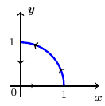***Solution***

Along the unit circle: 













 to : 









 







***Exercise***

Find the work required to move an object on the given oriented curve

 on the parabola  from  to 

***Solution***



 

















***Exercise***

Find the work required to move an object on the given oriented curve

 on the line  from  to 

***Solution***

















***Exercise***

Find the work required to move an object on the given oriented curve

 on the tilted ellipse 

***Solution***



















***Exercise***

Find the work required to move an object on the given oriented curve

 on the helix 

***Solution***

















***Exercise***

Find the work required to move an object on the given oriented curve

 on the line segment from  to 

***Solution***

























***Exercise***

Find the work required to move an object on the given oriented curve

 on the path 

***Solution***















 







***Exercise***

Find the work required to move an object on the given oriented curve

 over the plane curve  from the point  to the point  by using the parametrization of the curve to evaluate the work integral

***Solution***























 





***Exercise***

Find the work required to move an object on the given oriented curve

 on the line segment from  to 

***Solution***

















 













***Exercise***

Let *C* be the circle of radius 2 centered at the origin with counterclockwise orientation

1. Give the unit outward vector at any point  on *C*.
2. Find the normal component of the vector field  at any point on *C*.
3. Find the normal component of the vector field  at any point on *C*.

***Solution***

 @ origin, *ccw*.

1.  outward normal







∴ unit outward normal: 

1. Normal component is:







1. Normal component is:







***Exercise***

Find the flow of the field 

1. Once around the ellipse *C* in which the plane  intersects the cylinder, clockwise as viewed from the positive *y*-axis.
2. Along the curved boundary of the helicoid  from  to 

***Solution***

1. For any closed path *C*.



 is conservative.

1. 







