***Solution*** ***Section* 4.4 – Green's Theorem**

***Exercise***

Use Green’s theorem to find the counterclockwise circulation and outward flux for the field  and curve *C* is the square bounded by 

***Solution***



















***Exercise***

Use Green’s theorem to find the counterclockwise circulation and outward flux for the field  and curve *C* is the square bounded by 

***Solution***

























***Exercise***

Use Green’s theorem to find the counterclockwise circulation and outward flux for the field  and curve *C* is the triangle bounded by 

***Solution***































***Exercise***

Use Green’s theorem to find the counterclockwise circulation and outward flux for the field  and curve *C*

***Solution***





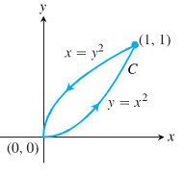





























***Exercise***

Use Green’s theorem to find the counterclockwise circulation and outward flux for the field  and curve *C*

***Solution***

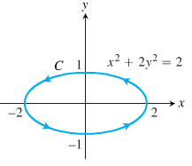













 











***Exercise***

Use Green’s theorem to find the counterclockwise circulation and outward flux for the field  and curve *C* is the right-hand loop of the lemniscate 

***Solution***



 















 







***Exercise***

Use Green’s Theorem to find the counterclockwise circulation and outward flux for the field and curves  

***Solution***





 













 











***Exercise***

Use Green’s Theorem to find the counterclockwise circulation and outward flux for the field and curves 



***Solution***





 













 



***Exercise***

Find the circulation and the outward flux of the vector field  for the curve 

***Solution***











 











 











***Exercise***

Use Green’s theorem to find the counterclockwise circulation and outward flux for the field

; where *R* is the half-annulus 

***Solution***





 







 







***Exercise***

Use Green’s theorem to find the counterclockwise circulation and outward flux for the field

; where *R* is the annulus 

***Solution***

 









 





***Exercise***

Use Green’s theorem to find the counterclockwise circulation and outward flux for the field

; where *R* is the quarter-annulus 

***Solution***

 





 









***Exercise***

Use Green’s theorem to find the counterclockwise circulation and outward flux for the field

; where *R* is the parallelogram 

***Solution***

 





 











***Exercise***

Use Green’s theorem to find the counterclockwise circulation and outward flux for the field

; where *R* is the annulus 

***Solution***

 

 















 

 















***Exercise***

Use Green’s theorem to find the counterclockwise circulation and outward flux for the field

; where *R* is the half-annulus 

***Solution***





 





 













***Exercise***

Use Green’s theorem to find the counterclockwise circulation and outward flux for the field

; where *R* is the square 

***Solution***

 









 









***Exercise***

Use Green’s theorem to find the counterclockwise circulation and outward flux for the field

; where 

***Solution***





 



















 





***Exercise***

Find the outward flux for the field  across the cardioid 

***Solution***













 









***Exercise***

Find the work done by  in moving a particle once counterclockwise around the curve *C*: The boundary of the triangular region in the first quadrant enclosed by the *x*-axis, the line  and the curve 

***Solution***



 













***Exercise***

Apply Green’s Theorem to evaluate the integral  *C*: The triangle bounded by 

***Solution***



















***Exercise***

Apply Green’s Theorem to evaluate the integral  *C*: The boundary of 

***Solution***













***Exercise***

Apply Green’s Theorem to evaluate the integral : where *C* is the circle 

***Solution***













***Exercise***

Apply Green’s Theorem to evaluate the integral : where *C* is the ellipse 

***Solution***















 









***Exercise***

Use either form of Green’s Theorem to evaluate the line integral ; *C* is the square with vertices  with *counterclockwise* orientation

***Solution***



















***Exercise***

Use either form of Green’s Theorem to evaluate the line integral ; *C* is the circle of radius 4 centered at the origin with *clockwise* orientation.

***Solution***

















Since the orientation is *cw*: 

***Exercise***

Evaluate  counterclockwise around the triangle with vertices (0, 0),  and 

***Solution***

Along : 







Along : 







Along : 



















***Exercise***

Use Green’s theorem to evaluate the line integral  *C* is the triangle with vertices , ,  with counterclockwise orientation.

***Solution***







***Exercise***

Use Green’s theorem to evaluate the line integral  *C* is the boundary of the half disk  with counterclockwise orientation.

***Solution***





 *Semicircle* 



***Exercise***

Apply Green’s Theorem to evaluate the integral : *C* is the boundary of the square with vertices , ,  with counterclockwise orientation.

***Solution***













***Exercise***

Apply Green’s Theorem to evaluate the integral : *C* is the unit circle

***Solution***









***Exercise***

Apply Green’s Theorem to evaluate the integral  where  and *C* is the triangle with vertices , ,  with counterclockwise orientation.

***Solution***

 − : 

















***Exercise***

Apply Green’s Theorem to evaluate the integral  where  and *C* is the upper half of the unit circle and the line segment  with clockwise orientation.

***Solution***

 *upper half of the unit circle*

 ***clockwise orientation***

















***Exercise***

Apply Green’s Theorem to evaluate the integral, the circulation line integral of , where *C* is the boundary of 

***Solution***

Using Circulation form

















***Exercise***

Apply Green’s Theorem to evaluate the integral, the circulation line integral of , where *C* is the boundary of 

***Solution***

Using Circulation form













|  |  |  |  |  |  |  |
| --- | --- | --- | --- | --- | --- | --- |
|  |  |  |  |  |  |  |
| **+** |  |  |  | **+** |  |  |
| **−** |  |  |  | **−** | 1 |  |
| **+** | 24 |  |  |  |  |  |







***Exercise***

Apply Green’s Theorem to evaluate the integral, the flus line integral of , where *C* is the boundary of 

***Solution***

Using flux form















***Exercise***

Evaluate  *C* is the circle 

***Solution***

















***Exercise***

Use the flux form to Green’s Theorem to evaluate , where *R* is the triangle with vertices , , and .

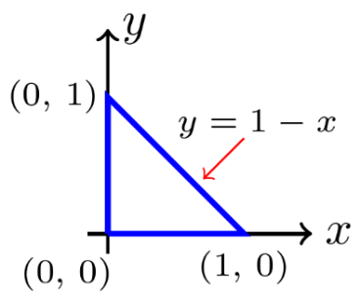***Solution***

 − : 

















***Exercise***

Show that  for any closed curve *C* to which Green’s Theorem applies.

***Solution***







 ***√***

***Exercise***

Prove that the radial field  where  and *p* is a real number, is conservative on  with the origin removed. For what value of *p* is  conservative on  (including the origin)?

***Solution***













 

For 















For 



















Thus  is conservative on all  for 

***Exercise***

Find the area of the elliptical region cut from the plane  by the cylinder 

***Solution***







 







***Exercise***

Find the area of the cap cut from the paraboloid  by the plane 

***Solution***

















 















***Exercise***

Evaluate both integrals in Green’s theorem of the vector field. Is the vector field conservative?



***Solution***



 























∴ The vector field is conservative since its curl is zero.

***Exercise***

Evaluate both integrals in Green’s theorem of the vector field. Is the vector field conservative?

 *R* is the square with vertices , , , 

***Solution***



 







 − 











 − 











 − 

















∴ The vector field is conservative since its curl is zero.

***Exercise***

Evaluate both integrals in Green’s theorem of the vector field. Is the vector field conservative?

 *R* is the region bounded by  and  for 

***Solution***



 

















































∴ The vector field is ***not*** conservative since its curl is nonzero.

***Exercise***

Evaluate both integrals in Green’s theorem of the vector field. Is the vector field conservative?

 *R* is the triangle with vertices , , 

***Solution***



 















 − 











 − 













 − 

















∴ The vector field is conservative since its curl is zero.

***Exercise***

Evaluate both integrals in Green’s theorem of the vector field. Is the vector field conservative?

 *R* is the region bounded by  and 

***Solution***





 

















































∴ The vector field is conservative since its curl is zero.

***Exercise***

Evaluate both integrals in Green’s theorem of the vector field. Is the vector field conservative?



***Solution***





 































∴ The vector field is ***not*** conservative since its curl is nonzero.

***Exercise***

Find the area of the region using line integral of the region enclosed by the ellipse 

***Solution***













***Exercise***

Find the area of the region using line integral of the region bounded by the hypocycloid  for .

***Solution***

 



















***Exercise***

Find the area of the region using line integral of the region enclosed by a disk of radius 5

***Solution***





 







***Exercise***

Find the area of the region using line integral of the region bounded by an ellipse with semi-major and semi-minor axes of length 12 and 8, respectively.

***Solution***







 







***Exercise***

Find the area of the region using line integral of the region bounded by an ellipse .

***Solution***







 







***Exercise***

Find the area of the region using line integral of the region 

***Solution***





 







***Exercise***

Find the area of the region using line integral of the region bounded by the parabolas  and  for 

***Solution***





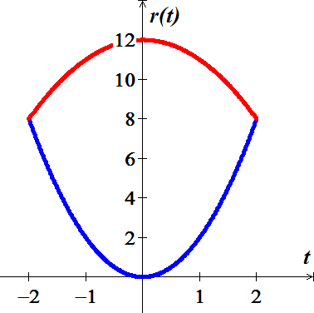 











***Exercise***

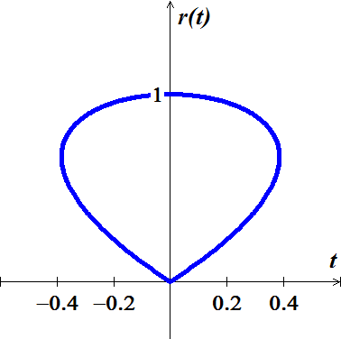Find the area of the region using line integral of the region bounded by the curve  for 

***Solution***







The curve travels in counterclockwise, therefore;

 











***Exercise***

Find the area of the region using line integral of the shaded region

***Solution***

For the path :

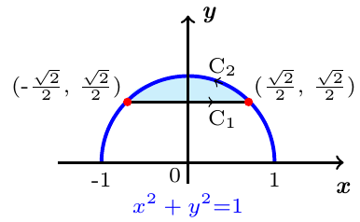











For the path :





 







***Exercise***

Prove the identity , where *C* is a simple closed smooth oriented curve

***Solution***





This is an outward flux of the constant vector field 





 ***√***

***Exercise***

Prove the identity , where *f* and *g* have continuous derivatives on the region enclosed by *C* (is a simple closed smooth oriented curve)

***Solution***

By Green’s Theorem:



 ***√***

***Exercise***

Show that the value of  depends only on the area of the region enclosed by *C*.

***Solution***









∴  depends only on the area of the region

***Exercise***

In terms of the parameters *a* and *b*, how is the value of  related to the area of the region enclosed by *C*, assuming counterclockwise orientation of *C*?

***Solution***







***Exercise***

Show that if the circulation form of Green’s Theorem is applied to the vector field  and , then the result is the Fundamental Theorem of Calculus,



***Solution***

If  is continuous, then the circulation form of Green’s Theorem is given

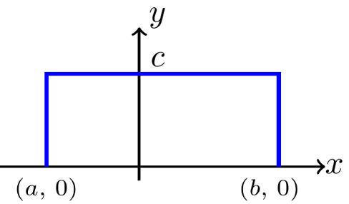

































































***Exercise***

Show that if the flux form of Green’s Theorem is applied to the vector field  and , then the result is the Fundamental Theorem of Calculus,



***Solution***

If  is continuous, then the circulation form of Green’s Theorem is given

























































