***Solution Section* 4.5 – Divergence and Curl**

***Exercise***

Find the divergence of the following vector field 

***Solution***

 





***Exercise***

Find the divergence of the following vector field 

***Solution***

 



***Exercise***

Find the divergence of the following vector field 

***Solution***

 





***Exercise***

Find the divergence of the following vector field 

***Solution***

 



***Exercise***

Find the divergence of the following vector field 

***Solution***

 



***Exercise***

Find the divergence of the following vector field 

***Solution***





***Exercise***

Find the divergence of the following vector field 

***Solution***

 





***Exercise***

Find the divergence of the following vector field 

***Solution***

 





***Exercise***

Calculate the divergence of the radial fields. 

Express the result in terms of the position vector ***r*** and its length .

***Solution***



 





***Exercise***

Calculate the divergence of the radial fields. 

Express the result in terms of the position vector ***r*** and its length .

***Solution***











***Exercise***

Calculate the divergence of the radial fields. 

Express the result in terms of the position vector ***r*** and its length .

***Solution***







***Exercise***

Calculate the divergence of the radial fields. 

Express the result in terms of the position vector ***r*** and its length .

***Solution***









***Exercise***

Consider the following vector fields , the circle *C*, and two points *P* and *Q*.

1. Without computing the divergence, does the graph suggest that the divergence is positive or negative at *P* and *Q*?
2. Compute the divergence and confirm your conjecture in part (*a*).
3. On what part of *C* is the flux outward? Inward?
4. Is the net outward flux across *C* positive or negative?vector

***Solution***

1. At both *P* and *Q*, the arrows going away from the point are larger in both number and magnitude than those going in, so we would expect the divergence to be positive at both points.

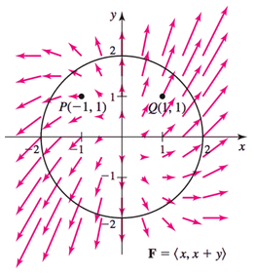

1. 

It is positive everywhere.

1. The arrows all point roughly away from the origin, so we the flux is outward everywhere.
2. The net flux across *C* should be positive.

***Exercise***

Consider the following vector fields , the circle *C*, and two points *P* and *Q*.

1. Without computing the divergence, does the graph suggest that the divergence is positive or negative at *P* and *Q*?
2. Compute the divergence and confirm your conjecture in part (*a*).
3. On what part of *C* is the flux outward? Inward?
4. Is the net outward flux across *C* positive or negative?

***Solution***

1. At *P*, the divergence should be positive.

At *Q*, the larger arrows point in towards *Q*, so the divergence should be negative.

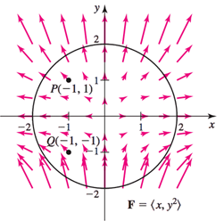

1. 

At  At 

1. The flux is outward above the line ; below this line, the flux is inward across *C*.
2. The size of the narrows pointing outward at the top of the circle seems to roughly equal those pointing inward at the bottom, so the remaining outward-pointing arrows result in a net positive flux across *C*.

***Exercise***

Consider the vector fields , where 

1. Compute the curl field and verify that it has the same direction as the axis of rotation
2. Compute the magnitude of the curl of the field

***Solution***

1. 



 





The curl is the same direction as the axis of rotation.

1. The magnitude of the curl is 

***Exercise***

Consider the vector fields , where 

1. Compute the curl field and verify that it has the same direction as the axis of rotation
2. Compute the magnitude of the curl of the field

***Solution***

1. 



 





The curl is the same direction as the axis of rotation.

1. The magnitude of the curl is 

***Exercise***

Consider the vector fields , where 

1. Compute the curl field and verify that it has the same direction as the axis of rotation
2. Compute the magnitude of the curl of the field

***Solution***

1. 



 





The curl is the same direction as the axis of rotation.

1. The magnitude of the curl is 

***Exercise***

Consider the vector fields , where 

1. Compute the curl field and verify that it has the same direction as the axis of rotation
2. Compute the magnitude of the curl of the field

***Solution***

1. 









The curl is the same direction as the axis of rotation.

1. The magnitude of the curl is



***Exercise***

Compute the curl of the vector field 

***Solution***

 







***Exercise***

Compute the curl of the vector field 

***Solution***

 







***Exercise***

Compute the curl of the vector field 

***Solution***

 





***Exercise***

Compute the curl of the vector field 

***Solution***

 











***Exercise***

Compute the curl of the vector field 

***Solution***

 





***Exercise***

Compute the curl of the vector field 

***Solution***

 





***Exercise***

Compute the curl of the vector field 

***Solution***

 





***Exercise***

Compute the curl of the vector field 

***Solution***





 

***Exercise***

Compute the divergence and curl of the following vector fields, state whether the field is *source-free* or *irrotational*. 

***Solution***

 



 







∴ The field is both source-free and irrotational.

***Exercise***

Compute the divergence and curl of the following vector fields, state whether the field is *source-free* or *irrotational*. 

***Solution***

 











 







 







∴ The field is irrotational but not a source-free.

***Exercise***

Compute the divergence and curl of the following vector fields, state whether the field is *source-free* or *irrotational*. 

***Solution***

 



 







∴ The field is neither source-free nor irrotational.

***Exercise***

Compute the divergence and curl of the following vector fields, state whether the field is *source-free* or *irrotational*. 

***Solution***

 



 







∴ The field is irrotational but not a source-free.

***Exercise***

Let 

1. What are the components of curl  in the directions  and 
2. In what direction is the scalar component of curl  a maximum?

***Solution***

1.  



Scalar component in the direction of 



Scalar component in the direction of 



1. The scalar component of the curl is a maximum in the direction of the curl, in the direction  whose unit direction vector is 

***Exercise***

Let 

1. What are the components of curl  in the directions  and 
2. In what direction  is  a maximum?

***Solution***

1.  



Scalar component in the direction of 



Scalar component in the direction of 



1. The component of the curl is a maximum in the direction of the curl, in the direction  whose unit direction vector is 

***Exercise***

Within the cube , where does  have the greatest magnitude when 

***Solution***

 





For the greatest magnitude, *x* and *y & z* have the same sign









 have the greatest magnitude of 6.

***Exercise***

Show that the general rotation field , where ***a*** is a nonzero constant vector and , has zero divergence.

***Solution***

Let 







 





***Exercise***

Let ,  and consider the rotation field . Use the right-hand rule for cross product to find the direction of ***F*** at the points , , , and 

***Solution***

; ***F*** points in the positive *x-*direction

; ***F*** points in the negative *z-*direction

; ***F*** points in the negative *x-*direction

; ***F*** points in the positive *z-*direction

***Exercise***

Find the exact points on the circle  at which the field  switches from pointing inward to outward on the circle, or vice versa.

***Solution***

The field switches from inward-pointing to outward-pointing at points where it is tangent to the circle , where it is orthogonal to the normal to the circle.

The normal to the circle at  is a multiple of , so we want to find  so that







The solutions are: 

***Exercise***

Suppose a solid object in  has a temperature distribution given by . The heat flow vector field in the object is , where the conductivity *k* > 0 is a property of the material. Note that the heat flow vector points in the direction opposite to that of the gradient, which is the direction of greatest temperature decrease. The divergence of the heat flow vector is  (the Laplacian of *T*). Compute the heat flow vector field and its divergence for the following temperature distribution.

1. 
2. 
3. 

***Solution***

1. 

 























1. 

 









1. 













***Exercise***

Consider the rotational velocity field 

1. If a paddle is placed in the *xy-*plane with its axis normal to this plane, what is its angular speed?
2. If a paddle is placed in the *xz-*plane with its axis normal to this plane, what is its angular speed?
3. If a paddle is placed in the *yz-*plane with its axis normal to this plane, what is its angular speed?

***Solution***







1. In *xy-*plane with its axis normal to this plane, then the wheel is placed with its axis in the direction of *z-*axis , so the component of velocity in that direction is



its angular speed: 

1. In *xz-*plane with its axis normal to this plane, then the wheel is placed with its axis in the direction of *y-*axis , so the component of velocity in that direction is



The wheel ***does not*** turn.

1. In *yz-*plane with its axis normal to this plane, then the wheel is placed with its axis in the direction of *x-*axis , so the component of velocity in that direction is



its angular speed: 

***Exercise***

Consider the rotational velocity field . If a paddle wheel is placed in the plane  with its axis normal to this plane, how fast does the paddle wheel spin (revolutions per unit time)?

***Solution***







Since the wheel is placed in the plane  with its axis normal to this plane, then must point in the direction 

The unit vector: 



The component of velocity along that direction is 

The angular velocity 

The paddle wheel spin: 

***Exercise***

The potential function for the gravitational force field due to a mass *M* at the origin acting on a mass *m* is  , where  is the position vector of the mass m and *G* is the gravitational constant.

1. Compute the gravitational force field 
2. Show that the field is irrotational; that is 

***Solution***

1. 











1. 

















***Exercise***

The potential function for the force field due to a charge *q* at the origin is , where  is the position vector of the mass m and *G* is the gravitational constant.

1. Compute the force field 
2. Show that the field is irrotational; that is 

***Solution***

1. 











1. 

















***Exercise***

The Navier-Stokes equation is the fundamental equation of fluid dynamics that models the motion of water in everything from bathtubs to oceans. In one of its many forms (incompressible, viscous flow), the equation is



In this notation  is the three-dimensional velocity field, *p* is the (scalar) pressure, *ρ* is the constant density of the fluid, and *μ* is the constant viscosity. Write out the three component equations of this vector equation.

***Solution***

































***Exercise***

One of Maxwell’s equations for electromagnetic waves is , where  is the electric field,  is the magnetic field, and *C* is a constant.

1. Show that the fields 

Satisfy the equation for constants *A*, *k,* and *ω*, provided 

1. Make a rough sketch showing the directions of  and 

***Solution***

1. 















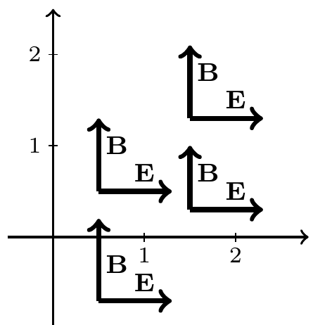

***Exercise***

Prove that for a real number *p*, with , 

***Solution***













 ***√***

***Exercise***

Prove that for a real number *p*, with , 

***Solution***









 ***√***

***Exercise***

Prove that for a real number *p*, with , 

***Solution***





















 ***√***