***Solution*** ***Section* 4.6 – Surfaces and Area**

***Exercise***

Find a parametrization of the surface: The paraboloid 

***Solution***



 

Then:  

***Exercise***

Find a parametrization of the surface: The portion of the cone  between the planes  and 

***Solution***



 

Then:  

***Exercise***

Find a parametrization of the surface cut from the sphere  by the plane 

***Solution***







For 







For 







Then:  

***Exercise***

Find a parametrization of the surface the plane 

***Solution***



Then:  

***Exercise***

Find a parametrization of the surface the cap of the sphere  for 

***Solution***





For 







For 







Then:  

***Exercise***

Find a parametrization of the surface the frustum of the cone  for 

***Solution***







Then:  

***Exercise***

Find a parametrization of the surface the cone  for 

***Solution***











Then:  

***Exercise***

Find a parametrization of the surface the portion of the cylinder  in the first octant, for 

***Solution***





Then:  

***Exercise***

Find a parametrization of the surface the cylinder  for 

***Solution***





Then:  

***Exercise***

Use a parametrization to express the area of the surface as a double integral. Then evaluate the integral of the portion of the plane  inside the cylinder 

***Solution***





Then:  

























***Exercise***

Use a parametrization to express the area of the surface as a double integral. Then evaluate the integral of the portion of the cone  between the planes  and 

***Solution***



 

Then:  

























***Exercise***

Use a parametrization to express the area of the surface as a double integral. Then evaluate the integral of the portion of the cylinder  between the planes  and 

***Solution***







Then: 





















***Exercise***

Use a parametrization to express the area of the surface as a double integral. Then evaluate the integral of the portion of the cap cut from the paraboloid  between the planes  and 

***Solution***







Then:  



























***Exercise***

Find the area of the following surface using a parametric description of the surface:

The half cylinder 

***Solution***





Then: 



















***Exercise***

Find the area of the following surface using a parametric description of the surface:

The plane  in the first octant

***Solution***



































***Exercise***

Find the area of the following surface using a parametric description of the surface

The plane  above the square 

***Solution***



























***Exercise***

Find the area of the following surface using a parametric description of the surface

The hemisphere 

***Solution***



































***Exercise***

Find the area of the following surfaces using a parametric description of the surface

A cone with base radius *r* and height *h*, where *r* and *h* are positive constants.

***Solution***

Cone equation:  with 



































***Exercise***

Find the area of the following surfaces using a parametric description of the surface

The cap of the sphere 

***Solution***









































***Exercise***

Find the area of the surface cut from the bottom of the paraboloid  by the plane .

***Solution***





















 









***Exercise***

Find the area of the portion of the surface that lies above the triangle bounded by the lines , and  in the *xy*-plane.

***Solution***



















 











***Exercise***

Find the area of the cap cut from the sphere  by the cone .

***Solution***

























 













***Exercise***

Find the area of the ellipse cut from the plane  (*c* a constant) by the cylinder .

***Solution***













 









***Exercise***

Find the area of the surface cut from the nose of the paraboloid  by *yz*-plane.

***Solution***







 







***Exercise***

Find the area of the surface in the first octant cut from the cylinder  by the planes  and 

***Solution***



















 









***Exercise***

Use a surface integral to find the area of the helicoid 

***Solution***













 



Let 





Let: 























***Exercise***

Use a surface integral to find the area of the surface  above the origin 

***Solution***









 









***Exercise***

Use a surface integral to find the area of the hemisphere , for  (excluding the base).

***Solution***

































***Exercise***

Use a surface integral to find the area of the frustum of the cone , for  (excluding the bases).

***Solution***

























***Exercise***

Use a surface integral to find the area of the plane  above the square , .

***Solution***















***Exercise***

Use a surface integral to find the area of: The cone 

***Solution***

























***Exercise***

Use a surface integral to find the area of: The paraboloid 

***Solution***

























***Exercise***

Use a surface integral to find the area of: The trough 

***Solution***







 









Let: 







































***Exercise***

Use a surface integral to find the area of: The part of the hyperbolic paraboloid  above the sector 

***Solution***

















***Exercise***

Use a surface integral to find the area of:  , where *S* is the plane  in the first octant

***Solution***











First octant: 















***Exercise***

Use a surface integral to find the area of:  , where *S* is the paraboloid 

***Solution***

















***Let*** 



















***Exercise***

Use a surface integral to find the area of:  , where *S* is the hemisphere centered at the origin with radius 5, for

***Solution***

*S* is the hemisphere with radius 5: 





























***Exercise***

Use a surface integral to find the area of:  , where *S* is the plane  in the first octant

***Solution***











First octant: 













***Exercise***

Use a surface integral to find the area of:  , where *S* is the plane  in the first octant

***Solution***











First octant: 





















***Exercise***

Evaluate the surface integral ; *S* is the plane  in the first octant.

***Solution***

































***Exercise***

Evaluate the surface integral ; *S* is the curve surface of the cylinder ,  with outward normal vectors.

***Solution***















***Exercise***

Evaluate the surface integral ; *S* is the entire surface including the base of the hemisphere , for .

***Solution***









































***Exercise***

Evaluate , where *S* is the hemisphere , for , and where . Assume normal vectors point either outward or in the positive *z-*direction.

***Solution***



 







Since the normal vector point either outward or in the positive *z-*direction

























***Exercise***

Evaluate , where *S* is the cylinder , for , and where  Assume normal vectors point either outward or in the positive *z-*direction.

***Solution***

Parametrize the surface:































Let: 

























***Exercise***

Evaluate , where *S* is the part of the plane  that lies on the cylinder  Assume normal vectors point either outward or in the positive *z-*direction.

***Solution***



























***Exercise***

Evaluate , where *S* is the cylinder . Assume normal vectors point either outward or in the positive *z-*direction.

***Solution***

















***Exercise***

Evaluate the surface integral :  , where *S* is the hemisphere 

***Solution***









































***Exercise***

Evaluate the surface integral ;  , where *S* is the cylinder 

***Solution***

Parametrize the surface:

























***Exercise***

Evaluate the surface integral ;  , where *S* is the cylinder 

***Solution***

























***Exercise***

Evaluate the surface integral ;  , where *S* is the part of the unit shpere in the first octant

***Solution***



































***Exercise***

Find the flux of  across the sphere of radius *a* centered at the origin, where . Assume the normal vectors to the surface point outward.

***Solution***



Using spherical to parametrize the sphere.







Using the table























***Exercise***

Find the flux of the vector field  across the curved surface of the cylinder  for 

***Solution***



















***Exercise***

Find the flux of the vector fields across the given surface with the specified orientation

 across the slanted face of the tetrahedron  in the first octant; normal vectors point upward

***Solution***



Normal vectors point upward & first octant.























***Exercise***

Find the flux of the vector fields across the given surface with the specified orientation

 across the slanted face of the tetrahedron  in the first octant; normal vectors point upward

***Solution***



Normal vectors point upward & first octant. 

























***Exercise***

Find the flux of the vector fields across the given surface with the specified orientation

 across the slanted face of the cone  for  ; normal vectors point upward

***Solution***





Normal vectors point upward: 











***Exercise***

Find the flux of the vector fields across the given surface with the specified orientation

 across the curved sides of the surface ; normal vectors point upward

***Solution***



Normal vectors point upward: 















***Exercise***

Find the flux of the vector fields across the given surface with the specified orientation

 across the sphere of radius *a* centered at the origin, where  ; normal vectors point outward

***Solution***

 pointing outward















***Exercise***

Find the flux of the vector fields across the given surface with the specified orientation

 across the cylinder  for  ; normal vectors point in the general direction of the positive *y-*axis

***Solution***











Normal vectors point in the general direction of the positive *y-*axis, then:

















***Exercise***

Consider the ellipsoid , where *a ,b*, and *c* are positive real numbers.

1. Show that the surface is described by the parametric equations  for 
2. ***Write*** an integral for the surface area of the ellipsoid.

***Solution***

1. 









 ***√***

1. 













***Exercise***

The cone , cuts the sphere  along a curve *C*.

1. Find the surface area of the sphere below *C*, for 
2. Find the surface area of the sphere above *C*.
3. Find the surface area of the cone below *C*, for 

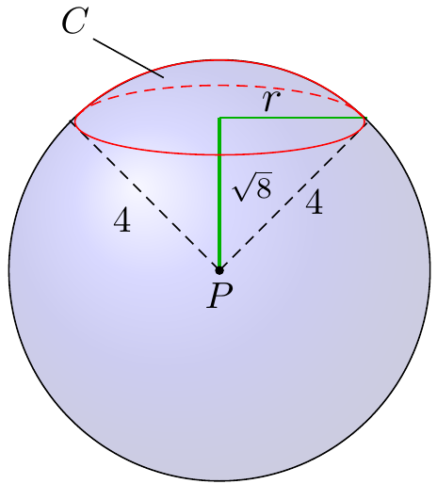***Solution***











Since the normal vector point outward & in the positive *z-*direction













1. 









The total surface area of the sphere: 

Since the cone in the positive *z-*direction, then

Surface area of the sphere below *C* 



1. 













1. 





***Exercise***

Consider the sphere  and the cylinder  for .

1. Find the surface area of the cylinder inside the sphere
2. Find the surface area of the sphere inside the cylinder.

***Solution***

1. 































 











1. 











































Since it cannot be zero, we have to change  to half and multiply by 2.

∴ 







***Exercise***

Find the upward flux of the field  across the plane  in the first octant. Show that the flux equals *c* times the area if the base of the origin.

***Solution***







First octant 











As *c* increases, the slope of the plane gets closer to vertical, so that the *x* and *y* components of the vector field  contribute more to the flux; also, the values of *z* get larger. This the flux increases as *c* does.

***Exercise***

Consider the field  and the cone , for 

1. Show that when , the outward flux across the cone is zero.
2. Find the outward flux (away from the *z-*axis); for any .

***Solution***





Since the normal is outward: 

1. 





 







1. 











The flow is a radial flow, so it is always tangent to the surface.

***Exercise***

A sphere of radius *a* is sliced parallel to the equatorial plane at a distance  from the equatorial plane.

Find the general formula for the surface area of the resulting spherical cap (excluding the base) with thickness *h*.

***Solution***

The sphere equation is: 









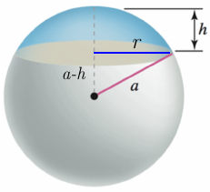 































***Exercise***

Consider the radial field , where  and *p* is a real number. Let *S* be he sphere of radius *a* centered at the origin. Show that the outward flux of  across the sphere is . It is instructive to do the calculation using both an explicit and parametric description of the sphere.

***Solution***





























***Parametric***



























***Exercise***

The heat flow vector field for conducting objects is , where  is the temperature in the object and  is a constant that depends on the material. Compute the outward flux of  across the following surface *S* for the given temperature distributions. Assume .

; *S* consists of the faces of the cube 

***Solution***







Thus, the flow is parallel to the 2 sides where , so the flus is zero.

For the side: 





















For the side: 





















For the side: 





















For the side: 



















The total flux: 









***Exercise***

The heat flow vector field for conducting objects is , where  is the temperature in the object and  is a constant that depends on the material. Compute the outward flux of  across the following surface *S* for the given temperature distributions. Assume .

; *S* cis the sphere 

***Solution***































Because the vector field is symmetric, then the outward flux of  across is



***Exercise***

The heat flow vector field for conducting objects is , where  is the temperature in the object and  is a constant that depends on the material. Compute the outward flux of  across the following surface *S* for the given temperature distributions. Assume .

; *S* cis the sphere 

***Solution***

































Because the vector field is symmetric, then the outward flux of  across is



***Exercise***

Given: 

1. Show that a torus with radii  may be described parametrically by  for 

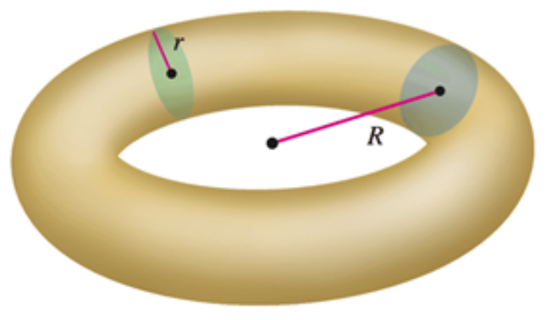

1. Show that the surface area of the torus is 

***Solution***

1. If we let  the parametrized for the (outer) circle of radius *R*.

For the inner circle, that includes the *z-*axis, we can write the parametrization as:.

Therefore, the set of points on the torus can be parametrized by the sum of the se 2 vectors.





1. 



























