***Lecture Four* – Vector Calculus**

***Section* 4.1 – Vector Fields**

Gravitational and electric forces have both a direction and a magnitude. They are represented by a vector, in a subset of Euclidean space, at each point in their domain, producing a ***vector field***.

Vector fields are often used to model, for example, the speed and direction of a moving fluid throughout space, or the strength and direction of some force, such as the magnetic or gravitational force, as it changes from point to point. A line integral can be used to find the rate at which the fluid flows along or across a curve within the domain.

**Vector Fields**

Suppose a region in the plane or in space occupied by a moving fluid, such air or water. The fluid is made up of a large number of particles, where a particle has a velocity which can vary. Such a fluid flow is an example of a ***vector field***.

Vectors fields are associated with forces such as gravitational attraction, and to magnetic fields, electric fields, and also purely mathematical fields.

|  |  |
| --- | --- |
|  |  |
|  | |

A vector filed is a function that assigns a vector to each point in its domain.

A vector field on a three-dimensional domain in space is given by



The velocity field expression: 

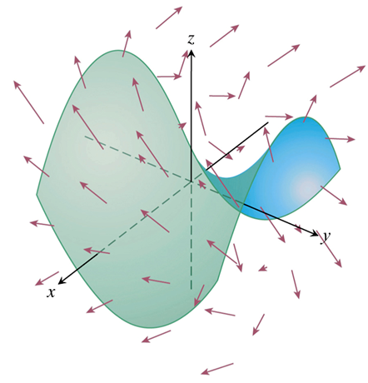

|  |  |
| --- | --- |
|  |  |
| The radial field  of position vectors of points in the plane. | A spin field of rotating unit vectors    In the plane |

***Definition***

Let *f* and *g* be defined a region *R* of . A vector field in  is a function  assigns to each point in *R* a vector . The vector field is written as





A vector field  is continuous or differentiable on a region *R* of  if *f* and *g* are continuous or differentiable on *R*, respectively.

**Gradient Fields**

The gradient vector of a differentiable scalar-valued function at a point gives the direction of greatest increase of the function. An important type of vector field is formed by all the gradient vectors of the function. We define the gradient field of a differentiable function  to be the field gradient vectors



|  |  |
| --- | --- |
|  |  |

***Example***

Suppose that the temperature *T* at each point  in a region of space is given by



And that  is defined to be the gradient of *T*. Find the vector field .

***Solution***

The gradient field  is the field





At each point in space, the field  gives the direction for which the increase in temperature is greatest.