***Section* 4.2 – Line Integrals**

***Definition***

If  is defined on a curve *C* given parametrically by , , then the line integral of  over *C* is



Provided this limit exists.

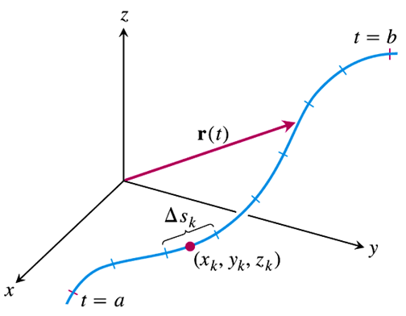

**How to Evaluate a Line Integral**

1. Find a smooth parametrization of *C*, 
2. Evaluate the integral as



***Example***

Integrate  over the line segment *C* joining the origin to the point (1, 1, 1).

***Solution***

Assume that:







 (The parameterization is smooth)

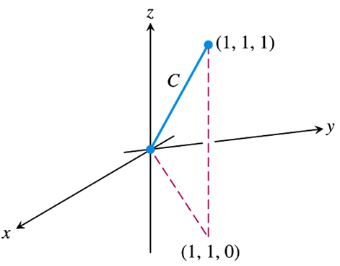











***Example***

Integrate  over using the path the origin to the point (1, 1, 1).

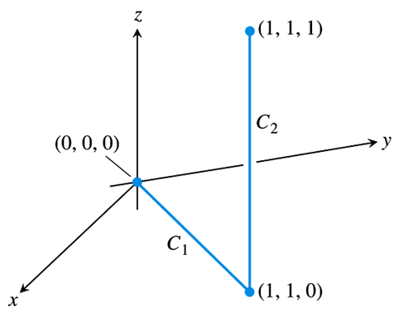***Solution***









 









* The value of the line integral along a path joining two points can change if you change the path between them.

**Line Integrals in the Plane**

There is an interesting geometric interpretation for line integrals in the plane. If *C* is a smooth curve in the *xy*-plane parametrized by , we generate a cylindrical surface by moving a straight line along *C* orthogonal to the plane, holding the line parallel to the *z*-axis.

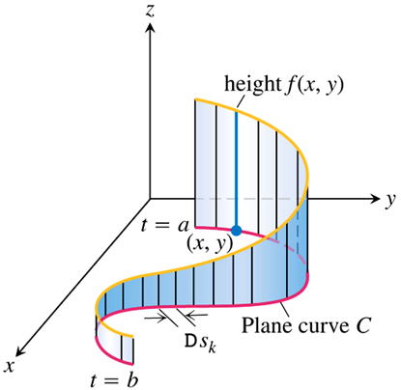

The cylinder cuts through the surface, forming a curve on it. The part of the cylindrical surface that lies beneath the surface curve and above the *xy*-plane is like a ***winding wall*** or ***fence*** standing on the curve *C* and orthogonal to the plane.



Where , we see that he line integral  is the area of the wall.

**Line Integrals with Respect to the *xyz* Coordinates**







***Example***

Evaluate the line integral , where *C* is the helix



***Solution***









|  |  |  |
| --- | --- | --- |
|  |  |  |
| **+** |  |  |
| **−** |  |  |











***Exercises*** ***Section* 4.2 – Line Integrals**

1. Evaluate  where *C* is the straight-line segment  from (0, 1, 0) to (1, 0, 0).
2. Evaluate  where *C* is the straight-line segment  from  to .
3. Evaluate  along the curve 
4. Evaluate  *C*: is the line segment from  to .
5. Evaluate  *C*: is the unit circle 
6. Evaluate  *C*: is the circle of radius 1 centered at 
7. Evaluate  *C*: is the line 
8. Evaluate  *C*: is the line 
9. Evaluate  *C*: is the circle of radius 4 centered at 
10. Evaluate  *C*: is the line segment from  to 
11. Evaluate  *C*: is the line segment from  to 
12. Evaluate  *C*: is the curve 
13. Evaluate  *C*: is a portion of the ellipse  in the first quadrant, oriented counterclockwise.
14. Evaluate  *C*: is the line segment from  to  followed by the line segment from  to 
15. Evaluate ; *C* is the circle 
16. Evaluate ; *C* is the circle 
17. Evaluate ; *C* is the circle 
18. Evaluate ; *C* is the line segment from  to 
19. Evaluate ; *C* is the line segment from  to 
20. Evaluate ; *C* is the helix 
21. Evaluate ; *C* is 
22. Find the integral of  over the straight−line segment from  to 
23. Find the integral of  over the curve 
24. Evaluate  where *C* is
25. The straight-line segment , from (0, 0) to (4, 2).
26. The parabolic curve , from (0, 0) to (2, 4).
27. Evaluate  where *C* is
28. The straight-line segment , from (0, 0) to (1, 4).
29.   is the line segment (0, 0) to (1, 0) and  is the line segment (1, 0) to (1, 2).
30. Find the line integral of  along the curve 
31. Find the line integral of  over the curve 
32. Find the line integral of  over the curve  in the first quadrant from (0, 2) to 
33. Evaluate  where *C* is

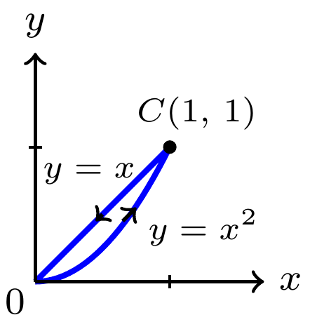

1. Evaluate  where *C* is

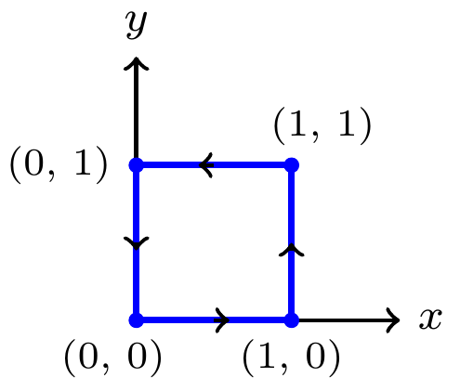

1. Find the line integral of  over the curve 
2. Find the line integral of  over the curve  in the first quadrant from (0, 2) to 
3. Evaluate the line integral  *C* is the upper half of a circle 
4. Evaluate the line integral  *C* is the path 
5. Integrate  over the circle 
6. Integrate  over the involute curve



(**37 − 40**) Find the average of the function on the given curves

1.  on the line segment from  to 
2.  on the circle of radius 9 centered at the origin.
3.  on the circle of radius 1 centered at the origin.
4.  on the curve , for 

(**41 − 42**) Find the length of the curve

1. 
2. 