***Section* 4.3 – Conservative Vector Fields**

**Line Integrals of Vector Fields**

Assume the vector field  has a continuous components, and the curve *C* has a smooth parametrization ****, .  defines along the path *C* which we call the ***forward direction***. At each point along the path *C*, the tangent vector  is a unit vector tangent to the path and pointing is this forward direction. The tangential component is given by the dot product



***Definition***

Let  be a vector field with continuous components defined along a smooth curve *C* parametrized by . Then the line integral of along *C* is



**Evaluating the Line Integral of  along *C*: **

1. Express the vector field in terms of the parametrized curve *C* as  by substituting the components  of into the scalar components  of.
2. Find the derivative (velocity) vector .
3. Evaluate the line integral with respect to the parameter *t*, , to obtain



***Example***

Evaluate , where  along the curve *C* given by .

***Solution***























**Work Done by a Force over a Curve in Space**

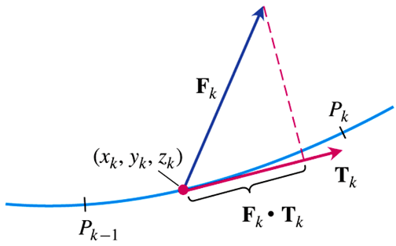

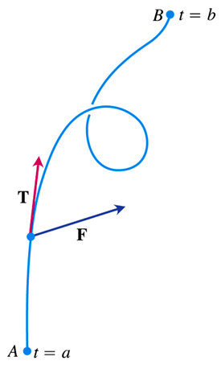

***Definition***

Let *C* be a smooth curve parametrized by , and  be a continuous force field over a region containing *C*. Then the ***work*** done in moving an object from point  to the point  along *C* is



|  |  |
| --- | --- |
| ***Different ways to write the work integral for  over the curve C:*** | |
|  | ***The definition*** |
|  | ***Vector differential form*** |
|  | ***Parametric vector evaluation*** |
|  | ***Parametric scalar evaluation*** |
|  | ***Scalar differential form*** |

***Example***

Find the work done by the force field  along the curve , form (0, 0, 0) to (1, 1, 1).

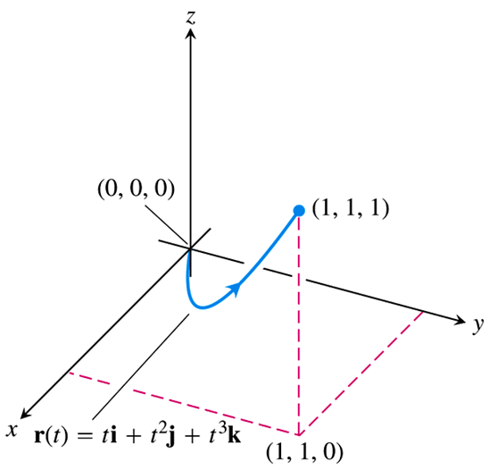***Solution***



























***Example***

Find the work done by the force field  in moving an object along the curve C parametrized by .

***Solution***











The work done is the line integral







***Flow integrals and Circulation for Velocity Fields***

***Definitions***

If  parametrizes a smooth curve *C* in the domain of a continuous velocity field, the ***flow*** along the curve point  to  is



The integral in this case is called a ***flow integral***. If the curve starts and ends at the same point, so that , the flow is called the ***circulation*** around the curve.

***Example***

A fluid’s velocity field is . Find the flow along the helix



***Solution***











|  |  |  |
| --- | --- | --- |
|  |  |  |
| **+** |  |  |
| **−** |  |  |











***Example***

Find the circulation of the field  around the circle 

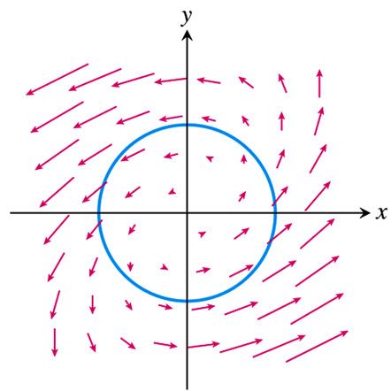

***Solution***





















**Flux across a Simple Plane Curve**

A curve in the *xy*-plane is simple if it does not cross itself. When a curve starts and ends at the same point, it is a ***closed curve*** or ***loop***.

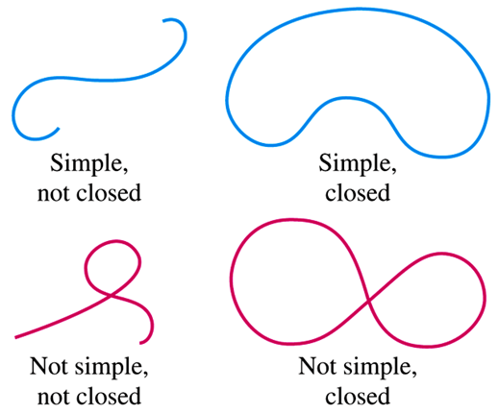

***Definition***

If *C* is a smooth simple closed curve in the domain of a continuous velocity field in  in the plane, and if  is the outward-pointing unit normal vector on *C*, the flux of across *C* is



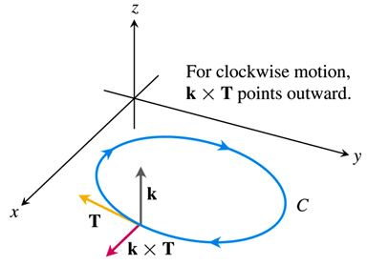 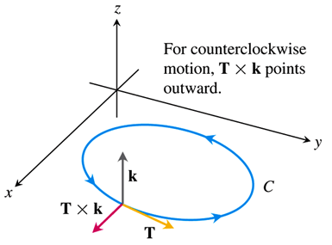









**Calculating Flux Across a Smooth Closed Plane Curve**



The integral can be evaluated from any smooth parametrization , that traces C counterclockwise exactly once.

***Example***

Find the flux of  across the circle  in the *xy*-plane. (The vector field and curve)

***Solution***

The parametrization  traces the circle counterclockwise exactly once.















***Exercises*** ***Section* 4.3 – Conservative Vector Fields**

1. Find the gradient field of the function 
2. Find the gradient field of the function 
3. Find the gradient field of the function 
4. Find the line integral of  where 
5. Find the line integral of  where *C* is

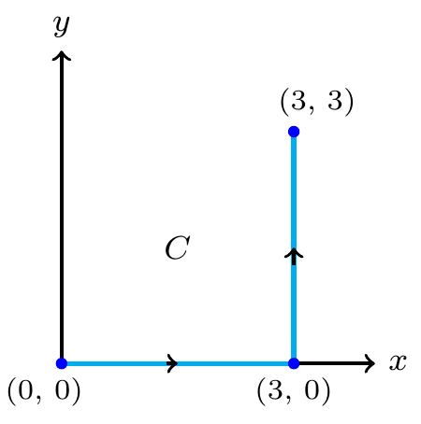

1. Find the line integral of  where *C* is

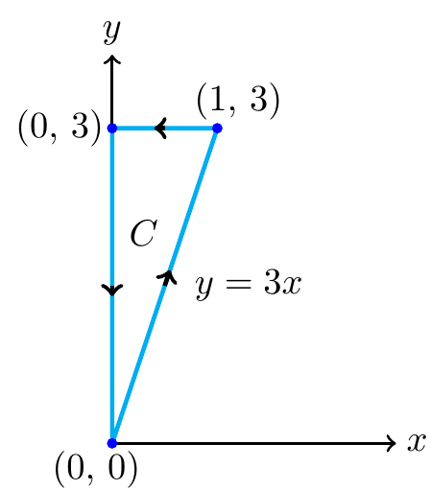

1. Find the work done by the force field  over the curve .
2. Find the work done by the force field  over the curve 
3. Find the work done by the force field  over the curve .
4. Find the work required to move an object with given force field  on the path consisting of the line segments from  to  followed by the line segment from  to 
5. Find the work required to move an object with given force field  on the path for 
6. Evaluate  for the vector field  along the curve  from  to 
7. Find the circulation and flux of the fields  around and across each of the following curves.
8. The circle 
9. The ellipse 
10. Find the circulation and flux of the fields  across the circle 
11. Find a field  in the *xy*-plane with the property that at each point ,  points toward the origin and  is
12. The distance from (*x, y*) to the origin
13. Inversely proportional to the distance from (*x, y*) to the origin.

(The field is undefined at (0, 0).)

1. A fluid’s velocity field is . Find the flow along the curve 
2. A fluid’s velocity field is . Find the flow along the curve 
3. Find the circulation of  around the closed path consisting of the following three curves traversed in the direction of increasing *t*.

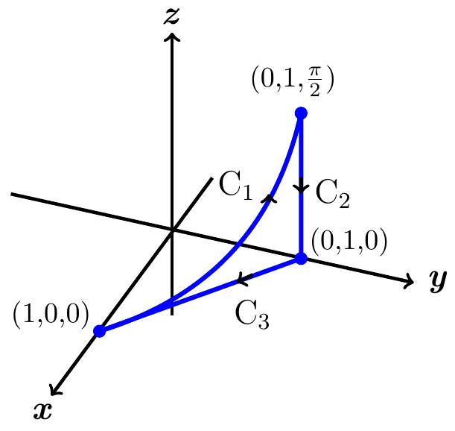







1. The field  is the velocity field of a flow in space. Find the flow from  to  along the curve of intersection of the cylinder  and the plane .

(***Hint***: Use  as the parameter.)

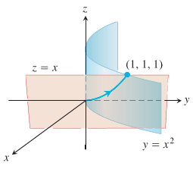

1. Find the work required to move an object with given force field  on the path consisting of the line segments from  to  followed by the line segment from  to 
2. Find the work required to move an object with given force field  on the path for 
3. Evaluate  counterclockwise around the triangle with vertices (0, 0),  and 

(**23−28**) Evaluate the line integral  for the vector fields  and curves *C*.

1. 
2. 
3.  *C* is the square with vertices  with counterclockwise orientation.

1. 
2.  where *C* is the arc of the parabola  from  to 
3.  where *C* is the straight line segment from  to 

(**29−34**) Evaluate the line integral  for the vector fields  and curves *C*.

1.  on the parabola 
2.  on the semicircle 
3.  on the line segment from  to 
4.  on the parabola  from  to 
5.  on the curve 
6.  on the line 

(**35−45**) Find the work required to move an object on the given oriented curve

1.  on the path consisting of the line segment from  to  followed by the line segment from  to 

1.  on the path consisting of the line segment from  to  followed by the line segment from  to 
2.  on runs from  to  along the unit circle and then from  to  along the *y-*axis.
3.  on the parabola  from  to 
4.  on the line  from  to 
5.  on the tilted ellipse 
6.  on the helix 
7.  on the line segment from  to 

1.  on the path 
2.  over the plane curve  from the point  to the point  by using the parametrization of the curve to evaluate the work integral
3.  on the line segment from  to 
4. Let *C* be the circle of radius 2 centered at the origin with counterclockwise orientation
5. Give the unit outward vector at any point  on *C*.
6. Find the normal component of the vector field  at any point on *C*.
7. Find the normal component of the vector field  at any point on *C*.
8. Find the flow of the field 
9. Once around the ellipse *C* in which the plane  intersects the cylinder, clockwise as viewed from the positive *y*-axis.
10. Along the curved boundary of the helicoid  from  to 