***Section* 4.4 – Green's Theorem**

***Green's theorem*** gives the relationship between a line integral around a simple closed curve *C* and a double integral over the plane region *D* bounded by *C*. It is the two-dimensional special case of the more general ***Stokes' theorem***, and is named after British mathematician *George Green*.

Green’s theorem applies to any vector field, independent of any particular interpretation of the field, provided assumptions of the theorem are satisfied, We introduce two new ideas for Green’s theorem: *divergence* and *circulation density* around an axis perpendicular to the plane.

***Divergence***

Suppose that  is the velocity field of fluid flowing in the plane and that the first partial derivatives of *M* and *N* are continuous at each point of a region *R*.

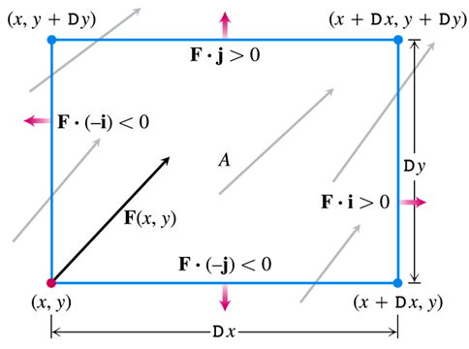

***Fluid Flow Rates***: Top: 

Bottom: 

Right: 

Left: 

Top and Bottom: 

Right and Left: 

Adding the last two equations gives the net effect of the flow rates:

*Flux across rectangle boundary* 

The estimate of the total flux per unit area or flux density for the rectangle:



***Definition***

The divergence (flux density) of a vector field  at the point  is



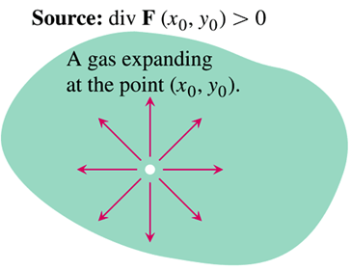 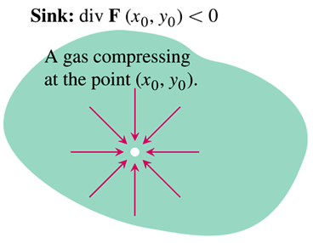

***Example***

The following vector fields represent the velocity of a gas flowing in the *xy*-plane. Find the divergence of each vector field and interpret its physical meaning.

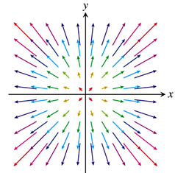 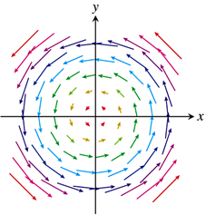

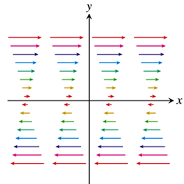 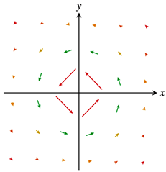

1. Uniform expansion or compression: 
2. Uniform rotation: 
3. Shearing flow: 
4. Whirlpool effect: 

***Solution***

1. 







If  the gas is undergoing uniform expansion

If  the gas is undergoing uniform compression

1. 





The gas is neither expanding nor compressing.

1. 





The gas is neither expanding nor compressing.

1. 







The divergence is zero at all points in the domain of the velocity field.

**Spin Around an Axis: The −Component of Curl**

The Green’s Theorem has to do with measuring how a floating paddle wheel, with axis perpendicular to the plane, spins at a point in fluid flowing in a plane region. Sometimes refer to *circulation density* of a vector field  at a point.



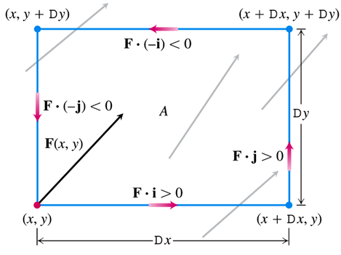

The circulation rate of  around the boundary of *A* is the sum of flow rates along the sides in the tangential direction.

Top: 

Bottom: 

Right: 

Left: 

Top and Bottom: 

Right and Left: 



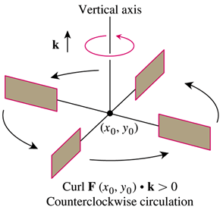 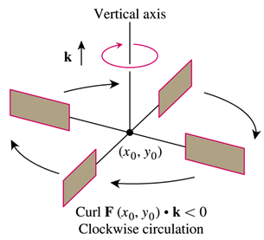

***Definition***

The ***circulation density*** of a vector field  at the point  is the scalar expression



This expression is also called the ***k-component of the curl***, denoted by 

***Example***

Find the circulation density, and interpret what it means, for each vector field

***Solution***

1. *Uniform expansion*: 





The gas is not circulating at very small scales.

1. *Rotation*: 





The constant circulation density indicates rotation at every point.

If  the rotation is counterclockwise

If  the rotation is clockwise

1. *Shear*: 





The circulation density is constant and negative, so a paddle wheel floating in water undergoing such a shearing flow spins clockwise. The rate of rotation is the same at each point. The average effect of the fluid flow is to push fluid clockwise around each of the small circles.

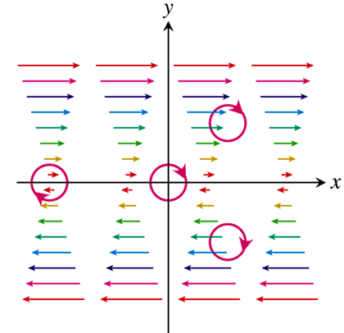

1. *Whirlpool*: 







The circulation density is 0 at every point away from the origin (where the vector field is undefined and the whirlpool effect is taking place), and the gas is not circulating at any point for which the vector field is defined.

***Theorem* − Green’s Theorem (Flux-Divergence or Normal Form)**

Let *C* be a piecewise smooth, simple closed curve enclosing a region *R* in the plane. Let  be a vector field with *M* and *N* having continuous first partial derivatives in an open region containing *R*. Then the outward flux of across *C* equals the double integral of div over the region *R* enclosed by *C*.



***Theorem* − Green’s Theorem (Circulation-Curl or Tangential Form)**

Let *C* be a piecewise smooth, simple closed curve enclosing a region *R* in the plane. Let  be a vector field with *M* and *N* having continuous first partial derivatives in an open region containing *R*. Then the counterclockwise circulation of around *C* equals the double integral of  over *R*.



***Example***

Verify both forms of Green’s Theorem for the vector field 

And the region *R* bounded by the unit circle 

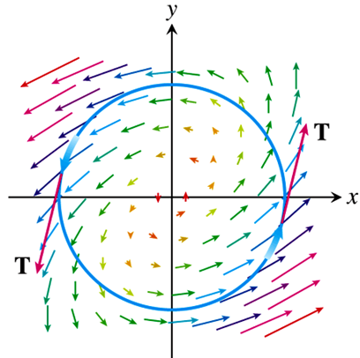***Solution***











1. 

















1. 















***Example***

Evaluate the line integral 

Where *C* is the square cut from the first quadrant by the lines  and 

***Solution***

*With the Normal Form Equation*: 















*With the Tangential Form Equation*: 







***Example***

Calculate the outward flux of the vector field  across the square bounded by the lines  and 

***Solution***



 

 ***Green’s Theorem***















***Exercises*** ***Section* 4.4 – Green's Theorem**

(**1−17**) Use Green’s theorem to find the counterclockwise circulation and outward flux for the field

1.  and curve *C* is the square bounded by 
2.  and curve *C* is the square bounded by 
3.  and curve *C* is the triangle bounded by 
4.  and curve *C*

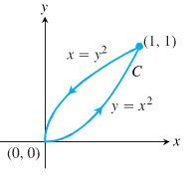

1.  and curve *C*

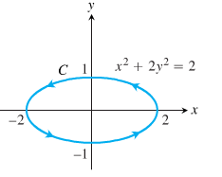

1.  and curve *C* is the right-hand loop of the lemniscate 
2.  
3. 



1.  for the curve 
2. ; where *R* is the half-annulus 
3. ; where *R* is the annulus 
4. ; where *R* is the quarter-annulus 
5. ; where *R* is the parallelogram 
6. ; where *R* is the annulus 
7. ; where *R* is the half-annulus 
8. ; where *R* is the square 
9. ; where 
10. Find the outward flux for the field  across the cardioid 
11. Find the work done by  in moving a particle once counterclockwise around the curve *C*: The boundary of the triangular region in the first quadrant enclosed by the *x*-axis, the line  and the curve 

(**20−32**) Apply Green’s Theorem to evaluate the integral

1.  *C*: The triangle bounded by 

1.  *C*: The boundary of 
2.  *C* is the triangle with vertices , ,  with counterclockwise orientation.
3.  *C* is the boundary of the half disk  with counterclockwise orientation.
4. : *C* is the boundary of the square with vertices , ,  with counterclockwise orientation.
5. : *C* is the unit circle
6.  where  and *C* is the triangle with vertices , ,  with counterclockwise orientation.
7.  where  and *C* is the upper half of the unit circle and the line segment  with clockwise orientation.
8. The circulation line integral of , where *C* is the boundary of 
9. The circulation line integral of , where *C* is the boundary of 
10. The flus line integral of , where *C* is the boundary of 
11. : where *C* is the circle 
12. : where *C* is the ellipse 
13. Use either form of Green’s Theorem to evaluate the line integral ; *C* is the square with vertices  with *counterclockwise* orientation
14. Use either form of Green’s Theorem to evaluate the line integral ; *C* is the circle of radius 4 centered at the origin with *clockwise* orientation.
15. Evaluate  *C* is the circle 
16. Use the flux form to Green’s Theorem to evaluate , where R is the triangle with vertices , , and .
17. Show that  for any closed curve *C* to which Green’s Theorem applies.
18. Prove that the radial field  where  and *p* is a real number, is conservative on  with the origin removed. For what value of *p* is  conservative on  (including the origin)?
19. Find the area of the elliptical region cut from the plane  by the cylinder 
20. Find the area of the cap cut from the paraboloid  by the plane 

(**41−46**) Evaluate both integrals in Green’s theorem of the vector field. Is the vector field conservative?

1. 
2.  *R* is the square with vertices , , , 
3.  *R* is the region bounded by  and  for 
4.  *R* is the triangle with vertices , , 
5.  *R* is the region bounded by  and 
6. 

(**47−55**) Find the area of the regions using line integral

1. The region enclosed by the ellipse 
2. The region bounded by the hypocycloid  for .
3. The region enclosed by a disk of radius 5
4. A region bounded by an ellipse with semi-major and semi-minor axes of length 12 and 8, respectively.
5. The region bounded by an ellipse 
6. 
7. The region bounded by the parabolas  and  for 
8. The region bounded by the curve  for 
9. The shaded region

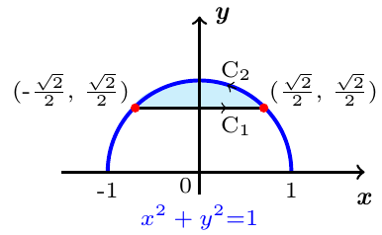

1. Prove the identity , where *C* is a simple closed smooth oriented curve.
2. Prove the identity , where *f* and *g* have continuous derivatives on the region enclosed by *C* (is a simple closed smooth oriented curve)
3. Show that the value of  depends only on the area of the region enclosed by *C*.
4. In terms of the parameters *a* and *b*, how is the value of  related to the area of the region enclosed by *C*, assuming counterclockwise orientation of *C*?
5. Show that if the circulation form of Green’s Theorem is applied to the vector field  and , then the result is the Fundamental Theorem of Calculus,



1. Show that if the flux form of Green’s Theorem is applied to the vector field  and , then the result is the Fundamental Theorem of Calculus,

