***Section* 4.5 – Divergence and Curl**

Green’s Theorem out of the plane  and into space , it is done as follows:

* The circulation form of Green’s Theorem relates a line integral over a simple closed oriented curve in the plane to a double integral over the enclosed region. Stoke’s Theorem relates a line integral over a simple closed oriented curve in  to a double integral over a surface whose boundary is the same curve.
* The flux form of Green’s Theorem relates a line integral over a simple closed oriented curve in the plane to a double integral over the enclosed region. Similarly, the Divergence Theorem relates an integral over a closed oriented surface in  to a triple integral over the region enclosed by the surface.

***Definition***

The divergence of a vector field  that is differentiable on a region of  is





If , the vector field is ***source free***.

***Example***

Compute the divergence of the following vector fields

1. 
2. 
3. 

***Solution***

1. The divergence is







Because the divergence is positive, the flow expands outward at all points

. 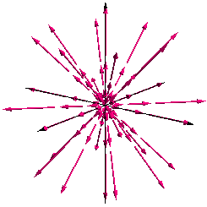

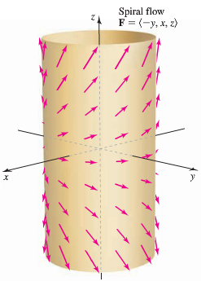Radial field 

1. The divergence is







The field is source free.

1. The divergence is







The rotational part of the field in *x* and *y* does not contribute to the divergence.

However, the *z-*component of the field produces a nonzero divergence.

***Example***

Compute the divergence of the radial vector field



***Solution***





















***Theorem***

For a real number *p*, the divergence of the radial vector field



***Example***

To gain some intuition about the divergence, consider the two-dimensional vector field  and a circle *C* of radius 2 centered at the origin.

1. Without computing it, determine whether the two-dimensional divergence is positive or negative at the point . Why?
2. Confirm tour conjecture in part (*a*) by computing the two-dimensional divergence at *Q*.
3. Based on part (*b*), over what regions within the circle is the divergence positive and over what regions within the circle is the divergence is negative?
4. By inspection of the figure, on what part of the circle is the flux across the boundary outward? Is the net flux out of the circle positive or negative?

***Solution***

1. At  the *x-*component and the *y-*component of the field are increasing , so the field is expanding at that point and the two-dimensional divergence is positive.
2. 





∴ The divergence is 3.

1. 



To the left of the line  the field is contracting and to the right of the line the field is expanding

1. It appears that the field is tangent to the circle at two points with .

For points on the circle with , the flow is into the circle.

For points on the circle with , the flow is out the circle.

It appears that the net outward flux across *C* is positive.

The points where the field changes from inward to outward may be determined exactly.

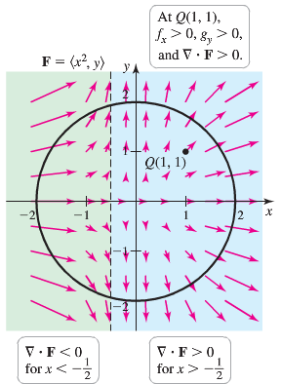

***Curl***

***Definition***

The curl of a vector field  that is differentiable on a region of  is







If , the vector field is ***irrotational***.

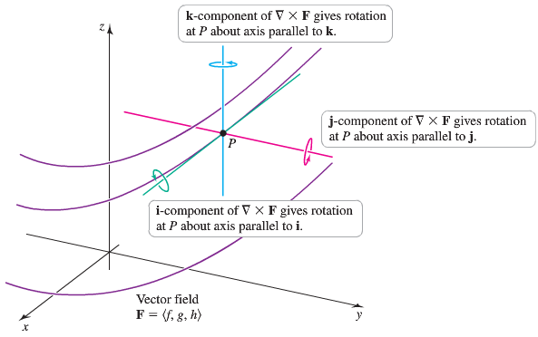

***Example***

Consider the vector field , where  is a nonzero vector and 







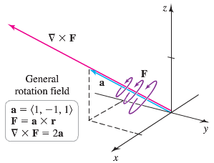

This vector field is a general rotation field in 3-dimensions.

Suppose a paddle wheel is placed in the vector field  at a point *P* with the axis of the wheel in the direction of a unit vector .



Where *θ* is the angle between  and .

The scalar component is greatest in magnitude and the paddle wheel spins fastest when ; that is when  and are parallel.

If the axis of the paddle wheel is orthogonal to , the wheel doesn’t spin.

**General Rotation Vector Field**

The general rotation vector field is  where the nonzero constant vector  is the axis of rotation and . For all choices of,  and . The constant angular speed of the vector field is





|  |
| --- |
|  |
| Paddle wheel at *P* with axis measures rotation about.  Rotation is a maximum when  is parallel to. |

***Example***

Compute the curl of the rotation field  where  is the axis of rotation and . What is the direction and the magnitude of the curl?

***Solution***















The direction of the curl is the direction of , which is the axis rotation.

The magnitude of 

**Working with Divergence and Curl**

***Theorem***

Suppose that  is a conservative vector field on an open region ***D*** of  Let  , where  is a potential function with continuous second partial derivatives on ***D***. Then ; that is, the curl of the gradient is the zero vector and is irrotational.







**Product Rule for the Divergence**

***Theorem***

Let *u* be a scalar-valued function that is differentiable on a region *D* and let  be a vector field that us differentiable on *D*. Then



***Example***

Let  and let  be a potential function.

1. Find the associated gradient field 
2. Compute 

***Solution***

1. 























This result reveals that  is an inverse square vector field and its potential function is 

1. 













































**Properties of a Conservative a Vector Field**

Let be a conservative vector field whose components have continuous second partial derivatives on an open connected region *D* in .

1. There exists a potential function  such that 
2.  for all points *A* and *B* in ***D*** and all piecewise-smooth oriented curves *C* from *A* to *B*.
3.  on all simple piecewise-smooth closed oriented curves *C* in *D*.
4.  at all points of *D*.

***Exercises Section* 4.5 – Divergence and Curl**

(**1 − 8**) Find the divergence of the following vector fields

|  |  |
| --- | --- |
|  |  |

(**9 − 12**) Calculate the divergence of the following radial fields. Express the result in terms of the position vector  and its length .

|  |  |
| --- | --- |
|  |  |

(**13 −14**) Consider the following vector fields, the circle *C*, and two points *P* and *Q*.

1. Without computing the divergence, does the graph suggest that the divergence is positive or negative at *P* and *Q*?
2. Compute the divergence and confirm your conjecture in part (*a*).
3. On what part of *C* is the flux outward? Inward?
4. Is the net outward flux across *C* positive or negative?

|  |  |
| --- | --- |
|  |  |
|  |  |

(**15−18**) Consider the following vector fields, where 

1. Compute the curl field and verify that it has the same direction as the axis of rotation
2. Compute the magnitude of the curl of the field

|  |  |
| --- | --- |
|  |  |

(**19−26**) Compute the curl of the following vector fields

|  |  |
| --- | --- |
|  |  |

(**27−30**) Compute the divergence and curl of the following vector fields, state whether the field is *source-free* or *irrotational*.

1. 
2. 
3. 
4. 
5. Let 
6. What are the components of curl  in the directions  and 
7. In what direction is the scalar component of curl  a maximum?
8. Let 
9. What are the components of curl  in the directions  and 
10. In what direction  is  a maximum?
11. Within the cube , where does  have the greatest magnitude when 
12. Show that the general rotation field , where  is a nonzero constant vector and , has zero divergence.
13. Let ,  and consider the rotation field . Use the right-hand rule for cross product to find the direction of  at the points , , , and 
14. Find the exact points on the circle  at which the field  switches from pointing inward to outward on the circle, or vice versa.
15. Suppose a solid object in  has a temperature distribution given by . The heat flow vector field in the object is , where the conductivity *k* > 0 is a property of the material. Note that the heat flow vector points in the direction opposite to that of the gradient, which is the direction of greatest temperature decrease. The divergence of the heat flow vector is  (the Laplacian of *T*). Compute the heat flow vector field and its divergence for the following temperature distribution.
16. 
17. 
18. 
19. Consider the rotational velocity field 
20. If a paddle is placed in the *xy-*plane with its axis normal to this plane, what is its angular speed?
21. If a paddle is placed in the *xz-*plane with its axis normal to this plane, what is its angular speed?
22. If a paddle is placed in the *yz-*plane with its axis normal to this plane, what is its angular speed?
23. Consider the rotational velocity field . If a paddle wheel is placed in the plane  with its axis normal to this plane, how fast does the paddle wheel spin (revolutions per unit time)?
24. The potential function for the gravitational force field due to a mass *M* at the origin acting on a mass *m* is  , where  is the position vector of the mass m and *G* is the gravitational constant.
25. Compute the gravitational force field 
26. Show that the field is irrotational; that is 
27. The potential function for the force field due to a charge *q* at the origin is , where  is the position vector of the mass m and *G* is the gravitational constant.
28. Compute the force field 
29. Show that the field is irrotational; that is 
30. The Navier-Stokes equation is the fundamental equation of fluid dynamics that models the motion of water in everything from bathtubs to oceans. In one of its many forms (incompressible, viscous flow), the equation is



In this notation  is the three-dimensional velocity field, *p* is the (scalar) pressure, *ρ* is the constant density of the fluid, and *μ* is the constant viscosity. Write out the three component equations of this vector equation.

1. One of Maxwell’s equations for electromagnetic waves is , where  is the electric field,  is the magnetic field, and *C* is a constant.
2. Show that the fields 

Satisfy the equation for constants *A*, *k,* and *ω*, provided 

1. Make a rough sketch showing the directions of  and 
2. Prove that for a real number *p*, with , 
3. Prove that for a real number *p*, with , 
4. Prove that for a real number *p*, with , 