***Section* 4.6 – Surfaces Integrals**

We have defined curves in the plane in three different ways:

Explicit form: 

Implicit form: 

Parametric vector form: 

And

Explicit form: 

Implicit form: 

**Parameterizations of Surfaces**

Suppose:

|  |  |  |
| --- | --- | --- |
|  | ***Parameterization*** |  |

We call the range of ***r*** the ***surface*** *S* defined or traced by ***r***.

*u* and *v*: variable parameters

*R*: parameter domain

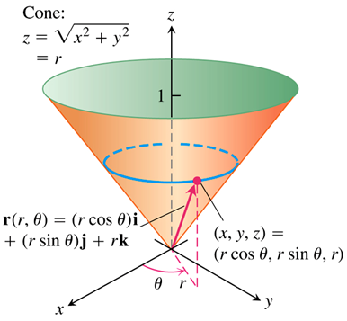***Example***

Find a parameterization of the cone 

***Solution***





Assume 





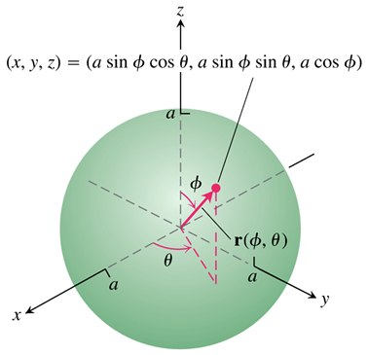***Example***

Find a parameterization of the cone 

***Solution***

A typical point  on the sphere has





Taking 



The parameterization is one-to-one on the interior of the domain *R*, though not on its boundary “*poles*” where 

***Example***

Find a parameterization of the cone 

***Solution***

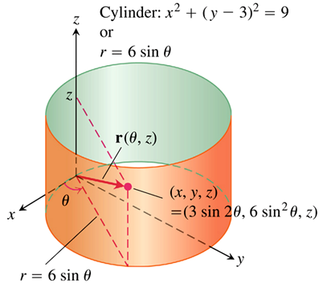











A typical point on the cylinder has



Taking 



***Surface Area***

Calculating the area of a curved surface *S* based on the parameterization



The definition of smoothness involves the partial derivatives of  with respect to *u* and *v*:

 

***Definition***

A ***parameterized*** surface  is smooth if  and  are continuous and  is never zero on the interior of the parameter domain.

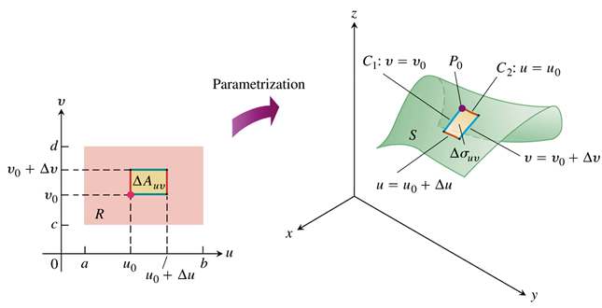

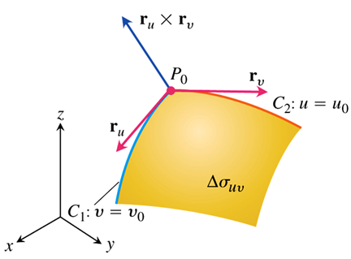 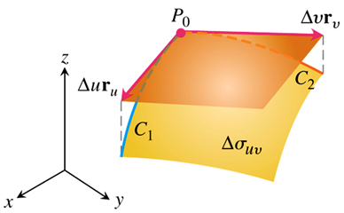

***Definition***

The area of the smooth surface



is 

**Surface area Differential for a Parameterized Surface**



***Example***

Find the surface area of the cone 

***Solution***

, and 





























***Example***

Find the surface area of a sphere of radius *a*.

***Solution***































***Example***

Let *S* be the “football” surface formed by rotating the curve  around the *z*-axis. Find the parameterization for *S* and compute its surface area.

**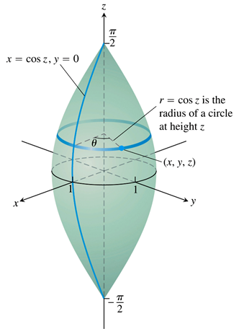*Solution***

Let  be an arbitrary point on the circle.

The parameters:  and .

We have:











































***Implicit Surfaces***

Surfaces are often presented as level sets of a function  for some constant c. Such a level surface does not come with an explicit parameterization, and is called am *implicit defined surface*.

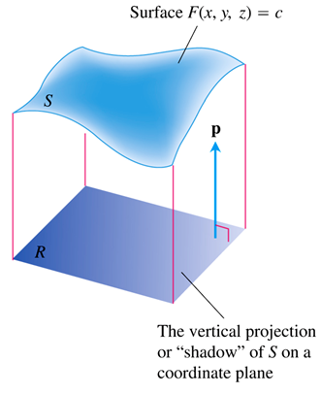

The surface is defined by the equation  and  is a unit vector normal to the plane region *R*.





Define the parameters *u* and *v* by *u* = *x* and *v* = *y*. Then *z* = *h*(*u, v*) and



Calculating the partial derivatives of ,

















Therefore, the surface area differential is given by



**Formula for the Surface Area of an Implicit Surface**

The area of the surface  over a closed and bounded plane region *R* is



Where  is normal to *R* and 

***Example***

Find the area of the surface cut from the bottom of the paraboloid  by the plane .

***Solution***

Let  and *R* the disk 



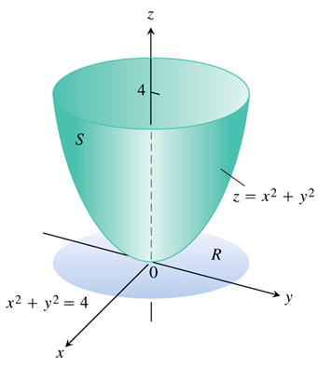









In the region *R*, . Therefore,















**Formula for the Surface Area of a Graph **

For a graph  over the region *R* in the *xy*-plane, the surface area formula is



|  |  |  |  |
| --- | --- | --- | --- |
| ***Surface*** | ***Equation*** | ***Explicit Description*** | |
|  |  | ***Normal Vector*** | ***Magnitude*** |
| **Cylinder** |  |  |  |
| **Cone** |  |  |  |
| **Sphere** |  |  |  |
| **Paraboloid** |  |  |  |

|  |  |  |  |
| --- | --- | --- | --- |
| ***Surface*** | ***Equation*** | ***Parametric Description*** | |
|  |  | ***Normal Vector*** | ***Magnitude*** |
| **Cylinder** |  |  |  |
| **Cone** |  |  |  |
| **Sphere** |  |  |  |
| **Paraboloid** |  |  |  |

***Exercises*** ***Section* 4.6 – Surfaces Integrals**

(**1−9**) Find a parametrization of the surface:

1. The paraboloid 
2. The portion of the cone  between the planes  and 
3. The sphere  cuts by the plane 
4. The plane 
5. The cap of the sphere  for 
6. The frustum of the cone  for 
7. The cone  for 
8. The portion of the cylinder  in the first octant, for 
9. The cylinder  for 

(**10−19**) Use a parametrization to express the area of the surface as a double integral. Then evaluate the integral of the portion of

1. A plane  inside the cylinder 
2. A cone  between the planes  and 
3. A cylinder  between the planes  and 
4. Cap cut from the paraboloid  between the planes  and 
5. The half cylinder 
6. The plane  in the first octant
7. The plane  above the square 
8. The hemisphere 
9. A cone with base radius *r* and height *h*, where *r* and *h* are positive constants.
10. The cap of the sphere 

(**20−39**) Use a surface integral to find the area of

1. Cut from the bottom of the paraboloid  by the plane .
2. Portion that lies above the triangle bounded by the lines , and  in the *xy*-plane.
3. Cap cut from the sphere  by the cone .
4. Ellipse cut from the plane  (*c* a constant) by the cylinder .
5. From the nose of the paraboloid  by *yz*-plane.
6. First octant cut from the cylinder  by the planes  and 
7. Helicoid 
8. Surface  above the origin 
9. Hemisphere , for  (excluding the base)
10. Frustum of the cone , for  (excluding the bases)
11. Area of the plane  above the square , 
12. The cone 
13. The paraboloid 
14. The trough 
15. The part of the hyperbolic paraboloid  above the sector 
16.  , where *S* is the plane  in the first octant
17.  , where *S* is the paraboloid 
18.  , where *S* is the hemisphere centered at the origin with radius 5, for
19.  , where *S* is the plane  in the first octant
20.  , where *S* is the plane  in the first octant

(**40−46**) Evaluate the surface integrals

1. ; *S* is the plane  in the first octant.
2. ; *S* is the curve surface of the cylinder ,  with outward normal vectors.

1. ; *S* is the entire surface including the base of the hemisphere , for .
2. , where *S* is the hemisphere , for , and where . Assume normal vectors point either outward or in the positive *z-*direction.
3. , where *S* is the cylinder , for , and where . Assume normal vectors point either outward or in the positive *z-*direction.
4. , where *S* is the part of the plane  that lies on the cylinder . Assume normal vectors point either outward or in the positive *z-*direction.
5. , where *S* is the cylinder . Assume normal vectors point either outward or in the positive *z-*direction.

(**47−50**) Evaluate the surface integral 

1.  , where *S* is the hemisphere 
2.  , where *S* is the cylinder 
3.  , where *S* is the cylinder 
4.  , where *S* is the part of the unit shpere in the first octant

(**51−58**) Find the flux of the vector fields across the given surface with the specified orientation

1.  across the sphere of radius *a* centered at the origin, where . Assume the normal vectors to the surface point outward.
2.  across the curved surface of the cylinder  for 
3.  across the slanted face of the tetrahedron  in the first octant; normal vectors point upward
4.  across the slanted face of the tetrahedron  in the first octant; normal vectors point upward
5.  across the slanted face of the cone  for  ; normal vectors point upward
6.  across the curved sides of the surface ; normal vectors point upward.
7.  across the sphere of radius *a* centered at the origin, where  ; normal vectors point outward
8.  across the cylinder  for  ; normal vectors point in the general direction of the positive *y-*axis
9. Consider the ellipsoid , where *a ,b*, and *c* are positive real numbers.
10. Show that the surface is described by the parametric equations  for 
11. Write an integral for the surface area of the ellipsoid.
12. The cone , cuts the sphere  along a curve *C*.
13. Find the surface area of the sphere below *C*, for 
14. Find the surface area of the sphere above *C*.
15. Find the surface area of the cone below *C*, for 
16. Consider the sphere  and the cylinder  for .
17. Find the surface area of the cylinder inside the sphere
18. Find the surface area of the sphere inside the cylinder.
19. Find the upward flux of the field  across the plane  in the first octant. Show that the flux equals *c* times the area if the base of the origin.
20. Consider the field  and the cone , for 
21. Show that when , the outward flux across the cone is zero.
22. Find the outward flux (away from the *z-*axis); for any .
23. A sphere of radius *a* is sliced parallel to the equatorial plane at a distance  from the equatorial plane. Find the general formula for the surface area of the resulting spherical cap (excluding the base) with thickness *h*.

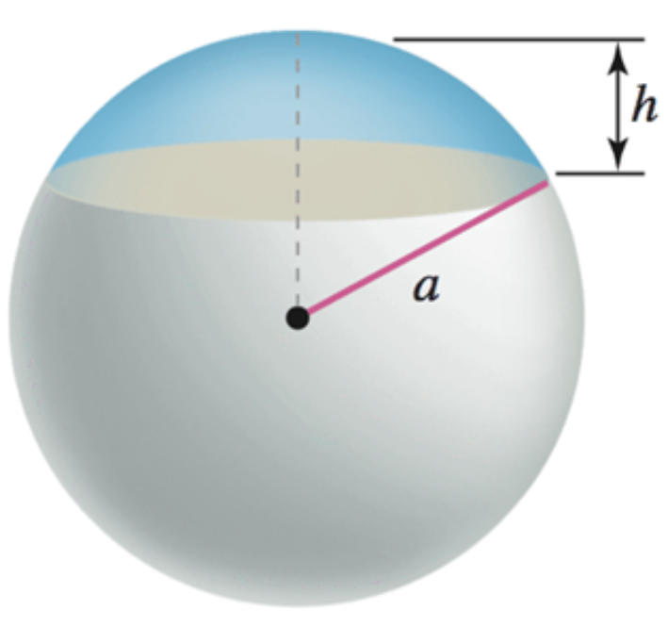

1. Consider the radial field , where  and *p* is a real number. Let *S* be he sphere of radius *a* centered at the origin. Show that the outward flux of  across the sphere is . It is instructive to do the calculation using both an explicit and parametric description of the sphere.

(**66−68**) The heat flow vector field for conducting objects is , where  is the temperature in the object and  is a constant that depends on the material. Compute the outward flux of  across the following surfaces *S* for the given temperature distributions. Assume .

1. ; *S* consists of the faces of the cube 
2. ; *S* cis the sphere 
3. ; *S* cis the sphere 
4. Given: 
5. Show that a torus with radii  may be described parametrically by  for 

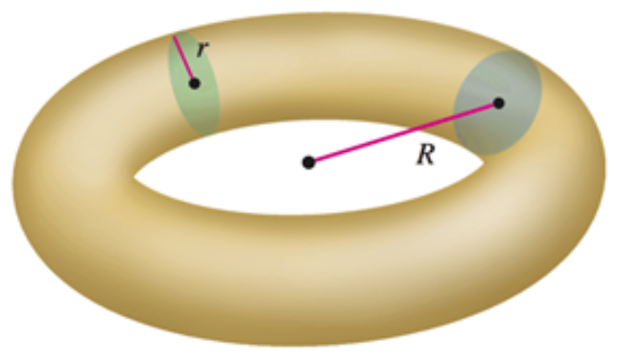

1. Show that the surface area of the torus is 