***Section* 4.7 – Stokes’ Theorem**

**Stokes’ Theorem**

Stokes’ Theorem is the three-dimensional version of the circulation from of Green’s Theorem.

If *C* is a closed simple piecewise-smooth oriented curve in the *xy-*plane enclosing a region *R* and  is a differentiable vector field on *R*. Green’s Theorem says that



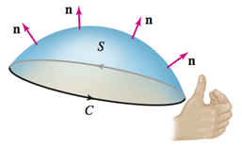

If the fingers of your right hand curl in the positive direction around *C*, then your right thumb points in the direction of the vectors normal to *S*.

***Theorem***

Let *S* be an oriented surface in  with a piecewise-smooth closed boundary *C* whose orientation is consistent with that of *S*. Assume that  is a vector field whose components have continuous first partial derivatives on *S*. Then



Where  is the unit vector normal to *S* determined by the orientation of *S*.

***Example***

Confirm that Stokes’ Theorem holds for the vector field  where *S* is the hemisphere , for , and *C* is the circle  oriented counterclockwise.

***Solution***

The orientation of *C* says that the vectors normal to *S* point in the outward direction. The vector field is a rotation field , where  and , so the axis of rotation points in the direction of the vector .

Compute first the circulation integral in Stokes’ Theorem. The curve *C* with the given orientation is parametrized as , for 









 















The region of integration is the base of the hemisphere in the *xy-*plane, which is





The normal vector from the table: 











 















***Example***

Evaluate the line integral  where  and *C* consists of the three line segments that bound the plane  in the first octant, oriented as shown

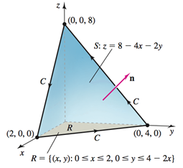

***Solution***





























***Example***

Evaluate the line integral  where  and *S* is the cap of the paraboloid  above the plane .

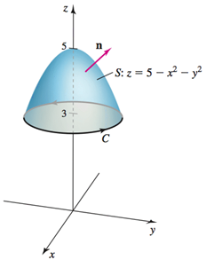

Assume  points in the upward direction on *S*.

***Solution***



 



















**Interpreting the Curl**

Stokes’ Theorem leads to another interpretation of the curl at a point in a vector field. We need the idea of the average circulation. If *C* is the boundary of an oriented surface *C*, we define the average circulation of  over *S* as



Where Stokes’ Theorem is used to convert the circulation integral to a surface integral.

***Example***

Consider the vector field , where  is a nonzero vector and 















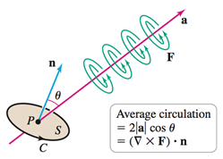

Let *S* to be a small circular disk centered at a point *P*, whose normal vector  makes an angle *θ* with the axis  .

Let *C* be the boundary of *S* with a counterclockwise orientation.

The average circulation of this vector field on *S* is







***Example***

Consider the velocity field , for  and , which represents a horizontal flow in the *y-*direction.

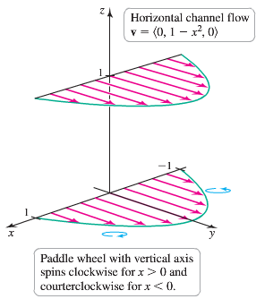

1. Suppose you place a paddle wheel at the point . Using physical arguments, in which of the coordinate directions should the axis of the wheel point in order for the wheel to spin? In which direction does it spin? What happens if you place the wheel at ?
2. Compute and graph the curl of  and provide an interpretation.

***Solution***

1. If the axis of the wheel is aligned with the *x-*axis at *P*, the flow strikes the upper and lower halves of the wheel symmetrically and the wheel does not spin. If the axis of the wheel is aligned with the *z-*axis at *P*, the flow in the *y-*direction is greater for  than it is for .

Therefore, a wheel located at  spins in the clockwise direction, looking from above.

Using the similar argument, we conclude that a vertically oriented paddle wheel placed at  spins in the counterclockwise direction (when viewing from above).

1. 



The curl points in the *z-*direction, which is the direction of the paddle wheel axis that gives the maximum angular speed of the wheel. Consider the *z*-component of the curl, which is 

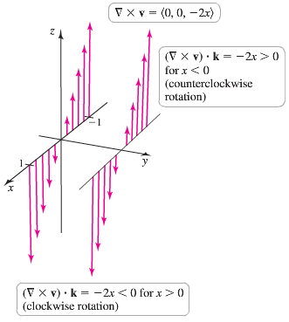

At *x* = 0, this component is zero, meaning the wheel does not spin at any point along the *y-*axis when its axis of the wheel is aligned with the *z-*axis. For , we see that , which corresponds to clockwise rotation of the vector field.

For , we see that , which corresponds to counterclockwise rotation.

**Proof of Stokes’ Theorem**

Consider the case in which the surface *S* is the graph of the function , defined on a region in the *xy-*plane. Let *C* be the curve that bounds *S* with a counterclockwise orientation, let *R* be the projection of *S* in the *xy-*plane, and let  the projection of *C* in the *xy-*plane.

|  |
| --- |
|  |
| is the projection of *C* in the *xy-*plane |

Let  the line integral in Stokes’ Theorem is







Where 

Applying Green’s Theorem: 

 











Where the upward vector normal 

**Notes on Stokes’ *Theorem***

1. Stokes’ Theorem allows a surface integral  to be evaluated using only the values of the vector field in the boundary *C*.



|  |  |
| --- | --- |
|  |  |

Since  and  are equal in magnitude and of opposite sign; therefore





1. If  is conservative vector field, then .

***Theorem*** Curl = 0 Implies is Conservative

Suppose that  throughout an open simply connected region *D* of . Then  on all closed simple smooth curves *C* in *D* and is a conservative vector field on *D*.





***Exercises*** ***Section* 4.7 – Stokes’ Theorem**

(**1**−**6**) Verify that the line integral and the surface integral of Stokes’ Theorem are equal for the following vector fields, surfaces *S*, and closed curves *C*. Assume that *C* has counterclockwise orientation and *S* has a consistent orientation.

1. ; *S* is the upper half of the sphere  and *C* is the circle  in the *xy-*plane
2. ; *S* is the upper half of the sphere  and *C* is the circle  in the *xy-*plane
3. ; *S* is the paraboloid  for  and *C* is the circle  in the *xy-*plane
4. ; *S* is the cap of the sphere  above the plane  and *C* is the boundary of *S*.
5. ; *S* is the cap of the sphere  above the plane  and *C* is the boundary of *S*.
6. ; *S* is the part of the plane  that lies in the cylinder  and *C* is the boundary of *S*.

(**7**−**14**) Evaluate the line integral  by evaluating the surface integral in Stokes’ Theorem with an appropriate choice of *S*. Assume that *C* has a counterclockwise orientation

1. ; *C* is the circle  in the plane .
2. ; *C* is the ellipse  in the plane .
3. ; *C* is the boundary of the plane  in the plane first octant.
4. ; *C* is the circle  for  .

1. ; *C* is the boundary of the plane  in the first octant.
2. ; *C*: is the circle  in the *xy-*plane.

1. ; *C* is the boundary of the plane  in the first octant.
2. ; *C* is the boundary of the square  in the plane 

(**15**−**20**) Evaluate the line integral in Stokes’ Theorem to evaluate the surface integral. Assume that   points in an upward direction.

1. ; *S* is the upper half of the ellipsoid 

1. ; *S* is the cap of the sphere 

1. ; *S* is the tilted disk enclosed 
2. ; *S* is the paraboloid  (excluding its base), and 

1. , where *S* is the hyperboloid . Assume that  is the *outward normal*.
2. , where *S* is the hemisphere , for . Assume that  is the outward normal.

(**21**−**24**) Use Stokes’ Theorem to find the circulation of the following vector fields around any simple closed smooth curve *C*.

1. 
2. 
3. 
4. 
5. Use Stokes’ Theorem and a surface integral to find the circulation on *C* of the vector field  as a function of . For what value of  is the circulation a maximum?
6. A circle *C* in the plane  has a radius of 4 and center (2, 3, 3). Evaluate  for  where *C* has a counterclockwise orientation when viewed from above. Does the circulation depend on the radius of the circle? Does it depend on the location of the center of the circle?
7. Begin with the paraboloid , for , and slice it with the plane . Let *S* be the surface that remains for  (including the planar surface in the *xz-*plane). Let *C* be the semicircle and line segment that bound the cap of *S* in the plane  with counterclockwise orientation. Let 

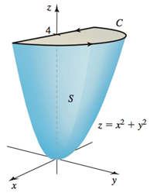

1. Describe the direction of the vectors normal to the surface that are consistent with the orientation of *C*.
2. Evaluate 
3. Evaluate  and check for argument with part (*b*).
4. The French Physicist André-Marie Ampère discovered that an electrical current *I* in a wire produces a magnetic field *B*. A special case of Ampère’s Law relates the current to the magnetic field through the equation , where *C* is any closed curve through which the wire passes and *μ* is a physical constant. Assume that the current *I* is given in terms of the current density ***J*** as , where *S* is an oriented surface with *C* as a boundary. Use Stokes’ Theorem to show that an equivalent form of Ampère’s Law is .
5. Let S be the paraboloid , for , where *a* > 0 is a real number. Let . For what value(s) of *a* (if any) does  have its maximum value?
6. The goal is to evaluate , where  and S ids the surface of the upper half of the ellipsoid 
7. Evaluate a surface integral over a more convenient surface to find the value of *A*.
8. Evaluate *A* using a line integral.
9. Let  and let *S* be the hemisphere of radius *a* with its base in the *xy-*plane and center at the origin.
10. Evaluate  by computing  and appealing to symmetry.
11. Evaluate the line integral using Stokes’ Theorem to check part (*a*).
12. Let *S* be the disk enclosed by the curve  fot , where  is a fixed angle.
13. Find the a vector normal to *S*.
14. What is the areas of *S*?
15. Whant the length of *C*?
16. Use the Stokes’ Theorem and a surface integral to find the ciurculation on *C* of the vector field  as a function of *φ*. For what value of *φ* is the circulation a maximum?
17. What is the circulation on C of the vector field  as a function of *φ*? For what value of *φ* is the circulation a maximum?
18. Consider the vector field , where  is a constant nonzero vector and . Show that the circulation is a maximum when  points in the direection of the normal to *S*.
19. Let *R* be a region in a plane that has a unit normal vector  and boundary *C*. Let 
20. Show that 
21. Use Stokes’ Theorem to show that



1. Consider the curve *C* given by , for . Prove that *C* lies in a plane by showing that  is constant for all *t*.
2. Use part (*b*) to find the area of the region enclosed by *C* in part (*c*). (*Hint*: Find the unit normal vector that is consistent with the orientation of *C*.)
3. Consider the radial vector fields , where *p* is a real number and . Let *C* be any circle in the *xy-*plane centered at the origin.
4. Evaluate a line integral to show that the field has zero circulation on *C*.
5. For what values of *p* does Stokes’ Theorem apply? For those values of *p*, use the surface integral in Stokes’ Theorem to show that the field has zero circulation on *C*.
6. Consider the vector fierld 
7. Show that 
8. Show that  is not zero on circle *C* in the *xy-*plane enclosing the origin.
9. Explain why Stokes’ Theorem does not apply in this case.
10. Let *S* be a small circular disk of radius *R* centered at the point *P* with a unit normal vector . Let *C* be the boundary of *S*.
11. Express the average circulation of the vector field  on *S* as a surface integral of 
12. Argue for that small *R*, the average circulation approaches  (the component of  in the direction of  evaluated at *P*) with the approximation improving as .