***Lecture One* – Vectors and Vector-Values Functions**

***Solution*** ***Section* 1.1 – Vectors**

***Exercise***

Give a geometric description of the set of points in space whose coordinates satisfy the given pairs of equations 

***Solution***

The circle  in the ***xz***-plane

***Exercise***

Give a geometric description of the set of points in space whose coordinates satisfy the given pairs of equations 

***Solution***

The circle  in the plane 

***Exercise***

Give a geometric description of the set of points in space whose coordinates satisfy the given pairs of equations 

***Solution***

The circle  in the ***yz***-plane

***Exercise***

Give a geometric description of the set of points in space whose coordinates satisfy the given pairs of equations 

***Solution***



The circle  in the ***xz***-plane

***Exercise***

Give a geometric description of the set of points in space whose coordinates satisfy the given pairs of equations 

***Solution***

The circle formed by the intersection of the sphere  and the plane 

***Exercise***

Find the distance between points 

***Solution***









***Exercise***

Find the distance between points 

***Solution***









***Exercise***

Find the distance between points 

***Solution***







***Exercise***

Find the distance between points 

***Solution***







***Exercise***

Find the center and radii of the spheres 

***Solution***







The center is at  and the radius is 

***Exercise***

Find the center and radii of the spheres 

***Solution***







The center is at  and the radius is 

***Exercise***

Find the center and radii of the spheres 

***Solution***









The center is at  and the radius is 

***Exercise***

Find a formula for the distance from the point  to *x*-axis

***Solution***

The distance between  and  is:





***Exercise***

Find a formula for the distance from the point  to *xy*-plane

***Solution***

The distance between  and  is:





***Exercise***

Let . Find the component form and the magnitude if the vector

|  |  |  |  |  |
| --- | --- | --- | --- | --- |
| 1. 3***u*** | 1. ***u*** − ***v*** |  |  |  |

***Solution***

1. 
2. 
3. 





1. 





1. 





***Exercise***

Find the component form of the vector: The sum of  and  where



***Solution***







***Exercise***

Find the component form of the vector: The unit vector that makes an angle  with the positive *x*-axis

***Solution***



***Exercise***

Find the component form of the vector: The unit vector obtained by rotating the vector  counterclockwise about the origin

***Solution***

The angle of unit vector  is 90°, this unit vector rotates 120° which makes an angle of  with the positive *x*-axis



***Exercise***

Find the component form of the vector: The unit vector obtained by rotating the vector  counterclockwise about the origin

***Solution***

The angle of unit vector  is 0°, this unit vector rotates 135° which makes an angle of  with the positive *x*-axis



***Exercise***

Sketch the indicated vector

|  |  |  |
| --- | --- | --- |
| 1. ***u*** − ***v*** |  |  |

***Solution***

|  |  |
| --- | --- |
|  |  |



***Exercise***

An Airplane is flying in the direction 25° west of north at 800 *km/h*. Find the component form of the velocity of the airplane, assuming that the positive *x*-axis represents due east and the positive *y*-axis represents due north.

***Solution***

25° west of north is 25° + 90° = 115° north of east



***Exercise***

A jet airliner, flying due east at 500 *mph* in still air, encounters a 70-*mph* tailwind blowing in the direction 60° north of east. The airplane holds its compass heading due east but, because of the wind, acquires a new ground speed and direction. What speed and direction should the jetliner have in order for the resultant vector to be 500 *mph* due east?

***Solution***

= the velocity of the airplane; ***v*** = the velocity of the tailwind

 





 





 The direction is  south of east

***Exercise***

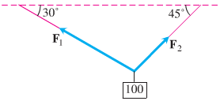Consider a 100-N weight suspended by two wires. Find the magnitudes and components of the force vectors 

***Solution***

 

 









 

 

***Exercise***

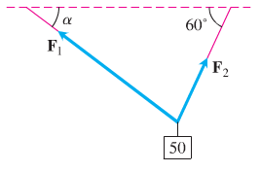Consider a 50-N weight suspended by two wires, If the magnitude of vector , find the angle α and the magnitude of vector 

***Solution***

 

 







 



















Since α > 0 











***Exercise***

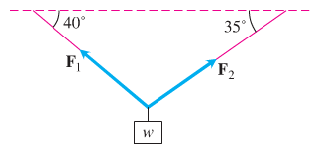Consider a ***w***-N weight suspended by two wires, If the magnitude of vector , find ***w*** and the magnitude of vector 

***Solution***

























***Exercise***

Consider a 25-N weight suspended by two wires, If the magnitude of vector are both 75 N, then angles α and β are equal. Find α.

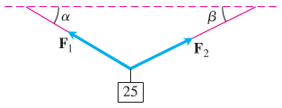***Solution***

 

 



 











***Exercise***

A bird flies from its nest 5 km in the direction 60° north east, where it stops to rest on a tree. It then flies 10 km in the direction due southeast and lands atop a telephone pole. Place an *xy*-coordinate system so that the origin is the bird’s nest, the *x*-axis points east, and the *y*-axis points north.

1. At what point is the tree located?
2. At what point is the telephone pole?

***Solution***

1. 



The tree is located at the point



1. 









The pole is located at the point 

***Exercise***

Suppose that *A*, *B*, and *C* are the corner points of the thin triangular plate of constant density.

1. Find the vector from *C* to the midpoint *M* of side *AB*.
2. Find the vector from *C* to the point that lies two-thirds of the way from *C* to *M* on the median *CM*.
3. Find the coordinates of the point in which the medians of  intersect (this point is the plate’s center of mass).

***Solution***

1. The midpoint of AB is: 







1. The desired vector is 





1. The vector whose sum is the vector from the origin to C and the result of part (b) will terminate at the center of mass.







Therefore; the center of mass point is 

***Exercise***

Show that a unit vector in the plane can be expressed as , obtained by rotating ***i*** through an angle *θ* in the counterclockwise direction. Explain why this form gives ***every*** *unit vector* in the plane.

***Solution***

Let ***u*** be any unit vector in the plane.

If ***u*** is positioned so that its initial point and terminal point is at , then ***u*** makes an angle *θ* with ***i***, measured in the *ccw* direction.

Since 

That implies to: 

Since ***u*** is any unit vector in the plane; this holds for every unit vector in the plane.

***Solution*** ***Section* 1.2 – Dot Products**

***Exercise***

Find for 

1. 
2. The cosine of the angle between ***v*** and ***u***
3. The scalar component of ***u*** in the direction of ***v***
4. The vector 

***Solution***

1. 



















1. 
2. 
3. 







***Exercise***

Find for 

1. 
2. The cosine of the angle between ***v*** and ***u***
3. The scalar component of ***u*** in the direction of ***v***
4. The vector 

***Solution***

1. 















1. 





1. 
2. 





***Exercise***

Find for 

1. 
2. The cosine of the angle between ***v*** and ***u***
3. The scalar component of ***u*** in the direction of ***v***
4. The vector 

***Solution***

1. 

















1. 





1. 
2. 





***Exercise***

Find for 

1. 
2. The cosine of the angle between ***v*** and ***u***
3. The scalar component of ***u*** in the direction of ***v***
4. The vector 

***Solution***

1. 





1. 





1. 



1. 



***Exercise***

Find for 

1. 
2. The cosine of the angle between ***v*** and ***u***
3. The scalar component of ***u*** in the direction of ***v***
4. The vector 

***Solution***

1. 





1. 







1. 
2. 





***Exercise***

Find the angles between the vectors 

***Solution***





 



***Exercise***

Find the angles between the vectors 

***Solution***





 



***Exercise***

Find the angles between the vectors 

***Solution***





 



***Exercise***

The direction angles α, β, and γ of a vector  are defined as follows:

is the angle between ***v*** and the positive *x*-axis 

is the angle between ***v*** and the positive *y*-axis 

is the angle between ***v*** and the positive *z*-axis 

1. Show that and  . These cosines are called the direction cosines of ***v***.
2. Show that if  is a unit vector, then *a, b*, and *c* are the direction cosines of ***v***.

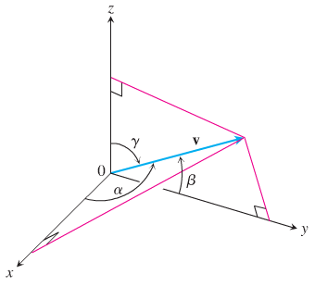***Solution***

1. 















1. If  is a unit vector 

 are the direction cosines of ***v***.

***Exercise***

A water main is to be constructed with 20% grade in the north direction and a 10% grade in the east direction. Determine the angle θ required in the water main for the turn from north to east.

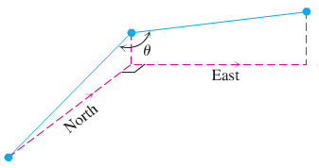

***Solution***

20% grade in the north direction 

Let  be parallel to the pipe in the north direction.

 be parallel to the pipe in the east direction.









***Exercise***

A gun with muzzle velocity of 1200 ft/sec is fired at an angle of 8° above the horizontal. Find the horizontal and vertical components of the velocity.

***Solution***

Horizontal component: 

Vertical component: 

***Exercise***

Suppose that a box is being towed up an inclined plane. Find the force ***w*** needed to make the component of the force parallel to the indicated plane equal to 2.5 lb.

***Solution***



 





***Exercise***

Find the work done by a force ***F*** = 5***i*** (magnitude 5 N) in moving an object along the line from the origin to the point (1, 1) (distance in meters)

***Solution***



  

***Exercise***

How much work does it take to slide a crate 20 m along a loading dock by pulling on it with a 200 N force at an angle of 30° from the horizontal?

***Solution***

  

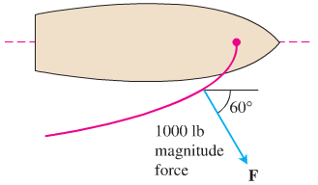***Exercise***

The wind passing over a boat’s sail exerted a 1000-*lb* magnitude force F. How much work did the wind perform in moving the boat forward 1 *mi*? Answer in foot-pounds.

***Solution***







***Solution Section* 1.3 – Cross Products**

***Exercise***

Find the length and direction of  and : 

***Solution***



Length: 

Direction: 



Length: 

Direction: 

***Exercise***

Find the length and direction of  and : 

***Solution***



Length: 

Direction: No direction



Length: 

Direction: No direction

***Exercise***

Find the length and direction of  and : 

***Solution***



Length: 

Direction: 



Length: 

Direction: 

***Exercise***

Find the length and direction of  and : 

***Solution***



Length: 

Direction: 



Length: 

Direction: 

***Exercise***

Sketch the coordinate axes and then include the vectors ***u***, ***v***, and as vectors starting origin for 

***Solution***





***Exercise***

Sketch the coordinate axes and then include the vectors ***u***, ***v***, and as vectors starting origin for 

***Solution***



***Exercise***

Find the area of the triangle determined by the points *P, Q*, and *R*, and then find a unit vector perpendicular to plane *PQ* *R*. 

***Solution***





















***Exercise***

Find the area of the triangle determined by the points *P, Q*, and *R*, and then find a unit vector perpendicular to plane *PQ* *R*. 

***Solution***





















***Exercise***

Find the area of the triangle determined by the points *P, Q*, and *R*, and then find a unit vector perpendicular to plane *PQ* *R*. 

***Solution***

















***Exercise***

Verify that  and find the volume of the parallelepiped determined by 

***Solution***

Let 

  

Which all have the same absolute value, by interchanging the rows the determinant does not change its absolute value.



***Exercise***

Find the volume of the parallelepiped determined by



***Solution***



***Exercise***

Find the volume of the parallelepiped determined by



***Solution***



***Exercise***

Find the magnitude of the torque force exerted by ***F*** on the bolt at *P* if  and 

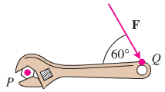***Solution***







***Exercise***

Find the magnitude of the torque force exerted by ***F*** on the bolt at *P* if  and 

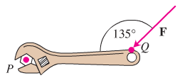***Solution***







***Exercise***

Find the area of the parallelogram whose vertices are: 

***Solution***













***Exercise***

Find the area of the parallelogram whose vertices are: 

***Solution***













***Exercise***

Find the area of the parallelogram whose vertices are: 

***Solution***













***Exercise***

Find the area of the parallelogram whose vertices are:



***Solution***



 is parallel to 



 is parallel to 









***Exercise***

Find the area of the parallelogram whose vertices are:



***Solution***













***Exercise***

Find the area of the triangle whose vertices are: 

***Solution***











***Exercise***

Find the area of the triangle whose vertices are: 

***Solution***











***Exercise***

Find the area of the triangle whose vertices are: 

***Solution***











***Exercise***

Find the area of the triangle whose vertices are: 

***Solution***













***Exercise***

Find the volume of the parallelepiped if four of its eight vertices are:



***Solution***







***Solution*** ***Section* 1.4 – Lines and Curves in Space**

***Exercise***

Find the parametric equation for the line through the point  parallel to the vector 

***Solution***



***Exercise***

Find the parametric equation for the line through the points  and 

***Solution***

The direction:  and 



***Exercise***

Find the parametric equation for the line through the points  and 

***Solution***

The direction:  and  

***Exercise***

Find the parametric equation for the line through the origin parallel to the vector 

***Solution***

The direction:  and  

***Exercise***

Find the parametric equation for the line through the point  parallel to the line 

***Solution***

The direction:  and  

***Exercise***

Find the parametric equation for the line through  perpendicular to the plane 

***Solution***

The direction:  and 



***Exercise***

Find the parametric equation for the line through  perpendicular to the vectors  and 

***Solution***

The direction:  and 



***Exercise***

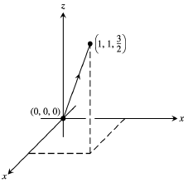Find the parameterization for the line segment joining the points . Draw coordinate axes and sketch the segment, indicate the direction on increasing *t* for the parametrization.

***Solution***

The direction:  and

***Exercise***

Find the parameterization for the line segment joining the points . Draw coordinate axes and sketch the segment, indicate the direction on increasing *t* for the parametrization.

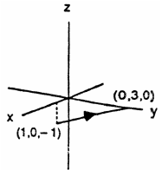***Solution***

The direction:  and 



***Exercise***

Find equation for the plane through normal to 

***Solution***







***Exercise***

Find equation for the plane through  parallel to the plane 

***Solution***



 

***Exercise***

Find equation for the plane through ,  and 

***Solution***



 is normal to the plane.







***Exercise***

Find equation for the plane through  perpendicular to the line 

***Solution***

 







***Exercise***

Find equation for the plane through  perpendicular to the vector from the origin to *A*.

***Solution***









***Exercise***

Find the point of intersection of the lines  and , and find the plane determined by these lines.

***Solution***



 **√** (satisfied)

The lines intersect when *t* = 0 and *s* = −1 ⇒ The point of intersection 

Therefore; the point is 

The normal vectors: 

  are directions of the lines.

The plane containing the lines is represented by



***Exercise***

Find the plane determined by the intersecting lines:





***Solution***

The normal vectors: 



Let *t* = 0 

Therefore; the desired plane is:







***Exercise***

Find a plane through and perpendicular to the line of intersection of the planes 

***Solution***

The normal vectors: 

 is the vector in the direction of the line of intersection of the planes.





 is the desired plane containing 

***Exercise***

Find the distance from the point to the plane 

***Solution***

At *t* = 0  and let 

 and 













***Exercise***

Find the distance from the point to the plane 

***Solution***

At *t* = 0  and let 

 and 













***Exercise***

Find the distance from the point to the plane 

***Solution***

At *t* = 0  and let 

 and 















***Exercise***

Find the distance from the point to the plane 

***Solution***

 and let 

 and 











***Exercise***

Find the distance from the point to the plane 

***Solution***



 and let 

 and  







***Exercise***

Find the distance from the point to the plane 

***Solution***

 and let 

 and  









***Exercise***

Find the distance from the plane  to the plane 

***Solution***





 and  









***Exercise***

Find the angle between the planes 

***Solution***

The vectors:  are normal to the planes.

The angle between them is:





 



***Exercise***

Find the angle between the planes 

***Solution***

The vectors:  are normal to the planes.

The angle between them is:



 



***Exercise***

Find the point in which the line meets the plane 

***Solution***













***Exercise***

Find the point in which the line meets the plane 

***Solution***













***Solution*** ***Section*** **1.5 – Calculus of Vector-Valued Functions**

***Exercise***

 is the position of a particle in the *xy*-plane at time *t*. Find an equation in *x* and *y* whose is the path of the particle. Then find the particle’s velocity and acceleration vectors at the given value of *t*.



***Solution***











***Exercise***

 is the position of a particle in the *xy*-plane at time *t*. Find an equation in *x* and *y* whose is the path of the particle. Then find the particle’s velocity and acceleration vectors at the given value of *t*.



***Solution***





 





 









***Exercise***

 is the position of a particle in the *xy*-plane at time *t*. Find an equation in *x* and *y* whose is the path of the particle. Then find the particle’s velocity and acceleration vectors at the given value of *t*.



***Solution***







 











***Exercise***

 is the position of a particle in the *xy*-plane at time *t*. Find an equation in *x* and *y* whose is the path of the particle. Then find the particle’s velocity and acceleration vectors at the given value of *t*.



***Solution***













***Exercise***

Give the position vectors of particles moving along various curves in the *xy*-plane. Find the particle’s velocity and acceleration vectors at the stated times and sketch them as vectors on the curve

Motion on the circle 

***Solution***

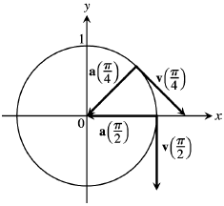











***Exercise***

Give the position vectors of particles moving along various curves in the *xy*-plane. Find the particle’s velocity and acceleration vectors at the stated times and sketch them as vectors on the curve

Motion on the cycloid 



***Solution***













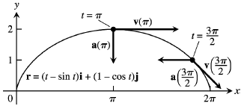

***Exercise***

 is the position of a particle in the *xy*-plane at time *t*. Find the particle’s velocity and acceleration vectors. Then find the particle’s speed and direction of motion at the given value of *t*. Write the particle’s velocity at that time as the product of its speed and direction.



***Solution***







***Speed***: 

***Direction***: 





***Exercise***

 is the position of a particle in the *xy*-plane at time *t*. Find the particle’s velocity and acceleration vectors. Then find the particle’s speed and direction of motion at the given value of *t*. Write the particle’s velocity at that time as the product of its speed and direction.



***Solution***







***Speed***: 

***Direction***: 





***Exercise***

 is the position of a particle in the *xy*-plane at time *t*. Find the particle’s velocity and acceleration vectors. Then find the particle’s speed and direction of motion at the given value of *t*. Write the particle’s velocity at that time as the product of its speed and direction.



***Solution***







***Speed***: 

***Direction***: 





***Exercise***

 is the position of a particle in the *xy*-plane at time *t*. Find the particle’s velocity and acceleration vectors. Then find the particle’s speed and direction of motion at the given value of *t*. Write the particle’s velocity at that time as the product of its speed and direction.



***Solution***







***Speed***: 

***Direction***: 





***Exercise***

 is the position of a particle in the *xy*-plane at time *t*. Find the particle’s velocity and acceleration vectors. Then find the particle’s speed and direction of motion at the given value of *t*. Write the particle’s velocity at that time as the product of its speed and direction.



***Solution***

 



***Speed***: 

***Direction***: 





***Solution*** ***Section* 1.6 – Motion in Space**

***Exercise***

Evaluate the integral: 

***Solution***







***Exercise***

Evaluate the integral: 

***Solution***









***Exercise***

Evaluate the integral: 

***Solution***













***Exercise***

Evaluate the integral: 

***Solution***













***Exercise***

Evaluate the integral: 

***Solution***









***Exercise***

Evaluate the integral: 

***Solution***

|  |  |  |
| --- | --- | --- |
|  |  |  |
|  |  |  |
|  |  |  |
|  |  |  |

 











***Exercise***

Evaluate the integral: 

***Solution***











***Exercise***

Solve the initial value problem for ***r*** as a vector function of *t*.



***Solution***













***Exercise***

Solve the initial value problem for ***r*** as a vector function of *t*.



***Solution***













***Exercise***

Solve the initial value problem for ***r*** as a vector function of *t*.



***Solution***















***Exercise***

Solve the initial value problem for ***r*** as a vector function of *t*.



***Solution***





















***Exercise***

Solve the initial value problem for r as a vector function of t.



***Solution***























***Exercise***

At time *t* = 0, a particle is located at the point . It travels in a straight line to the point , has speed 2 at  and constant acceleration . Find an equation for the position vector of the particle at time *t*.

***Solution***







Since the particle travels in a straight line in the direction of the vector:



At *t* = 0, the particle has a speed of 2.













At time *t* = 0, a particle is located at the point  









***Exercise***

A projectile is fired at a speed of 840 *m/sec* at an angle of 60°. How long will it take to get 21 *km* downrange?

***Solution***









***Exercise***

Find the muzzle speed of a gun whose maximum range is 24.5 *km*.

***Solution***



Maximum R occurs when sine equals to 1 









***Exercise***

A spring gun at ground level fires a golf ball at an angle of 45°. The ball lands 10 *m* away.

1. What was the ball’s initial speed?
2. For the same initial speed, find the two firing angles that make the range 6 *m*.

***Solution***

1. 







1. 









***Exercise***

An electron in a TV tube is beamed horizontally at a speed of toward the face of the tube 40 cm away. About how far will the electron drop before it hits?

***Solution***





 ***Horizontal α* = 0°**









Therefore, the electron drop 

***Exercise***

A golf ball is hit with an initial speed of 116 ft/sec at an angle of elevation of 45° from the tee to a green that is elevated 45 ft above the tee. Assuming that the pin, 369 ft downrange, does not get in the way, where will the ball land in relation to the pin?

***Solution***

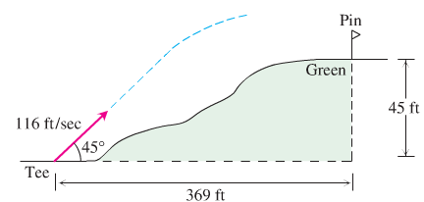













It will take the ball 4.5 sec to travel 369 ft. at the time the ball will be 45.11 ft in the air and will hit the green past the pin.

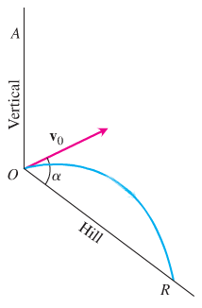***Exercise***

An ideal projectile is launched straight down an inclined plane.

1. Show that the greates1 downhill range is achieved when the initial velocity vector bisects angle *AOR*
2. If the projectile were fired uphill instead of down, what launch angle would maximize its range?

***Solution***

1. 



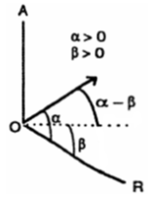 







;

Which is time when the projectile hits the downhill slope.

















 

1. 

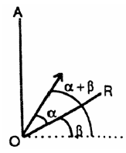









; which is time when the projectile hits the uphill slope.















 

***Exercise***

A volleyball is hit when it is 4 *ft* above the ground and 12 *ft* from a 6-*ft*-high net. It leaves the point of impact with an initial velocity of 35 *ft/sec* at an angle of 27° and slips by the opposing team untouched.

1. Find a vector equation for the path of the volleyball.
2. How high does the volleyball go, and when does it reach maximum height?
3. Find its range and flight time.
4. When is the volleyball 7 *ft* above the ground? How far (ground distance) is the volleyball from where it will land?
5. Suppose that the net is raised to 8 *ft*. Does this change things? Explain.

***Solution***

***Given***: 

1. 









1. 







1.  *Solve for* ***t***



Range: 

1.  *Solve for* ***t***









1. Since , the ball won’t clear the 8 *ft* net, therefore, Yes, it changes things.

***Solution*** ***Section* 1.7 – Length of Curves**

***Exercise***

Find the curve’s unit tangent vector. Also, find the length of the indicated portion of the curve



***Solution***







Length: 

***Exercise***

Find the curve’s unit tangent vector. Also, find the length of the indicated portion of the curve



***Solution***

 



Length: 

 









***Exercise***

Find the curve’s unit tangent vector. Also, find the length of the indicated portion of the curve



***Solution***







Length: 

***Exercise***

Find the curve’s unit tangent vector. Also, find the length of the indicated portion of the curve



***Solution***













Length: 

 











***Exercise***

Find the curve’s unit tangent vector. Also, find the length of the indicated portion of the curve



***Solution***











Length: 









***Exercise***

Find the curve’s unit tangent vector. Also, find the length of the indicated portion of the curve



***Solution***



















Length: 









***Exercise***

Find the point on the curve  at a distance 26π units along the curve from the point (0, 5, 0) in the direction of increasing arc length.

***Solution***





















The point is: 

***Exercise***

Find the arc length parameter along the curve from the point where *t* = 0. Also, find the length of the indicated portion of the curve. 

***Solution***









***Exercise***

Find the arc length parameter along the curve from the point where *t* = 0. Also, find the length of the indicated portion of the curve. 

***Solution***



































***Exercise***

Find the arc length parameter along the curve from the point where *t* = 0. Also, find the length of the indicated portion of the curve. 

***Solution***







Length: 

***Exercise***

If a string wound around a fixed circle in unwound while held taut in the plane of the circle, its end *P* traces an involute of the circle. The circle in question is the circle  and the tracing point starts at (1, 0). The unwound portion of the string is tangent to the circle at *Q*, and *t* is the radian measure of the angle from the position *x*-axis to segment *OQ*. Derive the parametric equations

 of the point  for the involute.

***Solution***





PQ = Length of the unwound string

















***Solution Section* 1.8 – Curvature and Normal Vectors**

***Exercise***

Find ***T***, ***N***, and κ for the plane curves: 

***Solution***





























***Exercise***

Find ***T***, ***N***, and κ for the plane curves: 

***Solution***















***Exercise***

Find ***T***, ***N***, and κ for the plane curves: 

***Solution***



































***Exercise***

Find ***T***, ***N***, and κ for the plane curves: 

***Solution***















***Exercise***

Find ***T***, ***N***, and κ for the space curves: 

***Solution***















***Exercise***

Find ***T***, ***N***, and κ for the space curves: 

***Solution***































***Exercise***

Find ***T***, ***N***, and κ for the space curves: 

***Solution***

























***Exercise***

Find ***T***, ***N***, and κ for the space curves: 

***Solution***























***Exercise***

Find ***T***, ***N***, and κ for the space curves: 

***Solution***



 



























***Exercise***

Find an equation for the circle of curvature of the curve , at the point . (The curve parametrizes the graph  in the *xy*-plane.)

***Solution***





























The radius of curvature is: 

The center of the circle is 

The equation of the osculating circle is: 

***Exercise***

Write ***a*** of the motion  without finding ***T*** and ***N***. 

***Solution***















***Exercise***

Write ***a*** of the motion  without finding ***T*** and ***N***. 

***Solution***













***Exercise***

Write ***a*** of the motion  at the given value of *t* without finding ***T*** and ***N***.



***Solution***

















***Exercise***

Write ***a*** of the motion  at the given value of *t* without finding ***T*** and ***N***.



***Solution***



























***Exercise***

Write ***a*** of the motion  at the given value of *t* without finding ***T*** and ***N***.



***Solution***



























***Exercise***

Find ***r, T, N***, and ***B*** at the given value of *t*. Then find equations for the osculating, normal, and rectifying planes at that value of *t*. 

***Solution***

















The normal to the osculating plane  lies on the osculating plane (using ***B***):  is the osculating plane.

***T*** is normal to the normal plane



 is the normal plane

***N*** is normal to the rectifying plane:



 is the rectifying plane.

***Exercise***

Find ***r, T, N***, and ***B*** at the given value of *t*. Then find equations for the osculating, normal, and rectifying planes at that value of *t*. 

***Solution***



















The normal to the osculating plane  lies on the osculating plane (using ***B***):



is the osculating plane.

***T*** is normal to the normal plane 

 is the normal plane

***N*** is normal to the rectifying plane: 

 is the rectifying plane.

***Exercise***

Find ***B*** and τ for: 

***Solution***





























***Exercise***

Find ***B*** and τ for: 

***Solution***































***Exercise***

Find ***B*** and τ for: 

***Solution***





























***Exercise***

The speedometer on your car reads a steady 35 mph. Could you be accelerating? Explain.

***Solution***

Yes.

If the car is moving along a curved path, then  and 



***Exercise***

Can anything be said about the acceleration of a particle that is moving at a constant speed? Give reasons for your answer.

***Solution***

 is constant ⇒ 

 is orthogonal to ***T***.

∴ The acceleration is normal to the path.

***Exercise***

Find ***T***, ***N***, ***B***, τ and κ as functions of *t* for the plane curves: , then write ***a*** of the motion 

***Solution***



































