***Solution*** ***Section* 2.1 – Graphs and Level Curves**

***Exercise***

Find the specific values for 

*a*)  *b*)  *c*)  *d*) 

***Solution***

1. 
2. 
3. 
4. 

***Exercise***

Find the specific values for 

*a*)  *b*)  *c*)  *d*) 

***Solution***

1. 
2. 
3. 
4. 

***Exercise***

Find and sketch the domain for each function 

***Solution***



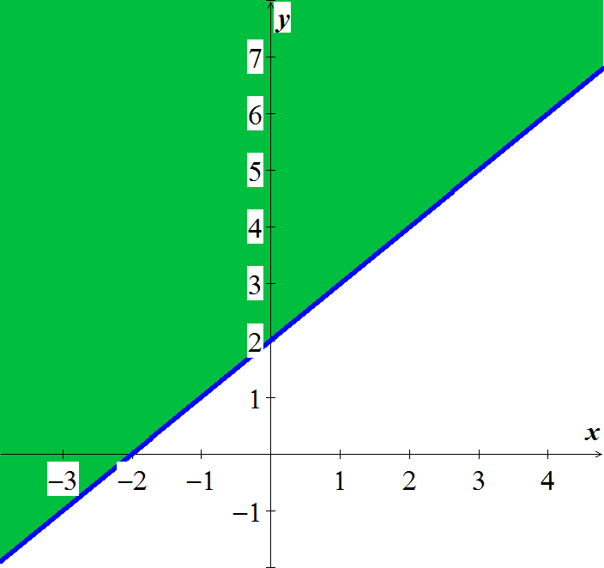

***Exercise***

Find and sketch the domain for each function 

***Solution***



*Domain*: All points  outside the circle

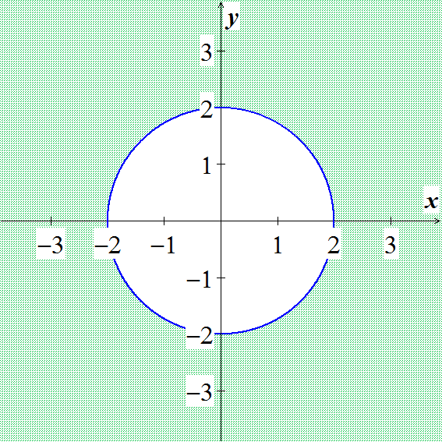

***Exercise***

Find and sketch the domain for each function 

***Solution***



*Domain*: All points  not lying on the circle 

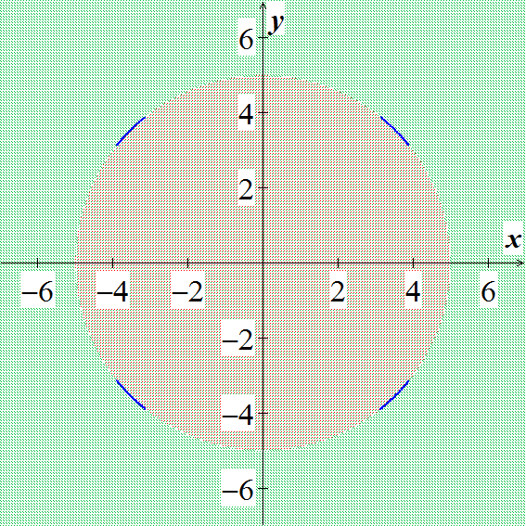

***Exercise***

Find and sketch the domain for each function 

***Solution***





*Domain*: All points  satisfying 

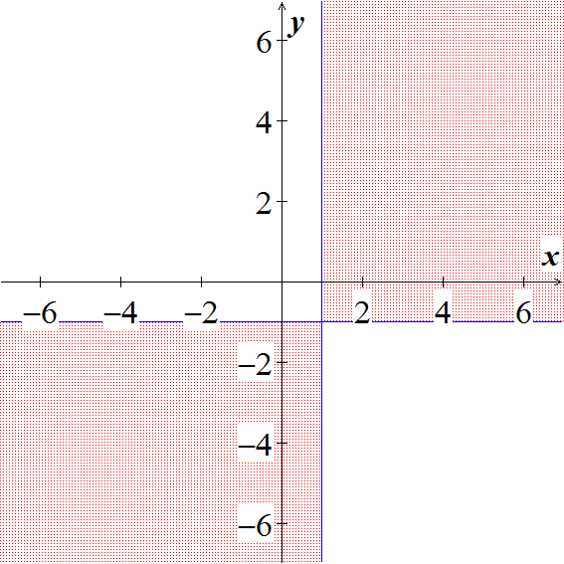

***Exercise***

Find and sketch the domain for each function 

***Solution***



*Domain*: All points  satisfying 

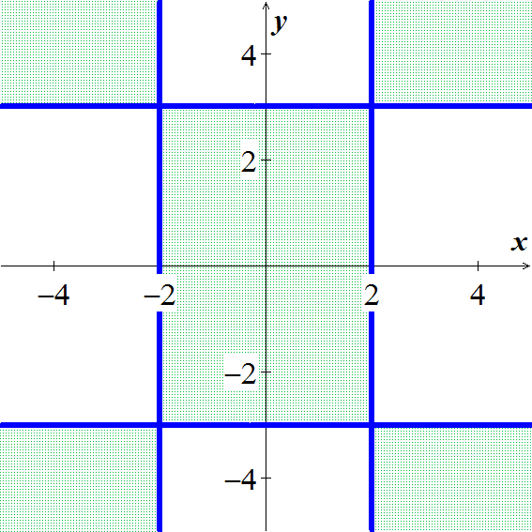

***Exercise***

Find and sketch the level curves  on the same set of coordinate axes for the given values of *c*, we refer to these level curves as a contour map. 

***Solution***



***Exercise***

Find and sketch the level curves  on the same set of coordinate axes for the given values of *c*, we refer to these level curves as a contour map.



***Solution***



***Exercise***

For the function: :

1. Find the function’s domain
2. Find the function’s range
3. Find the function’s level curves
4. Find the boundary of the function’s domain
5. Determine if the domain is an open region, a closed region, or neither
6. Decide if the domain is bounded or unbounded

***Solution***

1. *Domain*: all points in the *xy*-plane
2. *Range*: 
3. Level curves: For 

For  with center (0, 0) and major and minor axes along the *x*- and *y*-axes, respectively

1. No boundary points
2. Both open and closed
3. Unbounded

***Exercise***

For the function: :

1. Find the function’s domain
2. Find the function’s range
3. Find the function’s level curves
4. Find the boundary of the function’s domain
5. Determine if the domain is an open region, a closed region, or neither
6. Decide if the domain is bounded or unbounded

***Solution***

1. *Domain*: all points in the *xy*-plane
2. *Range*: 
3. Level curves: Hyperbolas with the *x*- and *y*-axes as asymptotes when  and the *x*- and *y*-axes when 
4. No boundary points
5. Both open and closed
6. Unbounded

***Exercise***

For the function: 

1. Find the function’s domain
2. Find the function’s range
3. Find the function’s level curves
4. Find the boundary of the function’s domain
5. Determine if the domain is an open region, a closed region, or neither
6. Decide if the domain is bounded or unbounded

***Solution***

1. *Domain*: all points in the *xy*-plane
2. *Range*: 
3. Level curves are the origin itself and the circles with center (0, 0) and radii *r* > 0
4. No boundary points
5. Both open and closed
6. Unbounded

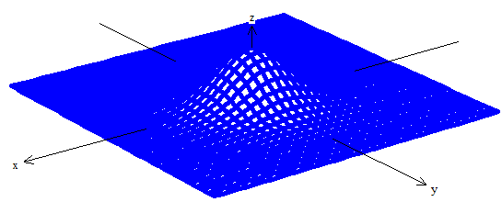

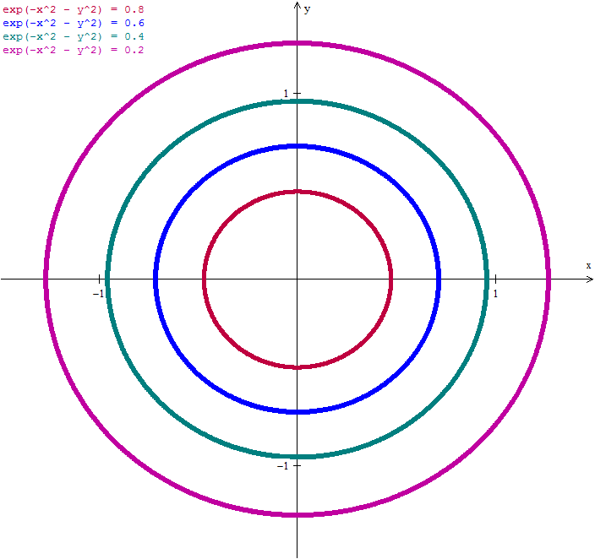

***Exercise***

For the function: 

1. Find the function’s domain
2. Find the function’s range
3. Find the function’s level curves
4. Find the boundary of the function’s domain
5. Determine if the domain is an open region, a closed region, or neither
6. Decide if the domain is bounded or unbounded

***Solution***



1. *Domain*: all points inside the circle 
2. *Range*: 
3. Level curves are circles centered at the origin and radii *r* < 9
4. Boundary: the circle 
5. Open
6. Bounded

***Exercise***

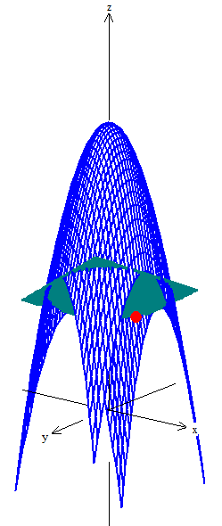Find an equation for  and sketch the graph of the level curve of the function  that passes through the point 

***Solution***











***Exercise***

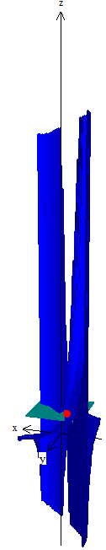Find an equation for  and sketch the graph of the level curve of the function  that passes through the point 

***Solution***













***Exercise***

Sketch a typical level surface for the function 

***Solution***

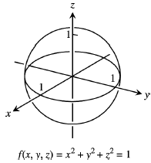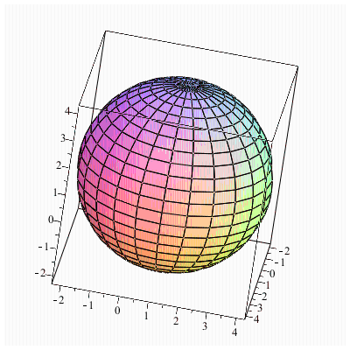

***Exercise***

Sketch a typical level surface for the function 

***Solution***

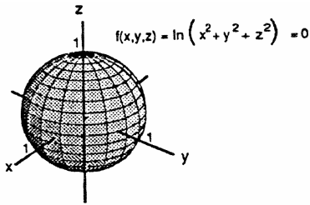

***Exercise***

Sketch a typical level surface for the function 

***Solution***



***Exercise***

Sketch a typical level surface for the function   
***Solution***



***Solution*** ***Section* 2.2 – Limits and Continuity**

***Exercise***

Find the limits 

***Solution***



***Exercise***

Find the limits 

***Solution***



***Exercise***

Find the limits 

***Solution***



***Exercise***

Find the limits 

***Solution***



***Exercise***

Find the limits 

***Solution***



***Exercise***

Find the limits 

***Solution***



***Exercise***

Find the limits 

***Solution***











***Exercise***

Find the limits 

***Solution***











***Exercise***

Find the limits 

***Solution***











***Exercise***

Find the limits 

***Solution***





 



***Exercise***

Find the limits 

***Solution***











***Exercise***

Find the limits 

***Solution***











***Exercise***

Find the limits 

***Solution***



***Exercise***

Find the limits 

***Solution***



***Exercise***

Find the limits 

***Solution***



***Exercise***

Find the limits 

***Solution***



***Exercise***

At what points (*x, y, z*) in space are the functions continuous 

***Solution***

All 

***Exercise***

At what points (*x, y, z*) in space are the functions continuous 

***Solution***

. All  except the interior of the cylinder 

***Exercise***

At what points (*x, y, z*) in space are the functions continuous 

***Solution***

All  so that 

***Exercise***

At what points (*x, y, z*) in space are the functions continuous 

***Solution***

All 

***Exercise***

At what points (*x, y, z*) in space are the functions continuous 

***Solution***

All  except 

***Exercise***

At what points (*x, y, z*) in space are the functions continuous 

***Solution***

All  except 

***Solution*** ***Section* 2.3 – Partial Derivatives**

***Exercise***

Find  and  

***Solution***





***Exercise***

Find  and  

***Solution***





***Exercise***

Find  and  

***Solution***





***Exercise***

Find  and  

***Solution***





***Exercise***

Find  and  

***Solution***





***Exercise***

Find  and  

***Solution***

 



***Exercise***

Find  and  

***Solution***

 



***Exercise***

Find  and  

***Solution***















***Exercise***

Find  and  

***Solution***











***Exercise***

Find  and  

***Solution***









***Exercise***

Find  and  

***Solution***

















***Exercise***

Find  and  

***Solution***

















***Exercise***

Find  and  

***Solution***





***Exercise***

Find  

***Solution***



***Exercise***

Find  

***Solution***

  

***Exercise***

Find  

***Solution***















***Exercise***

Find  

***Solution***







***Exercise***

Find  

***Solution***







***Exercise***

Find  

***Solution***







***Exercise***

Find  

***Solution***







***Exercise***

Find  

***Solution***







***Exercise***

Find  

***Solution***







***Exercise***

Find all the second-order partial derivatives of 

***Solution***



***Exercise***

Find all the second-order partial derivatives of 

***Solution***

  

  

***Exercise***

Find all the second-order partial derivatives of 

***Solution***

  

  

***Exercise***

Find all the second-order partial derivatives of 

***Solution***

  

  

***Exercise***

Find all the second-order partial derivatives of 

***Solution***



















***Exercise***

Find all the second-order partial derivatives of 

***Solution***



















***Exercise***

Let . Find the slope of the line tangent to this surface at the point  and lying in the **a**. plane  **b**. plane .

***Solution***

1. In the plane  ; 
2. In the plane ; 

***Exercise***

Let  be a function of three independent variables and writs the formal definition of the partial derivative  at . Use this definition to find  at  for .

***Solution***













***Exercise***

Find the value of  at the point  if the equation  defines *x* as a function of the two independent variables *y* and *z* and the partial derivative exists.

***Solution***









***Exercise***

Express *A* implicitly as a function of *a, b*, and *c* and calculate  and .

***Solution***

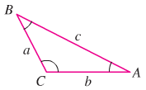



 → 







***Exercise***

An important partial differential equation that describes the distribution of heat in a region at time *t* can be represented by the one-dimensional heat equation



Show that  satisfies the heat equation for constants *α* and *β*. What is the relationship between *α* and *β* for this function to be a solution?

***Solution***







For 



⇒ 

***Solution Section* 2.4 – Chain Rule**

***Exercise***

Express as a function of *t*, then evaluate  at the given value of *t*.



***Solution***

|  |  |
| --- | --- |
|  |  |



***Exercise***

Express as a function of *t*, then evaluate  at the given value of *t*.



***Solution***













***Exercise***

Express as a function of *t*, then evaluate  at the given value of *t*.



***Solution***















***Exercise***

Express as a function of *t*, then evaluate  at the given value of *t*.



***Solution***

|  |  |
| --- | --- |
|  |  |



***Exercise***

Express  and  as functions of *u* and *v* if , then evaluate  and  at the point .

***Solution***

























|  |  |
| --- | --- |
|  |  |

***Exercise***

Express  and  as functions of *u* and *v* if , then evaluate  and  at the point .

***Solution***

|  |  |
| --- | --- |
|  |  |
|  |  |

***Exercise***

Express ,  and  as functions of *x, y* and *z* if , then evaluate ,  and  at the point .

***Solution***















































***Exercise***

Find the values of  and if  at the point 

***Solution***













***Exercise***

Find the values of  and if  at the point 

***Solution***

















***Exercise***

Find the values of  and if  at the point 

***Solution***



  









***Exercise***

Find  when  if 

***Solution***

















***Exercise***

Find  when  if 

***Solution***















***Exercise***

Find  and  when  if 

***Solution***











***Exercise***

Find  and  when  if 

***Solution***





















***Exercise***

Assume that  and . Find  and 

***Solution***







***Exercise***

The voltage *V* in a circuit that satisfies the law  is slowly dropping as the battery wears out. At the same time, the resistance *R* is increasing as the resistor heats up. Use the equation



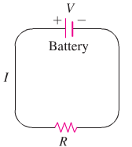To find how the current is changing at the instant when , , , and 

***Solution***











***Exercise***

The lengths *a, b*, and *c* of the edges of a rectangular box are changing with time. At the instant in question, , , and . At what rates the box’s volume *V* and surface area *S* changing at that instant? Are the box’s interior diagonals increasing in length or decreasing?

***Solution***









***Exercise***

Let  be the temperature at the point  on the circle  and suppose that



1. Find where the maximum and minimum temperatures on the circle occur by examining the derivatives  and .
2. Suppose that . Find the maximum and minimum values of *T* on the circle.

***Solution***

1. 















 on the interval 



 ⇒ T has a minimum at 

 ⇒ T has a maximum at 

 ⇒ T has a minimum at 

 ⇒ T has a maximum at 

1. 









The maximum value is 6 at  and 

The minimum value is 2 at  and 

***Exercise***

Evaluate : 

***Solution***









***Exercise***

Evaluate : 

***Solution***







***Exercise***

Evaluate : 

***Solution***









***Exercise***

Evaluate : 

***Solution***









***Exercise***

Evaluate : 

***Solution***



 



***Exercise***

Evaluate : 

***Solution***



 



***Exercise***

Find  and  at the given point. 

***Solution***





 

 

***Exercise***

Find  and  at the given point. 

***Solution***





 

***Exercise***

Find  and  at the given point. 

***Solution***









 

***Exercise***

Find  and  at the given point. 

***Solution***













***Solution*** ***Section* 2.5 – Directional Derivatives and the Gradient**

***Exercise***

Find the gradient of the function at the given point. Then sketch the gradient together with the level curve that passes through the point 

***Solution***







 is the level curve

***Exercise***

Find the gradient of the function at the given point. Then sketch the gradient together with the level curve that passes through the point 

***Solution***









 is the level curve

***Exercise***

Find the gradient of the function at the given point. Then sketch the gradient together with the level curve that passes through the point 

***Solution***









 is the level curve

***Exercise***

Find  at the given point 

***Solution***









***Exercise***

Find  at the given point 

***Solution***









***Exercise***

Find  at the given point 

***Solution***









***Exercise***

Find the derivative of the function  at  in the direction of 

***Solution***



















***Exercise***

Find the derivative of the function  at  in the direction of 

***Solution***

















***Exercise***

Find the derivative of the function  at  in the direction of 

***Solution***

















***Exercise***

Find the derivative of the function  at  in the direction of 

***Solution***



















***Exercise***

Find the derivative of the function  at  in the direction of 

***Solution***















***Exercise***

Find the derivative of the function  at  in the direction of 

***Solution***



















***Exercise***

Find the directions in which the function  increase and decrease most rapidly at . Then find the derivatives of the function in these directions.

***Solution***





 *increases* most rapidly in the direction 

 *decreases* most rapidly in the direction 











***Exercise***

Find the directions in which the function  increase and decrease most rapidly at . Then find the derivatives of the function in these directions.

***Solution***





 *increases* most rapidly in the direction 

 *decreases* most rapidly in the direction 





***Exercise***

Find the directions in which the function  increase and decrease most rapidly at . Then find the derivatives of the function in these directions.

***Solution***





 *increases* most rapidly in the direction 

 *decreases* most rapidly in the direction 











***Exercise***

Find the directions in which the function  increase and decrease most rapidly at . Then find the derivatives of the function in these directions.

***Solution***





 *increases* most rapidly in the direction 

 *decreases* most rapidly in the direction 





***Exercise***

Sketch the curve  together with  and the tangent line at the point . Then write an equation for the tangent line.

***Solution***



Tangent line: 







***Exercise***

Sketch the curve  together with  and the tangent line at the point . Then write an equation for the tangent line.

***Solution***



Tangent line: 





***Exercise***

Sketch the curve  together with  and the tangent line at the point . Then write an equation for the tangent line.

***Solution***





Tangent line: 





***Exercise***

In what direction is the derivative of  at  equal to zero?

***Solution***





A vector is orthogonal to  is 





 and  are the directions where the derivatives is zero.

***Solution*** ***Section* 2.6 – Tangent Planes and Linear Approximation**

***Exercise***

Find the tangent plane and normal line of the surface  at the point 

***Solution***







***Tangent Line***: 







***Normal Line***: 



***Exercise***

Find the tangent plane and normal line of the surface  at the point 

***Solution***





***Tangent Line***: 







***Normal Line***: 



***Exercise***

Find the tangent plane and normal line of the surface  at the point 

***Solution***







***Tangent Line***: 





***Normal Line***: 



***Exercise***

Find the tangent plane and normal line of the surface  at the point 

***Solution***







***Tangent Line***: 





***Normal Line***: 



***Exercise***

Find the tangent plane and normal line of the surface  at the point 

***Solution***







***Tangent Line***: 





***Normal Line***: 



***Exercise***

Find an equation for the plane that is tangent to the surface  at the point 

***Solution***





***Tangent Line***:  



***Exercise***

Find an equation for the plane that is tangent to the surface  at the point 

***Solution***





***Tangent Line***:  



***Exercise***

Find an equation for the plane that is tangent to the surface  at the point 

***Solution***





***Tangent Line***: 





***Exercise***

Find parametric equation for the line tangent to the curve of intersection of the surfaces  at the point 

***Solution***













***Tangent Line***: 

***Exercise***

Find parametric equation for the line tangent to the curve of intersection of the surfaces  at the point 

***Solution***















***Tangent Line***: 

***Exercise***

Find parametric equation for the line tangent to the curve of intersection of the surfaces  at the point 

***Solution***















***Tangent Line***: 

***Exercise***

Find parametric equation for the line tangent to the curve of intersection of the surfaces  at the point 

***Solution***















***Tangent Line***: 

***Exercise***

By about how much will  change if the point  moves from  a distance of  unit in the direction of ?

***Solution***

 









***Exercise***

By about how much will  change if the point  moves from origin a distance of  unit in the direction of ?

***Solution***









***Exercise***

Find the linearization  of  at the point (0, 0) and (1, 1)

***Solution***



















***Exercise***

Find the linearization  of  at the point (0, 0) and (1, 2)

***Solution***



















***Exercise***

Find the linearization  of  at the point (1, 1) and (0, 0)

***Solution***















***Exercise***

Find the linearization  of  at the point (0, 0) and (1, 2)

***Solution***



















***Exercise***

Find the linearization  of  at the point (1, 1, 1)

***Solution***











***Exercise***

Find the linearization  of  at the point (1, 2, 2)

***Solution***











***Exercise***

Find the linearization  of  at the point 

***Solution***











***Exercise***

Find the linearization  of  at the point 

Consider a closed rectangular box with a square base. If *x* is measured with error at most 2% and *y* is measured with error at most 3% use a differential to estimate the corresponding percentage error in computing the box’s

1. Surface area
2. Volume

***Solution***

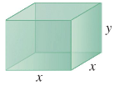***Given***: 

1. 



















1. 











***Exercise***

Consider a closed container in the shape of a cylinder of radius 10 *cm* and height 15 *cm* with a hemisphere on each end.

The container is coated with a layer of ice  cm thick. Use a differential to estimate the total volume of ice. (*Hint*: assume *r* is radius with  and *h* is height with )

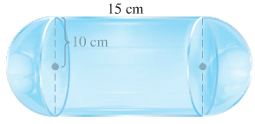***Solution***











***Exercise***

A standard 12-fl-oz can of soda is essentially a cylinder of radius  and height 

1. At these dimensions, how sensitive is the can’s volume to a small change in radius versus a small change in height?
2. Could you design a soda can that appears to hold more soda but in fact holds the same 12-fl-oz? What might its dimensions be? (There is more than one correct answer.)

***Solution***

Given: 

1. 





The volume is about 10 times more sensitive to a change in *r*.

1. 





Assume , then 



 is one solution for 

***Solution*** ***Section* 2.7 – Maximum/Minimum Problems**

***Exercise***

Find all the local maxima, local minima, and saddle points of the function



***Solution***



 Therefore, the critical point is 





The function *f* has a local minimum at  and the value is 

***Exercise***

Find all the local maxima, local minima, and saddle points of the function



***Solution***



 Therefore, the critical point is 





The function  has a local maximum at  and the value is 

***Exercise***

Find all the local maxima, local minima, and saddle points of the function



***Solution***



 Therefore, the critical point is 





***Exercise***

Find all the local maxima, local minima, and saddle points of the function



***Solution***



 Therefore, the critical point is 





The function  has a local minimum at  and the value is 

***Exercise***

Find all the local maxima, local minima, and saddle points of the function



***Solution***



 Therefore, the critical point is 





***Exercise***

Find all the local maxima, local minima, and saddle points of the function



***Solution***





Therefore, the critical point is 









The function  has a local maximum at  and the value is 

***Exercise***

Find all the local maxima, local minima, and saddle points of the function 

***Solution***





There are no solutions to the system  , however, this occurs when  . The critical point is 

We cannot use the second derivative test, but this is the only possible local maximum, local minimum, or saddle point.  has a local maximum of  since 

***Exercise***

Find all the local maxima, local minima, and saddle points of the function



***Solution***





Therefore, the critical point is , , , and 



For  



For  



The function  has a local minimum at  and the value is 

For  



The function  has a local maximum at  and the value is 

For  



***Exercise***

Find all the local maxima, local minima, and saddle points of the function 

***Solution***





Therefore, the critical point is , , and 



For  



For  



The function has a local maximum at  and the value is 

For  



The function  has a local maximum at  and the value is 

***Exercise***

Find all the local maxima, local minima, and saddle points of the function 

***Solution***



 Therefore, the critical point is 











The function  has a local maximum at  and the value is 

***Exercise***

Find all the local maxima, local minima, and saddle points of the function 

***Solution***



 Therefore, the critical point is 





The function  has a local minimum at  and the value is 

***Exercise***

Find all the local maxima, local minima, and saddle points of the function 

***Solution***



 Therefore, the critical point is 



If *n* is even: 

If *n* is odd: 

***Exercise***

Find all the local maxima, local minima, and saddle points of the function 

***Solution***



Since , the functions  and  cannot equal to zero for the same *y*.

∴ No critical points ⇒ no extrema and no saddle points.

***Exercise***

Find all the local maxima, local minima, and saddle points of the function 

***Solution***



 ∴ The critical point is 





***Exercise***

Find all the local maxima, local minima, and saddle points of the function 

***Solution***



 ∴ The critical point is  and 







For  



The function  has a local minimum at  and the value is 

For  



***Exercise***

Find all the local maxima, minima, and saddle points of the function 

***Solution***



 ∴ The critical point is 





The function  has a local maximum at  and the value is 

***Exercise***

Find all the local maxima, minima, and saddle points of the function 

***Solution***





∴ The critical point is 







***Exercise***

Find the absolute maxima and minima of the function  on the closed triangular plate bounded by the lines  in the first quadrant.

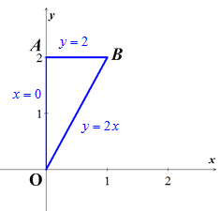***Solution***





The critical point is  and the value is 

1. On the segment *OA*. The function 

This function is defined on the closed interval .





1. On the segment *OB*





 ∴  is not interior point of *OB*

1. On the segment *AB*







⇒  is not interior point of triangular region.

Therefore; the absolute maximum is 1 at (0, 0) and the absolute minimum is −5 at 

***Exercise***

Find the absolute maxima and minima of the function  on the closed triangular plate bounded by the lines  in the first quadrant.

***Solution***



The critical point is  and the value is 

1. On the segment *OA*.







1. On the segment *OB*

 



1. On the segment *AB*







⇒  is not interior point of triangular region.

Therefore; the absolute maximum is 11 at  and the absolute minimum is 1 at 

***Exercise***

Find the absolute maxima and minima of the function  on the triangular plate .

***Solution***





The critical point is  and the value is 

1. On the segment *OA*.







1. On the segment *AB*







1. On the segment *BC*







1. On the segment *CO*







Therefore; the absolute maximum is 11 at  and the absolute minimum is −10 at 

***Exercise***

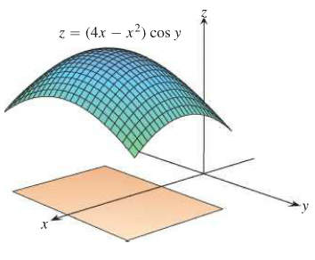Find the absolute maxima and minima of the function  on the triangular plate .

***Solution***







The critical point is  and the value is 

Values of all 4 corner points:









1. On the segment *AB*







1. On the segment *BC*







1. On the segment *CD*





1. On the segment *DA*





Therefore; the absolute maximum is 4 at  and the absolute minimum is at 

***Exercise***

Find the point on the graph of  nearest the plane 

***Solution***

The point on  where the tangent plane is parallel to the plane .

Let  is normal to  at .

The vector  is parallel to  which is normal to the plane if 

, 

Thus the point  is the point on the surface  nearest the plane 

***Exercise***

Find the minimum distance from the point  to the plane 

***Solution***





Let: 





|  |  |
| --- | --- |
|  |  |



∴ The critical point is .







Therefore, the local minimum of the distance is



***Exercise***

Find the maximum value of  where 

***Solution***











 



∴ The critical point is .







Therefore, the local maximum of the distance is



***Solution*** ***Section* 2.8 – Lagrange Multipliers**

***Exercise***

Find the points on the ellipse  where  has its extreme values.

***Solution***









 







***Case*** 1: If  . But (0, 0) is not on the ellipse so 

***Case*** 2: If 













Therefore,  has extreme values at 

The extreme values of  on the ellipse are 

***Exercise***

Find the extreme values of  subject to the constraint .

***Solution***









 



***Case*** 1: If  . But (0, 0) is not on the circle so 

***Case*** 2: If 













Therefore,  has extreme values at 

The extreme values of  on the circle are 

***Exercise***

Find the maximum value of  on the line .

***Solution***





 

 











Therefore,  has extreme values at .

The extreme values of  is 

***Exercise***

Find the points on the curve  nearest the origin.

***Solution***

Let , the square of the distance to the origin subject to the constraint 





 

 









∴  are the points on the curve  nearest the origin.

***Exercise***

Use the method of Lagrange multipliers to find

1. The minimum value of , subject to the constraints 
2. The maximum value of , subject to the constraints 

***Solution***

1. 











For  

For 

The minimum value is .

 is a branch of a hyperbola in the first quadrant with *x*- and *y*-axes as asymptotes.

The equations  give a family of parallel lines with . Thus the minimum value of ***c*** occurs where  is tangent to the hyperbola’s branch.

1. 







For 

The maximum value is .

The equations  give a family of hyperbolas in the first and third quadrants with *x*- and *y*-axes as asymptotes. Thus the maximum value of ***c*** occurs where  is tangent to the line .

***Exercise***

Find the radius and height of the open right circular cylinder of largest surface area that can be inscribed in a sphere of radius *a*. What is the largest surface area?

***Solution***

For a cylinder of radius *r* and height *h*, to maximize the surface area  subject to the constraint 



















***Exercise***

Use the method of Lagrange multipliers to find the dimensions of the rectangle of greatest area that can be inscribed in the ellipse  with sides parallel to the coordinate axes.

***Solution***

The area of a rectangle is  subject to the constraint .







 





Since *x* and *y* represents distance, then 

∴ The length is  and the width is 

***Exercise***

Find the maximum and minimum values of  subject to the constraint 

***Solution***







 

 

  











∴  is the minimum value, and  is the maximum value.

***Exercise***

The temperature at a point  on a metal plate is . An ant on the plate walks around the circle of radius 5 centered at the origin. What are the highest and lowest temperatures encountered by the ant?

***Solution***



















***Case*** 1: , but (0, 0) is not on the circle 

***Case*** 2: 



***Case*** 3: 











∴ The minimum temperature is 0° at 

The maximum temperature is 125° at 

***Exercise***

Your firm has been asked to design a storage tank for liquid petroleum gas. The customer’s specifications call for a cylindrical tank with hemispherical ends, and the tank is to hold  of gas. He customer also wants to use the smallest amount of material possible in building the tank. What radius and height do you recommend for the cylindrical portion of the tank?

***Solution***

The surface area is:  subject to the constraint .













The tank is a sphere, there is no cylindrical part, and





***Exercise***

Find the point on the plane  closest to the point 

***Solution***

Let  (be the square of the distance from )













∴ The point  is closet.

***Exercise***

Find the point on the sphere  farthest from the point 

***Solution***

Let  (be the square of the distance from )

















∴ The largest value of *f* occurs at  on the sphere.

***Exercise***

Find the minimum distance from the surface  to the origin

***Solution***

Let  (be the square of the distance from origin)







***Case*** 1: 

***Case*** 2: 

∴ The points on the unit circle  are the points on the surface  closest to the origin.

***Exercise***

Find the maximum and minimum values of  on the sphere 

***Solution***





















∴ The maximum value  and the minimum is 

***Exercise***

Find three real numbers whose sum is 9 and the sum of whose squares is as small as possible.

***Solution***















***Exercise***

A space probe in the shape of the ellipsoid  enters Earth’s atmosphere and its surface begins to heat. After 1 hour, the temperature at the point  on the probe’s surface is . Find the hottest point on the probe’s surface.

***Solution***







***Case*** 1: 



***Case*** 2: 



















∴  are the hottest points on the space probe.

***Exercise***

Find the extreme values of 

Subject to the constraint 

***Solution***

|  |  |  |
| --- | --- | --- |
|  |  |  |





 



***Case*** 1:

If  

***Case*** 2:

If  



The extreme point is  with a value of 1024.

***Exercise***

Find the extreme values of 

Subject to the constraint 

***Solution***

|  |  |  |
| --- | --- | --- |
|  |  |  |





  

   



The extreme point is  with a value of 72.