**Math 2415 − Calculus III** ***Assignment −* 1**

*Professor*: Fred Khoury

1. Two surface ships on maneuvers are trying to determine a submarine’s course and speed to prepare for an aircraft intercept. Ship ***A*** is located at (4, 0, 0), whereas ship ***B*** is located at (0, 5, 0). All coordinates are given in thousands of feet. Ship ***A*** locates the submarine in the direction of the vector , and ship ***B*** locates the submarine in the direction of the vector . Four minutes ago, the submarine was located at . The aircraft is due in 20 *min*. Assuming that the submarine moves in a straight line at a constant speed, to what position should the surface direct the aircraft?

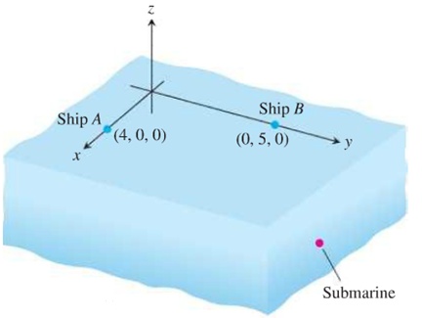

1. Consider the weight suspended by two wires where  and  are force vectors directed along the wires.

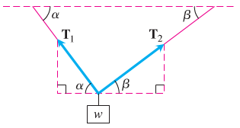

1. Find the vectors  and and show that their magnitudes are



1. For a fixed *β* determine the value of *α* which minimizes the magnitude 
2. For a fixed *α* determine the value of *β* which minimizes the magnitude 
3. A projectile is launched from the origin, which is a point 50 *ft* from a 30-*ft* vertical cliff. It is launched at a speed of  *ft/s* at an angle of 45° to the horizontal. Assume the ground is horizontal on top of the cliff and only the gravitational force affects the motion of the object

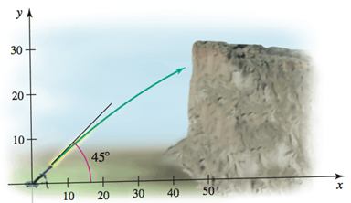

1. Give the coordinates of the landing spot of the projectile on the top of the cliff.
2. What is the maximum height reached by the projectile?
3. What is the time of flight?
4. Write the integral that gives the length of the trajectory.
5. Approximate the length of the trajectory.
6. What is the range of launch angles needed to clear the edge of the cliff?