***Section* 1.4 – Quadratic Graphics**

***Quadratic Function***

A function *f* is a ***quadratic function*** if

***Formula Example***

***Vertex* of a Parabola** 

|  |  |
| --- | --- |
| The ***vertex*** of the graph of  is | Vertex point: |

***Axis of Symmetry***:

 Axis of Symmetry: *x* = 2

***Minimum or Maximum Point***

|  |  |
| --- | --- |
| If *a* > 0 ⇒ *f(x)* has a ***minimum*** point  If *a* < 0 ⇒ *f(x)* has a ***maximum*** point  @ vertex point | Minimum point @ |

***Range***

|  |  |
| --- | --- |
| If *a* > 0 ⇒  If *a* < 0 ⇒ |  |

***Domain***: 



***Minimum / Vertex point***

***x-intercept***

***Symmetry Line***

***Example***

For the graph of the function 

1. **Find the vertex point**





***Vertex*** point (−1, 9)

1. **Find the line of symmetry:** *x* = −1
2. **State whether there is a maximum or minimum value *and* find that value**

Minimum point, value (−1, 9)

1. **Find the *x*-intercept**



1. **Find the *y-*intercept**

*y* = 8

1. **Find the range and the domain of the function.**

*Range*: (−∞, 9] *Domain*: (−∞, ∞)

1. **Graph the function and label, show part *a thru d* on the plot below**

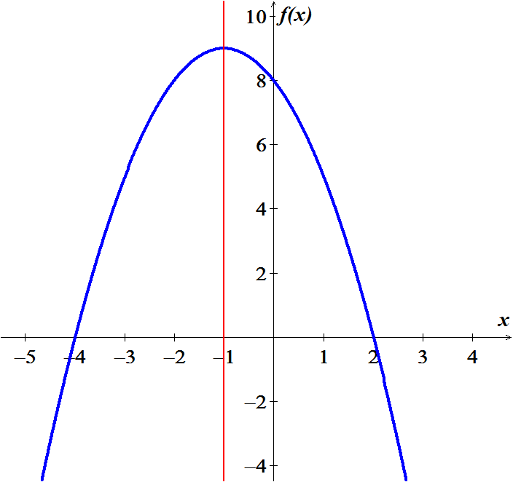

**Symmetry: *x* = −1**

**Vertex Point / Max** (−1, 9)



***x*-intercept**

1. **On what intervals is the function increasing? Decreasing?**

*Increasing*: (−∞, −1) *Decreasing*: (−1, ∞)

***Example***

Find the axis and vertex of the parabola having equation 

***Solution***







Axis of the parabola: 







Vertex point: 

***Definition* of a Parabola**

A ***parabola*** is the set of all points in a plane equidistant from a fixed−point *F* (the ***focus***) and a fixed line *l* (the ***directrix***) that lie in the plane

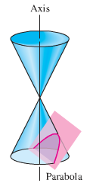

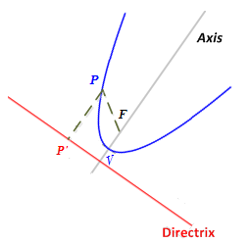 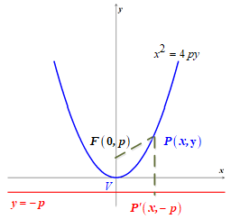

 

 

The standard equation is a parabola with vertex *V* = (0, 0).

Moreover, 

|  |  |  |
| --- | --- | --- |
| **Equation, focus, Directrix** | **Graph for** | **Graph for** |
| Focus:  Directrix: |  |  |
| Focus:  Directrix: |  |  |
| Focus:  Directrix: |  |  |
| Focus:  Directrix: |  |  |

***Example***

Find the focus and directrix of the parabola .

***Solution***

***Given***: 









The parabola opens downward and has focus .

The directrix is the horizontal line  which is a distance  above *V*.

***Example***

1. Find an equation of a parabola that has vertex at the origin, open right, and passes through the point *P*(7, −3).
2. Find the focus of the parabola.

***Solution***

1. An equation of a parabola with vertex at the origin that opens right has the form 





The equation is: 

1. 





Thus, the focus has coordinate 

***Example***

Sketch the graph of 

***Solution***



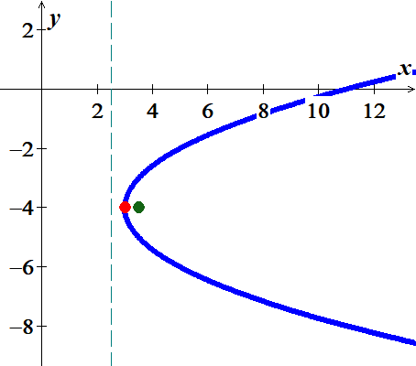





The vertex is 

The focus is 



The directrix is 



***Example***

A parabola has vertex *V*(−4, 2) and directrix *y* = 5. Express the equation of the parabola in the form 

***Solution***

Directrix: 



















***Exercises Section* 1.4 – Quadratic Graphics**

(**1 − 21**) For the Given functions

1. Find the vertex point
2. Find the line of symmetry
3. State whether there is a *maximum* or *minimum* value *and* find that value
4. Find the zeros of 
5. Find the *y*-intercept
6. Find the *range* and the *domain* of the function.
7. Graph the function and label, show part *a thru d*
8. On what intervals is the function *increasing*? *decreasing*?

|  |  |  |
| --- | --- | --- |
|  |  |  |

(**22 − 36**) Find the vertex, focus, and directrix of the parabola. Sketch its graph.

|  |  |  |
| --- | --- | --- |
|  |  |  |

(**37 − 45**) Find an equation of the parabola that satisfies the given conditions

|  |  |
| --- | --- |
|  |  |